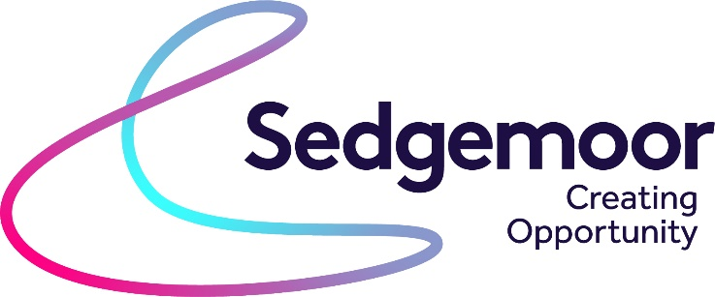

Sedgemoor District Council are seeking expressions of interest for the coordination and delivery of employment and skills services for Sedgemoor residents aged 18 to 24
Budget available: £43,910
Duration of project: 12 months

Background
This initiative is for DWP to work in partnership with Sedgemoor District Council and community organisations to fill vacancies from within the area’s diverse and most deprived communities and reduce unemployment, increasing skills and resilience support.
The support will pull together a community of practice across the district, working with our partners, support agencies and the voluntary sector to provide a holistic support offer to all 18 to 24 year old residents who are without work or training or who are underemployed.

Scope
Sedgemoor District Council wishes to appoint a suitably qualified and experienced organisation to:
- Produce and deliver an agile local Youth Hub service offer that addresses the embedded worklessness experienced by the younger residents of Sedgemoor.
- Improved access to holistic employment support through high quality education, training and skills provision increasing opportunities to secure employment.
- Provision of a specialist service which engages, inspires and motivates younger residents to ensure the skills and confidence required to successfully gain and regain employment and/or actively contribute to the community.
- The hub must address individual’s digital barriers allowing the matching of vacancies with jobseekers living in Sedgemoor’s most deprived communities.
- Engaging with a minimum of 100 younger claimants to enhance their skills and abilities and knowledge of the variety of roles and the job opportunities on offer.
- Enabling peer support and a role model mentoring.
- Engage with employers with harder to fill vacancies and local vacancies.
- Deliver a service that is a catalyst for positive change.

Funding
Sedgemoor District Council has secured funding for activity in both Bridgwater and Highbridge areas of Sedgemoor. The funding is intended to provide:
- Hire of physical space
- Staffing costs to support customers for two days per week plus admin support for one day per week.
- Admin/documentation costs
- Design and creation of posters etc.
- Specialist training for staff and volunteers.
- Overarching co-ordination – This is the element that Sedgemoor District Council is making available for expressions of interest. This element of the funding is for £43,910 for 1 year.
We would expect the support to commence as soon as practically possible. Should timescales allow, we hope this to be December 2021
The exact scope of the work, targets and dates for key deliverables will be agreed with the appointed provider. Payment for services will be paid quarterly and will be subject to achieving the agreed performance.

Submission of expression of interest and provider selection
Interested parties are required to submit
A statement (not more than 2000 words) explaining the relevant experience the organisation has in provision of this type of service and an outline of how you would approach this project achieving the ambitions set out in the project scope utilising the funding to maximum effect.
Expressions of interest need to be submitted via the supplyingthesouthwest.org.uk portal by 12 noon on Monday 15th November
Further information or clarification questions should be raised via the portal or via email to procurement@sedgemoor.gov.uk
Any clarifications that will are raised will be shared with all those considering expressing an interest via the portal.
Once EOI’s are submitted, up to four providers will be invited to present their proposal and attend an interview with a stakeholder panel. The dates for this will be advised to providers in due course.

