

LEA BRIDGE GATEWAY
STRATEGIC INDUSTRIAL LOCATION

CONSULTANTS BRIEF
FOR THE PRODUCTION OF A
2-STAGE MASTERPLAN

For the comprehensive employment-led redevelopment
of
Lea Bridge Gateway SIL
May 2019

This Brief forms part of the ITT SPECIFICATION

CONTENTS

1. PURPOSE
2. LEA BRIDGE GATEWAY SIL – THE AREA OF APPLICATION
3. THE COUNCIL’S VISION AND OBJECTIVES
4. THE MASTERPLAN SCOPE
5. INDICATIVE TIMETABLE
6. BUDGET ALLOCATION
7. COMMISSION MANAGEMENT
8. REQUIRED COMPETENCIES
9. COPYRIGHT

LIST OF BACKGROUND DOCUMENTS

- PURPOSE

  - The London Borough of Waltham Forest (the Council) has made a public commitment to landowners and businesses in Rigg Approach, to lead the development of a Masterplan, including phasing and delivery, for the intensification and comprehensive employment-led redevelopment of Rigg Approach, a sub area within the Lea Bridge Gateway Strategic Industrial Location (SIL) and the Argall Avenue Business Improvement District. It has committed to produce this Masterplan in 2019-20 in parallel with the Council’s review of the Local Plan.

  - The Local Plan Review and this Masterplan will be positioned sub regionally at the interface of the Upper and Lower Lea Valley Opportunity areas, and it’s contribution to the development of economic growth in the ‘productive valley’, where the Council is working closely with Haringey, Enfield and Hackney.

  - The Council will also be working closely with the GLA, and undertaking this work in accordance with the GLA’s November 2018 draft practice note on ‘Industrial intensification and co-location through plan-led and Masterplan approaches’ (see Appendix 1) and policies E4-E7 in the draft New London Plan. In accordance with the GLA’s draft practice note this Masterplan commission will be in two stages:

  - Stage 1 will examine the whole of the Lea Bridge Gateway SIL including Borough Employment Area (BEA) 8 Argall Avenue Extension, and draw on evidence of industrial supply and demand, whilst identifying the wider spatial context and non-standard uses. Options for which parts (sub areas) of the SIL could undergo intensification, co-location and/or release for housing will be identified and appraised.

  - The principal outputs of stage 1 will be the proposed sub-area(s) for intensification, co-location and/or release for housing, together with the broad quantum of industrial capacity identified that could be delivered.

  - Stage 2 will be a detailed analysis of the sub-area(s) selected in Stage1, informed by planning policy, land ownership, engagement, land audits and business intentions.

  - The principal output of stage 2 will be a defined and agreed area for industrial intensification, co-location and residential release showing the capacity of the area. The Masterplan will set out a design of the industrial area and buildings with an analysis of access, Agent of Change, public transport and local services and infrastructure requirements. Stage 2 will also identify a delivery plan, including a decant and phasing strategy.

  - This commission will also identify and appraise the most appropriate development partner options and vehicles to secure investment in and delivery of the Masterplan, including a partner(s) for the Council, and/or necessary planning conditions/development agreements to ensure development is comprehensive and coordinated across the Masterplan area.

  - Whilst stage 1 will require a consideration of all of the Lea Bridge Gateway SIL sub areas, it’s important to stress that the Council currently sees the Rigg Approach sub area as the preferred sub area for selective colocation and the stage 2 Masterplan.

  - The Masterplan will be produced with a collaborative approach involving landowners and key business, the Argall BID, and the preferred development partner(s) at key stages, enabling their full contribution and thereby ensuring that the Masterplan is deliverable; without this involvement, managed through the Council and the Masterplan consultancy team appointed through this procurement, the Masterplan will not be grounded in reality and risks being ‘left on the shelf’.

  - The Masterplan consultancy team would be contracted by the Council but work closely and collaboratively with the GLA and existing landowners, through a steering group including business representatives.

  - The Council is therefore seeking to appoint a multi-disciplinary consultancy to produce a ground breaking Masterplan and associated delivery plan, and assist in the establishing a development partnership and delivery vehicle.

- LEA BRIDGE GATEWAY SIL - THE AREA OF APPLICATION

  - Stage 1 examines the whole of the Lea Bridge Gateway SIL, whilst stage 2 will focus on the selected sub areas agreed at the end of stage 1. Stage 1 will also consider BEA8 Argall Avenue Extension. The figures below show the location of the SIL, its sub areas and their respective make up by sector.

Figure 1: Lea Bridge Gateway SIL – Stage 1
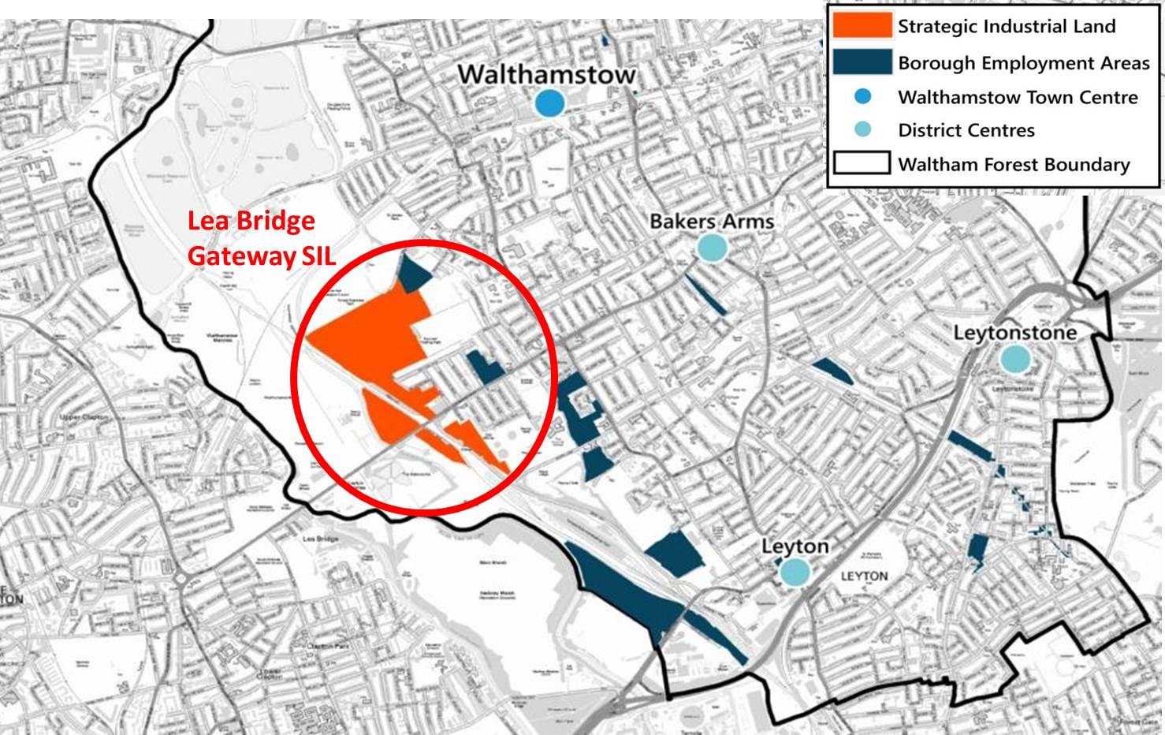
  - Lea Bridge Gateway SIL compromises of four separate SIL areas: Argall Avenue; Former Town Gas Works Site (Orient Way); Lammas Road and Rigg Approach. In addition, the Argall Avenue Extension Borough Employment Area (BEA) should also be included within the scope of Stage 1.

Figure 2: Argall Avenue (SIL 4)

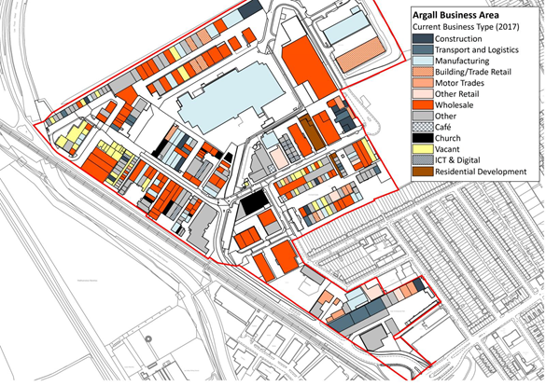
  - The borough's largest employment area and important driver of the economy. The SIL consists of a mix of light industry, warehousing and manufacturing, but Regeneris (see Appendix iv) noticed also an increasing level of creative activity.

  - Mix of building sizes and conditions; some newer good quality light industrial units, but many older plots and premises which could be intensified. Large number of council freeholds.

  - The site is home to 244 businesses in 306 premises with 2,500 employees, and offers about 124,330 sqm industrial floorspace.

Figure 3: Former Town Gas Works Site (SIL 7)

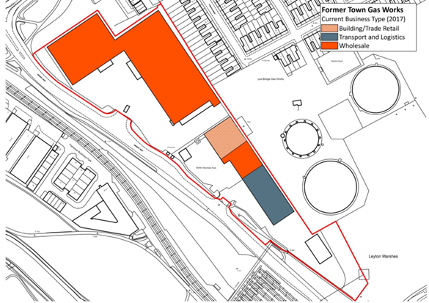
  - Relatively modern B8 distribution units occupy much of the site. There is a relatively low employment intensity reflecting whole sale activities. The site is in private ownership.

  - The site is home to 4 businesses in 4 premises with 260 employees, and offers about 17,170 sqm industrial floorspace.

Figure 4: Lammas Road (SIL 6)

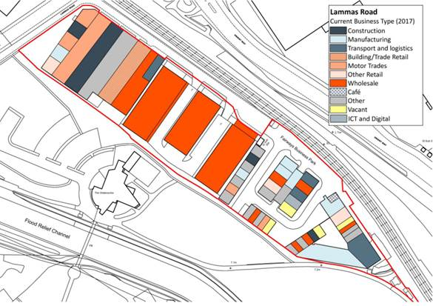
  - Consists of a mix of premises, largely 1-2 storeys. Many are in poor condition; some larger B1c units are in average condition. There is a comparatively low employment density; a mix of industrial activities, but some emerging evidence of creative uses.

  - Regeneris highlight a strong opportunity for intensification to improve the quality of commercial space and to attract new uses. The site is in fragmented ownership with Capital Industrial owning a major part.
  - The site is home to 55 businesses in 59 premises with 205 employees, and offers about 11,600 sqm industrial floorspace.

Figure 5: Rigg Approach (SIL 5)

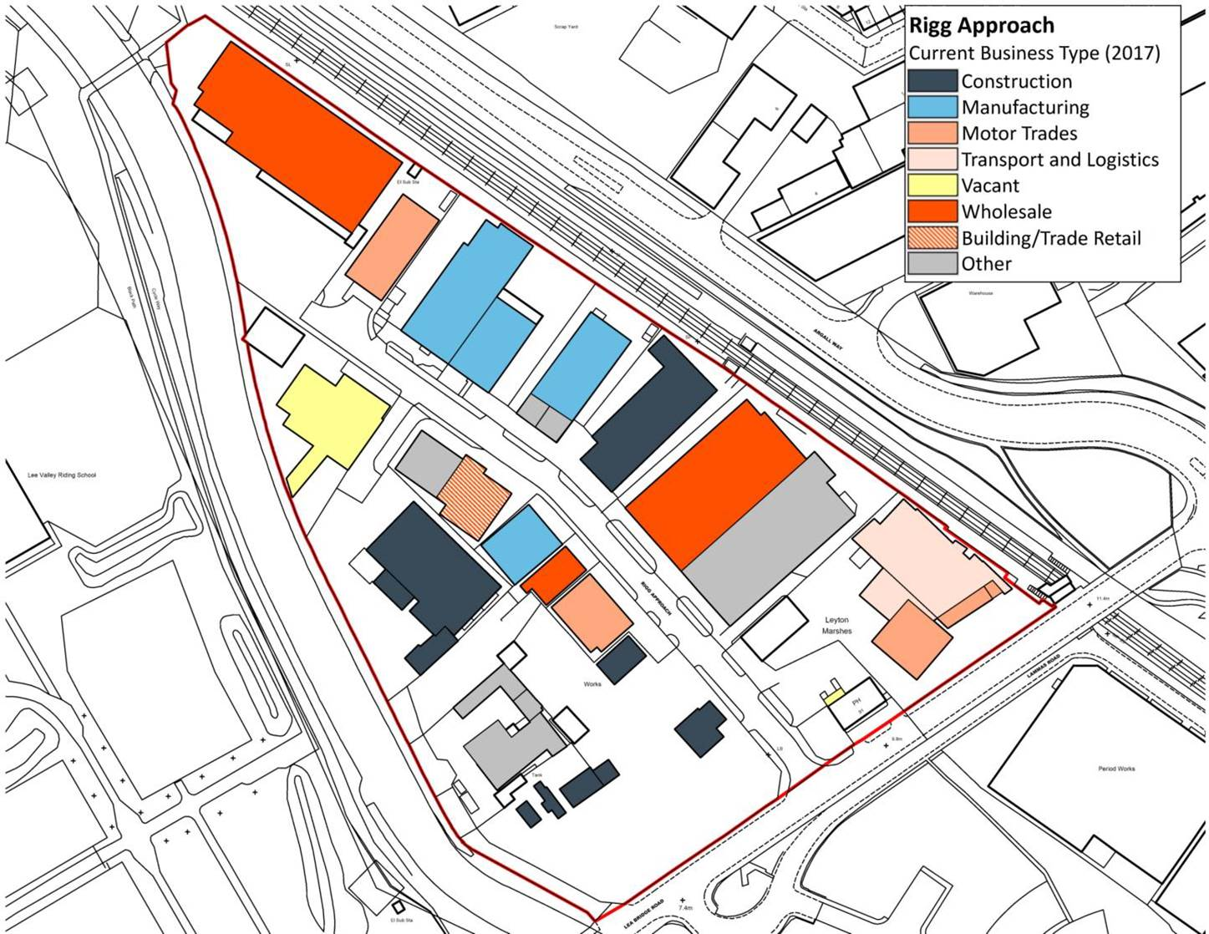
  - Mix of premises types from 1-3 storeys, but intensity across the site is generally low, and stock and environment in poor condition. Manufacturing and industrial activities are the main uses.

  - The site is in fragmented ownership with the council owning two premises. There is relatively high employment density with about 400 jobs on the 5ha site.

  - The site has been rated by Regeneris (2017) as priority for intensification considerations and the table below shows for each sub area, and the SIL as a whole, the number of businesses, premises, employees and industrial floor space.

Figure 6: Argall Avenue Extension (BEA8)

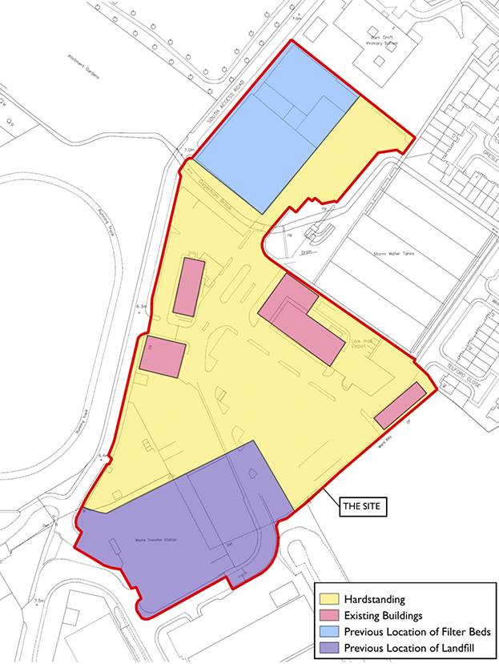
  - The Council is currently looking to re-design the existing Low Hall Depot to accommodate the existing operational uses on a smaller footprint and outline options for the potential redevelopment of parts of the site for other uses, which could include commercial, employment and potentially limited residential.

  - The council is freeholder of the whole site which is currently mainly designated as a Borough Employment Area (BEA 8) and partly as Strategic Industrial Land (SIL 4). Parts of the site also fall within flood zones 2, 3a and 3b.

  - The Low Hall Depot site is approx. 3.8 hectares. The Depot site is adjacent to a civic amenity site operated under contract and leased to the North London Waste Authority (NLWA). Including this site, the total area is approx. 4.1 hectares and the whole area has a long history as sewage works, refuse dump and depot.

Table 1: Lea Bridge Gateway SIL overview:
 | Businesses | Premises | Employees | Industrial Floorspace sqm
SIL 7 Former Town Gas Works Site | 4 | 4 | 260 | 14,170
SIL 6 Lammas Road | 55 | 59 | 205 | 11,600
SIL 5 Rigg Approach | 18 | 23 | 560 | 20,250
SIL 4 Argall Avenue | 244 | 306 | 2,500 | 124,330
BEA8 Argall Avenue Extension | 4  (3 contractors plus Council) | 5 | 633 | 2,897
Lea Bridge Gateway | 321 | 392 | 3,525 | 170,350

- THE COUNCIL’S VISION AND OBJECTIVES

  - The Council, as a landowner and a strategic regeneration and planning authority, is looking to collaboratively work with all interested parties to bring forward the comprehensive redevelopment of Rigg Approach and other identified sub-areas over the next ten years. The Council’s vision for the development is:

Economically-driven: based around a significant increase in modern commercial, industrial and work spaces that retains existing businesses who wish to stay and attracts target business sectors, substantially expanding opportunities for employment, skills development and new ways of working

Sub-regionally positioned: recognising Rigg Approach’s location at the interface of the Upper and Lower Lea Valley Opportunity Areas, its contribution to the development of economic growth and new employment uses in the “Productive Valley” and its role in delivering affordable housing growth and new communities

Future-proofed: anticipating, innovating and sufficiently flexible to accommodate economic, cultural, social and technological change

Locally-embedded: contributing to the transformative programme of regeneration in the Lea Bridge Growth Area

Exemplary-designed: creating a new liveable, sustainable, high quality, working neighbourhood, co-locating a mix of complex uses and occupiers, integrated with the Lee Valley Park and existing communities

Delivery-focused: underpinned by a public/private sector partnership, an agreed Masterplan and business case that unlocks, attracts and enables investment and phased delivery

  - The Council will not entertain any unilateral commercial or planning proposals that prejudice the comprehensive delivery of the SIL intensification area project and will apply its regulatory and wider powers to ensure this outcome.

The Waltham Forest Local Plan

  - The Council is currently reviewing its Local Plan with draft proposals due to be published in June 2019, which will include an updated Employment Land Review as part of the evidence base. This Review and the draft Local Plan proposals will need to be carefully considered as part of the development of the Stage 1 Masterplan in this commission.

- THE MASTERPLAN SCOPE

  - The Masterplan will be delivered in two stages as described in the GLA’s November 2018 draft practice note on ‘Industrial intensification and co-location through plan-led and Masterplan approaches’ (see Appendix 1).

  - The commission contract will be reviewed at the end of the stage 1 to consider the results of the borough wide strategic employment work for the Local Plan review, and how the brief for stage 2 of the Masterplan can incorporate, and if necessary be adjusted to incorporate these results and priorities. The contract will include a break clause at the end of stage 1 if a decision has been taken to not proceed with the Masterplan.

  - A decision to not proceed with stage 2 of the Masterplan will depend on:
- Stage 1 fulfilled all criteria described in section 4.3
- GLA approval to proceed with suggested sub areas(s)

Masterplan Stage 1

  - Stage 1 of the Masterplan will consider the whole Lea Bridge Gateway SIL and BEA8, and wider linkages and should consist of the following:

- Geographical scope
- Policy context
- Evidence of sub-regional and local industrial demand
- Wider spatial context
- Evidence of current industrial floorspace quantum, occupancy rates and business sectors
- Option appraisal for intensification and co-location across the various sub-areas
- High-level viability appraisal
- The proposed Masterplan approach for the selected sub area, in particular identifying the broad quantum of proposed industrial floor space capacity and yard space

  - The GLA/ We Made That 2018 study (Appendix ii) provides some initial spatial options testing on the preferred sub-area, Rigg Approach. The stage 1 Masterplan should build on the We Made That 2018 study.

  - The key outcome of stage 1 is to identify those parts of the SIL where development is proposed that would enable intensification of industrial uses or co-location to support the delivery of residential uses; the option appraisal should consider and set out why particular subareas within the SIL are being selected.

  - There are four clear sub areas within Lea Bridge Gateway SIL (see maps in section 3):

- Argall Avenue
- Former Town Gas Works Site (Orient Way)
- Lammas Road
- Rigg Approach

  - It is currently envisaged that the most relevant sub area would be Rigg Approach. However, it is conditional that Stage 1 should carefully consider the other three subareas and the rationale for including them or not and that this should be discussed and agreed with the GLA before progressing to Stage 2.

Masterplan Stage 2

  - Stage 2 of the Masterplan will concentrate on the relevant sub-area selected at the end of Stage 1 and where development is proposed, and consists of the following:

- Geographical scope, including detailed maps of where development is proposed

- The policy context, setting out how the proposals are consistent with the adopted and draft New London Plan, the emerging Local Plan and emerging site allocations, and other planning documents where relevant including Opportunity Area Frameworks and supplementary planning documents

- Evidence which demonstrates how the use classes, typologies and size of proposed units have been arrived at

- The wider spatial context, identifying how the sub area(s) link to:

  - strategic and local road networks, rail and river/canal networks, public transport and walking and cycling routes;
  - nearby town centres, high streets, retail parks, local services and social infrastructure
  - green infrastructure
  - the location of existing residential areas

- Non-standard land use designations, identifying:

  - Waste management, utilities or land for transport functions
  - Health and Safety Executive (HSE) hazardous area classifications

- Land ownership and delivery plan

  - The configuration of landownerships and tools available for land assembly and brokering development partnerships / to deliver strategic development

- Partnerships and engagement plan

  - Detail plan for engagement with landowners, businesses, existing partnerships, business alliances and the Argall BID

- Industrial land audit and assessment of business needs, including intention to stay or move, growth and investment plans, operational and servicing requirements, and how existing businesses and functions can be secured through the Masterplan

- Option appraisal, which identifies and appraises a range of options that have been considered for development of the sub area(s), drawing on the Combination Option set out in the We Make That report.

- The proposed Masterplan approach:

  - Spatial analysis identifying in the sub area sites capable of intensification:

    - for industrial only uses
    - for industrial co-location (i.e. industrial and residential/other non-industrial
    - for residential or other non- industrial development

- Site capacity analysis including:

  - An assessment of the capacity of relevant sites in the sub area to accommodate development (including industrial activities, residential and other uses). This should state

  - The quantum of industrial floorspace and functions that could be delivered across different sites broken down by industrial use categories in part A of the New London Plan, policy E4

  - A qualitative and spatial design vision for the relevant sub-area, alongside a quality-led design code to help protect future development and set an aspiration for the character of the Masterplan. This could include details of the assumed building typologies and number of storeys including high level design principles around building orientation, site and building access, key frontages, positioning of amenity space, and pedestrian / vehicle movement around the wider site to ensure residential / industrial adjacencies are successful

  - Assumed area for yard space for access, servicing and operational requirements, taking into account appropriate provision of public realm and landscaping

  - Details of the assumed industrial floorspace plot ratios and plot coverage for the relevant sites within the Masterplan area

  - The estimated number of residential units and non-industrial floorspace, where appropriate

- Infrastructure requirements to support the Masterplan proposals

- Access and servicing analysis –demonstrating that the access and servicing requirements of existing and new industrial businesses can be met and identifying potential impacts on the strategic and local road networks

- Agent of Change and ‘compatibility’ analysis demonstrating how different uses can be good neighbours and how potential impacts can be mitigated, especially in relation to new residential development

- Access to public transport and local services

- Decant and phasing – how the phasing will ensure the intensified industrial development is delivered and completed, in advance of the residential components plus the approach to decanting and relocating any businesses

- Deliverability – demonstrating the proposals are viable, achievable and can be delivered, including who is responsible for delivery and the nature of required development agreements

- Sustainable development and equalities – the Masterplan should support sustainable development and the requirements of the equalities Act 2010, in particular the Public Sector Equality Duty

  - Stage 2 of the Masterplan would prepare the ground for:

- formal agreements with development or investment partner(s) on the basis of delivering comprehensive employment-led redevelopment;
- the development of an Equalisation Scheme (commercial returns);
- a contribution to the review of the Waltham Forest Local Plan;
- an outline planning application for the whole of the selected sub area
- a detailed site/phase 1 planning application.

Estimated development costs

  - Estimated development costs should include the following:

- Land value and assembly
- Decant and relocation of businesses
- Site preparation (decontamination / remediation, demolition etc.)
- Building/construction costs that are appropriate to quality placemaking in co-location contexts
- Transport improvement costs
- High quality public realm
- Operation and maintenance
- Carbon Offset Fund , Community Infrastructure Levy and likely s.106 estimates

Equalisation scheme

  - The consultant is also required to set out, within the Delivery Plan part of the Masterplan, a possible equalisation scheme and how this would be managed through a preferred legal structure. This should be on the basis that an overall plan for the selected sub area Masterplan will achieve higher values, but that the position and location of some interests will be less advantageous in the redevelopment than others.

Engagement Programme

  - Development and implementation of an engagement plan.

KEY PERFORMANCE INDICATORS (KPIs)

  - The contract will include the following KPIs, to be completed in accordance with the quality criteria and signed off by the Council.

KPI | Date
Completion Draft Stage 1 Masterplan | 14/10/19
Completion Final Stage 1 Masterplan | 25/11/19
Completion of Appraisal of Delivery Options and Partners | 27/01/20
Draft Equalisation Scheme set out | 31/03/20
Completion of Stage 2 Option Appraisal | 09/03/20
Completion of First Draft Stage 2 Masterplan | 31/03/20
Completion of Stage 2 Masterplan | 29/05/20
Scoping of Outline Planning Application completed | 31/07/20

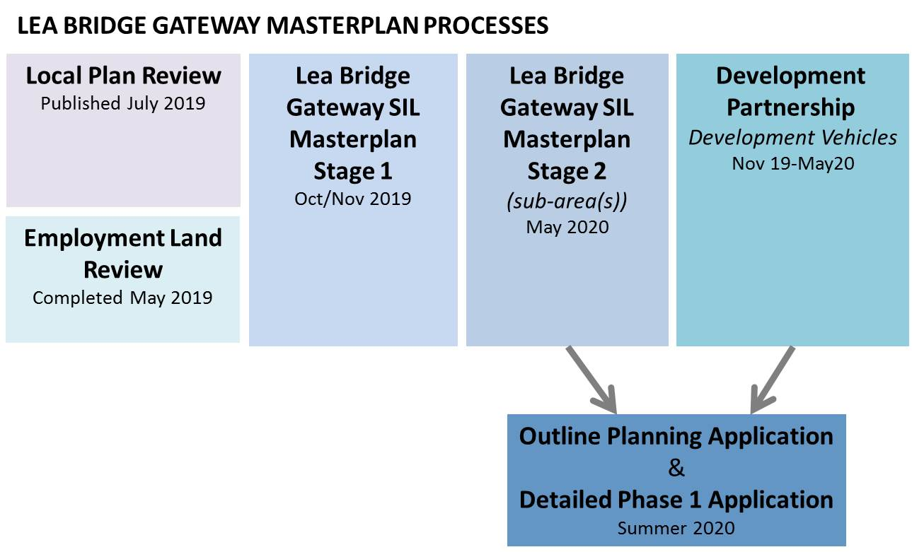

- INDICATIVE TIMETABLE

  - The principal milestones and timetable for this commission are set out in the table below.

Tender issued | 13/04/19
Deadline for clarifications | 18/06/19
Return date for submissions | 02/07/19  12 noon
Presentation/Interview | 22nd and 24th July
Decision Panel | By 29/07/19
Notification to Bidders of award decision | 02/08/19
Standstill period expires | 12/08/19 00:00
Consultants appointed | 13/08/19
Full inception meeting and briefing | 29.08.19
Draft Masterplan Stage 1 issued | 25/10/19
Completion Final Stage 1 Masterplan | 21/11/19
GLA Approves Stage 1 Masterplan | 06/12/19
Stage 2 Masterplan commission commences | 20/12/19
Completion of Appraisal of Delivery Options and Partners | 27/01/20
First Draft Masterplan Stage 2 issued | 31/03/20
Draft equalisation Scheme set out | 31/03/20
Second draft Masterplan Stage 2 issued | 30/04/20
Completed Stage 2 Masterplan | 29/05/20
Council Cabinet approves Masterplan | July 2020
Scoping of Outline Planning application completed | August 2020

Note: Milestones for inputs from landowners and business and the Masterplan Steering Group to be added.

- BUDGET ALLOCATION

  - Stage 1

The guideline budget for stage 1 of this commission is £75,000.

  - Stage 2

The guideline budget for stage 2 of this commission is £300,000.

- COMMISSION MANAGEMENT

  - The Council has established an internal corporate Steering Group, chaired by the Director of Investment and Delivery, to oversee the next steps of work.

  - Consultants will also be required to present to and work with a Steering Group including the Council, GLA, key landowners and business representatives and contribute to the consultation on the draft Masterplan.

  - The Commission will be managed day to day by the Council’s Area Regeneration Team through Britta Stoehr (Project Manager) britta.stoehr@walthamforest.gov.uk and Mark Adams (Programme Manager) mark.adams@walthamforest.gov.uk.

- 8. REQUIRED COMPETENCIES

  - Amongst the core skills and experience required from the quoting organisations are:

- Industrial intensification understanding and demonstrable delivery experience
- Co-location of industrial and non-industrial, including residential, uses understanding and delivery experience
- Planning, regeneration, design and urban design expertise
- Business and commercial viability skills,
- Knowledge and experience of appropriate delivery vehicles
- Development viability appraisal skills
- Infrastructure planning skills
- Current market understanding and networks to draw advice from
- Sustainable transport skills
- Creative consultation, consensus building and engagement skills in a context of a range of potentially conflicting interests
- Strong project management and research skills
- Robust sustainable development experience and skill

Evaluation Methodology

  - Following compliance checks each bid will be evaluated and scored against the evaluation criteria and weightings set out in the Invitation to Tender.

- COPYRIGHT

  - All written, graphic and photographic outputs produced directly by the consultant shall be provided in electronic form or shall be scanned so that it can be stored and reproduced electronically.

  - The London Borough of Waltham Forest will retain copyright of all the material produced in the context of the project.

  - The Council will have the right to reproduce any material provided. The consultant may only reproduce material with the permission of the Council.

  - Waltham Forest Council shall be able to distribute the material in part or whole to any organisation or individual it determines, at no extra cost.

BACKGROUND INFORMATION

i) Practice Note: Industrial intensification and co-location through plan-led and Masterplan approaches
https://www.london.gov.uk/sites/default/files/practice_note_- industrial_intensification.pdf

ii). GLA Industrial Intensification Study by We Made That
https://www.london.gov.uk/sites/default/files/136_industrial_intensification_and_co-location_study_-_design_and_delivery_testing_reduced_size.pdf

iii). Places that Work, 11 July 2018 https://drive.google.com/file/d/1H95vDs20wRoRaxa68SbKVFML-ZwVLZFd/view

iv). Regeneris Business Audit and Intensification Study, 2018.

v) Lea Bridge & Leyton Vision
https://walthamforest.gov.uk/content/town-centres#leavalley

The GLA’s Industrial Intensification and Co-location Study (2018) includes a section on Urban Scale Guidance that can help inform the design principles for the wider Masterplan

