FOLKESTONE & HYTHE DISTRICT COUNCIL

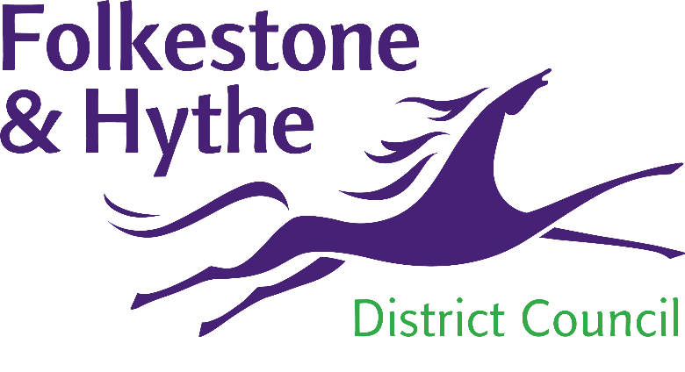

REQUEST FOR QUOTATION:

Inspection of Hackney Carriage

and Private Hire Vehicles
CONTENTS
- This Invitation to Quote
- Example Vehicle Inspection Sheet
- Example Certificate of Compliance
- Terms and Conditions

the requirement
Bidders are invited to quote for the contract to carry out the inspection of Hackney Carriages and Private Hire vehicles for an initial period from 1st April 2020 to 31st March 2022 with an option to extend the agreement for a further 12 months.
The Council has issued approximately 290 active licences.
Garages eligible for this contract need to be an official M.O.T. testing station complete with the facility for testing the exhaust emission of diesel engines and have the capacity to inspect in excess of 200 taxis twice a year.
Vehicles tested must comply with the Council’s Hackney Carriage and Private Hire Vehicle and Driver Conditions and Procedures as may be amended from time to time, in addition to all legislative requirements relating to vehicle condition. All Hackney Carriage and Private Hire Vehicles have to be inspected twice each year, subject to the conditions contained in the Conditions and Procedures referred to above.
The current version of the handbook can be found at https://www.folkestone-hythe.gov.uk/article/831/Apply-for-a-taxi-drivers-licence.
The inspections consist of the following:
- Standard MOT (as approved by the Driver and Vehicle Standards Agency);
- Body and paintwork damage;
- Presence of a fire extinguisher;
- Presence of “No Smoking” stickers on or near the entrance doors;
- Presence of a Taxi plate;
- For hackney vehicles, presence of a taxi meter;
- For hackney vehicles, presence of a roof light.
The appointed garage will inspect hackney carriage and private hire vehicles to ensure they comply with the above. The owners of the vehicles are aware of the inspection dates for their vehicles and are required to arrange the time and date of their inspection with the garage directly. The exception to the above will be new vehicles entering the trade, or replacement vehicles for changeover. In this event of casualties, the Licensing Officer will issue the vehicle owner with written authority for the inspection of the vehicle beforehand.
The Council will supply a template for vehicle inspection sheets, an example of which is included in this Invitation to Quote. The Council’s inspection check sheets are similar to the standard M.O.T with an additional section for general comments.
When a vehicle passes inspection, the garage will complete a Certificate of Compliance for the vehicle.
The garage will send both the inspection sheets and certificates of compliance to the Council along with the details of any vehicle which has failed to pass inspection.
Vehicles failing their inspection MUST have their plates removed and held by the garage until a pass certificate is obtained.
The Council will pay the cost of each initial inspection, but retests for failed vehicles are to be paid by the vehicle owner. The charge for any retests should be no higher than the maximum amount allowable for an MOT.

evaluation of quotes
The Council is looking to appoint two contractors for these services.
The owners of the vehicles will be provided with a choice of garage from the two appointed contractors and are required to arrange the time and date of their inspection with the garage directly. The Council does not guarantee any minimum volume of work under this agreement.
Quotations will be scored according to cost. The quotations with the lowest value will be the quotations that the Council considers. No further negotiation will take place after the quotations have been received.
If it is necessary to make a decision between two quotes of equal cost, the Council will consider the convenience of the service customers (the vehicle owners).
Once the successful suppliers have been identified, they will be notified to this effect. All other suppliers will be notified that they are unsuccessful.

TERMS AND CONDITIONS OF CONTRACT
The Council’s Terms and Conditions applicable to this ITQ are attached (as a separate document) and will apply to any subsequent Contract that may arise. If you have any queries regarding the Terms and Conditions of Contract, these must be stated prior to submitting a quotation. The Council may agree upon any non-material changes to the Terms and Conditions of Contract which the supplier considers to be in the interests of the Council and the service, however any such agreement shall be at the sole and exclusive discretion of the Council.

instructions
Return of Quotations: Prospective Suppliers are required to complete and return this quotation document and return it either in person by 12:00 Noon Monday 17th February 2020 or by email to procurement@folkestone-hythe.gov.uk.
Quotations shall remain open for acceptance for 30 days from the Quotation Return Date.
The Council reserves the right to reject any quotation or to abort the ITQ process at any time and/or not to award the contract to any prospective Supplier without incurring any liability to the affected Suppliers.
All enquiries in relation to this Invitation should be directed to Procurement@folkestone-hythe.gov.uk. The Council will endeavour to answer all requests as quickly as possible.
Confidentiality: All information supplied in connection with this ITQ shall be regarded as confidential and by submitting a quotation, the Prospective Supplier agrees to be bound by the obligation to preserve the confidentiality of all such information.
Freedom of Information: The Council is subject to the provisions of the Freedom of Information Act 2004 and may therefore be required to provide information when requested under the said Act. Prospective Suppliers should be aware of this obligation and must specify in their quotation response if there is any information they require to remain confidential. This will be honoured if authorised by the Act.
Transparency: The Council must comply with transparency obligations imposed upon it as regards publication of information relevant to this procurement process and any contract(s) resulting therefrom. Furthermore, the Council routinely publishes details of its contracts, including the contract values and the identities of its service providers and suppliers, on its website.

the quote

company details

Company Name
Address

Postcode
Telephone
Facsimile
E-mail
Orders to be sent to
(if different from above)
Company contacts: -

PRICE
Sums must be entered in £ Sterling to two decimal places. Prices will exclude VAT.
£ per vehicle inspection.

DECLARATION
TO: Folkestone & Hythe District Council
PROVISION OF: Inspection of Hackney Carriage and Private Hire Vehicles
We [INSERT NAME[S]] the undersigned, having examined the Invitation to Quote (ITQ) and all other relevant documents provided, offer to provide the supplies, services and/or works to the Council as specified, commencing and continuing for the period stated above (including any option to extend).
If this offer is accepted, we will execute such documents as maybe appropriate in order to create a binding contract between the Council and ourselves.
We further agree with the Council in legally binding terms to comply with the confidentiality provision set out in this document.
We understand the Council is not bound to accept the lowest of any Quotation received, nor assign a reason for the rejection of any Quotation. We accept that any costs incurred in Quotation preparation are for our own account.
We further undertake and it shall be a condition of any Contract, that:
The amount of our Quotation has not been calculated by agreement or arrangement with any person other than the Council and that the amount of our Quotation has not been communicated to any person until after the Quotation Return Date and in any event not without the written consent of the Council.
We have not canvassed and will not before the evaluation process canvass or solicit any member or officer, employee or agent of the Council or other contracting authority in connection with the award of the Contract and undertake that no person employed by us has done or will do any such act.
I warrant that I have all requisite authority to sign this Quotation and confirm that I have complied with all the requirements of the ITQ.
Signature:
Name & status:
Dated:
For and on behalf of:

