FOR SALE

Land at Hornbeam Close, Savages Wood,

Bradley Stoke, South Gloucestershire, BS36 8FD.
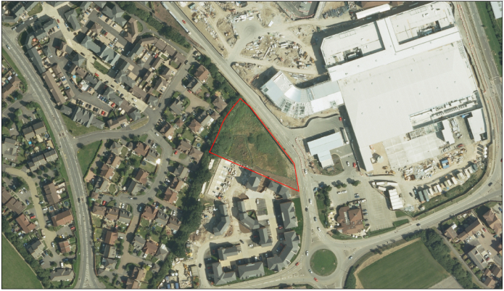

Self-Build Scheme.

Offers are invited to bring forward a Self-Build Scheme. This could be as a Joint Venture. Preference will be given to a Registered Provider to provide a 100% affordable Self-Build Scheme.

For full details and marketing pack please go to www.southglos.gov.uk/business/property-for-sale-or-rent/ .

Location
Potential residential site opposite the Willow Brook Shopping Centre in Bradley Stoke within 1 mile of junction 16 of the M5 motorway.

Description
Vacant level site circa 0.34 ha (0.85 ac).

Services
Service enquiries have been completed and form part of the marketing pack. It is believed that all main services are located within or close to the site. Prospective purchasers must satisfy themselves independently as to their location.

Tenure
The property is held freehold and is to be sold with vacant possession.

Planning
The site is allocated in the South Gloucestershire Local Plan for the provision of Main Town Centre and A1 Retail use.
Policy PSP31. It is anticipated that residential development from Hornbeam Close would be acceptable.

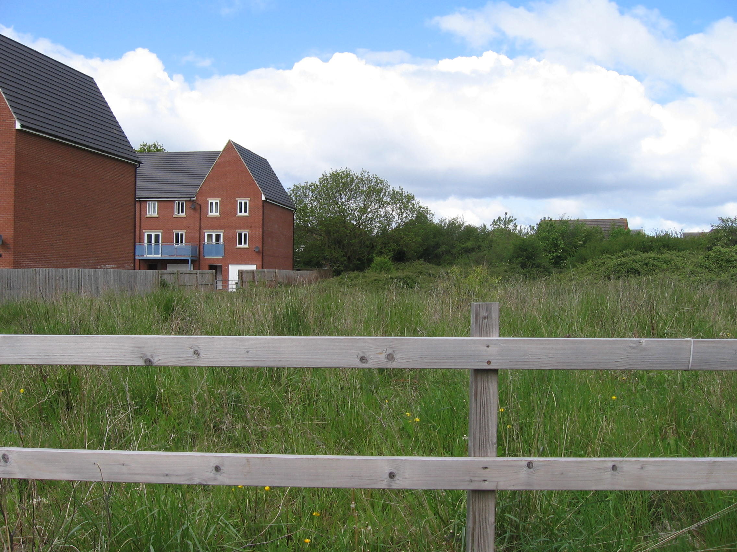

Proposal
Tenders are invited for the freehold acquisition on a conditional (subject to planning) basis. Bids to be submitted on the land value bid form in the marketing pack. Closing date for bids is 12 noon on 31st August 2018. The sale is subject to Council approval

Council’s costs and fees
Purchaser to pay South Gloucestershire Council’s legal costs and surveyors fees at the rates of 1% and 2% respectively of the purchase price.

Viewing/further information
www.southglos.gov.uk/business/property-for-sale-or-rent/
Contact: Phil Jones
Tel: 01454 86 3216
Email: phil.jones1@southglos.gov.uk

Disclaimer
These particulars, the information and measurements contained herein, are given as a guide only. They are not necessarily comprehensive and do not constitute any part of an offer or the contract and must not be relied upon as statements or representations of fact. July 2018

