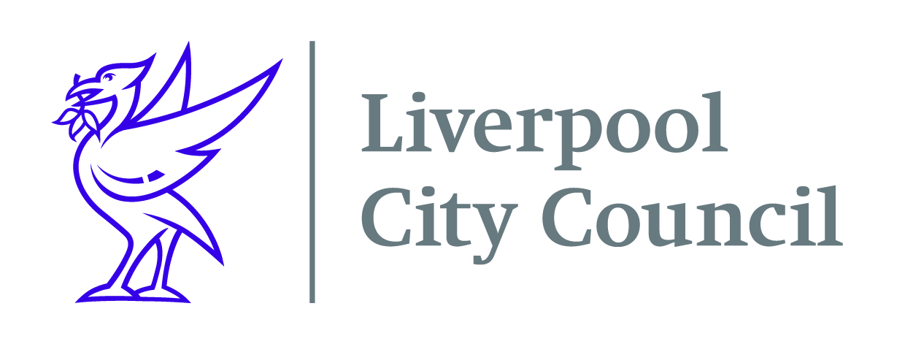
Liverpool City Council
Commercial Procurement Unit

Contract DN529001
World Gymnastics Championships – Liverpool 2022 Commercial Sales

The City of Liverpool is host to the World Artistic Gymnastics Championships in 2022.

The World Artistic Gymnastics Championships is the property of the International Gymnastics Federation (FIG) which is the governing body of Gymnastics worldwide. The Championships represent the pinnacle of elite gymnastics competition, attracting a substantial worldwide broadcast audience.

The venue for the 2022 Championships will be the M&S Bank Arena, Liverpool and it will take place over 9 days from 29th October to 6th November. The M&S Bank Arena also recently hosted the Vitality Netball World Cup 2019, the most successful ever netball world cup. Liverpool City Council will be the delivery organisation for the championships, working in partnership with a number of stakeholders, including British Gymnastics and UK Sport

For a successful World Gymnastics Championships in Liverpool 2022 (WGC2022), it is essential to maximize commercial revenue through industry partnerships; provide budget relieving value in kind relationships (where cash income is not achievable) and engage new audiences through commercial opportunities and event services. The event has an agreed commercial strategy and sponsor partner matrix. This tender is focused on activating the strategy by taking the opportunities to market. WGC2022 is looking to engage an individual or agency to deliver the commercial sales process and maximise commercial opportunities for the event.
The City Council and key stakeholders (UK Sport, British Gymnastics and the International Gymnastics Federation) are looking for tenders from individuals/companies who can clearly demonstrate the following key selection criteria:

• Demonstrable experience of working with international sporting partners/federations and global brands at the required level (preferably to a World or Olympic Games level);
• A strong record of delivering commercial partnerships and agreements, reaching or exceeding commercial targets set for cash income (and VIK);
• Demonstrable experience of providing innovative approaches to market, adding values to partnerships and engaging new audiences for the event through commercial contracts;
• Demonstrate an understanding of the production and logistical requirements of major sports events;
• A work plan that outlines; key work streams, delivery and milestones

Your company will need to register on Procontract (Due North) to be able to receive the opportunity. The documents will only be available on Procontract (available via the Due North site). Once you have registered you will need to go to the “my opportunities” section on the home page of Procontract and follow the instructions as a supplier to enable you to return your submission.
To register your organisation on Procontract click on the following link https://procontract.due-north.com/register, go to suppliers’ area and click on “register free”.

Closing date for submissions is Monday 15th March 2021 at 10am

