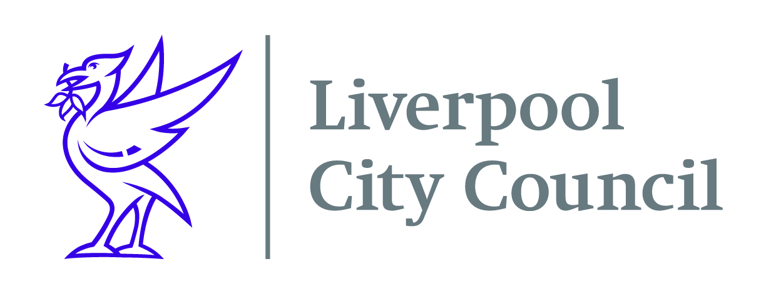

Liverpool City Council
Commercial Procurement Unit

Contract
Liverpool Cruise Terminal – Gig Boat Services
DN645109

Liverpool City Council seeks a supplier to provide Gig Boat Services to ships who require to use the mooring dolphin piles at Liverpool Cruise Terminal.

Your company will need to register on Procontract (Due North) to be able to receive the opportunity. The documents will only be available on Procontract (available via the Due North site). Once you have registered you will need to go to the “my opportunities” section on the home page of Procontract and follow the instructions as a supplier to enable you to return your submission.
To register your organisation on Procontract click on the following link https://procontract.due-north.com/register, go to suppliers’ area and click on “register free”.

Closing date for submissions is 9th January 2022 at 10am

