Call Reference: DN282367

Met Office tendering on behalf of BEIS.
Expressions of Interest title: Tropical Science and Forecasting Training
To register your interest, see notes at the end of this page. Registering interest requires no proposal detail at this stage and carries no obligation to bid.

Estimated value: £250k

The grant is currently expected to be up to £150k for a 2 year period.

Key Dates

Estimated Publish of Call:  (Start of bidding period). | 14/08/2017  A notification email will be sent to parties who have formally registered their interest by way of clicking on the ‘Register Interest’ button displayed below the opportunity on the ProContract portal
Estimated Bidding Period: | 6 weeks
Market Engagement Workshop | 27 July 2017
Estimated Award of Call: | 06/11/2017
Estimated Delivery Period: | 01/12/2017-31/05/2019

Background
The Met Office anticipates holding a call for research proposals in August 2017. In preparation for the call, the Met Office is inviting expressions of interest from UK researchers.

The Weather and Climate Science for Service Partnership for Southeast Asia (WCSSP Southeast Asia), supported by the UK Government’s Newton Fund, is a research programme that will support the development of capability to underpin services to provide improved advice of high impact weather and climate events and, therefore, will support climate and weather resilient economic development and social welfare.

Summary of WCSSP Southeast Asia aims
This project aims to develop underpinning capability in modeling at the global, regional and local scale, and advance the understanding of high-impact weather events in order to support services to improve advice and mitigate the impacts of extreme weather and climate events.

Specific aims include; improving the understanding of the impact of large scale atmospheric processes on the weather and climate of Southeast Asia, assessment and improvement of Unified Model performance at both convective and non-convective scales, improving the understanding of the local impact of tropical weather systems and improving the interpretation of global and convective scale forecasts.

For further information please visit the programme website -
http://www.metoffice.gov.uk/research/collaboration/newton
Submissions will be sought to deliver Tropical Science and Forecasting Training:
Rationale:
As part of the WCSSP Southeast Asia project there is a requirement for the delivery of a training course and training material that will advance the understanding of tropical meteorology for both research scientists and forecasters in the UK and partner institutes in Southeast Asia. The course will convey current understanding and include recent advances in tropical meteorology and cutting edge research.
Required activity:
The training should convey existing, advanced understanding of tropical dynamics and tropical modes of variability; global models and their performance in the tropics; convective scale models and their performance in the tropics; and the utilization of global and regional models along with observations and other information in the delivery of forecasts.

As the material and courses will be delivered to both Senior Scientists and Forecasters already working in the field it should be developed by a science expert with relevant world leading research experience but ideally also experience in working with forecasters from tropical countries. The forecasting component of the training material should be developed based on (i) a good interaction with in-country forecasting centres; (ii) interaction with UK forecasters and scientists working on the Southeast Asia project and (iii) relevant Southeast Asia scientists.

The course should have a core focus on weather timescales but relevant long term modes such as MJO, IOD and ENSO can be covered with application to meteorological influences. The geographic focus of course material will be on Southeast Asia and the Maritime Continent (in particular Philippines, Malaysia and Indonesia), however connection to global monsoon systems and influential teleconnections should also be covered.
- Some initial material to be delivered to ~20 UK scientists and 5 forecasters within 6 months of contract award.
- The final material to be delivered once to scientists and forecasters (in UK WCSSP Southeast Asia partner organisations) who are working on delivery of the WCSSP Southeast Asia project. The goal of this is to ensure those involved have a good understanding of the cutting edge science and forecasting techniques relevant for the project.
- The material is to be delivered to up to 3 partner countries for up to 10 scientists and 10 forecasters in each country (or once in region for 20 scientists and 20 meteorologists)
- The material (and therefore IP of the material) to be made available to the WCSSP Southeast Asia project team to allow bespoke training as needed as further partners become involved in the project.
- The delivery of the material could be made bespoke to allow more advanced science to be delivered to scientists with stronger background on dynamical meteorology will having a more basic science component suitable for meteorologists and non-expert scientists.

The supplier should determine best delivery methods (e.g. week long vs. individual days over longer period).

For UK delivery the Met Office will provide a training room in Exeter HQ and organise attendance. For Southeast Asia regional delivery a partner will provide facilities and organise.

Anticipated outputs or results:
- Some initial training in the UK and material within 6 months.
- The final course delivered in the UK and repeated in Southeast Asia within 12/18months.
Background on the Newton Fund
The Newton Fund builds scientific and innovation partnerships with 16 partner countries to support their economic development and social welfare, and to develop their research and innovation capacity for long-term sustainable growth. It has a total UK Government investment of £735 million up until 2021, with matched resources from the partner countries.

The Newton Fund is managed by the UK Department for Business, Energy and Industrial Strategy (BEIS), and delivered through 15 UK Delivery Partners, which include the Research Councils, the UK Academies, the British Council, Innovate UK and the Met Office. The Newton Fund is part of the UK’s official development assistance (ODA) and therefore requires that the UK funding is awarded in a manner that fits with ODA guidelines.

For further information visit the Newton Fund website (www.newtonfund.ac.uk) and follow via Twitter: @NewtonFund.

Background on the WCSSP ProgrammeThe Met Office is administering the Newton Fund through the Weather and Climate Science for Service Partnership Programme (WCSSP Programme), comprising projects to develop partnerships harnessing UK scientific expertise to build the basis for strengthening the resilience of vulnerable communities to weather and climate variability. WCSSP Southeast Asia is a project in the WCSSP Programme.
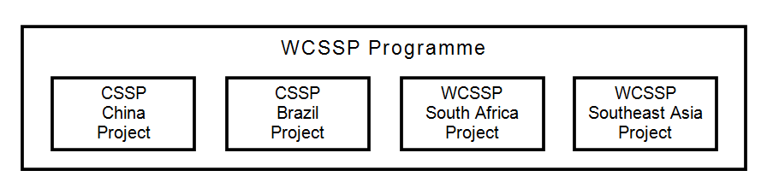

How to Apply:

The above Expression of Interest is advertised on the Met Office ProContract e-Tendering portal called ProContract. To access and register your interest you will need to log onto the ProContract portal via this link: tenders.metoffice.gov.uk You may need to search for the Call reference DN282367.

You will need to register your company (if you have not already done so) and register your interest against the opportunity before you are able to access the tender documents.

If you require guidance or ‘how to’ instructions – see the supplier manuals on the right hand side of the supplier home page.

Online Discussions between Bidders and the Met Office:
There is a Discussions function on ProContract which shall be used to provide all further information regarding this opportunity including any changes to time scales, scope or clarifications. This function must be used by bidders to submit all clarification questions.

