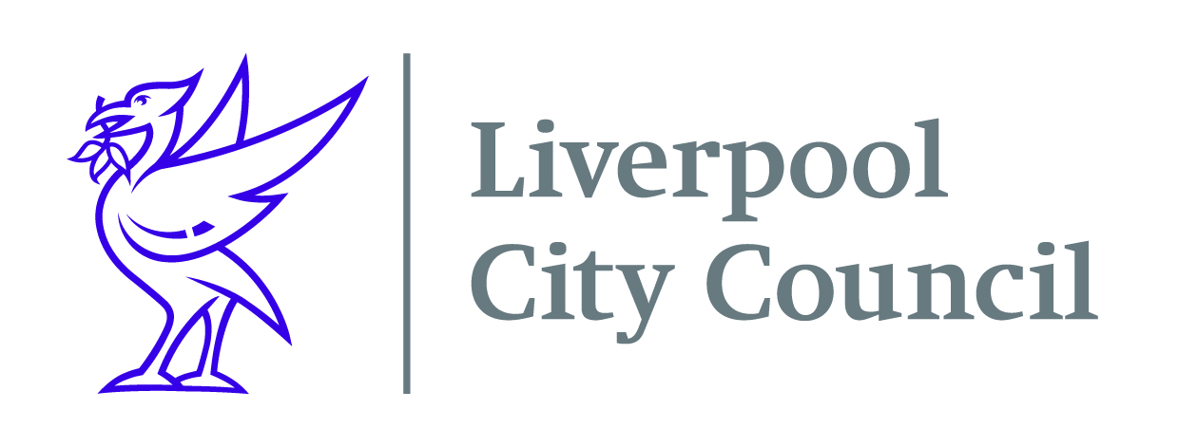

Liverpool City Council
Commercial Procurement Unit

Contract: DN454642
Physical Activity in the Workplace

To deliver a city wide comprehensive workplace initiative to engage employers in Liverpool in increasing awareness of the benefits of physical activities and opportunities within and outside the workplace, leading to improved physical activity levels of staff.

It is important that the initiative:
• Is delivered within the employer’s existing infrastructures
• Uses learning from Liverpool Active Workplace to enhance the offer
• Builds in sustainability for employers to continue to support their employees beyond the initial funded period.
• Promotes the Fit for Me Campaign, benefits of regular physical activity, provides information on the current guidelines and what opportunities are available locally.

Your company will need to register on Procontract (Due North) to be able to receive the opportunity.

The documents will only be available on Procontract (available via the Due North site). Once you have registered you will need to go to the “my opportunities” section on the home page of Procontract and follow the instructions as a supplier to enable you to return your submission.

To register your organisation on Procontract click on the following link https://procontract.due-north.com/register, go to suppliers’ area and click on “register free”.

Closing date for submissions is 31/01/2020 at 10:00am

