Hart, Rushmoor and Surrey Heath
SPA Mitigation Project

Access Management Research Study Project Brief

- Summary
  - Rushmoor Borough Council, Hart District Council and Surrey Heath Borough Council have been awarded funding to undertake a joint project related to the Thames Basin Heaths Special Protection Area (TBH SPA). On behalf of all three Councils, Rushmoor Borough Council is seeking to appoint suitably qualified and experienced consultants to prepare a research study to support this project.
- Background
  - The three Councils are part of a wider group of 11 local authorities affected by the Thames Basin Heaths Special Protection Area (TBH SPA), a network of heathland sites that provides a habitat for important bird species. It was designated as a Special Protection Area in March 2005 and is protected from adverse effects by law.
  - Natural England has advised the affected local authorities that new housing within 5km of the SPA may result in harm to these bird species. Larger developments located between 5 and 7km of the SPA may also have an impact. As a result, the Thames Basin Heaths Special Protection Area Delivery Framework was prepared. This was endorsed by Thames Basin Heaths Joint Strategic Partnership Board (JSPB) in 2009 and is the recommended approach followed by the local authorities affected by the Special Protection Area (SPA).
  - Within 400m of the SPA, the impact of net new residential development is likely to be such that it is not possible to conclude no adverse effect on the SPA. On this basis, there is a presumption against development within this zone. The Delivery Framework also includes a recommended approach to the provision of measures between 400m and 5km to avoid likely significant effect on the SPA. One element of these measures is the provision of the Suitable Alternative Natural Greenspace (SANG), alternative recreational land to attract new residents away from the SPA. This should be provided on the basis of at least 8ha per 1000 population, with suitable catchments of all net new residential development.
  - In addition to SANG, contributions towards strategic access management is required. This is known as the Strategic Access Management and Monitoring (SAMM) project. The overall objective of the SAMM project is to protect the SPA from recreational pressures arising from new housing development through education (both on and off site), guidance, promoting the use of SANG sites, and monitoring the effectiveness of the avoidance strategy.
  - The three Councils form part of the HRSH Housing Market Area (HMA) (Map 1). A significant proportion of the HMA is either designated as SPA or within the three buffer zones for the SPA (i.e. within 7km) (92%). 27% of the HMA designated as SPA or within the 400m. 59% of the HMA is between the 400m and 5km zone (i.e. where SANG is required).
  - The Councils have worked collaboratively to deliver access to cross boundary SANG solutions. However, there are many constraints to delivering development and new SANGs in the HMA. Opportunities for delivering SANG are reducing and the Councils are concerned that that the current approach to avoidance and mitigation will ultimately result in a moratorium on net new residential development in parts of the HMA.
  - As a result, the three Councils have been awarded funding by the Ministry of Housing, Communities and Local Government (MHCLG) to undertake joint work to investigate and seek to implement alternative and complementary avoidance and mitigation measures, which can be delivered in order to mitigate new residential development within the HMA. The project started on 1st October 2018 and will run until 31st September 2020. The three Councils are working in partnership with Natural England and at the end of the project are required to report to MHCLG.
Map 1 - Thames Basin Heaths Special Protection Area, associated buffer zones and the HRSH Housing Market Area
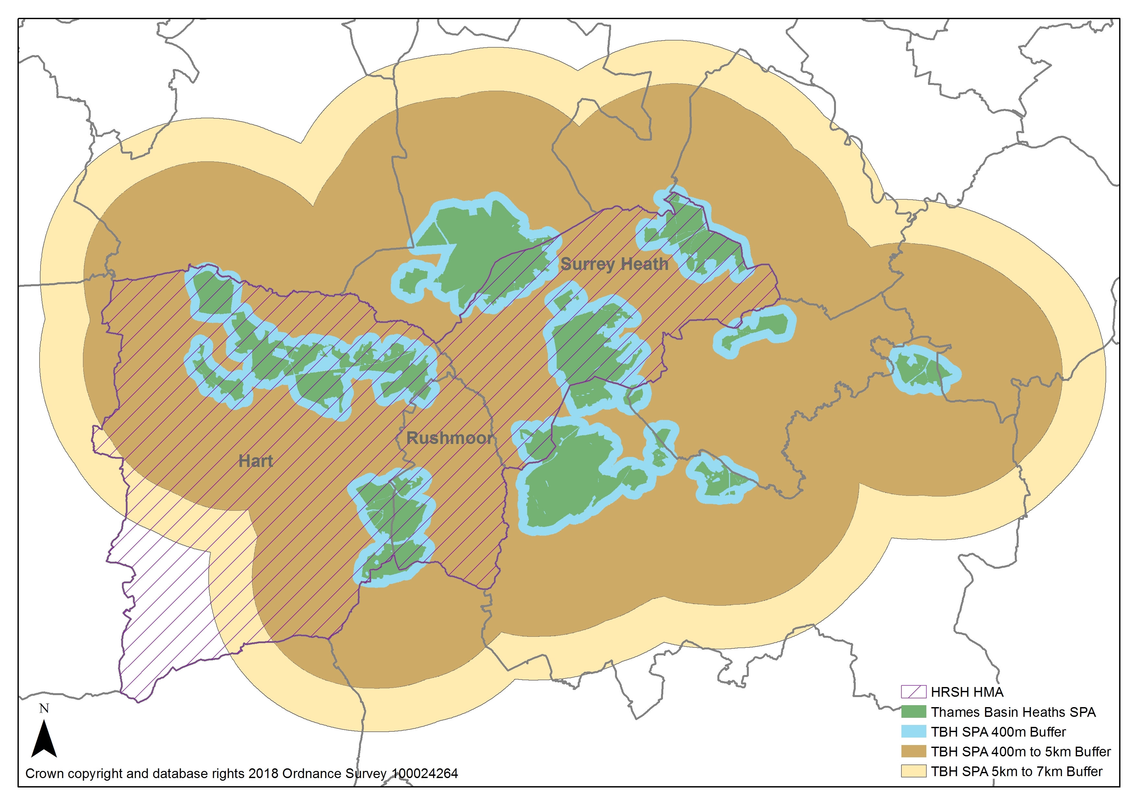
- Outputs
  - The overall aim of the two-year joint project is to identify complementary alternative mitigation measures, which can be delivered in order to mitigate new development within the HMA.
  - The three Councils are seeking to achieve three project outcomes:
      - Identification and evaluation of potential alternative and complementary mitigation measures.
      - Selection of a preferred/workable mitigation measure or measures, agreed in principle by Natural England and the three authorities
      - Publication of an Implementation Plan, agreed by Natural England and the three authorities.
  - The primary purpose of the project is to identify alternatives. However, it may be possible that no workable alternatives can be identified and/or agreed. In this situation, the three Councils will need to ensure that there is robust evidence prepared during the project to demonstrate why there is considered to be no alternative mitigation measure available.
  - As noted above, the existing approach requires contributions towards strategic access management, alongside the provision of SANG. As part of the ongoing assessment of the availability of potential SANG in the HMA, a review of the evidence and a review of avoidance and mitigation strategies in place elsewhere, a number of alternative mitigation options have been identified for assessment. It is important to clarify that the aim of the project is not to evaluate the effectiveness of the existing approach as a form of mitigation.
  - Two background papers are being prepared. These papers will collate existing information which may be relevant to this study, including information on existing visitor distribution, existing access restrictions and controls and details of the existing SAMM project.
  - As the Delivery Body for the SAMM project, Natural England is responsible for the implementation of the four elements which comprises: (i) a wardening service, (ii) a monitoring service, (iii) an education and communication service and (iv) a facilitation role.
  - We are exploring two options which would expand on three of the elements of the existing project:
- Potential for expanding the wardening service of the existing SAMM project
- Potential for expanding the education and communication service of the existing SAMM project
  - The initial analysis of these alternatives has identified some key questions which need to be answered:
  - Are there opportunities for additional work areas/expansion of existing elements of the SAMM project?
  - What locations could benefit from an expansion of the wardening, education or communication service?
  - Whether specific aspects of the wardening, education or communication service could benefit from expansion and does this vary in different parts of the SPA?
  - Whether there is a point at which expanding the wardening, education and communication service no longer increases the degree of mitigation?
  - How the expansion of the project could be funded, and could funds be targeted to specific aspects of the project or particular parts of the SPA?
  - Could site specific access assessments be used to target expansion of the project and/or define catchments for funding?
  - Are there particular areas where access management/ restriction measures would be most effective?
  - What are the potential costs of delivering these potential measures?
  - What would be the potential scale of mitigation achieved by expanding the SAMM project?
  - In order to answer these questions, we are commissioning a research study which will deliver a number of outputs, in order to achieve the following aims:
- To demonstrate how expansion of the existing SAMM project would be effective as a mitigation measure
- To explore the scope for implementing these measures
- To consider the potential capacity of these measures
  - The expected outputs and tasks required are set out in Table 1.1 below.
Table 1.1 – Expected Project Outputs
Question | Outputs
Aim 1 - To demonstrate how expansion of the existing SAMM project would be effective as a mitigation measure
Are there opportunities for additional work areas/expansion of existing elements of the SAMM project? | Recommendations on potential opportunities for expanding the existing project.  Identification of potential locations which could benefit from expansion of each element of the project.  Summary of evidence to demonstrate how this would be effective as additional mitigation.
What locations could benefit from an expansion of the wardening, education or communication service?
Whether specific aspects of the wardening, education or communication service could benefit from expansion and does this vary in different parts of the SPA?
Whether there is a point at which expanding the wardening, education and communication service no longer increases the degree of mitigation?
Aim 2 - To explore scope for implementing these measures
How the expansion of the project could be funded, and could funds be targeted to specific aspects of the project or particular parts of the SPA? | Recommendations on how expansion of the SAMM project could be funded and how funds could be allocated.
Could site specific access assessments be used to target expansion of the project and/or define catchments for funding?
Are there particular areas where access management measures would be most effective? | Recommendations on locations where measures would be most effective across the SPA.
What are the potential costs of delivering these potential measures? | Estimated costs of delivering measures.
Aim 3 - To consider the potential capacity of these measures
What would be the potential scale of mitigation achieved by expanding the SAMM project? | Recommendations on potential scale of mitigation achieved by expanding the different elements of the SAMM project.

  - An approximate number of working days will need to be determined for the outputs listed in Table 1.1 above. The estimated value of the proposed contract is between £5,000 and £7,500.
  - In addition to the options identified relating to the existing SAMM project (as listed above), we are exploring the potential for implementing other related access management/restriction measures, including:
- Potential for limiting or restricting car parking availability in and around the SPA.
- Potential for implementing dog control measures and wardening within the SPA
- Potential for limiting or restricting access to the SPA.
Alongside this brief, we have issued three briefs for research studies to gather evidence relating to these potential measures. This is intended to enable consultants to bid for one or multiple pieces of work, depending on expertise and capacity available to undertake the work within the timescales set out in each brief.
- Methodology
  - Under Article 6(3) of the Habitats Directive, Competent Authorities (in this case Hart District Council, Rushmoor Borough Council and Surrey Heath Borough Council) have a duty to ensure that all the activities they regulate have no adverse effect on the integrity of any of the Natura 2000 sites.
“Any plan or project not directly connected with or necessary to the management of the site but likely to have a significant effect thereon, either individually or in combination with other plans or projects, shall be subject to appropriate assessment of its implications for the site in view of the site's conservation objectives.”
  - The decision-maker must consider the likely and reasonably foreseeable effects in order to ascertain that the proposal will not have an adverse effect on the integrity of the SPA with certainty using the precautionary principle before it may grant permission (subject to the exception tests set out in Regulation 63 of the Habitats Regulations).
  - The competent authority has to be confident that the approach is legally robust. There will need to be evidence that any alternative measure or measures are based on evidence and will be effective, reliable, timely and that there will be sufficient certainty with regards to delivery.
  - Mitigation measures proposed must be sufficient, in place before any adverse effect can occur and are effective for as long as there is expected to be a risk. Overall, there must be confidence that mitigation will be effective and can be delivered.
  - In order to demonstrate this, it will be necessary to:
- understand the measures proposed and how they will avoid or mitigate any adverse effect;
- provide evidence in relation to how they will be secured, implemented and by whom;
- provide evidence on the degree of confidence in their likely success;
- provide a delivery timescale and identify when they will be implemented; and
- identify how the measures will be secured, monitored and enforced.
  - This research study will need to provide the necessary evidence in order to assist the Councils to demonstrate that the mitigation will be effective and can be delivered, taking into account the requirements of legislation set out above.
- Further Information
  - There are several published documents and other supporting information, which will be of relevance and assistance and can be provided by the Council.
General
- European Site Conservation Objectives for Thames Basin Heaths SPA
- Thames Basin Heaths SPA Conservation Objectives Supplementary Advice
- Thames Basin Heaths SPA Citation
- Thames Basin Heaths Special Protection Area Delivery Framework (2009)
- South East Plan Policy NRM6
Rushmoor
- Rushmoor Avoidance and Mitigation Strategy 2019
- Thames Basin Heaths Special Protection Area Topic Paper January 2018
Surrey Heath
- Thames Basin Heaths Special Protection Area Avoidance Strategy SPD (2012)
- Thames Basin Heaths Special Protection Area Avoidance Strategy SPD (2019)
- Current SANG Provision (webpage)
Hart
- Hart Interim Avoidance Strategy for the Thames Basin Heaths Special Protection Area (2010)
- Hart SANGs and Catchments Map
- Hart Council owned / controlled SANG allocation criteria
General information and links to documents listed above are on the following websites:
Joint Nature Conservation Committee (JNCC)
jncc.defra.gov.uk/page-2050-theme=default
Natural England
publications.naturalengland.org.uk/publication/4952859267301376
Rushmoor Borough Council
www.rushmoor.gov.uk/spa
Hart District Council
www.hart.gov.uk/planning-policy-guidance
Surrey Heath Borough Council
www.surreyheath.gov.uk/residents/planning/planning-policy/thames-basin-heaths-special-protection-area-avoidance-measures
www.surreyheath.gov.uk/residents/planning/planning-policy/supplementary-planning-documents/thames-basin-heaths-special
www.surreyheath.gov.uk/SANG
TBH SPA Joint Strategic Partnership Board
https://www.surreyheath.gov.uk/residents/planning/planning-policy/joint-strategic-partnership
surreyheath.moderngov.co.uk/mgCommitteeDetails.aspx?ID=316
www.tbhpartnership.org.uk/

- Timetable:
  - Consultants will need to demonstrate that they can deliver within the following timescales and be responsive to requests for assistance. The consultants should include a programme of delivery, which meets the following key dates within their quotation.
Table 1.2 – Summary of Project Timescales
Task | Date
Brief Issued | 19th March 2020
Deadline for receipt of quotations | 03rd April 2020
Interviews (TBC) | w/c 06th April 2020
Notification of award of contract | 10th April 2020
Inception Meeting | w/c 13th April 2020
Receipt of Draft | 03rd July 2020
Receipt of Comments on Draft | 10th July 2020
Receipt of Final Study | 17th July 2020

  - Please highlight any aspects of the work where there could be delays beyond your control (for example, reliance on information from other organisations).
- Submission
  - Consultants should be aware of the following:
- The final details of the brief, including the work programme and timetable will be agreed following discussions with the appointed consultant. Any variation to the brief will need to be agreed with the Borough Council.
- The consultant will be commissioned for a set number of days. Additional fees will only be considered where the Borough Council agrees to a change in the brief requiring additional professional input from the consultant. An indication of additional fee charges (such as hourly/daily rates for key personnel) against which further works as part of the ‘retained contract’ can be commissioned. In such event a written fee estimate will need to be agreed.

  - Selection will be on the basis of:
Evaluation Criteria | Weighting
Price – Value for money | 40%
Technical/Quality including:  Proposed approach  Robustness of proposed approach, which will ensure the project outputs meet legislative and other requirements.  Technical/Quality  Relevant experience of Thames Basin Heaths Special Protection Area and/or other Special Protection Areas.  Relevant knowledge and skills.  Timescales:  Ability to meet timescales, including expected ability to respond promptly to changing requirements. | 20%  20%  20%

  - Consultants are asked to submit the following as part of their quotation:
Price/Value for Money (40% weighting)
- A breakdown of the project costs, including the estimated number of days under each output (see Table 1.1) and the time spent by each nominated individual against the outputs listed in Table 1.1;
Proposed Approach (20% weighting)
- A full statement of the approach that would be used and how this would enable us to achieve the methodology set out in Section 4, including detail on how you will support the Councils to meet the requirements set out in paragraph 4.5;
- Provide a case study where similar work has been carried out, highlighting how this would enable you to prepare the background study and deliver the required outputs in Table 1.1;
Technical/Quality (20% weighting)
- Details of knowledge and relevant experience of the Thames Basin Heaths Special Protection Area and/or other Special Protection Areas and how this would be applied to the project;
- Details of the proposed team and a breakdown of their respective roles, experience and costs per day;
Timescales (20% weighting)
- A detailed programme of delivery, outlining how the proposed approach would fit with the key dates outlined in this brief;
- Details of proposed approach, outlining how this would ensure that there is consistency throughout and the ability to respond promptly to changing requirements.
Other
- Contact details for at least three independent referees for whom the consultants have carried out recent, similar work.
- Completed company details from (appendix 1)
- Completed Insurance form (appendix 2)
- Health and Safety Questionnaire (appendix 3)
  - Each of the Quality sections within this submission will be scored based on the method detailed below:
Exceptional demonstration of the relevant ability, understanding & skills required to provide the service with evidence to support the response, where appropriate. Demonstrates added value. | 5 – Excellent
Good demonstration of the relevant ability, understanding & skills required to provide the service with evidence to support the response, where appropriate. | 4 – Good
Satisfactory demonstration of the relevant ability, understanding, skills, facilities & quality measures required to provide the services with evidence to support the response, where appropriate. | 3 – Satisfactory
Contains minor shortcomings in the demonstration of the relevant ability, understanding & skills required to provide the services with evidence to support the response, where appropriate and/or is inconsistent or in conflict with other proposals with little or no evidence to support the response. | 2 – Minor Reservations
Satisfies the requirement but with considerable reservations of relevant ability, understanding & skills required to provide the services, with little or no evidence to support the response. | 1 – Serious Reservations  Submissions which receive a ‘1 – serious reservations’ will not be considered further
No response provided. | 0 – no score – Fail  Submissions that ‘Fail’ will not be considered further

- Freedom of Information Act
  - Information in relation to this application may be made available on request in accordance with the requirements of the Freedom of Information Act 2000 (the ‘FoIA’). Where a company considers any information submitted to be commercially sensitive, the company should:
- clearly identify such information as commercially sensitive;
- explain the potential implications of disclosure of such information; and
- provide an estimate of the period of time during which the company believes that such information will remain commercially sensitive.

  - The Council will endeavour to maintain confidentiality, but companies should note that, even where information is identified as commercially sensitive, the Council might be required to disclose such information in accordance with the FoIA. It is also important to note that information may be commercially sensitive for a time (e.g. during a quotation process) but afterwards it may not be. Accordingly, the Council cannot guarantee that any information marked ‘commercially sensitive’ will not be disclosed.
- Pricing Schedule
  - Please provide a pricing schedule showing a breakdown of the costs in full (exclusive of VAT)

Appendix 1

- Basic Company Details
The information requested below must be provided
 | BASIC DETAILS OF YOUR ORGANISATION
 | Name of the organisation in whose name the quotation would be submitted:
 | Contact name for enquiries about this quotation:
 | Job Title:
Company Address:

Post Code:
 | Telephone number:
 | Fax number:
 | E-mail address:
 | Website address (if any):
 | Company Registration number (if this applies):
 | Charities or Housing Association or other Registration number (if this applies). Please specify registering body:
 | Date of Registration: (if this applies)
Registered address if different from the above:

Post Code:
Are you registered for VAT?
If so, please provide Registration number:
 | Is your organisation: | i) a public limited company?
 | Is your organisation: | ii) a limited company?
 | Is your organisation: | iii) a partnership
 | Is your organisation: | iv) registered charity
 | Is your organisation: | v) other (please specify)
1.14b | Are you acting as the lead organisation for a consortium? |  |  | Yes/No
1.15 | Please confirm whether or not you have formed, or are forming a consortium for the purpose of this requirement.
1.16 | If members of your consortium or sub-contractors are likely to deliver a significant (over 50%) proportion of the contract, give their company name(s) and address(es). Please provide this information in a separate annex at the end of this document
1.17 | If you have answered "Yes" to Question 1.15, please confirm the structure of the Consortium (e.g. One Legal Entity, Lead Organisation on behalf of the consortium, External Non-Delivering Organisation).
1.18 | Name of (ultimate) parent company** (must be provided if you wish a financial assessment to be undertaken on the parent company rather than your own);
1.19 | Companies House Registration number of parent company** (must be provided if you wish a financial assessment to be undertaken on the parent company rather than your own).

**This confirms your commitment to obtain a Parent Company Guarantee prior to contract award, if the Council deems this necessary. Evidence of the commitment will be requested as part of the quotation invitation process (if your firm is short-listed) and be a ‘Pass/Fail’ requirement of the evaluation process. If your organisation is unable to provide the evidence at that point or to subsequently furnish the Parent Company Guarantee, the Council will be unable to proceed with the contract award.

Appendix 2

- Insurance
 | INSURANCE
1.30 | Does your organisation hold Employer’s Liability of not less than £5 Million? | Yes/No
1.31 | Does your organisation hold Public Liability of not less than £10 Million? | Yes/No
1.32 | Does your organisation hold Professional Indemnity of not less than £1 Million? | Yes/No
1.34 | If the answer is “No” to any of the above please confirm whether you would be willing to take out the appropriate level of insurance cover? | Yes/No

Appendix 3

- Health and Safety Questionnaire

HEALTH & SAFETY
1 | Please self-certify that your organisation has a Health and Safety Policy that complies with current legislative requirements. | Yes / No
2 | Has your organisation or any of its Directors or Executive Officers been in receipt of enforcement/remedial orders in relation to the Health and Safety Executive (or equivalent body) in the last 3 years?  If your answer to this question was “Yes”, please provide details of any enforcement/remedial orders served and give details of any remedial action or changes to procedures you have made as a result.  The authority will exclude bidder(s) that have been in receipt of enforcement/remedial action orders unless the bidder(s) can demonstrate to the authority’s satisfaction that appropriate remedial action has been taken to prevent future occurrences or breaches. | Yes / No
 | Response:
3 | If you use sub-contractors, do you have processes in place to check whether any of the above circumstances apply to these other organisations? | Yes / No

END

The Conservation of Habitats and Species Regulations 2017

