Leicestershire County Council
Guide to submitting tenders via the e-tendering portal
25th February 2016

The e-tendering portal can be accessed via the following link;

https://procontract.due-north.com/SupplierPreLoginHome/

Step One - Registration / login
- First time users of the Portal must register on the website
- If already registered you must login to the site
Step 2 - Find the opportunity
- East Mids tenders Homepage – View opportunities
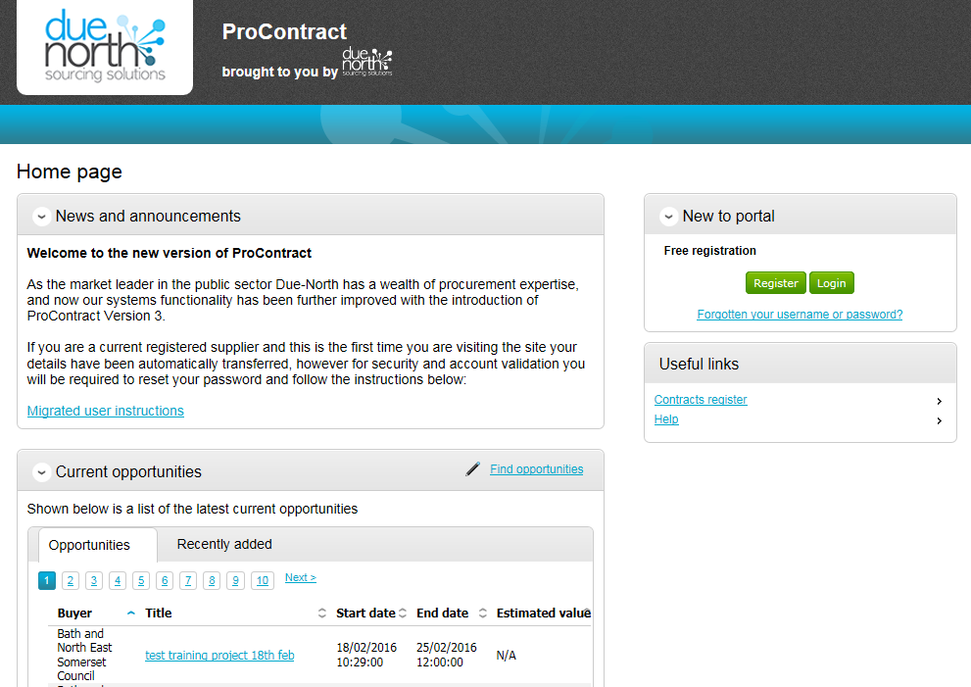
- Supplier Homepage - Find opportunities

Under Narrow your results: Portals – select EastMids Tenders and Update
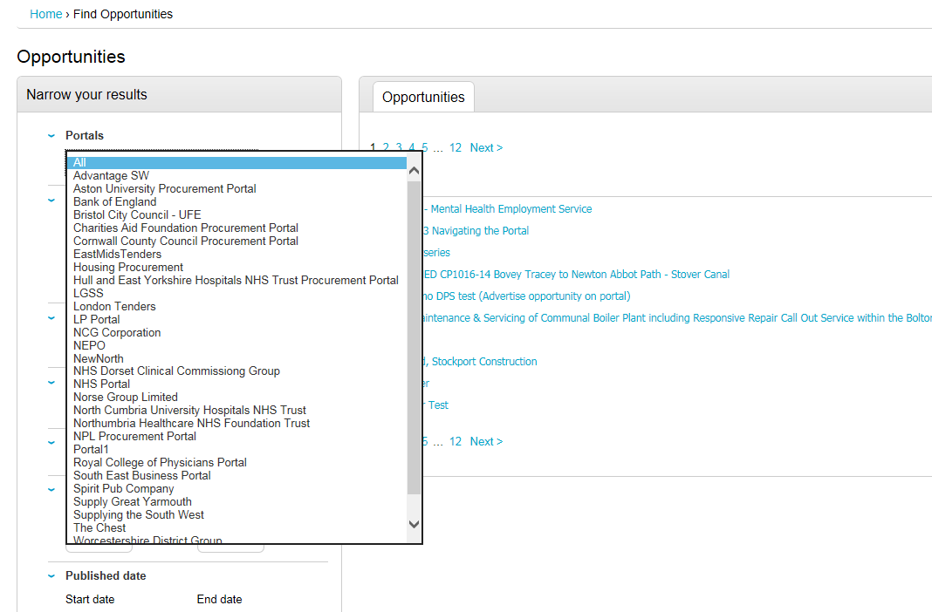

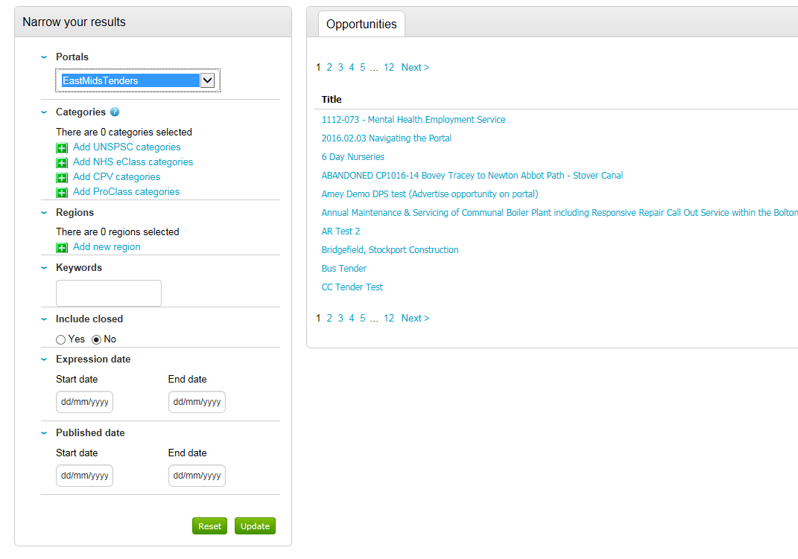

Under Narrow your results: Organisations– select Leicestershire County Council and Update

Under Opportunities select Cadaver Transportation by clicking on the blue hyperlink

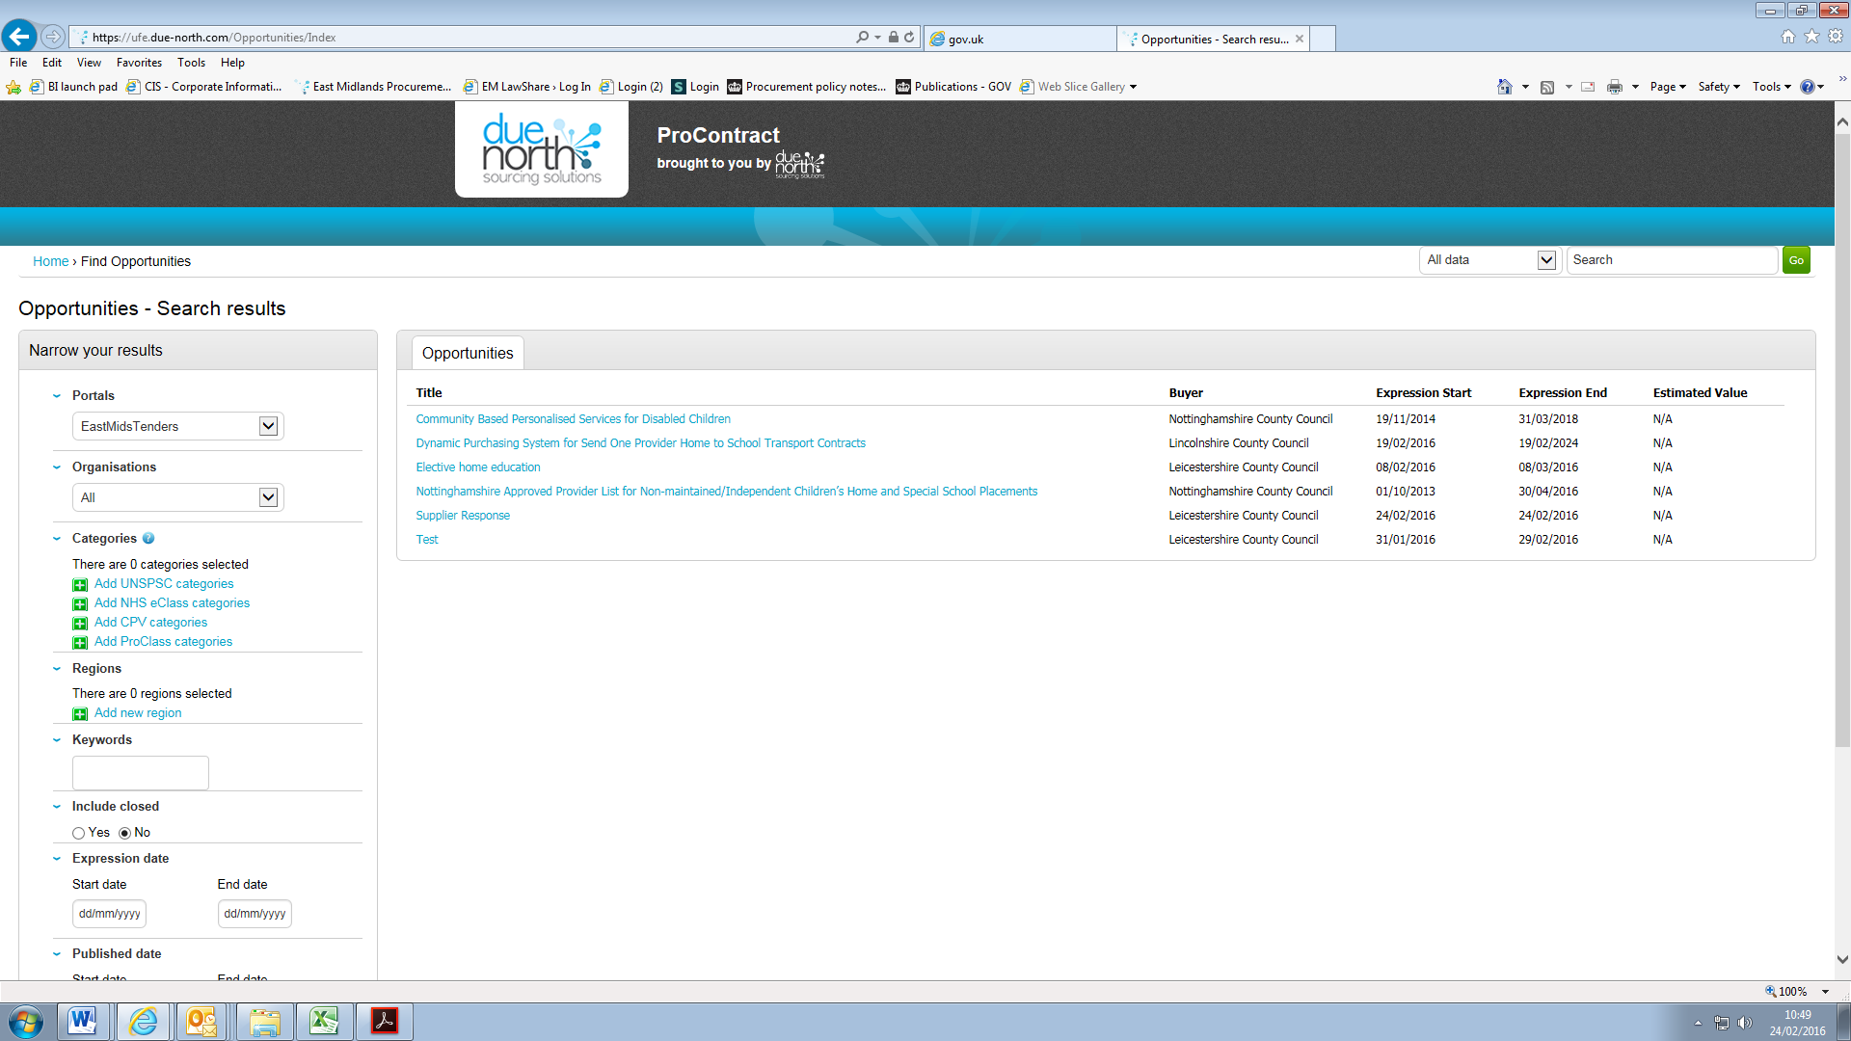

Step 3 - Registering an interest in the opportunity

If not logged in click on Login and Register interest in this opportunity

If logged in click on Register interest in this opportunity

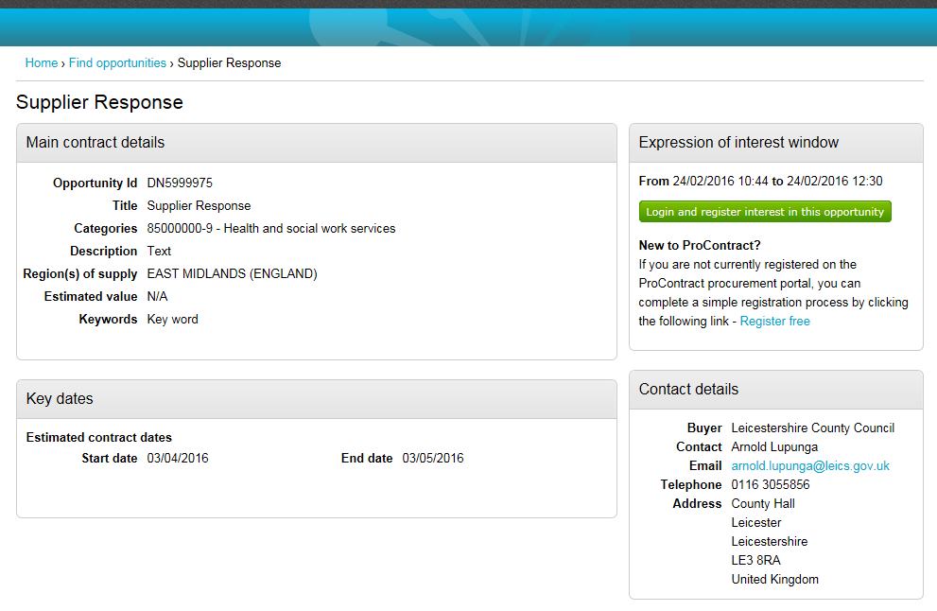

Step 4 - Accessing the application documents

Click on My activities located on the blue toolbar

Under Narrow your results select Leicestershire County Council and Update

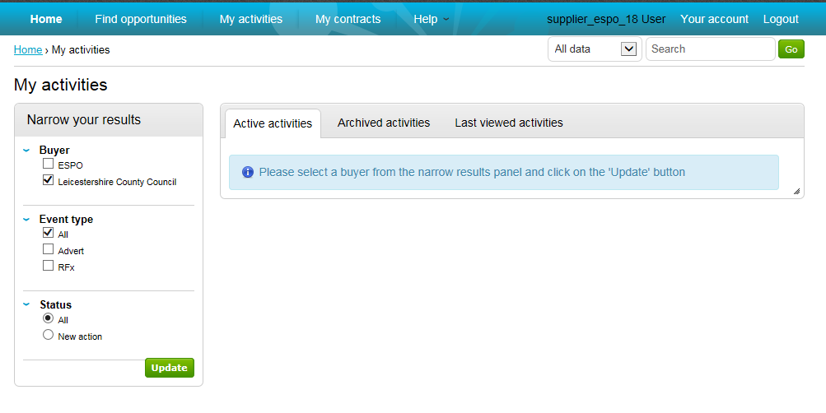

Select the contract opportuntity you want to respond to by clicking on the blue hyperlink

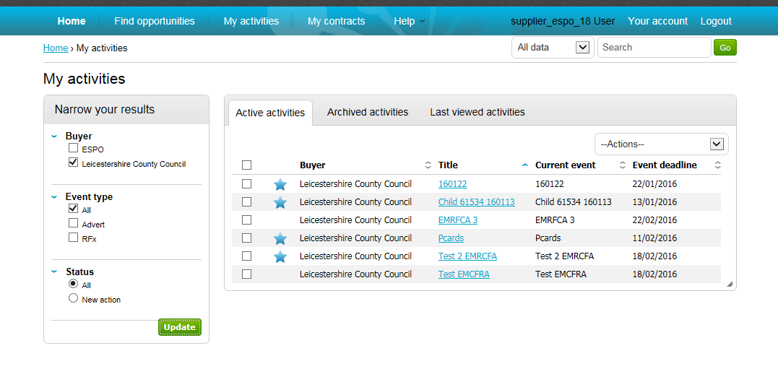

Under Events: Supplier Response: Not Started click on Start

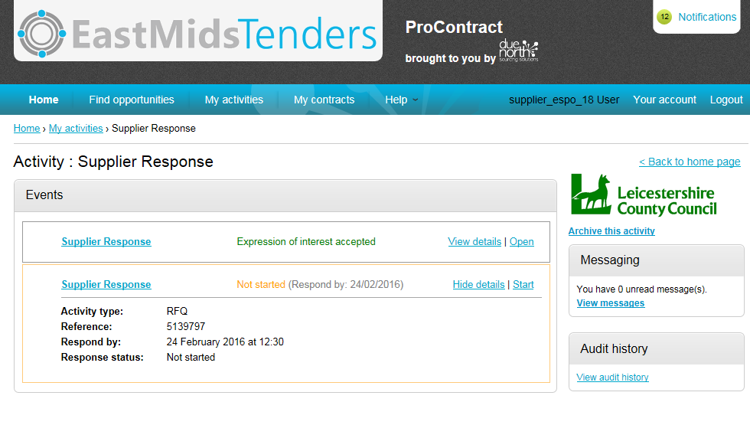

Download the application documents by clicking on the blue hyperlink

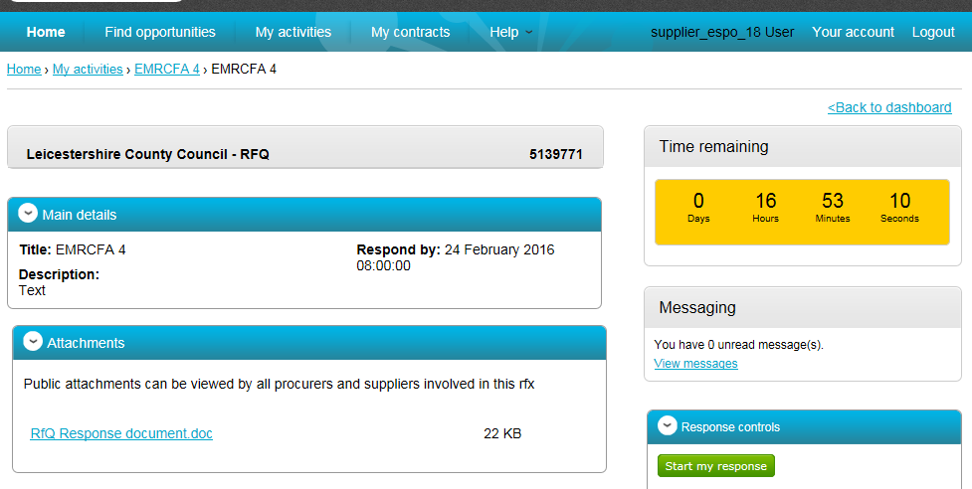

Step 5 – Submitting a response

Complete your application offline.

When ready to upload your completed application click on “Start my response”

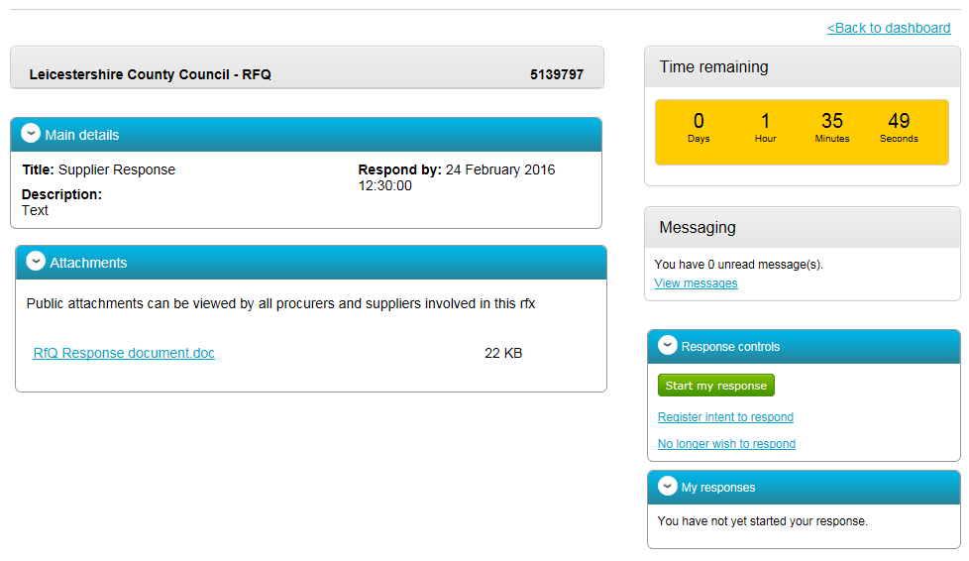

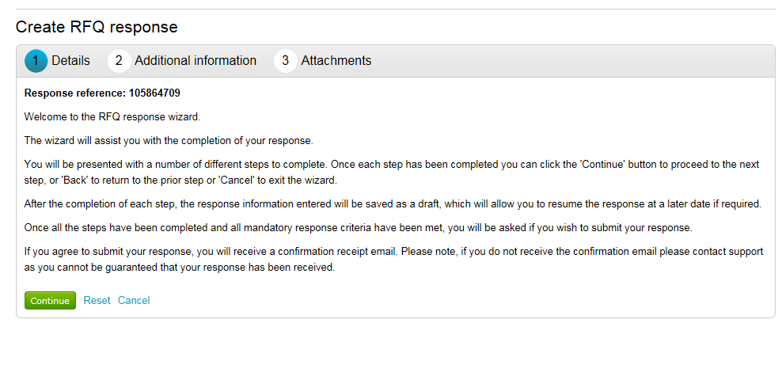

Enter your own reference and click Continue

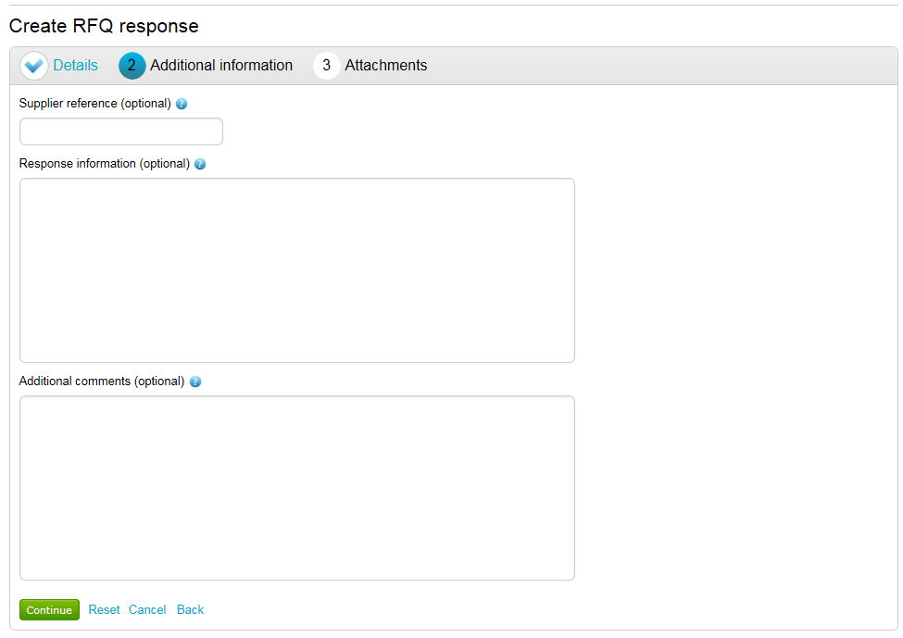

Click on Add Attachment

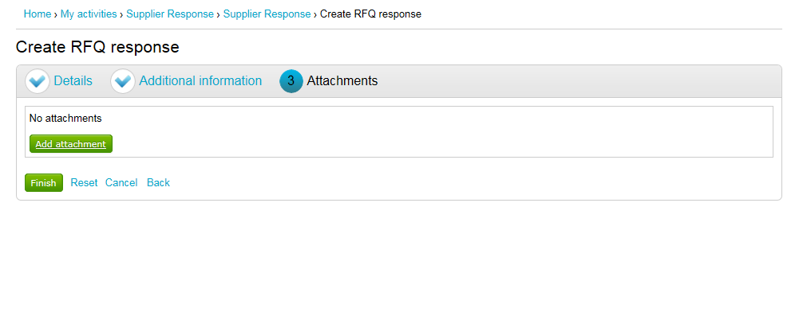

Click on Add Attachment and attach your completed application

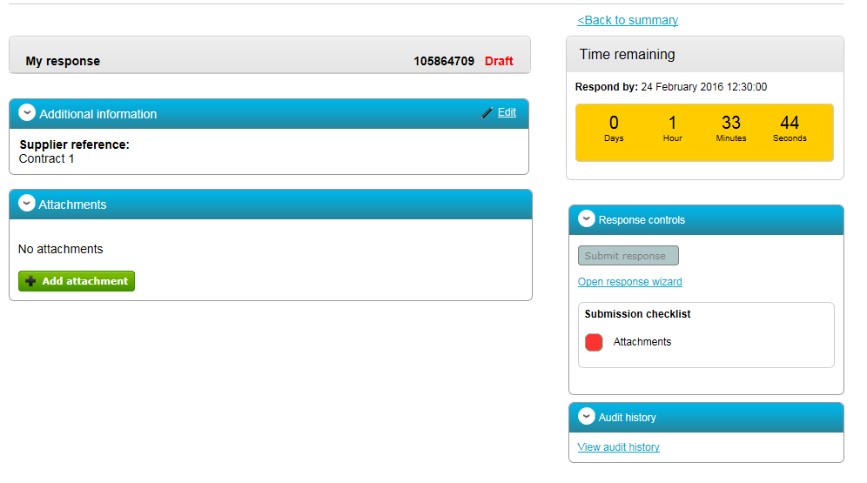

Once the application document is attached click on Submit Response

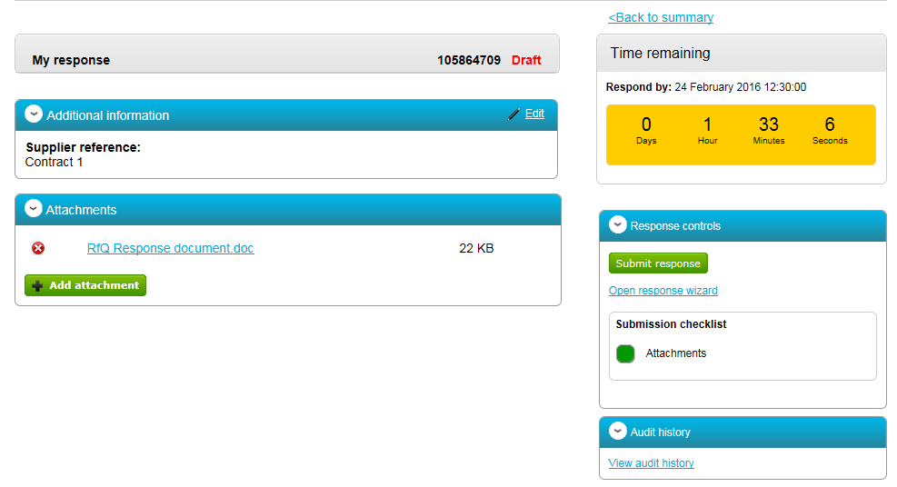

When your application has been submitted the word Submitted will appear on the right-hand side on the screen

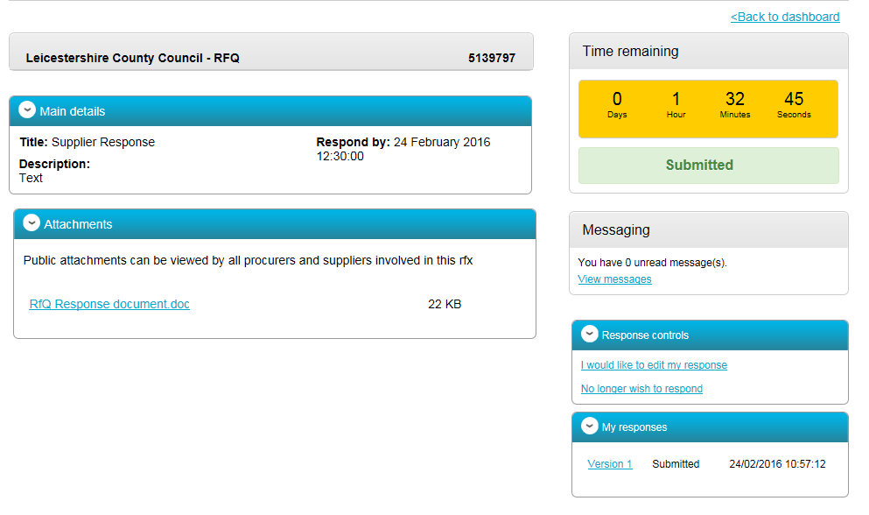

If you have questions or require assistance with this process please contact either;

Caroline Dickens
Commercial Specialist (Public Health)
Commissioning Support Unit
Corporate Resources- Leicestershire County Council
Tel: 0116 305 5855
Email: caroline.dickens@leics.gov.uk

Sophie Alice Bower-Scott
Trainee Commissioning Officer

Commissioning Support Unit
Corporate Resources- Leicestershire County Council
Tel: 0116 305 2048
Email: Sophie.Bower-Scott@leics.gov.uk

