Due North V3 Procedure Notes for Suppliers – ADVERTISED TO THE PUBLIC
- Open an internet session and go to WWW.WOLVERHAMPTONTENDERS.COM – you will be redirected to our new site,
click Home
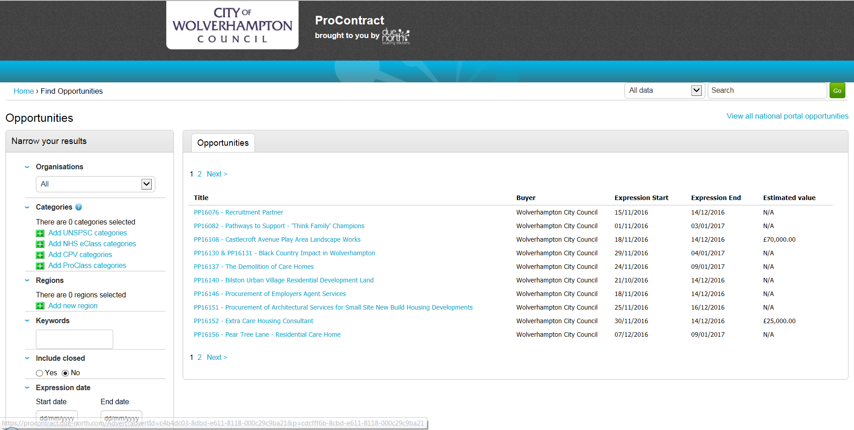

- Click Login
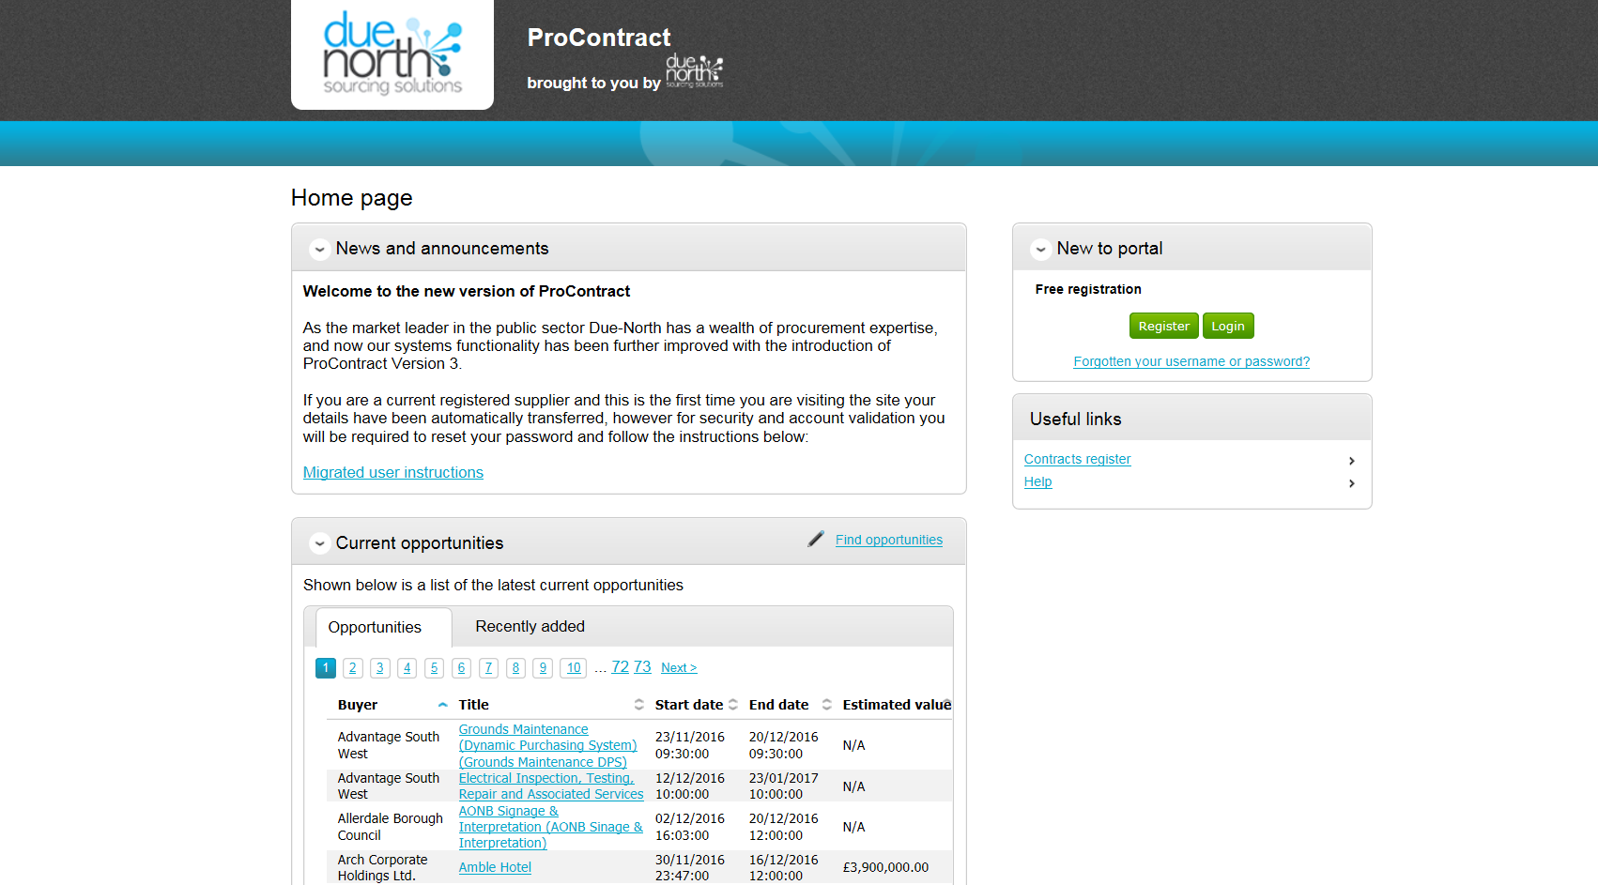

- Click the link here if you have NOT changed your password so that it contains a character - one of these !”£$%^&*()@?
If you HAVE changed your password already please goto step 4
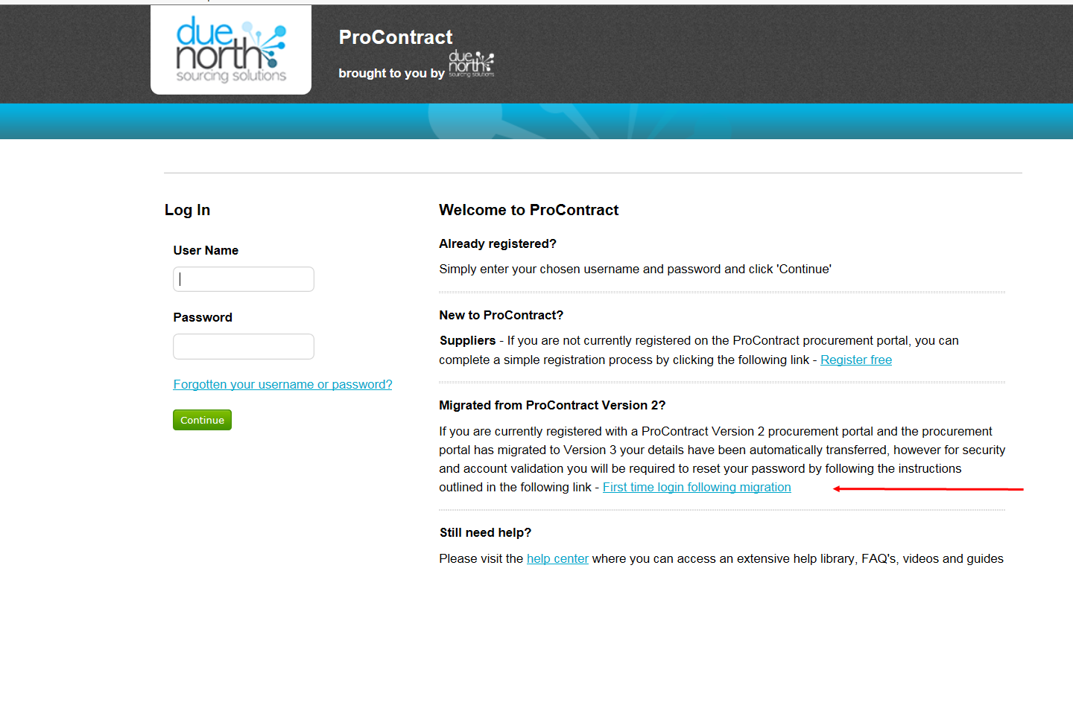

Follow the instructions to reset your password and check your details
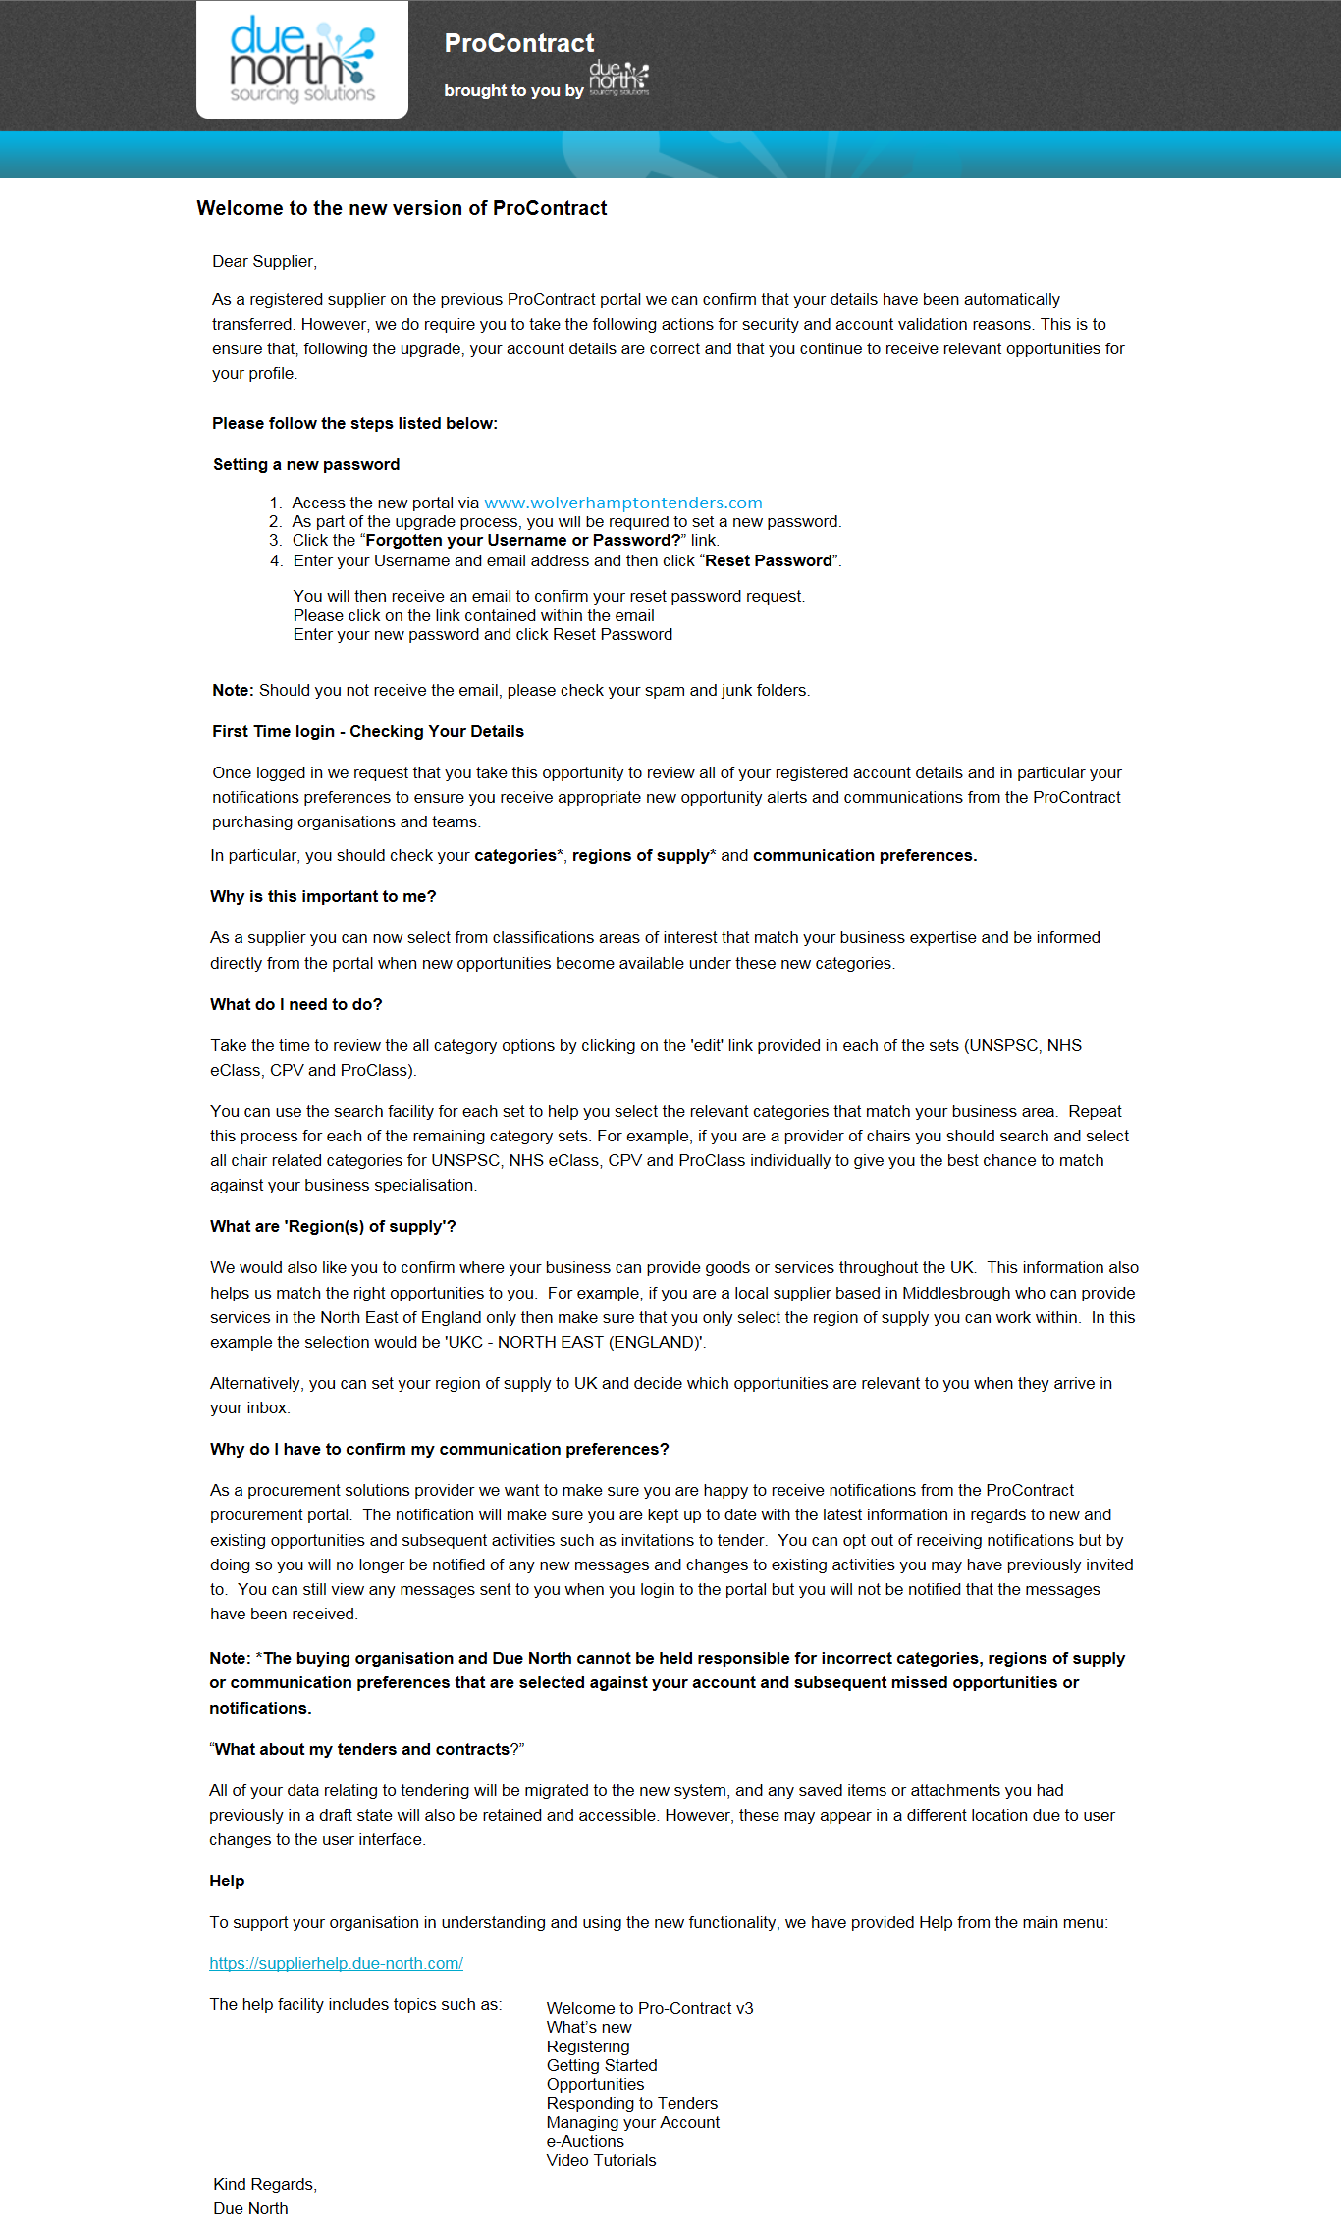

- Once you have followed the instructions above close the program and open a new internet session – follow steps 1 & 2 and log in using your Username and New Password
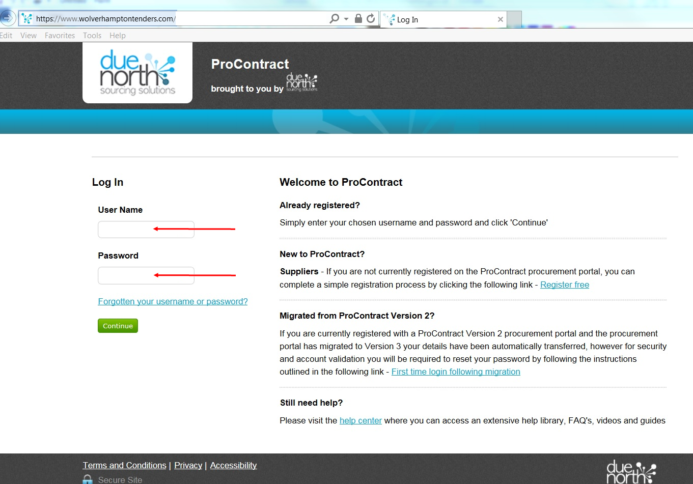

- Select ‘Find opportunities’
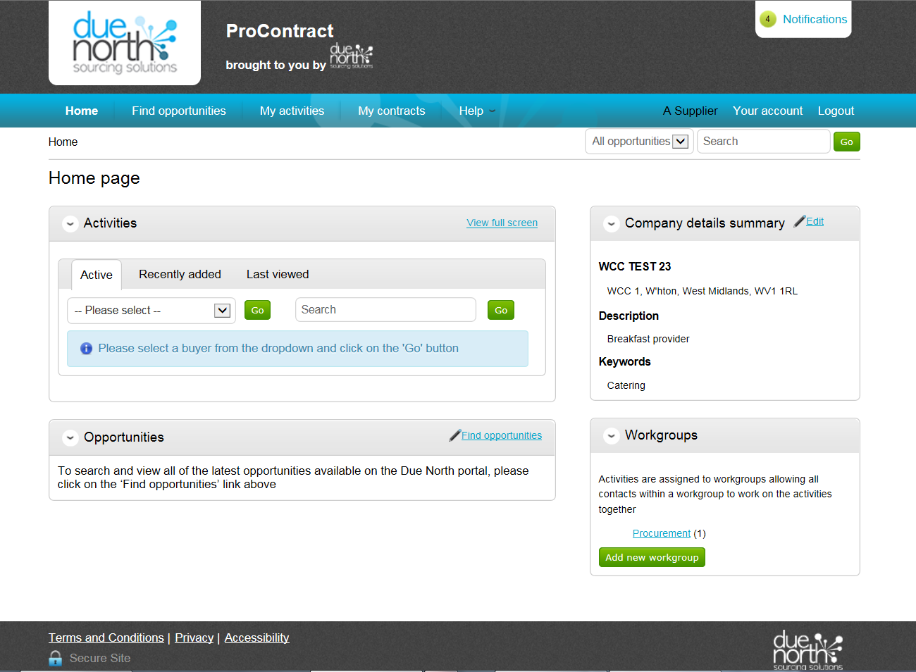
- Now drop the Portals selection list and select Wolverhampton City Council tick the Wolverhampton City Council box and click Update
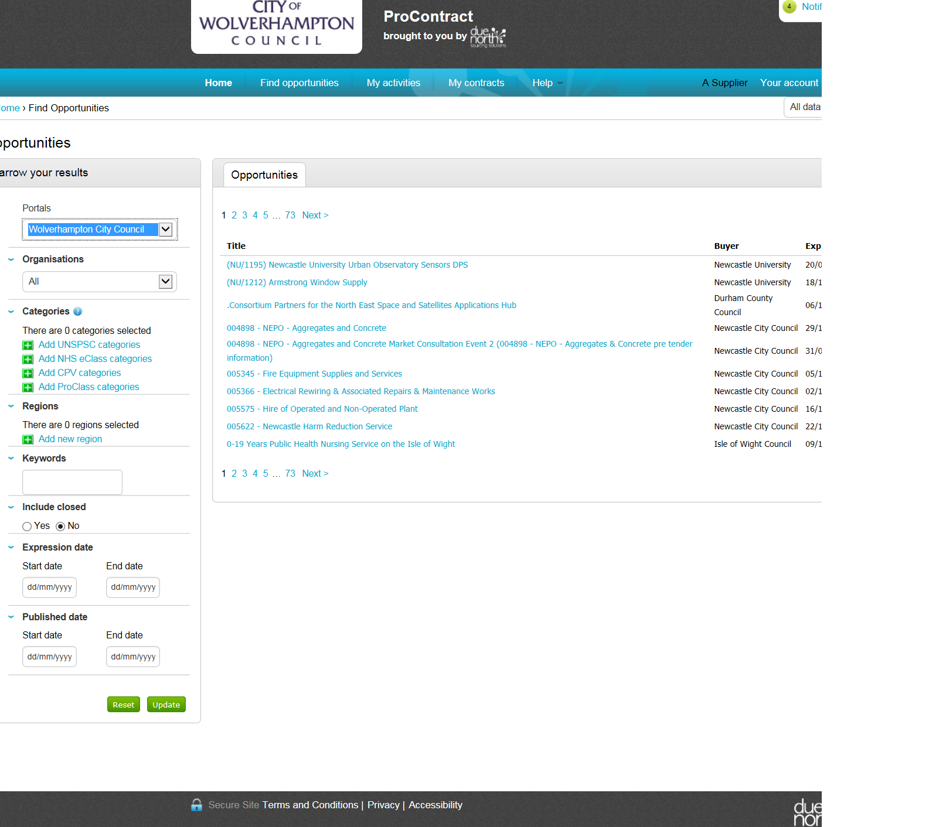

- You will see a list of opportunities that are available for you
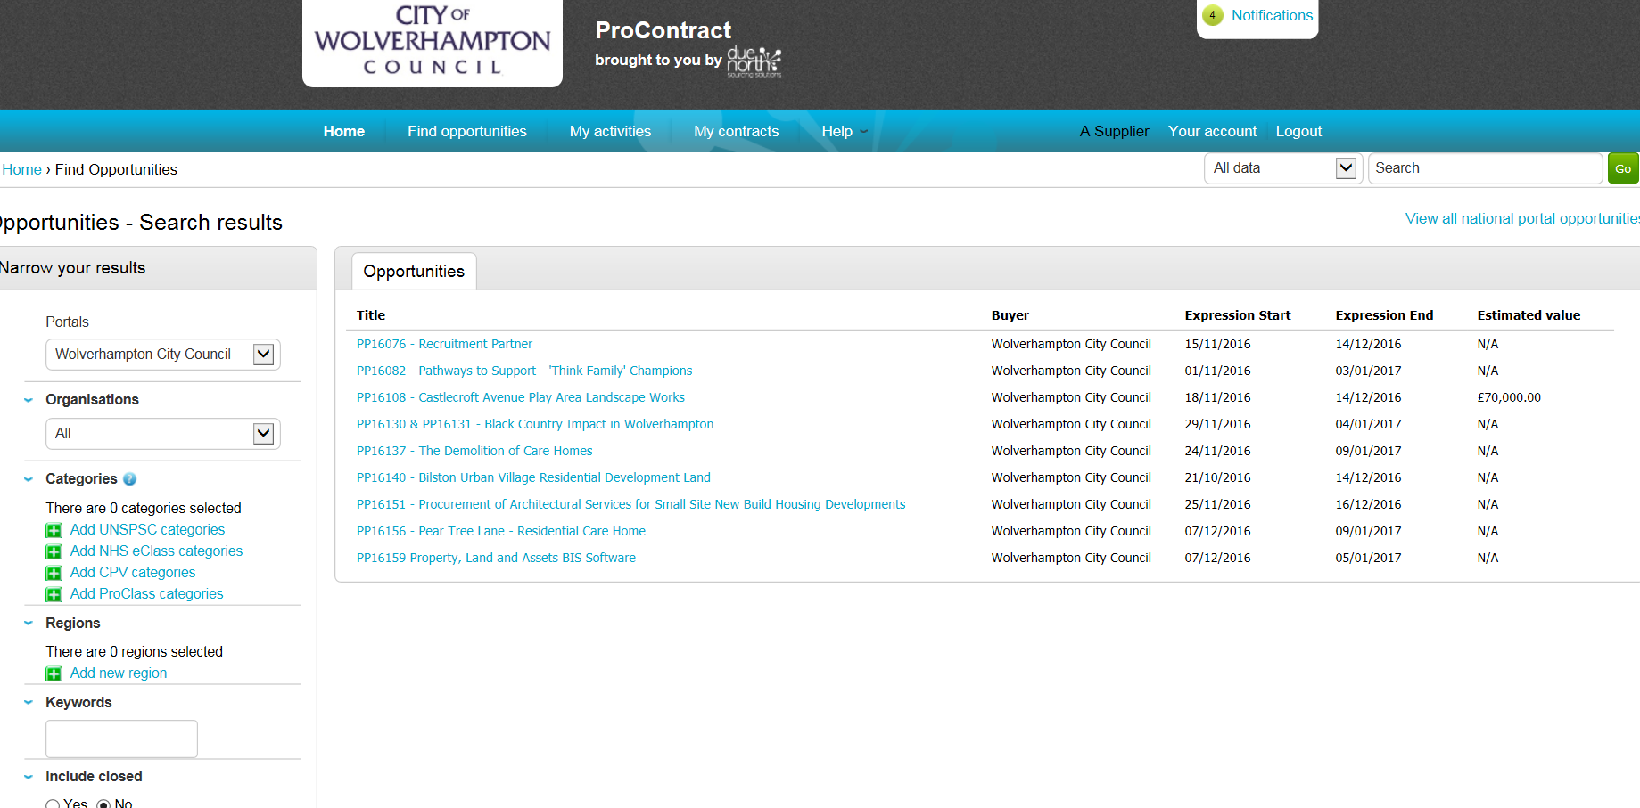
- Click on the Title for the project you require from the list
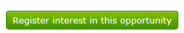
- Click on
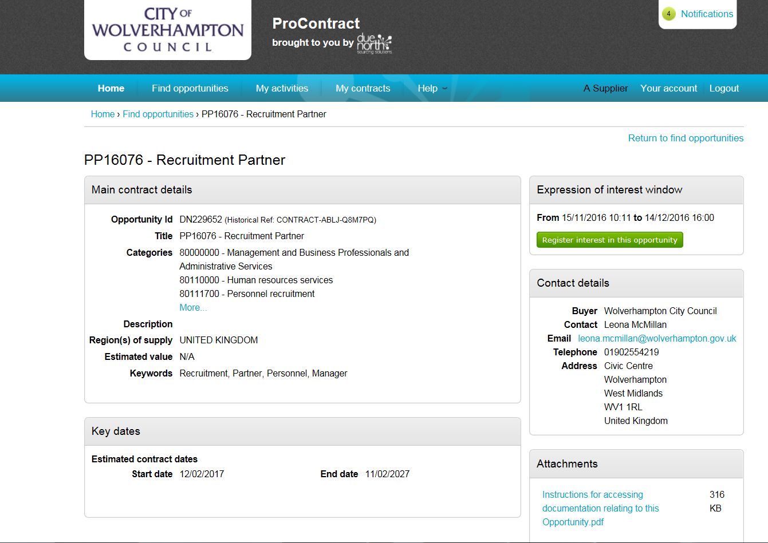

- Now click on My activities
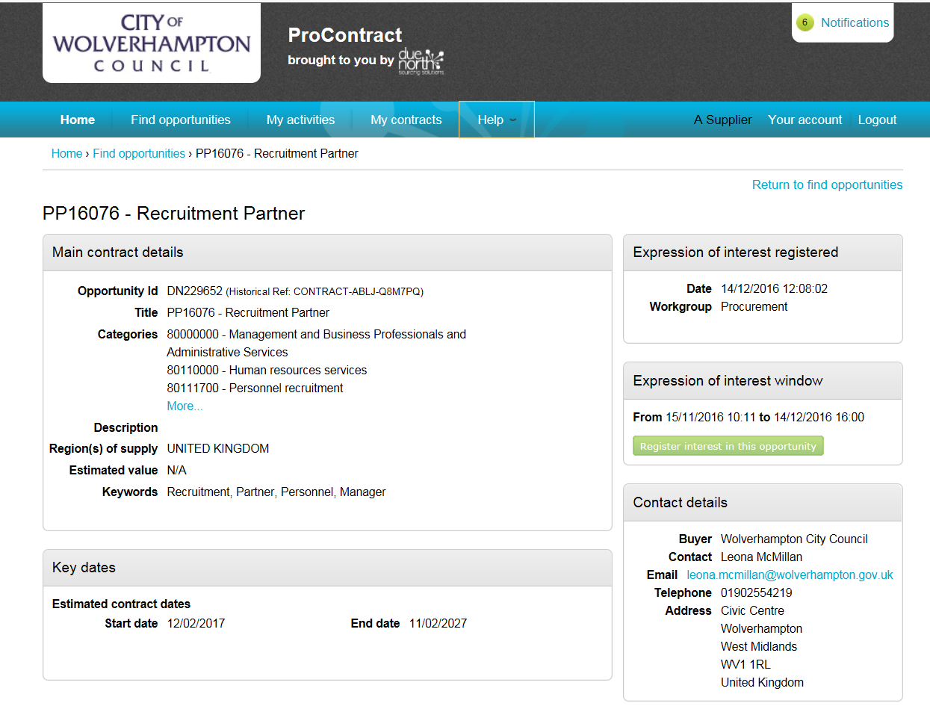

- Now tick the Wolverhampton City Council box and click Update
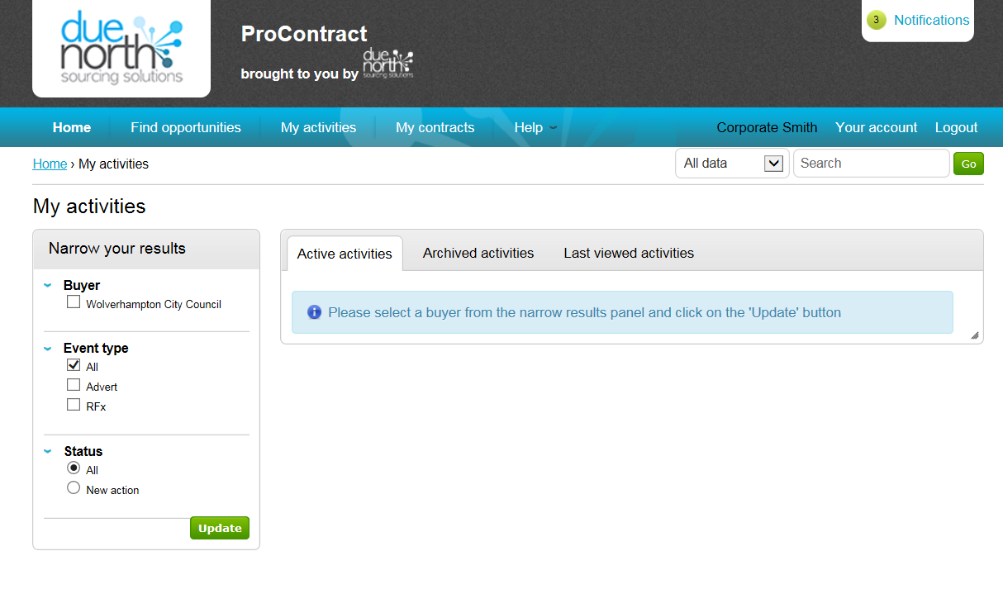

- You will see a list of activities that are available for you including the one you have just registered an interest in
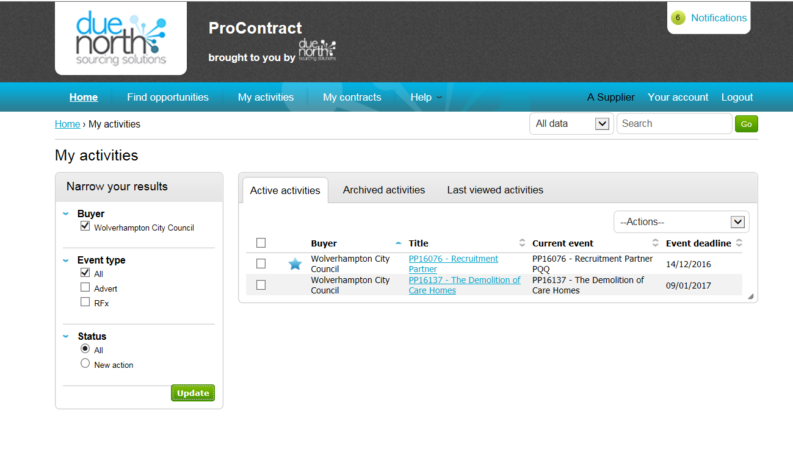

- Click on the Title for the project you require from the list

- Click on the Start
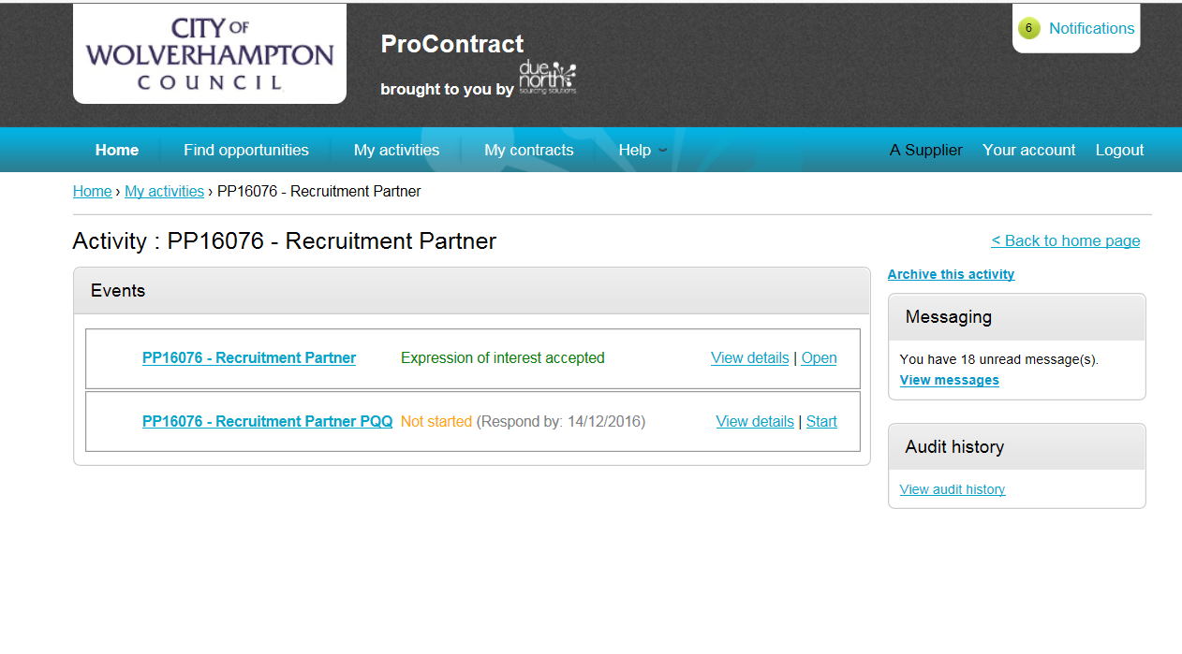
- You will be taken to the screen below – see notes
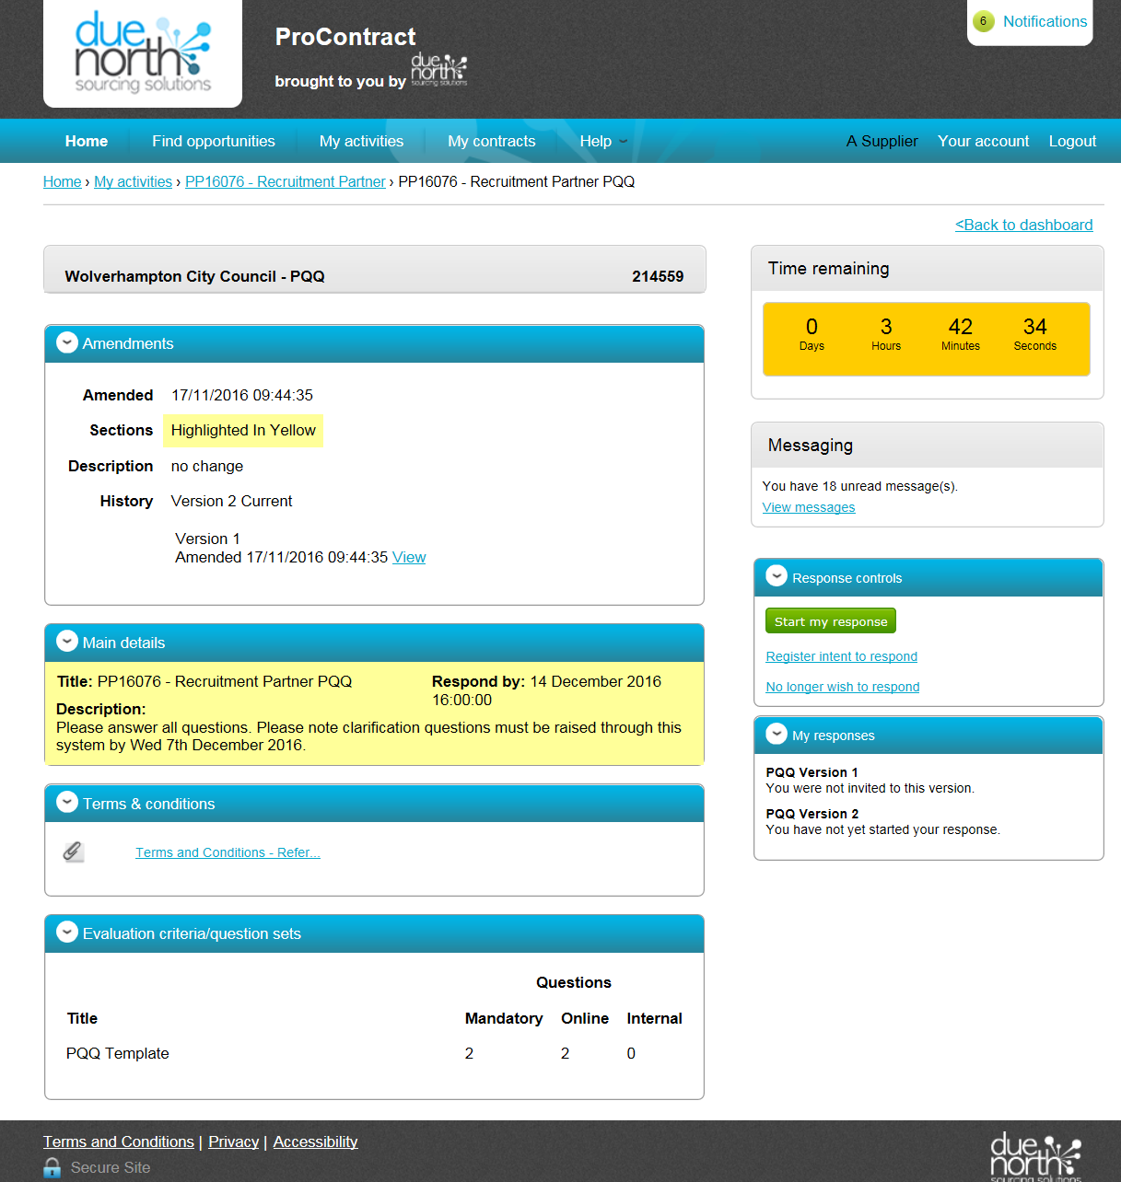
Title and info on this project
These are the terms associated with this project
This shows how many templates & questions
- Click Start my response to start the process of completing your submission.

- After reading the text - Click Continue
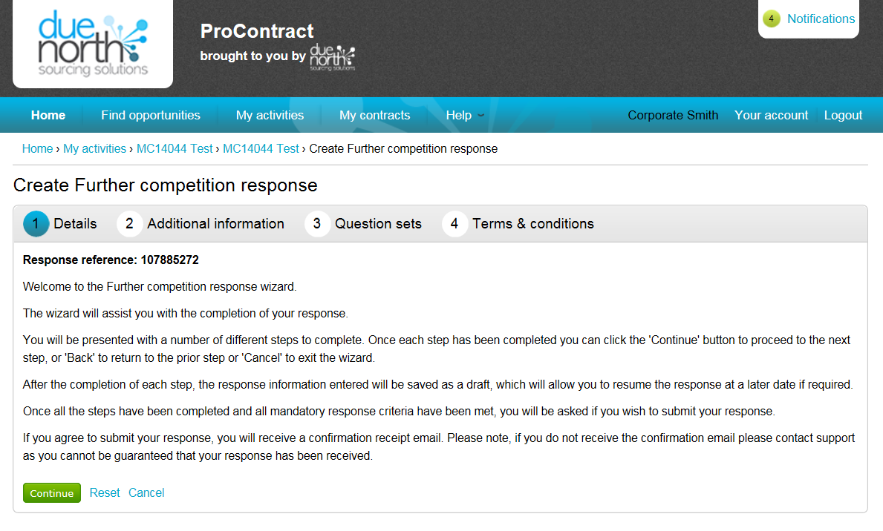

- We recommend you put a Supplier Reference in (can be anything text or numbers and please make a note of what you have entered). The lower two boxes can remain empty. Then click Continue.
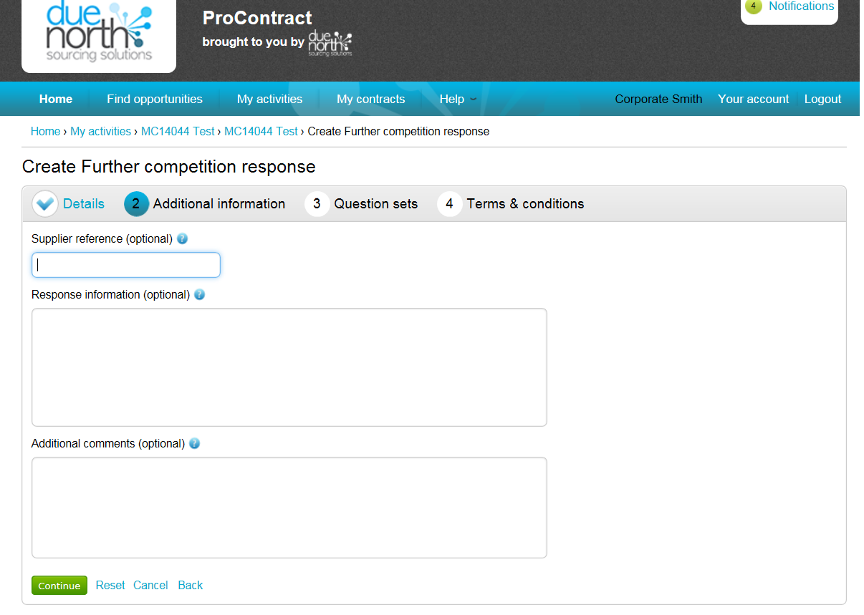

- Click Edit Response against the template you wish to complete – below there only shows one but there maybe 3 or more
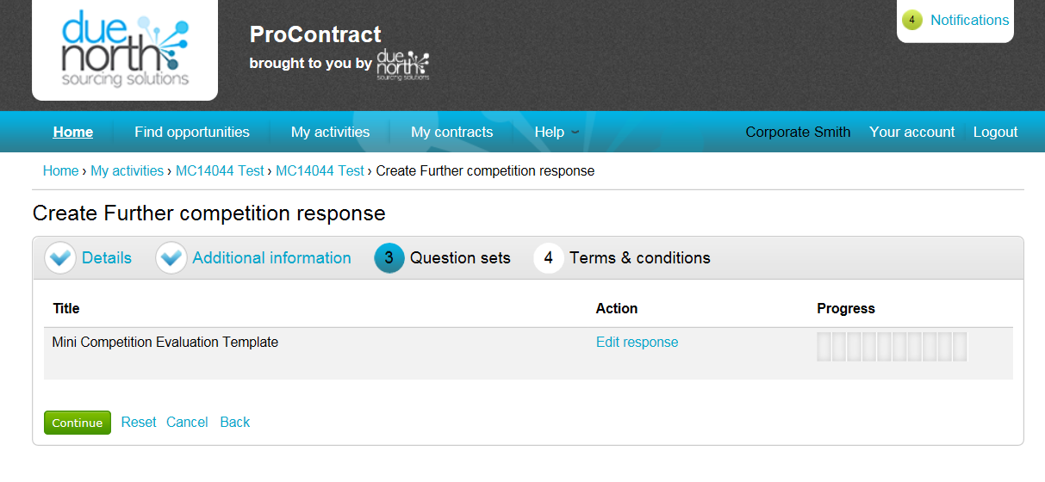

- Click Answer Question
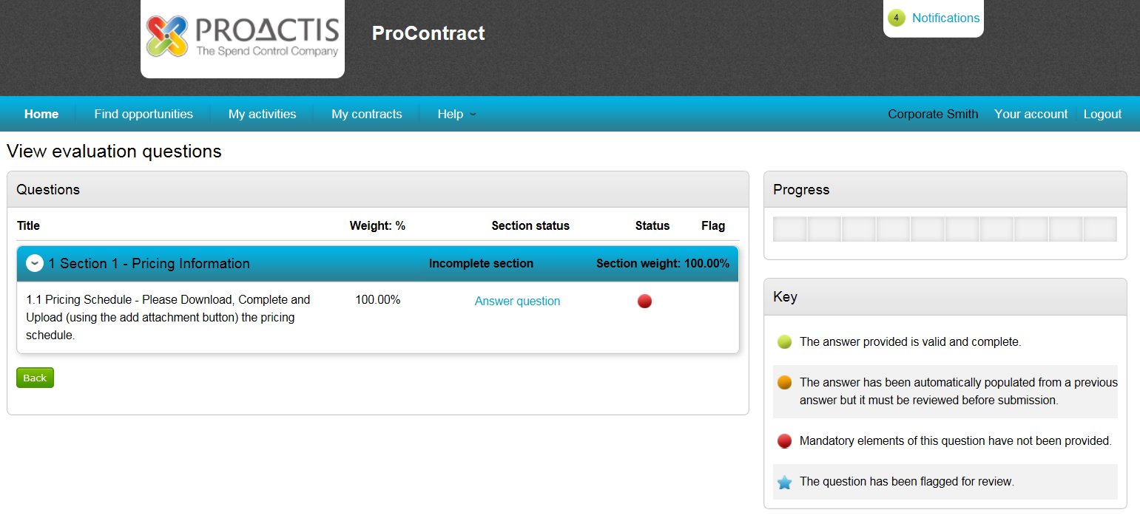

- Answer the question – questions can be yes/no options or text (where you will be required to input text) or checkbox or attachment questions as below. In an attachment question click on the attachment in ‘Question attachments’ 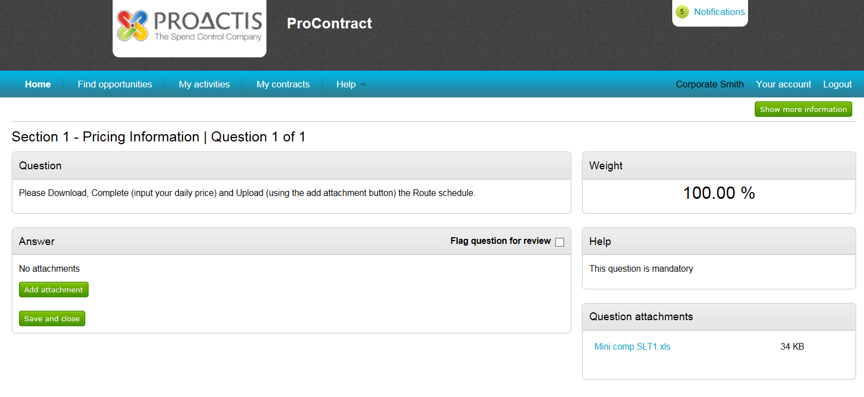

- Click Open (please note – dependent on your internet explorer version your ‘open’ screen may look different)

- The document will open (maybe Word, Excel, PDF or another format). Please complete the document as required and save it to your computer where you can find it later.

- Back in Due North (Pro-Contract) click Add attachment
- The pop up box shown below will appear, click If a diff pop up appears go to step 30
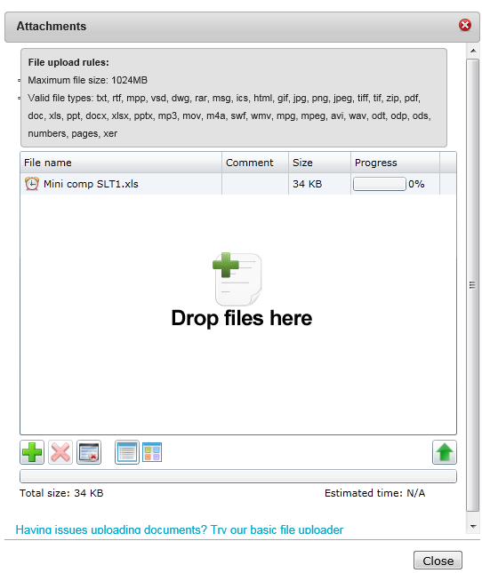

- A ‘browse’ box will appear – find the file you have saved, click on it so it is highlighted and click on Open
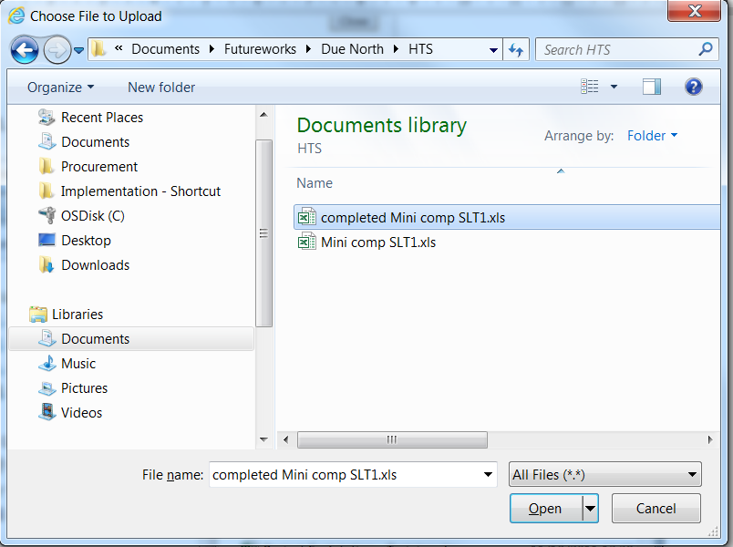
- Now click

- Click Continue
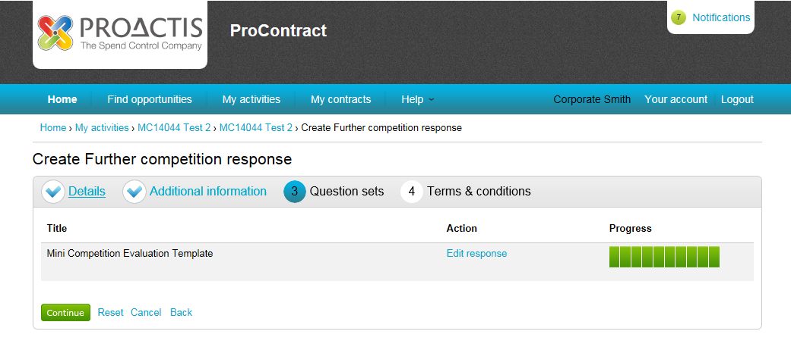

- You will be taken back to the screen below and the file should show here. Now click Save and close
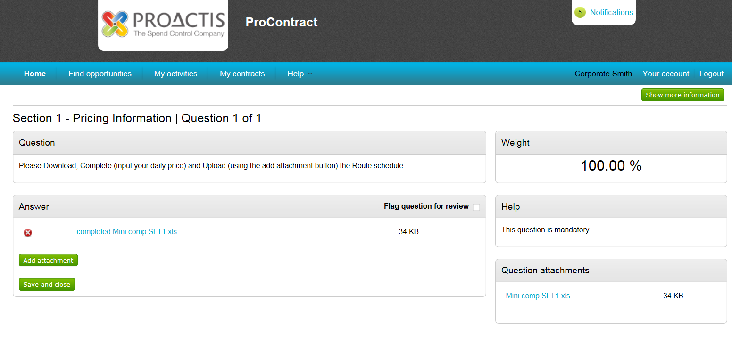
- You will be taken back to the list of templates – select the next template to answer by clicking Edit Response.
When all templates have been completed and you have completely green Progress bar’s click

- Now click Accept or Decline to the Terms and Conditions (if you click Decline you will have to state why in a pop up box that will appear)
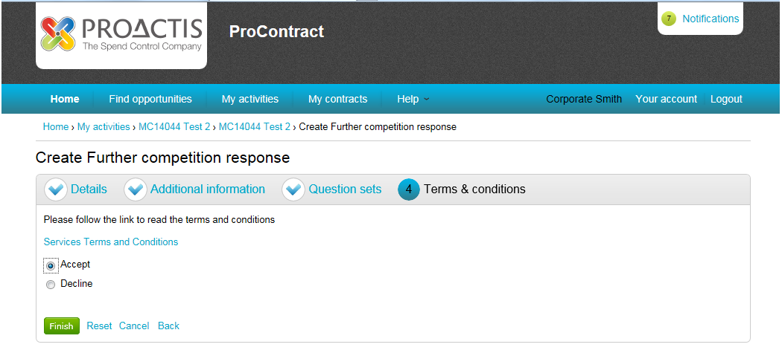

- If you have done all that is required, you will have Green dots next to the items in the Submission checklist and your Submit response button will be Green. Now click Submit response

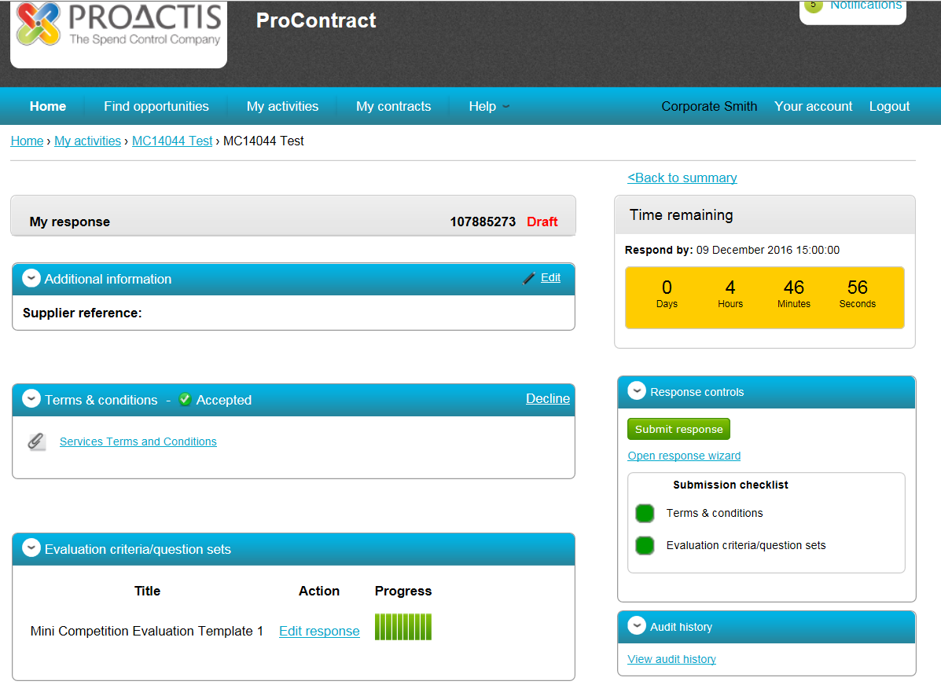

- A confirmation pop up box will appear, click Submit response again
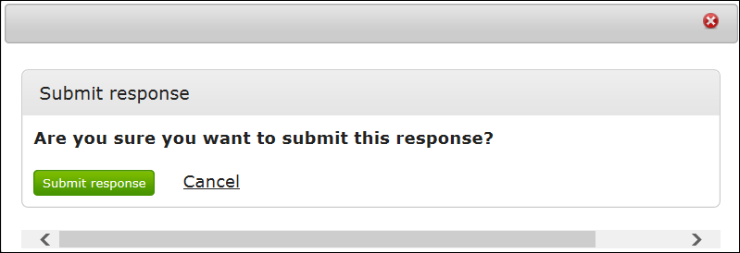
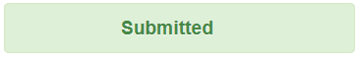
- You should see this confirms you have sent your response.
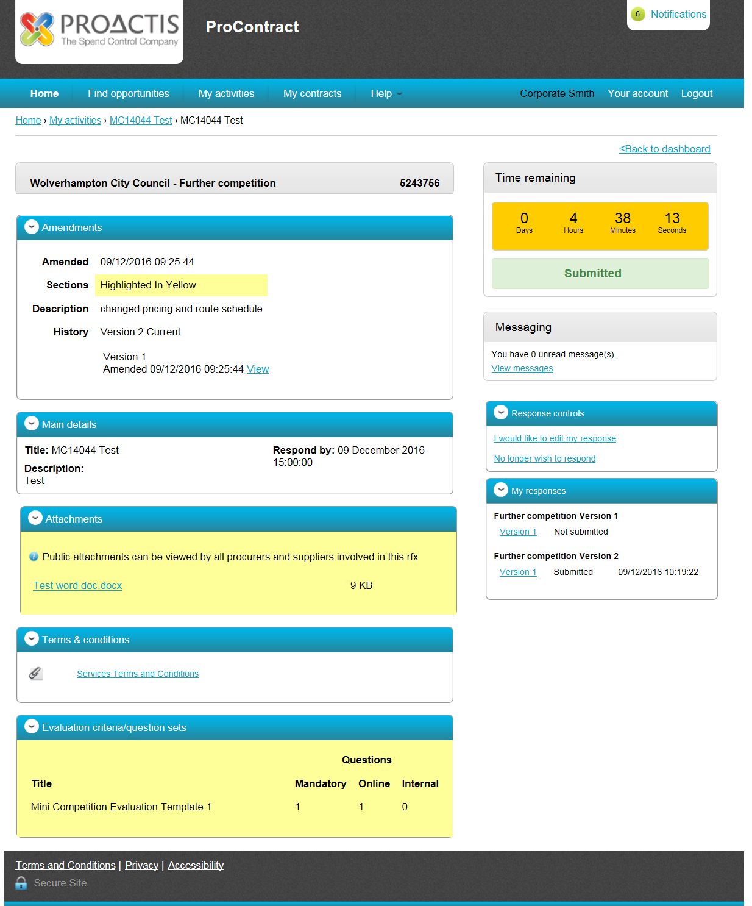

Click Logout
- The pop up box shown below will appear, click Add Files
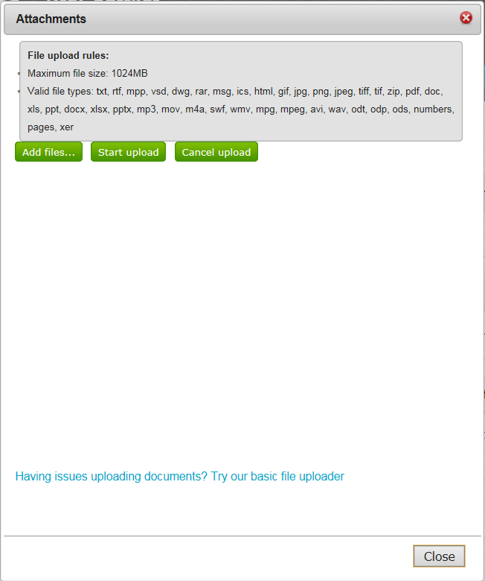

- A ‘browse’ box will appear – find the file you have saved, click on it so it is highlighted and click on Open

- Now click Start Upload
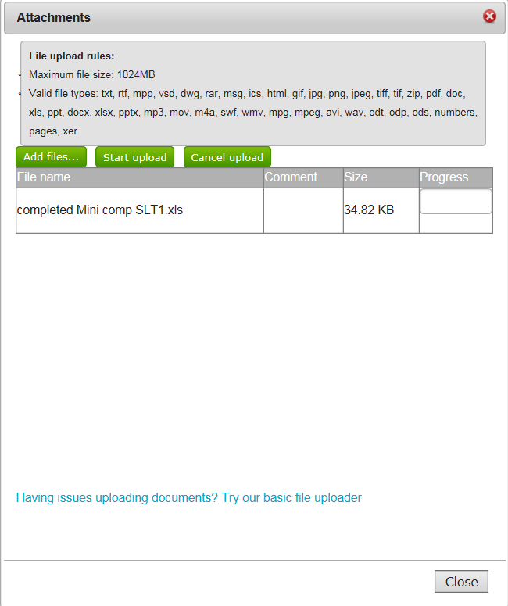

- Go to Step 23

