Tender Information Pack
6 Block Internals Pilot
April 2019

Unitas (Stoke on Trent) Ltd
Planned, Mechanical & Electrical
Alton House, Cromer Road, Stoke on Trent, ST1 6AY

Property Surveying Team

Tender Information Pack
6 Block Internal Refurbishment Programme

Client | City of Stoke on Trent
Project Description
Number of dwellings/ units: | 12
Build Year: | 1955 onwards
Construction Type: | Traditional cavity brickwork and pitched pan tiled roofs, UPVC double glazed windows and doors.
Property Type: | 1 & 2 bedroom flats
Number of Archetypes: | 1 Archetypes
Nr of storeys: | 2

Key Points
- This document outlines the work contained within the attached tender pack.
It provides a narrative and instructions to support contractors in the pricing process.
- This tender contains an estate refurbishment scheme and bungalow refurbishment scheme, split into work streams which reflect the intended delivery of the works detailed in the proposed programme.
- Contractors are reminded that they must familiarise themselves with the site(s) in order to fully appreciate the means of access, facilities for the storage of plant & materials etc. and, be satisfied with all site conditions, property types and layouts prior to commencement.
- Any Requests for Information must be submitted to Unitas prior to tender submission.
Quantified Schedule of Works
The pricing schedule is broken down as follows:
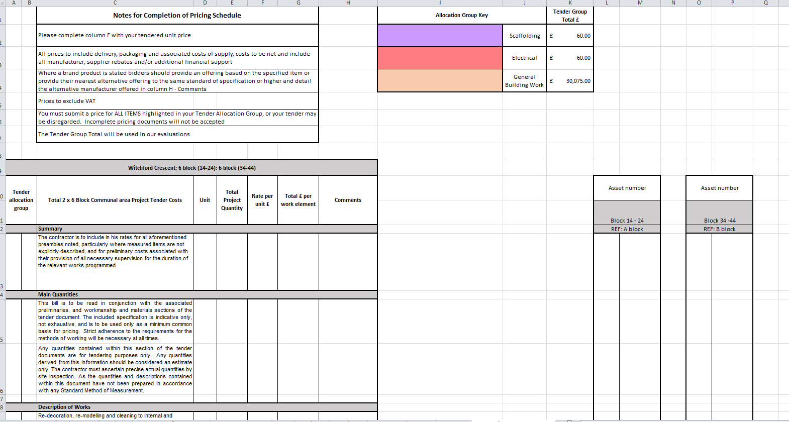
The schedule (tab 7.) consists the main programmed works to be priced.
Each item is measured, and details cumulative quantities across the scheme.
Each works package is identified by colour code detailed as “Tender allocation group” in columns A & B, and corresponds with the key above. (See Figure 1.)
Any contractor pricing a package of work must price all items within the work package to validate their submission.
Figure 1.

Provisional Items (tab 6.) are also broken down into work packages and must be priced accordingly.
** Note - the only Tabs that need to be priced are - 6, 7 **

The contractor will complete their tender submission by completing the “rate per unit” column (A).
On entering that rate in tab 9. the schedule will automatically populate the document at address level.

The project breakdown (B) shows how the overall quantity is built up at a glance.
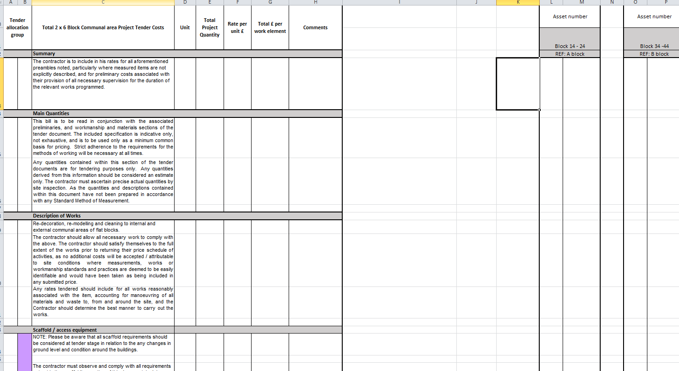
(A)
(B)

Project Overview
Witchford Crescent 6 Block Internal Refurbishment Works, Communal Areas
This scheme comprises 2 properties which consist of twelve 1 & 2 bedroom flats. These properties are cavity wall, with traditional pitched roofs, UPVC double glazed windows and doors.
The refurbishment to each of the internal communal areas will consist of redecoration of walls and ceilings, bricking up of access panels to coal bunkers, installation of composite panel to coal bunker, cleaning and repairs to stairs and floors, general enabling works.

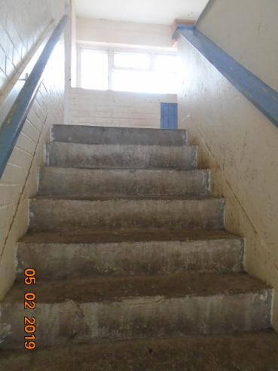
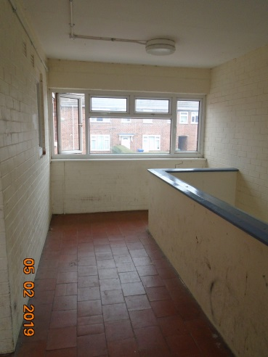

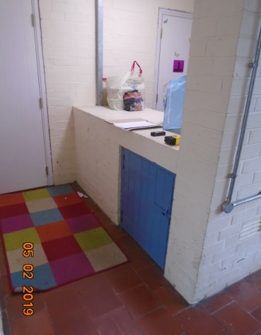
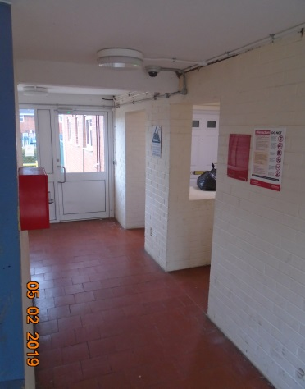

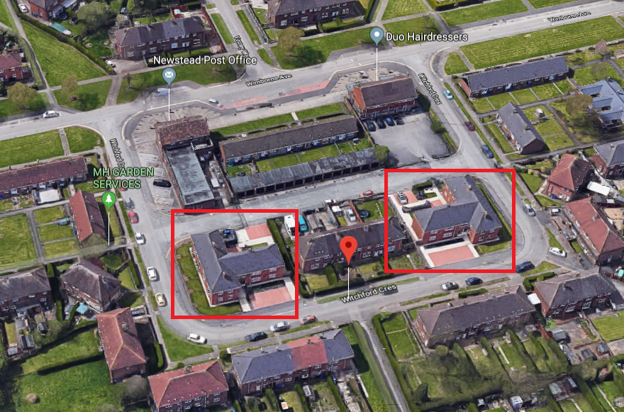

Witchford Crescent 6 Blocks – Plan view

- End of Document -

