- Login to the portal (www.kentbusinessportal.org.uk)

- Find the opportunity listed in the "Activities" box
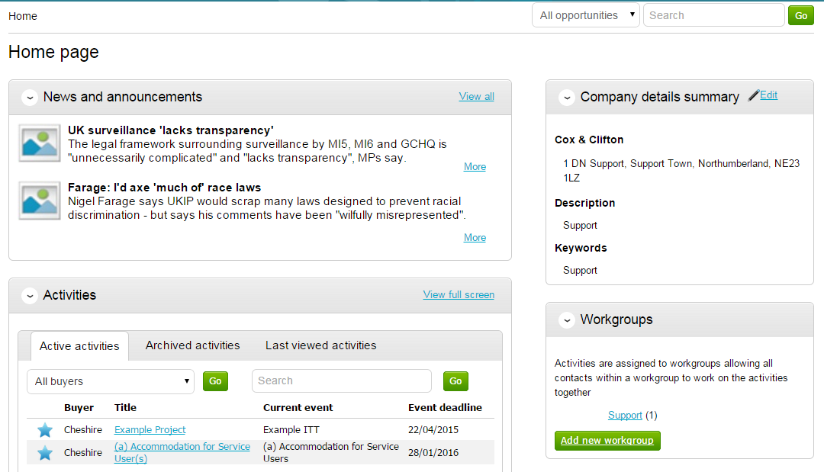

- Click "open event"
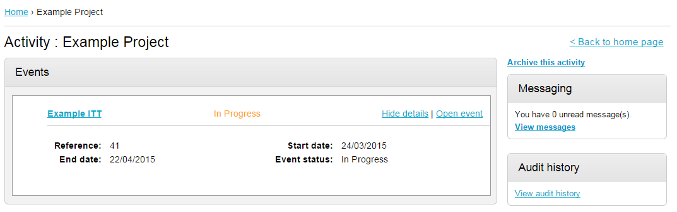

- Click "start my response"
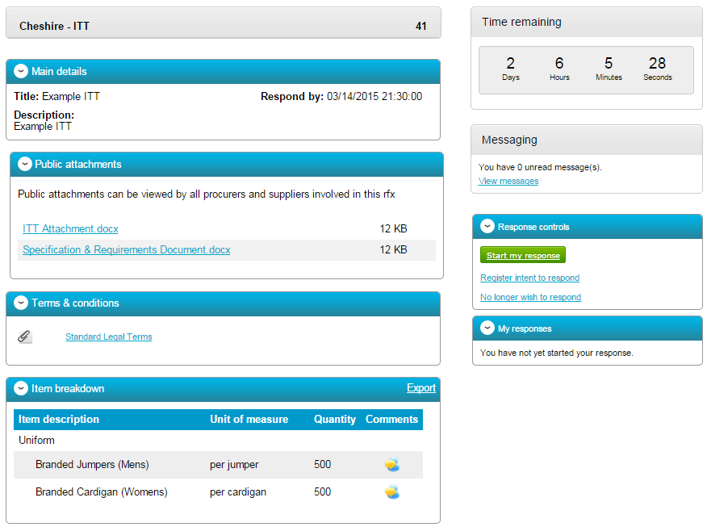
- Go to the attachments box and click "add"
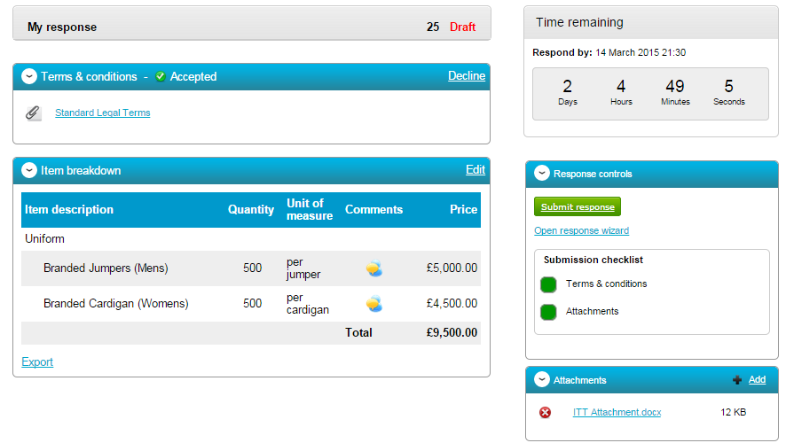

Or it might look like this:

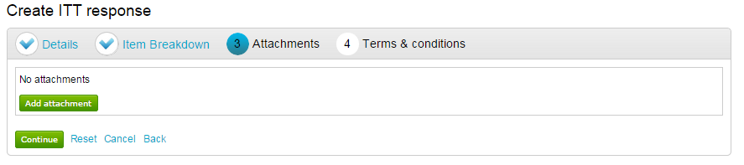

- Selected the files to be uploaded (or drag and drop them onto the pop-up window)

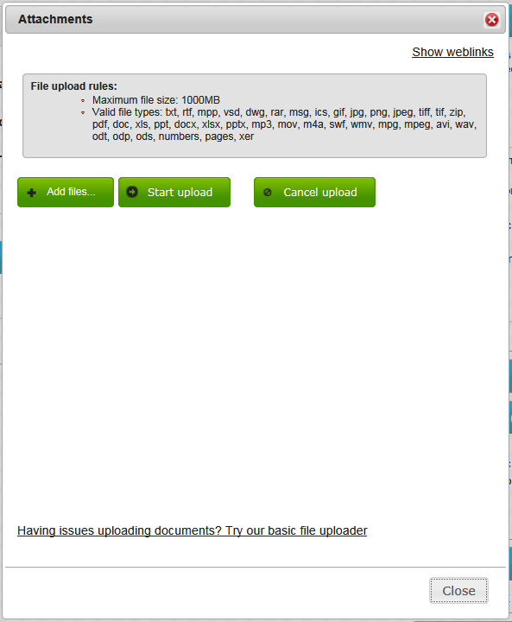

- Click "Upload" and wait for the loading bar to complete. Close the window when done.

- You will also need to accept the Terms & Conditions

Or it might look like this:

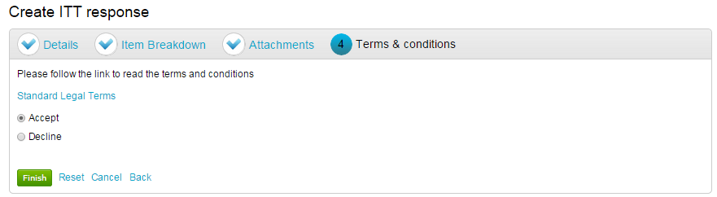

Don't worry about the file link in these boxes – it's blank. The portal requires us to put a file here. The contract terms are in Appendix C of the tender pack and you should have already reviewed these.

- Check all the files of your tender are listed in the Attachments box

- Click "submit response"

You should see this in the bottom corner

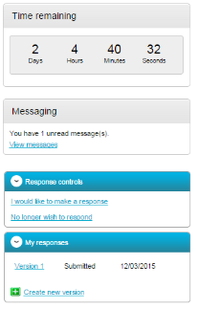

- IF you need to change anything, you can click "create new version" to re-upload.

