Supplier event- PPE & Workwear

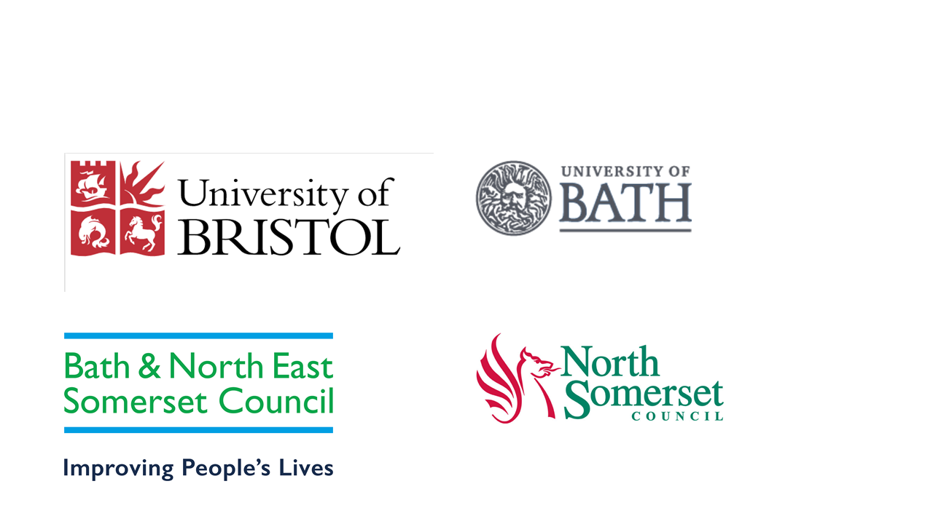

The University of Bristol, University of Bath, Bath & North East Somerset Council and North Somerset Council are collaborating to develop the best possible contract/s for Workwear and PPE.
We have great aspirations for this contract to set us on the way to deliver a robust contract that achieves value for money, including not just cost but encompassing a wide range of sustainability and social value requirements, as well as meeting requirements under the Modern Slavery Act.
We know that the supply market is the expert in these areas and we are keen to engage with you.
We are holding a supplier event for all suppliers of Workwear and Personal Protective Equipment. This event will give you a chance to hear what our aspirations and requirements are, and then the opportunity for you to have your say which is important to us. We have not decided on a procurement route yet and feedback from this event will help us determine the way forward
We invite suppliers to attend who would be interested in future opportunities to provide PPE and/or Workwear. The event will be held via Zoom on Tuesday 17th August 2021 from 2-3.30pm.
For suppliers wishing to attend, please register - https://workwear-ppe18aug21.eventbrite.co.uk

