Where to locate Documents – (Example Project)
From your home page, in the Activities section, select Bristol City Council from the drop down menu and click ‘Go’.
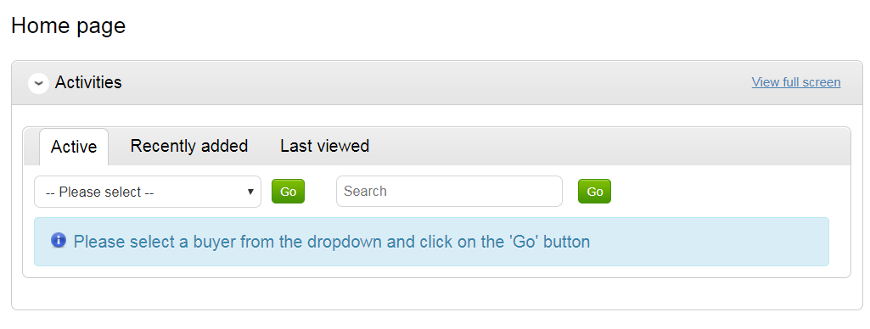
This will show all active projects. Click on the link for the relevant project. This will take you through to the following screen, where you will need to click on the link:
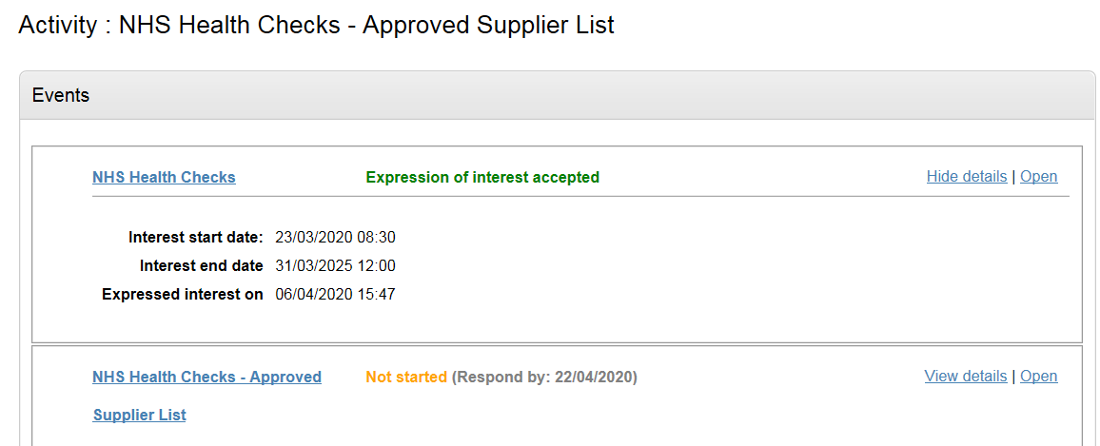

This takes you through to the Activity Summary page, halfway down this page are listed all the documents relating to this tender.
