Lake District National Park Authority Invitation to Tender

(Section 2 of the Southern Windermere Trail)

The design, supply and installation of an off road multi user trail from The Swan Hotel Newby Bridge to Lakeside

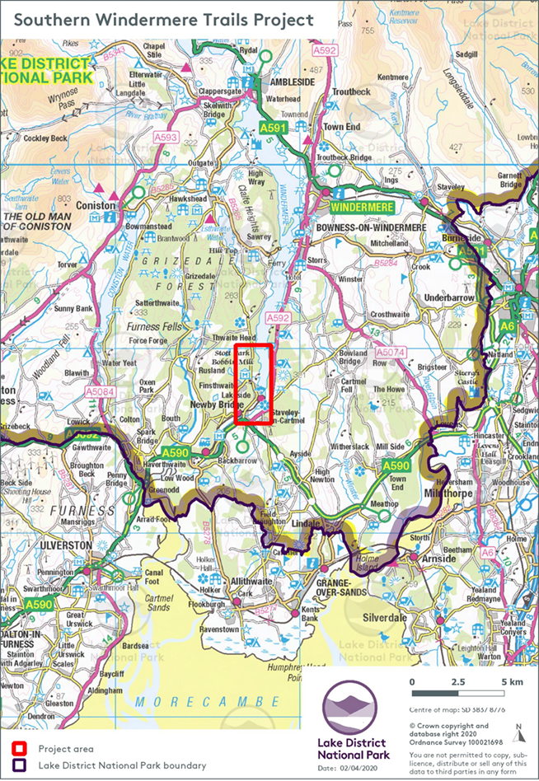

Date: 1st September 2021
Deadline for Submissions: 12:00 8th October 2021

Introduction and background to the project
This project is the first section of a proposed off-road trail from Newby Bridge to Lakeside, along the south western shore of Windermere. Once complete, the whole trail, will link to the YMCA National Centre and create a walking and cycle route along the western shore of England’s largest lake.
The Southern Windermere Trail is being funded by ESIF (European Structural Investment Fund) and CLEP (Cumbria Local Enterprise Partnership).
The aim of this project is to provide visitors a route that is predominately traffic free, connecting the key visitor attractions in the Southern Windermere Basin and encouraging them to use sustainable transport rather than use their car for short hop journeys between destinations. The target is to reduce carbon emissions by 26 tonnes within the first three years of project completion and to create 76 jobs in the local area.
In order to satisfy funding requirements, the entire project must be delivered by 31st March 2022.

Trail overview
The alignment corridor for the trail will be following the lakeshore where practically possible but also head away from the Lake to link key local visitor destinations. The trail will be formed of a mixture of new build sections or upgrades to existing public rights of way, private paths and tracks.
The total length of The Swan Hotel to YMCA section is 5633m. It is divided into five sub sections – set out in the table below.

Section | Name | Length (m)
2 | The Swan Hotel to Lakeside (Station) | 1475
3 | Lakeside (West of Village) | 555
4 | Lakeside to Finsthwaite / Bobbin Mill | 1444
5 | High Dam (Finsthwaite) to High Stott Park | 749
6 | High Stott Park to YMCA Lakeside | 1410
 | Total: | 5633

This tender relates to Section 2 only.

Project Development
The project is part way through the development phase and due to the recent pandemic and re-structure at LDNPA, the management of and responsibility for the delivery of the project has changed. As a result, the delivery is at risk of falling behind schedule.
LDNPA are therefore looking to phase the delivery starting with Section 2. An update of progress to date is provided below:

Site Surveys
A number of surveys were undertaken and submitted as part of the planning application:
- Preliminary Ecological Impact Assessment
- Cycle Level of Service Audit Report
- Topographical Survey
- Tree Survey
- Bat Survey

Design and Planning Permission
The majority of the design work has been completed by LDNPA Rangers Service as it consists of standard details for paths, fences, gates, drainage and signage. However, there are some bespoke elements such as the boardwalks and bridges in section 2 of the trail where additional technical details are required.
Sections 2 of the trail will create a new public right of way and therefore it requires planning consent.
The planning application documents (including the above surveys) can be found on the LDNPA website using the following references:
- Section 2: 7/2021/5481

The planning application for section 2 is currently out for public consultation and will be considered at the 1st September 2021 development control committee meeting.

Enabling Works
The tree works outlined in the tree survey will be undertaken during September 2021.

Tender Objective
The Lake District National Park Authority (LDNPA) invite contractors to submit tenders for the design, supply and installation of an off road multi-user trail connecting The Swan Hotel at Newby Bridge with Lakeside Hotel and Windermere Lake Cruises Jetty. The contract terms will be as contained with a standard JCT Design and Build contract.

The trail route crosses land owned by The Swan Hotel, Lakeside and Haverthwaite Railway, Lake District National Park Authority, Landing How (Private Residence) and Windermere Lake Cruises. The above businesses will be operational during the contract works and contactors must be mindful of this.

A route map is provided (Annex 5) to help orientate the reader by outlining each of the trail sections, access and egress points for construction traffic, compound locations and signage and furniture locations.

Included within the tender pack is a bill of quantities template (Annex 6) and employers requirements document (Annex 8) outlining our base requirements in terms of design standards and materials'. We expect the contractor to check all measurements and provide a fully priced bill of quantities including any bespoke, contractor designed items.

The contractor must also make allowances for delivering the project whilst maintaining appropriate Health and Safety standards as outlined in the employers requirements document. For clarification, the tender submission does not require the contractor to submit H & S documentation, but an allowance must be made within the tender sum to provide the appropriate information should the contractor be successful.

A weighted evaluation will be made on tender returns, based 60% on cost and 20% on quality of the proposed solution and 20% on contractor’s skills and experience.

The contractor will be expected to submit a fixed fee proposal and have the capacity to deliver the contract preferably by 12 February 2022.

A site visit is essential to fully appreciate the opportunity. Appointments are available on 27th September 2021 and can be arranged through Sharon.hodgson@lakedistrict.gov.uk telephone on 07929119389.

Tender Documents
The following documentation has been included:

Annex 1 - Invitation to Tender document (this document)
Annex 2 - Form of Tender
Annex 3 - Declaration of Non Collusion
Annex 4 - References
Annex 5 – Section 2 Trail route Overview
Annex 6 – Bill of Quantities Template
Annex 7 – Hough Tullett Drawings – Bridge and Boardwalk Designs
Annex 8 – LDNPA Employers Requirements/Specification
Annex 9 – Images of the route
Annex 10 – LDNPA Contractor Health and Safety Code of Practice

Submission of the tender documents

Your submission should include:
- Completed form of tender, including breakdown of costs and priced bill of quantities (Annex 2).
- Declaration of non-collusion (Annex 3).
- References – these should demonstrate where possible a similar project on a similar site (Annex 4).
- A programme/schedule of works, such as Gantt chart or a plan.
- Details and methodology of how you propose to effectively deliver the scheme with minimal disruption to landowners, tenants and neighbouring properties and appropriate consideration for employee and public safety.
- Details of your accounts and evidence in relation to financial viability of your business.
- Brief CVs of the key personnel who will be undertaking the work (for example Contracts manager and Site supervisor).
- Details of any sub-contractors who will be involved in this project for example, structural engineer.

Before commencing a formal tender evaluation, documents provided by tenderers will be checked to ensure that they are complete. At this stage, any non-compliant tenders will be rejected by the Authority. Tender responses which are deemed to meet the eligibility requirements will be shortlisted and we may invite tenderers for a second stage interview. Shortlisted tender submissions will be evaluated according to the Evaluation Criteria given later in this document.

Tenders must be received via the Chest procurement portal by 12:00 noon 8th October 2021. Please ensure you allow enough time to complete uploads before the deadline. Tender documents received late, i.e. after the specified date and time, will not be considered.

How to return the tender
The tender is to be submitted in electronic format via the Chest procurement portal.

Please raise all queries related to the tender via the Chest messaging system.
Opening of tenders

Tender documents will remain unopened until after the closing date, after which time they will all be passed to the originating department. All tenders submitted will be verified to ensure that the information requested has been provided before they are evaluated.
Timetable for this tender

Date | Activity
1st September 2021 | Publication of Tender Documentation
27th September 2021 | Planned site visit
12:00 noon 8th October 2021 | Tenders return deadline
11th – 12th October 2021 | Tender evaluation and shortlisting
18th October 2021 | Presentations by shortlisted consultants (if required)
20th October 2021 | Notification to successful supplier
3rd November 2021 | Contract Award (after 10 working day cooling off period)
Contact and information
For feedback on your submission please contact Sharon Hodgson at Sharon.Hodgson@lakedistrict.gov.uk

Lake District National Park Authority, Murley Moss Business Park, Oxenholme Road, Kendal, Cumbria. LA9 7RL

Checklist for Compliance

The following completed documents are required for the tender to be deemed compliant:

- Form of Tender and Bill of Quantities (Annex 2)
- Declaration of Non-Collusion (Annex 3)
- References (Annex 4)
- Programme/Schedule
- Detailed Methodology

Evaluation of tenders

Once verified as complete the tenders will be considered based on the information they have submitted in their tender. The tenders will be evaluated upon the following criteria;

Evaluation Criteria | Potential Score
Price  - Fixed fee proposal including breakdown of contractor prelims and priced schedule of works as follows (Annex 2):  - The design work  - The site clearance  - Priced bill of quantities, paths, fences, furniture, signage and interpretation  - The supply and Installation of bridges  - Contractor prelims (site welfare)  - Provisional sums (please specify) | 60
Quality  - Quality of tender submission (presentation and relevance of content)  - Ability to deliver within the required timescales (programme/schedule) | 10  10
Skills and Experience  - Appreciation of site specific issues and ability to demonstrate effective delivery whilst maintaining public safety and ability to demonstrate minimal disruption to landowners, tenants and neighbouring properties (methodology)  - Evidence of prior experience delivering similar services on a comparable site (references) | 10  10
Maximum Possible Score | 100

Questions on tender submissions

If tenderers have any questions they wish to ask the Authority, they must submit them via the Chest procurement portal.

Any questions received will be made anonymous and responses sent to all tenderers.
Award of tender

The Authority will decide to whom the contract shall be awarded based on the evaluation criteria outline above. The Authority does not bind itself to accept the lowest or any tender/quotation and reserves the right to accept the whole or parts of tenders/quotations. The Authority will notify acceptance of the tender to the successful tenderer as soon as is reasonably practicable.

TENDER INFORMATION
Confidentiality

The details of these documents and all associated documents are to be treated as private and confidential for use only in connection with the Tender process.
Freedom of Information

The Authority is committed to meeting its legal responsibilities under the Freedom of Information Act 2000. Accordingly all information submitted to the Authority may need to be disclosed in response to a request under the Act. If you consider that any of the information included in your tender is commercially sensitive, please identify it and explain (in broad terms) what harm may result from disclosure if a request is received, and the time period applicable to that sensitivity. You should be aware that, even where you have indicated that information is commercially sensitive, we may be required to disclose it under the Act if a request is received. Please also note that the receipt of any material marked ‘confidential’ or equivalent by the public authority should not be taken to mean that the public authority accepts any duty of confidence by virtue of that marking. If a request is received, we may also be required to disclose details of unsuccessful tenders.
Anti-Fraud and Corruption Policy

The Authority has an Anti-Fraud and Corruption Strategy which sets out the responsibilities of officers and action to be taken in cases of theft, corruption, irregularity, or when damage is suspected. The Confidential Reporting Code, (Whistle Blowing Policy), forms part of this Strategy which provides a mechanism for staff to report suspected wrong doings confidentially. In the event of such an issue, an investigation would be carried out and action taken as necessary.
Costs and expenses

The Authority will not be responsible for, or pay for, expenses or losses which may be incurred by a tenderer in the preparation of their tender. The Authority does not bind itself to accept any of the tenders as a result of the tendering process including the lowest tender.
Preparation of Tenders

For the preparation of their tender and entering into a contract with the Authority, tenderers must ensure that they have all the information required and must satisfy them of the correct interpretation of terminology used in these documents.
Alterations

None of these documents may be altered by the tenderer. If the tenderer wishes to propose modifications to any of the documents (which they may consider would provide a better way to achieve the contracts objectives) they must provide details in a separate letter accompanying the tender response.

Prices

All prices must be net and, where applicable, carriage paid with all cash and trade discounts allowed for.

VAT

All prices and/or rates shall be exclusive of VAT.
Validity of tenders

Tenders shall be valid for a minimum of three calendar months from the closing date for receipt of tenders.
Sub-contractors

The names and addresses of any sub-contractors the tenderer proposes to employ must be provided with the tender.
Quality of goods / services

Tenderers must possess relevant professional qualifications and experience.
Conflict of Interest

The Authority requires all tenderers to confirm whether any actual or potential conflicts of interest that exist which may prevent them undertaking this work, and a description of measures they would adopt if a potential conflict of interest arose during or following completion of this work.
Treatment of tender

The acknowledgement of receipt of any submitted tender shall not constitute any actual or implied agreement between the Authority and the tenderer.
Debriefing

All unsuccessful bidders will be offered the opportunity to be given a debriefing. Requests for debriefing are to be made in writing.
The Authority’s use of Contract Outputs

The Authority may wish to publicly quote the Contract Outputs such as any policies, figures, training materials, risk assessments etc. Tenders are requested to confirm that the Authority may (at the Authority’s own discretion) do so without restriction.
Ownership

The intellectual property rights rests with the Authority, not the tenderer.

