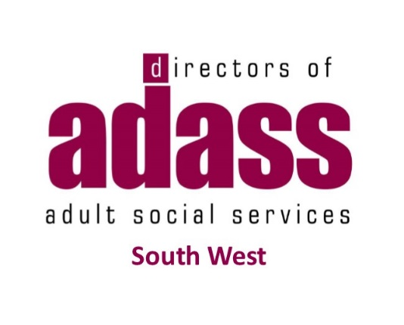
South West Region Learning Disability Residential Care Project
Provider Engagement Event
Wednesday 10th July 10.00 – 16.00
Taunton Rugby Club, Commsplus Stadium, Hyde Lane, Bathpool, Taunton, Somerset, TA2 8BU
SW ADASS and Local Authorities across the South West are working together to develop a regional contract and service specification that local authorities will be able to join to purchase residential care for adults with learning disabilities within the South West. Along with development of the contract, service specification and a standard Quality Assurance monitoring process, we are also exploring how we can have a consistent and transparent approach to ‘setting or agreeing’ fees to ensure best value is achieved across the region.
Providers who provide residential care for adults with learning disabilities within the South West region will be invited to join the regional contract. The providers who decide to join will sign up to one contract and service specification and will only be required to complete one accreditation process to enable them to contract with all participating Local Authorities. Providers will still work with individual authorities as they will still have the responsibility of making their own placements and payments.
We would like to work collaboratively with providers across the region to develop a way of purchasing placements in a streamlined way as well as working together in the development of a contract, service specification and costing model that would be used for residential placements made under this contract by local authorities who have agreed to use it.
We would like to invite providers to a market engagement event where we can:
- Gather feedback from providers on our proposals for a:
  - Service Specification and Contract
  - A Quality Assurance Process
  - Explore further the viability of an agreed costing model across the region
- Understand from providers about their business experience
If you would like to attend please complete and return the attached attendance form to naomi.taviner@southglos.gov.uk by Friday 28 June 2019.

