Invitation to Quote

Community Engagement services for Energy Project

– Babraham Rd Park and Ride

Cambridgeshire County Council

www.cambridgeshire.gov.uk

Invitation to Quote for Community Engagement Services for Energy Project – Babraham Rd Park and Ride

- Introduction & Instructions
  - These Instructions describe the Cambridgeshire County Council's (the Authority) requirements for the above requirement, the quotation process and the commercial terms on which the Authority proposes to contract in due course with the successful Tenderer.
  - All costs, expenses and liabilities incurred by the Tenderer in connection with the preparation and submission of the Quotation will be borne by the Tenderer.
  - The Tenderer shall have no claim whatsoever against the Authority in respect of such costs and in particular (but without limitation) the Authority shall not make any payments to the successful Tenderer or any other Tenderer save as expressly provided for in the Contract and (save to the extent set out in the Quotation Documents) no compensation or remuneration shall otherwise be payable by the Authority to the successful Tenderer or any other Tenderer in respect of the requirement by reason of the scope of the requirement being different from that envisaged by the successful Tenderer or otherwise, including without limitation any costs incurred by any Tenderer in the event this quotation process is aborted.
  - To ensure that the Authority will be able to carry out a proper comparison of quotations, no unauthorised alterations shall be permitted to the Quotation Documents. Quotations that contain unauthorised alterations or qualifications may be rejected.
  - Bids shall remain open for acceptance for a minimum of 90 days. The Authority expects to decide award of contract within 30 days of the closing date for submission of quotations.
  - The Authority is not bound to accept any quotation or make any award from this Invitation to Quote. The contract will be awarded on the basis of the Quotation Evaluation Criteria, based on the criteria as set out below and subject the Authority’s funding approval.
- Further Information and Enquiries:
  - The Tenderer may write to the Authority requesting any information or raising any query in connection with the Quotation Documents. Any such communication must be in writing via correspondence function on ProContract. Where appropriate, any such questions will be circulated to all other potential suppliers via the clarification function on ProContract. The Authority reserves the right to seek clarification of any matters arising from the Tenderers submission. The Authority reserves the right to make amendments to the text of the Quotation Documents during the quoting process and notify Tenderers of any such amendments.
- Terms and Conditions of Contract:
  - Please note this is not an order. If your quotation is accepted, an official purchase order will be raised. The order will be subject to Authorities Terms and Conditions of Contract and your completed quotation Submission. Acceptance of the quote by the Authority shall be in writing and on the Authorities terms and conditions, which are supplied as part of our quotation requirements. Tenderers should note the Authority will publish the awarded contract value and the name of the successful Tenderer.
  - Please note if you have any queries or require any clarifications regarding Authorities Terms and Conditions please submit these by 9/12/2019. Any clarifications received after this deadline will not be considered.
- Return of Quotation
  - All Quotations shall be submitted to the Authority through the ProContract portal before 12pm on 16/12/2019. Please be aware that the Authority will use the server clock on the ProContract portal to verify the time of submission. Tenderers should allow sufficient time to upload their submissions to ensure that it is fully loaded into ProContract before the deadline. Failure to upload your bid by the deadline may result in your submission being rejected at the sole discretion of the Authority. Tenderers should be aware that the quotation cannot be submitted while a document is in the process of being uploaded and the larger the file size (50 MB suggested maximum) the longer it will take to upload.

  - The following documents must be completed and returned through the ProContract portal:
- An on-line mandatory questionnaire on ProContract;
- A response to the Quotation Quality Evaluation questions (Section 2. Quotation Evaluation Criteria);
- Completed Pricing Schedule (if applicable, please see 4.3);
- All supporting documentation as required as part of the Quotation submission.
  - All pricing documents must be uploaded separately in an excel format and not embedded within any other documents. Where pricing information is embedded within other documents, tenderers must upload separate copies of the embedded documents.
  - Any attachments that are not identified or any general sales material submitted will not be considered by the Authority. Tenderers are therefore asked not to enclose any documents, brochures or other materials unless you are specifically requested to do so.
- Key dates
  - This procurement will follow a clear, structured and transparent process to ensure that all tenderers are treated equally, fairly and transparently. The key dates for this procurement are currently anticipated to be as follows:
Deadline for Tenderers Queries | 9/12/2019
Date for Tender Submission: | 16/12/2019 by 12:00pm
Contract Award Date: | 19/12/2019
Contract Start Date: | 7/1/2020
Contract End Date: | 30/4/2020
Contract Extension Date: | The project end date can be extended dependent on the project deliverables.

- Health and Safety
  - The Authority requires that all contractors, their employees and sub-contractors (where applicable) shall, whilst working for the Authority, conform with all requirements of the Health and Safety at Work Act 1974 and with all other Health and Safety Legislation that relate generally or specifically, to their trade, business or undertaking.
  - Where applicable the successful Tenderer must also comply with the Authorities Health and Safety policies included on the Guidance for Suppliers on ProContract.
- Accreditations
  - The Authority requires that where accreditation to professional bodies is necessary to deliver the Works, Supplies or Services all contractors and sub-contractors (where applicable), shall whilst working for the Authority, have all necessary accreditations in place.
- Insurance
8.1 If a contract is awarded to you, written evidence of your insurance cover will be required. Insurance requirements will form part of the Terms and Conditions of Contract. The Authority’s requirements are:
- Employers Liability Insurance £5,000,000 (if you are a sole trader and do not employ staff this will not apply)
- Public Liability Insurance £2,000,000

- Rejection of Quotation
  - The Authority in its absolute discretion may reject a quotation if:
    - the prices submitted are too high to be affordable;
    - the prices submitted are too low to be credible, but only after the Tenderer has been given the opportunity to provide an explanation of the quotation or part of the quotation which the Authority believes to be too low, and where the Authority does not accept the explanation;
    - all or part of the Quotation Documents are reproduced for submission in a different format from that provided by the Authority;
    - the Quotation is qualified;
    - the Tenderer makes or attempts to make any variation or alteration to the terms of the Contract Documents;
    - if the Tenderer discloses to any third party prices shown in its Quotation except where such disclosure is made in confidence in order to obtain quotations necessary for the purposes of financing or insurance and/or;
    - if the Tenderer enters into any agreement with any other person that such other person shall refrain from submitting a Quotation or shall limit or restrict the prices to be shown by any other Tenderer in its Quotation and/or;
    - if the Tenderer fixes prices in its Quotation in accordance with any arrangement with any person or by reference to any other Quotation and/or;
    - if the Tenderer offers or agrees to pay or give or does pay or give any sum of money, inducement or valuable consideration directly or indirectly to any person for doing or having done or causing or having caused to be done in relation to any other Tenderer or any other person's proposed Quotation any act or omission and/or;
    - if the Tenderer in connection with the award of the Contract commits an offence under the Bribery Act 2010 or an offence under Section 117(2) of the Local Government Act 1972 and/or;
    - if the Tenderer has directly or indirectly canvassed any member or official of the Authority concerning award of the Contract or who has directly or indirectly obtained or attempted to obtain information from any such member or official concerning any other Tenderer or Quotation submitted by any other Tenderer and/or;
    - if the Tenderer has done anything improper to influence the Authority during the Quotation period and/or;
    - if the Tenderer has failed to use the English language and/or;
    - if the Tenderer has failed to return any of the accompanying documents identified in paragraph 4.2 above.
    - if the Tenderer has failed to declare any conflict of interest or any circumstances that could give rise to a conflict of interest.
  - For the avoidance of doubt any non-acceptance or rejection in accordance with paragraphs 8.1.1 and 8.1.2 above shall be without prejudice to any other civil remedies available to the Authority or any criminal liability that such conduct by a Tenderer may attract.

- Specification of Services

Background to Cambridgeshire County Council

The UK Government declared a Climate Emergency and upgraded its targets to deliver net-zero carbon by 2050. The Council has also declared a climate emergency (May 2019) and is now developing a Climate Change and Environment Strategy, building on its Corporate Energy Strategy and Action Plan along with other areas.

The Council has successfully developed a schools energy programme and invested £11million into 55 schools from across the County and has delivered a 12 MW solar Park at Triangle Farm, Soham which generates clean energy and delivers revenues to the council to invest in services.

We are expanding our energy work and developing further solar parks along with energy projects on our park and ride sites, disused landfill sites and rural estate.

The Council is developing a planning application for an energy project at Babraham Rd Park and Ride and is seeking tenders for the provision of Community Engagement services. Tender responses will be assessed independently against the quotation evaluation criteria (set out in Table 2, page 12).

Project: Babraham Road Park & Ride Smart Energy Grid (BPR)

The County Council’s Corporate Energy Strategy sets out the need for a more ambitious and innovative approach in using and improving the efficient use of council assets. There is the opportunity to use those assets to generate or store electricity whilst also generating revenues. Across Cambridgeshire there are multiple County-owned park and ride sites

The park and ride sites have undergone initial screening for their potential to host clean energy projects. Of these sites, projects at St Ives and Babraham Park and Rides have been identified as good candidates for projects that combine solar on carports, battery storage, electric vehicles chargers and lighting upgrades. A 2.1 MW solar carport scheme is being developed for the Babraham site. The project will feature battery storage to support the site overnight. Revenue streams arise from the sale of electricity via a Power Purchase Agreement and an expanded network of electric vehicle chargers.

The extent of the site is shown in blue below and the extent of the project on-site is outlined in red.

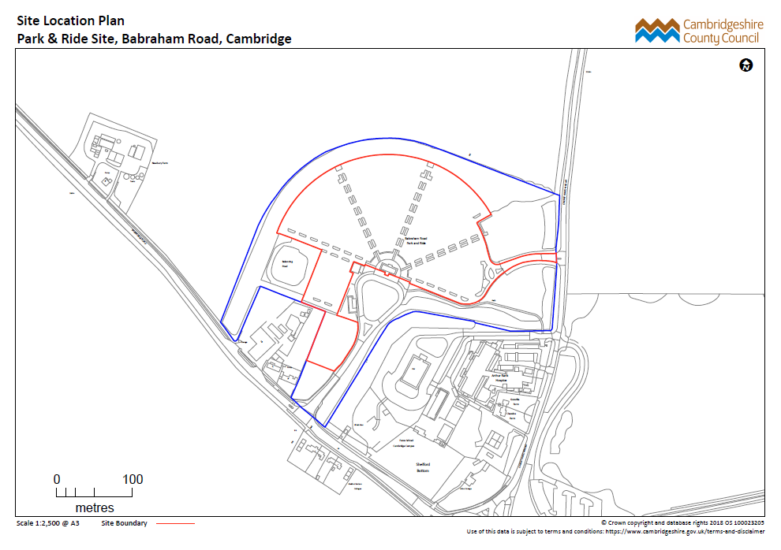

Public engagements sessions have been held with the Great Shelford Parish Council and Great Shelford residents in February and November 2019. Overall, the project has been well-received.

Project information has also been shared with commuters at the site, surrounding businesses and local representatives. A communication strategy has been prepared for the project. Further information is hosted on www.mlei.co.uk.

Community engagement Services

Aim: To design and implement community engagement to build understanding, trust and support for the Babraham project.

Community engagement will form a vital role in securing the success of the projects and ensuring that the community are able to see the benefits. The key objectives from community engagement will be:
- Development of engagement plans that target different sectors in the community
- Evidence of successful engagement across a section of the community
- Public exhibition / events for the community to learn more about the planning application proposal
- Mechanisms for the community to feedback on the project and evidence their feedback is considered and acknowledged
- A report on the key issues raised by the community and an indication of the levels of community support for the project

Why do we need community engagement support?
- Visual impact of renewable energy projects is a concern to nearby residents. Engagement will help keep residents informed of plans, including mitigation of visual impacts and dispel misconceptions.
- County Councillors have explicitly requested a programme of community engagement to inform residents and mitigate their concerns.
- The project team does not have the capacity to engage with the community to the levels that is needed and to help us, we need engagement expertise that can work with the Project Manager, our planning consultants Prospus and our technical partner Bouygues Energies & Services Ltd. Your support must complement the overall project and work to the timescales set for this stage of the project.

Key targets for the community development work:

- A significant presence (minimum of ½ day a fortnight) spent in the local community
- Active engagement with a minimum of 10% of the local community
- The number of events/sessions engaging with the community – to be included in your tender response
- Content for website updates
- Monthly progress updates to local parish newsletters
- Biweekly progress updates to the Project Manager
- Information boards to be produced to help with engagement with the community.

A total maximum budget of £12,000 (excluding VAT) including expenses. Please ensure that you include evening and weekend working in your resource planning.

Scope of work

The project will be evaluated according to your responses to the following deliverables. If you feel there are additional deliverables we are happy for you to suggest these and your reasons why, in your tender response under the question 1.1 in the evaluation criteria.

Deliverables:

- Detailed engagement plan
Working closely with the Project Manager, Prospus and Bouygues Energies and Services Ltd you will provide a detailed engagement plan, building on the existing communication strategy which aligns engagement activities with key information and the planning application process.

- Engagement with different sectors of the community (evenings, weekends, day time).
- Provide a clear overview of the project for residents, businesses and local community groups; describing the project benefits, identifying concerns and gathering feedback for input in to the design.
- Identify further information wanted/needed by residents and groups to inform decisions
- Identify key individuals to become advocates or ‘champions’ of the scheme, who may be willing to share more detailed knowledge of the project and its benefits within their wider, immediate circles

- Set up workshops/public meetings to share project progress as needed
- Design and set up a minimum of three public meetings to share progress from the technical and community engagement work
- Workshops must be designed to address key concerns raised by local residents and groups as well as clarifying key next steps of work
- Write up workshop notes to be published on the MLEI website

4. Organise and carry out educational sessions in the local schools
- Engage and educate local children and teachers with a clear understanding of solar energy, energy storage and the need for carbon reduction
- Source or create easy to follow diagrams and information on the above to be shared in the schools
- Share the presentation and the information to the rest of the community
- Develop a project timeline that is visible to the community which shows future milestones

5. Provide information and communication updates
- Meet monthly with the Project Manager to report progress and to share community views and information, to inform both the project development and to update the MLEI website and social media
- Contribute to community newsletters, articles for the media and local magazines
- Collaborate with the Project Manager and Bouygues on key challenges
- Respond to community emails in a timely manner

Key stakeholders

- Cambridge City Council
- South Cambridgeshire District Council
- Great Shelford Parish Council
- Babraham Road, Wort’s Causeway and Hinton Way residents
- Schools: the Netherhall School, Queen Edith Primary School, Queen Emma, Cambridge Academy for Science and Technology, Fawcett Primary, Stapleford Community School, Morley Memorial Primary School, Colvile Primary School, Trumpington Park Primary School, Babraham CofE, Great and Little Shelford CofE
- Surrounding businesses: Magog Court businesses, Gog Magog Golf Club, Arthur Rank Hospice, etc. A full list will be provided to the successful tenderer.

Health and safety
Consideration of how elderly and vulnerable residents are engaged is important for your protection and that of the residents. Please see question 1.3 below.

Progress reporting
Fortnightly progress reporting to the Project Manager and the Project Board will be required. Reports must provide key findings from your work that can inform other workstreams and the overall project and provide a gauge as to how the community is reacting to the project.

Contract management
You will be accountable to the Project Manager at Cambridgeshire County Council.

- Quotation Evaluation Criteria

Each Quotation will be scored by the evaluation team against each of the evaluation areas in Table 1 and Table 2 below. If a Tenderer is quoting for more than one project they must provide a separate cost for each project covered by their tender:

Table 1 Single Price
Overall Pricing Criteria 10% | Weighting
Cost | 100%

The Quality aspect of the quotation will take into account the criteria below in Table 2:
Table 2
Area | Overall Quality Criteria 90% | Weighting
 | Understanding of the Project Specification and scope
 | 1.1 Describe how your community engagement services will deliver the scope and outputs described in the specification? (Maximum of 2 pages A4) | 20%
 | 1.2 Identify the key challenges or risks for the delivery of the community engagement services? (Maximum of one page of A4) | 12%
 | 1.3 Identify how you will take a sensitive approach to engaging with the vulnerable and elderly in the community? (Maximum of half a page of A4) | 8%
 | Experience, knowledge and resources you bring to the Project and its scope
 | 2.1 Please provide previous examples of how you have engaged with the community to increase support for a project (Maximum of 2 pages of A4 in total) | 20%
 | - Please provide CVs for everyone that will deliver work on the project. | 10%
 | Understanding the context of the project
 | - Describe how existing social and community groups can support your community engagement work? (Two pages of A4) | 25%
 | - Describe in a one page picture, illustration or PowerPoint slide the financial and environmental benefits the project could offer the community. (One page of A4 or a Powerpoint slide) | 5%

In respect of each quality criteria in Table 2 a score will be awarded on a system of 0-4 in accordance with the scoring scale in Table 3:

Table 3
No. of Points | Definition
0 | Considered to be a poor response on the basis that:  - It does not answer the question or is completely irrelevant
1 | Considered to be a limited response on the basis that:  - Overall it lacks sufficient detail or is perceived to be unclear, meaning that evaluators are not confident that the criteria will be delivered to an acceptable level
2 | Considered to be an acceptable response on the basis that:  - It addresses most of the relevant criteria  - The supporting detail is clear for the most part and provides evaluators with an understanding that the criteria it does address will be met to an acceptable level
3 | Considered to be a good response on the basis that:  - It addresses all relevant criteria  - The supporting detail is considered to be clear and provides evaluators with confidence that the criteria will be delivered to a good standard
4 | Considered to be an outstanding response on the basis that:  - It addresses all relevant criteria  - The supporting detail is clear and robust and provides evaluators with the utmost confidence that all criteria will be delivered to the highest standard

Responses may score any whole number between 0 and 4. The scoring system is set such that an acceptable standard would gain a score of at least 2. The Council reserves the right not to consider further quotations which do not achieve this score. The score would be awarded for a response which shows that the Tenderer’s solution demonstrated performance of the service to an acceptable standard in accordance with the Specification. Where the response is lacking in appropriate detail, only partially complete or inadequately justified, the overall score will be adjusted accordingly.
The score for each of the evaluation criteria will be multiplied by the weighted factor as follows to give an overall initial score:
$$Points=\frac{Lowest cost}{Quotation cost}×Overall Pricing Weighting$$

Evaluation of the Quotation Price payable by the Authority:
Price Evaluation (costs payable by the Authority) will be evaluated in accordance with Table 4 below using 10% price as an example:
Table 4
 | Cost of Proposal (£) | Calculation | Points
Quotation 1 | 10,000 |  | 10
Quotation 2 | 15,000 | 10,000/15,000 x 10 | 6.67
Quotation 3 | 20,000 | 10,000/20,000 x 10 | 5
Quotation 4 | 25,000 | 10,000/25,000 x 10 | 4

The scores achieved for the quotation price and the quality criteria elements will be added together and, for each project, the tenderer achieving the highest score will be successful.
Note: failure to provide the required information requested may lead to your quotation being rejected.

