Invitation to submit an application to establish an
Alternative Provision Free School
with an Integrated Youth Offer

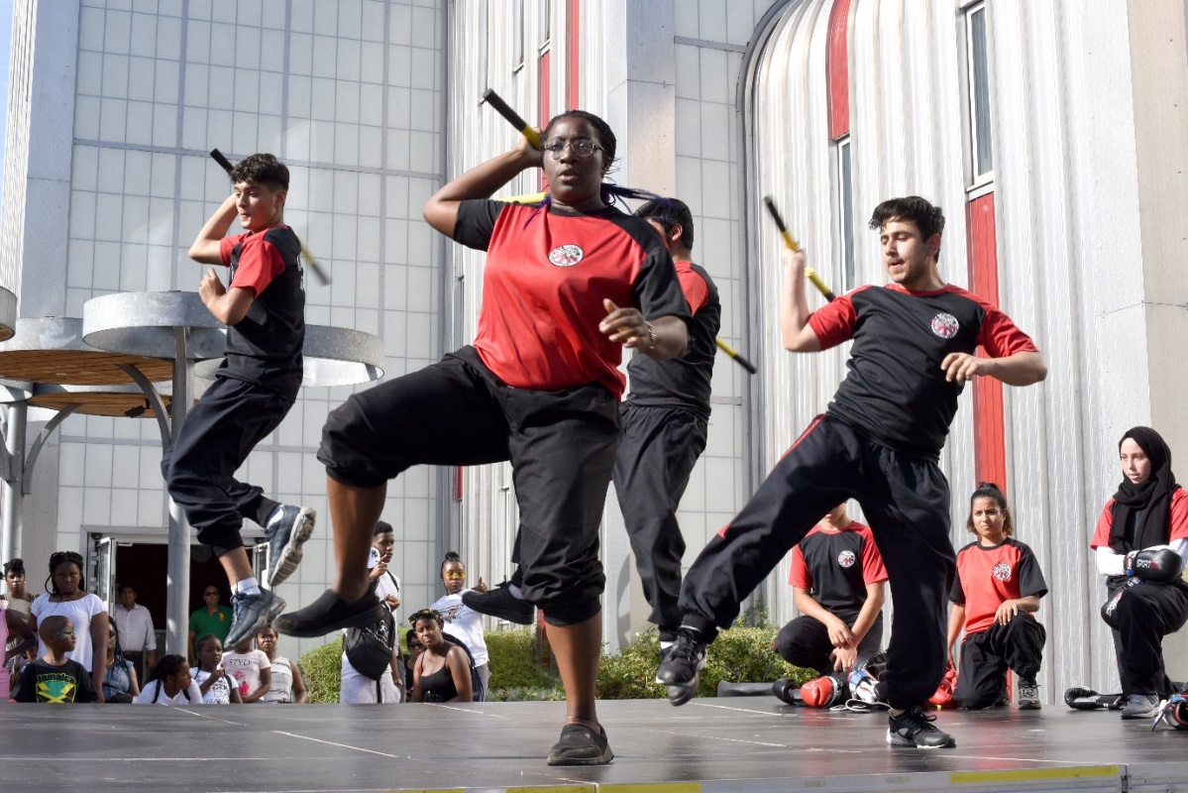

Introduction
Brent Council has identified the need for an Alternative Provision Free School with an Integrated Youth Offer. The school will operate from the Roundwood Centre in Harlesden. The intention is that this new school will open by September 2020.
Under Section 6A of the Education and Inspections Act 2006 (the ‘Free School presumption’), where a local authority identifies the need to establish a new school it must, in the first instance, seek proposals to establish an academy.
The authority is, therefore, seeking proposals from appropriate sponsors to open a new Alternative Provision Free School that will work in partnership with the voluntary sector to deliver an integrated youth offer providing positive diversionary activities for young people, pre and post school-day enrichment, as well as weekend and holiday programmes. It is envisaged that the school will provide places for 30 – 40 young people up to a maximum of 50, if there is sufficient local demand. Places will be open to boys and girls from year 7 (11 year-olds) to year 11 (16 year-olds).

The new Alternative Provision Free School with an Integrated Youth Offer will play a key part in the council’s strategy to safeguard vulnerable young people and ensure they achieve positive outcomes. As an alternative to mainstream education, this new provision will offer a unique approach for young people who may be disengaged in a formal school setting, supporting them to fulfil their potential in a different environment.

Brent context and local need
Please see the published Alternative Provision Free School with an Integrated Youth Offer Specification and the Equalities Impact Assessment for further information.

Presumption process
An indicative timescale for the Free School presumption route is outlined below. An information event for potential sponsors will be held at the Roundwood Centre on 15 July 2019.
Proposals must be submitted by 12.00 (noon) on 21 August 2019, using the Brent Free school presumption application form.
Proposals will be assessed by a panel against the criteria published within the Brent Assessment Criteria document. These should be read in conjunction with the specification. Each of the sections in the application form will be scored using the following 4-point scale:

1 = The evidence and argument contained in the application is ‘inadequate’.
2 = The evidence and argument contained in the application is ‘adequate’.
3 = The evidence and argument contained in the application is ‘good’.
4 = The evidence and argument contained in the application is ‘excellent’.

Shortlisted proposers will be invited to an interview with the Assessment Panel on 17 September 2019, at which they will be asked to make a short presentation outlining the features of their proposal.
Once all proposals have been received, Brent Council will send details of all applications to the Department for Education (DfE) and will seek the DfE’s views on the applications to inform Brent Council’s assessment. Brent will submit details of the council’s assessments to the Secretary of State for Education and inform the Secretary of State of Brent’s preferred sponsor by 30 September 2019.
The Regional Schools Commissioner (RSC), on behalf of the Secretary of State for Education, will consider Brent Council’s assessment before deciding whether or not to approve the council’s recommended proposer. The RSC will inform the local authority and the successful proposer of the decision, and Brent Council will inform any unsuccessful proposers.
Activity | Timescales
Competition period (8 weeks) | 10 June - 21 August 2019
Information event for potential sponsors | 15 July 2019
Assessment of proposals, including due diligence | 21 August - 30 September 2019
Interviews with shortlisted sponsors | 17 September 2019
Secretary of State approval (delegated to Regional Schools Commissioner) | By mid - December 2019
Pre-opening phase, including statutory 6 weeks consultation by provider | December 2019 – April 2020
Alternative Provision with youth offer opens | By September 2020

Proposers are responsible for obtaining all information necessary for the preparation of the application. All costs, expenses and liabilities incurred in connection with the preparation and submission of an application shall be borne by the proposer. Proposers will acknowledge upon submission, that they have satisfied themselves that they fully understand the requirements as set out in these instructions to proposers, the Specification and application documents and any clarification or additional information provided in response to any query.
Proposals must be returned by 12:00 (noon) on 21 August 2019 via the London Portal –https://procontract.due-north.com/Opportunities/Index?p=2241eb95-058a-e511-80f7-000c29c9ba21&v=1
Any proposal submitted after 12:00 (noon) on 21 August 2019 will be regarded as a late application, and therefore will NOT be considered (except in exceptional circumstances and at the discretion of Brent Council).
The following should be included in each proposal submission:
- Free School Presumption Application Form
- Financial model
Completed application forms should:

- be between 50 - 75 pages
- be formatted for printing on A4 paper
- be completed in Arial 12-point font
- include page numbers
- be in Word and Excel files – not PDF
- not include any comments or tracked changes
- not include photographs or maps
- include a financial plan, either within Section F on the application form, or in an Excel spreadsheet.

Annexes are excluded from the page limit and should be restricted to CVs of key individuals. Submission should not be larger than 9 megabytes.
If proposers require further information, or have questions in connection with any of the documents related to this Free School proposal, or these instructions, please contact Sarah Miller, Head of Inclusion within Brent’s Children and Young People’s Department, via the London Tenders Portal message system. All reasonable endeavours will be made to answer enquiries made no later than 14 August 2019. Please note that enquiries sent by means other than the London Portal’s message system will not be accepted. All questions received via the Electronic Tender Facility’s message system by 9 August 2019, together with the answers, shall be circulated in writing via the message system to all proposers, (on an anonymous basis), or to the affected proposer as appropriate, as and when any questions arise.
NB: This local authority led Free School presumption is a different route from the current window for the DfE’s Free School programme, for which some councils have already submitted a proposal. Brent is not one of these councils and hence, any new Alternative Provision Free School in Brent needs to follow the local authority presumption route. DfE guidance on the Free school presumption route is here:
https://www.gov.uk/government/publications/establishing-a-new-school-free-school-presumption

