GUIDANCE FOR REGISTRATION, APPLYING AND RESPONDING TO CONTRACT OPPORTUNITIES ON THE E-TENDERING SYSTEM.

    - Applicants must first register on the Councils e-tendering system EastMidsTenders (if they have not already done so) at https://www.eastmidstenders.org

    - To Register:
On the opportunities portal home page (https://www.eastmidstenders.org) there is an option to 'Register' link in the top right hand corner of the screen, click this to begin the registration process, which is step by step where you need to enter your details and your own company's' details.

Further information can be found in the user guide ‘how to do business on the portal' which can be found in the 'Help' section at the top right of the homepage. Once you have received the 2 system generated emails confirming your username and password you can search for new opportunities from the supplier home page.

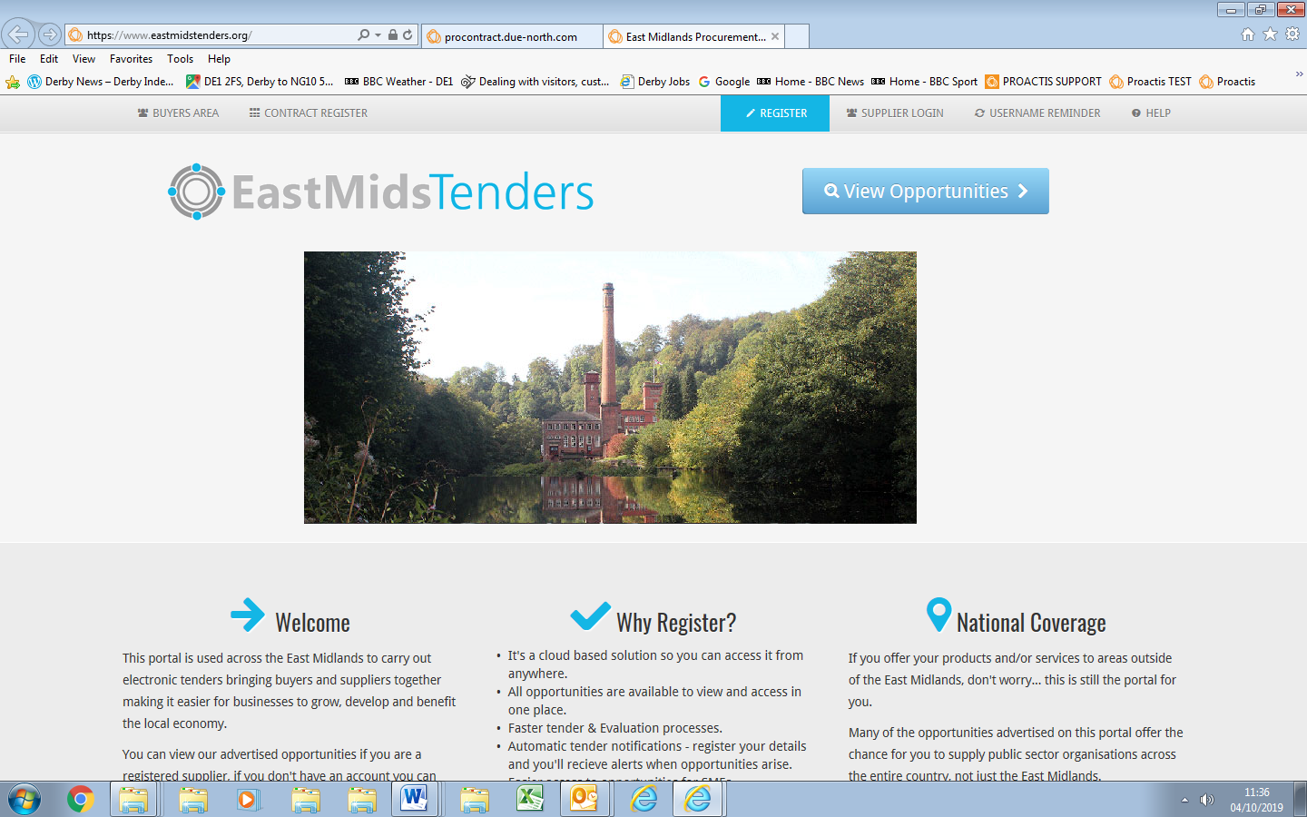

The portal provider should then confirm registration within two working days.

If you experience any issues with the system, and the online help tools cannot assist, please contact the Proactis Technical Support Team:

- Email: ProContractSuppliers@proactis.com
- Phone: 0330 0050352
- Supplier Support Portal https://proactis.kayako.com/default.

The Council is unable to help with the registration process as it does not control this or have any access to this part of the process.

    - To Search for the Opportunity:
On the opportunities portal home page (https://www.eastmidstenders.org), Click on 'view opportunities’. On the 'Find Opportunities' page you can narrow your search.

The "Organisation" field allows the organisation you are searching on to be chosen. Click the arrow to bring a dropdown menu displaying the various organisations. Select 'Derby City Council', then click on the 'Update' button to return the results. This will then return all the opportunities that are applicable to Derby City Council.

You can narrow the search further using the 'keyword' option – use the tender reference, for example 'TD1480’ (Telecare DPS). To view the further details of the opportunity, click the corresponding contract title and click on the 'Register Interest in this Opportunity' button. Read the documents particularly the Application document to understand what is required and the application process.

    - Electronic Submission:
Once you have registered your interest, the procurement information will be moved to, and can be found on, the ‘My Activities’ page on the EastMidsTenders page once you are logged in. You will need to complete and submit the online questionnaire.

See attached document for further guidance on completing the online Suitability Questionnaire. '

