Blackpool Community Opportunity

Revoe Library (First and Second Floor)
1 Revoe Street, Blackpool FY1 5HN

- Location

The property is situated in the residential area of Revoe with close proximity to both Central Drive only 500 meters from Blackpool Tower.

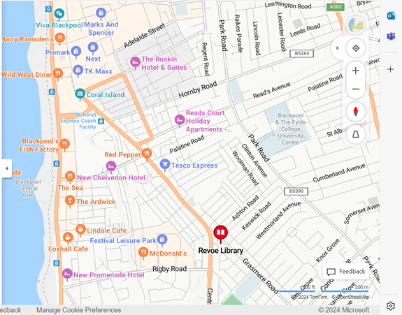

- Site description
The property comprises 322 square meters of first and second floor accommodation, which is currently used by a local Judo Club. The space benefits from a large hall, male & female changing facilities and small kitchen area/breakout space. The property has its own access via a separate entrance and stairs on the eastern elevation of the Revoe Library building.

- Opportunity and Use

The property is suitable for community opportunities and a variety of uses will be considered. Tenant will be responsible for gaining any necessary planning consents.

- Term

A contracted out Lease will be on offer to the successful applicant commencing September 2024 on an internal repairing basis. Terms can be flexible and will be negotiated with the successful applicant.
The Tenant will also be liable for meeting all other outgoings to include utilities and Business Rates.

The Councils legal fees and surveyors costs to be paid by the successful applicant.

- Timescales
Application closing date Midnight 7th July 2024
Applications assessed w/c 8th July
Organisations notified of outcome TBC
Deadline for receipt of clarifications 1 week prior to application deadline
Any clarifications must be sought no later than one week before the application closing date. For any enquiries please contact: Robbie Metcalfe MRICS, Estates Surveyor at estates.enquiries@blackpool.gov.uk or 01253 478742.
- Assessment Process

Interested parties should submit an application which will be assessed by a panel of officers from Blackpool Council. Applications will be assessed using the headings outlined below.

- Proposed Use / Current Delivery / Proposed Use
Examples of what we’re looking for:
What you are proposing to use the site for? Will it have a unique appeal and be different from what Blackpool already has to offer? What will it look like? How noisy will it be?
Provide information about any community opportunities you currently operate.
Provide information that will help us understand your business, its vision, aims and objectives and what type of organisation you are.
You may support your response with drawings / specifications or photographs showing your proposal.
Please insert your response below:

- Staff Management and Community Benefit
What we’re looking for:
Information on your management approach in relation to staffing.
What benefits could your proposal bring to the wider community?

Please insert your response below:

- Finances
In this section we require a cash flow projection. Please include descriptions and any assumptions you’ve made to support the forecasts.
Information about what capital investment you will be making.

Please insert your response below:

- Rent Proposed
Provide a profile of the rent that you will pay to the Council over your proposed term if successful.

Contact Details and Declaration
- I declare that to the best of my knowledge the responses submitted and information contained in this document are correct and accurate.
- I declare that, upon request and without delay I will provide the certificates or documentary evidence referred to in this document.
- I understand that the information will be used in the selection process to assess my organisation’s suitability.
- I understand that the authority may reject this submission in its entirety if there is a failure to answer all the relevant questions fully, or if false/misleading information or content is provided in any section.
- I am aware of the consequences of serious misrepresentation.

Section 1 | Contact details and declaration
 | Question | Response
1.3(a) | Contact name
1.3(b) | Name of organisation
1.3(c) | Role in organisation
1.3(d) | Phone number
1.3(e) | E-mail address
1.3(f) | Postal address
1.3(g) | Signature  (electronic is acceptable)
1.3(h) | Date

If the preferred bidder fails to obtain planning permission for their proposed use, the Council reserves the right to make an offer to the next highest ranking bidder but may choose to re-advertise the opportunity.

NB please retain a copy of this form for your records and should your circumstances or contact details change then please let the appropriate contact officer know.
Any information you provide on the form will be held by Blackpool Council for the purposes of assessing the application and decision making process. If successful it will be held for the term of the lease. If unsuccessful it will be held for 5 years.

Please Note: The information provided in this document is set out as an outline only, for guidance and does not constitute nor constitutes part of an offer or contract. All descriptions, dimensions, references to condition and other details, are given in good faith and believed to be correct, but all interested parties should not rely on them as statement or representation of fact, but must satisfy themselves by inspection, enquiry or otherwise as to the correctness of each of them.

