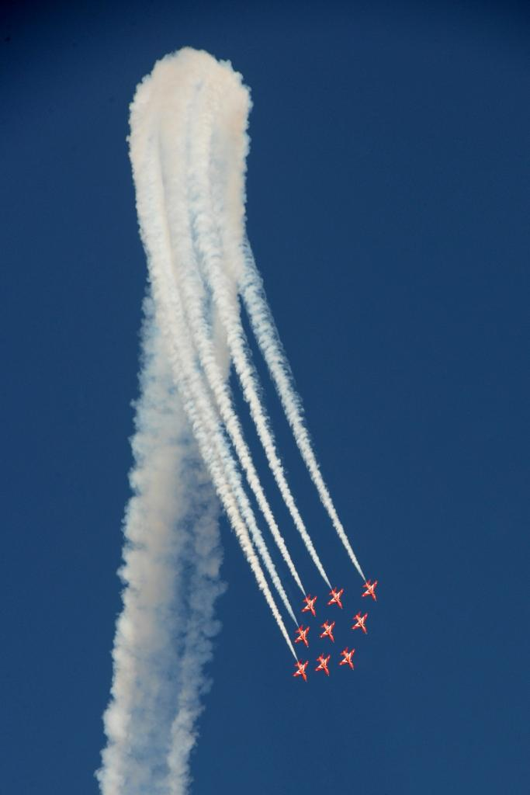
23 and 24 June 2018
EXPRESSION OF INTEREST FOR CATERING AND BAR CONCESSIONS
Expressions of interest to be submitted by 11am 20 February 2018

WESTON AIR FESTIVAL

Weston Air Festival is an annual international air show organised by North Somerset Council in partnership with the Weston-super-Mare Armed Forces Day Committee, Town Centre Partnership and Town Council.

The festival has two days of flying displays, as well as a host of attractions on the ground including trade stands, catering and refreshments, arena displays, rides and activities, an Armed Forces village, and a static display of helicopters and military vehicles.

Taking place on Saturday 23 and Sunday 24 June and now in its sixth year, the event continues to grow year on year. The festival attracts around 170,000 visitors to the town from around the country, as well as a substantial local audience. Free entry to the site encourages visitors to increase their spend whilst enjoying the many attractions.

The pedestrianised event site is on Weston-super-Mare seafront with over half a mile of beach lawns hosting the trade and catering stands, bars, exhibits and activities, and display arena. The seafront also boasts a huge expanse of sandy beach and a wide attractive promenade. Each year the festival attracts a wide range of traders and exhibitors, offering something for everyone who visits the event.

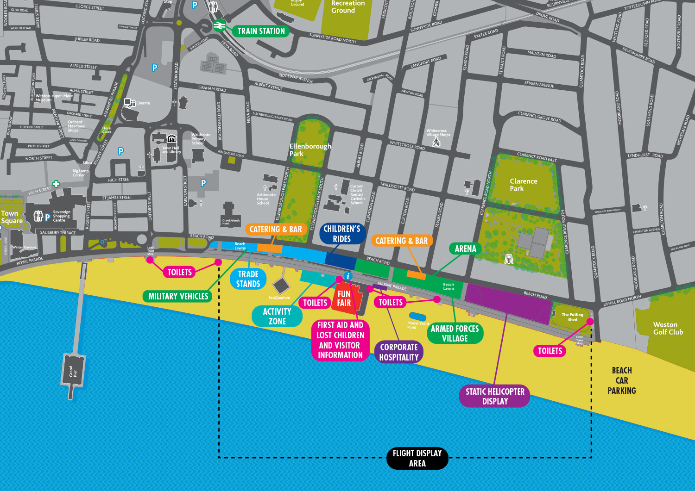
WESTON AIR FESTIVAL SITE MAP

Concession Opportunity
  - North Somerset Council invites you to submit your proposal for the provision of either of the following concession opportunities for the Weston Air Festival on Saturday 23 and Sunday 24 June 2018
- Licensed Bar provision
- Catering outlets
If you are interested in submitting for both opportunities, please submit two separate applications

  - The sites will be offered in the areas indicated on the site map. The scope of the concession opportunities are set out below:

Licensed Bars
The sole rights to licensed bar provision, from two pitches within the event site on the Beach Lawns.

The bar operator will be required to apply for a Temporary Event Notice (TEN) as the site’s current Premises Licence does not include sale of alcohol. This application can be completed online and submitted directly to the council’s Licensing Team. The cost for a TEN is £21. For more information on this licence please refer to the council’s website: Temporary Event Notice

Catering outlets
The provision of 10 large and 5 small units offering a variety of food and beverage options. The council has a preference that at least one of the units will provide a speciality or healthy eating option.

The concession for the catering outlets will be let to one supplier/consortium. The council will not accept applications for individual units. Please note that the council, at its sole discretion, may subsequently grant licences to a number of small individual units which it considers would complement the overall catering offer such as specialty ice creams or fresh fruit stalls.

Further information - both opportunities
The operator is required to make arrangements for the removal and disposal of waste generated by their operations.

Drinking water supplies will be provided via a standpipe located in the vicinity of the units.

Upon award of a concession the operator will need to provide:

- Evidence of food safety certification
- Electrical and gas test certificates as applicable
- Confirmation of public liability insurance cover of a minimum of £5million
- A risk assessment to cover set-up and operation of the bar/catering units
- A completed health and safety questionnaire to be provided by North Somerset Council

All operators will agree to abide to the Air Festival Terms and Conditions as set out in Appendix 1.

Payment
Invoices will be issued in April 2018. Any invoices not paid within 28 days will result in the forfeiture of your application.

Timetable
  - The table below outlines the indicative timetable for this opportunity. The council reserves the right to change this timetable.

STAGE | DEADLINE
Submission of Expression of Interest | 11am  20 February 2018
Council evaluate submissions | Late February 2018
Award notification | w/c 5 March 2018
Submission of all supporting information by successful suppliers | 31 March 2018
Invoices issued and payment due | April 2018
Event days | 23 and 24 June 2018

Expression of Interest Submission
  - Submission of this document must be with the council no later than 11am on Tuesday 20 February 2018 and submitted via the portal www.supplyingthesouthwest.org.uk.
If you are not currently registered on the Portal you will need to do so in order to apply for this opportunity. Registration is free and once registered you can opt to select notifications of opportunities being let by other councils that may be relevant to your business areas. A link to the registration screen is provided on the front page of the Portal. Please allow a few days for the submission and completion of your registration.

If you are new to using the portal, please take the time to familiarise yourself with it.

If you have any queries regarding this opportunity please email events@n-somerset.gov.uk or use the messaging section on the portal www.supplyingthesouthwest.org.uk to log your query.

  - Any submissions received after the specified deadline will not be considered unless the closing date is formally extended by the council and communicated. Submissions received after the closing date may be considered in exceptional cases where submission is not possible for reasons outside of the applicants control, however this will be permitted only at the discretion of North Somerset Council and their decision on this will be final.

Supplier Support
  - ProActis who provide our procurement portal also offer supplier support. For all support issues Bidders should in the first instance log their query via the following email:
- ProContractSuppliers@proactis.com
  - If the query is of a time sensitive nature they also have an Emergency Contact number:
- 03300 050352
  - In the first instance Bidders should log their call using the email address.

Compliant Submission
  - Before evaluating your submission the council needs to satisfy itself that you meet its minimum requirements.
  - Please answer all of the following questions and provide evidence if requested. Failure to answer any of the questions below will automatically disqualify your bid. In addition should a contract be awarded and it is subsequently discovered that these questions were not answered accurately it could render the contract void.
Questions 5.3 – 5.9 are a Pass / Fail requirement unless otherwise stated |  | Please reply using “Yes” or “No”
 | Acceptance of the Terms and Conditions - Has your quotation been submitted according to the Air Festival Terms and Conditions?
 | Insurance - Will your organisation have Public Liability Insurance not less than £5 million in place before any contract is signed?
 | Insurance - Will your organisation have Employer Liability Insurance not less than £5 million in place before any contract is signed?
 | Collusive tendering – Have you discussed and/or agreed your submission with any other bidders or third party?
 | Canvassing – Has any person employed by your organisation canvassed any member, employee, agent or contractor of NSC in connection with the award of this contract?
 | Health and Safety - Does your organisation have a Health and Safety Policy?
 | Equality and Diversity - Please confirm that you will comply with all legislation, official guidance and codes of practice relating to equal opportunities, including but not limited to The Equality Act 2010.

Evaluation criteria
  - The council will evaluate all submissions on the basis of what is the most economically advantageous to it. It proposes to take into account both quality and price. Submissions will be evaluated according to quality and price at the following ratio: 50% price/50% quality.
The submission offering the highest price will be awarded 50 marks, all other submissions will lose 1% of 50 for every 2% that their offer is lower than the highest.

For example if the highest bid received was £12,000, it would be awarded 50 marks, a lower bid of £10,800 would be awarded 47.5 marks.
(£10,800 is 10% lower then £12,000. 10/2 = 5. 50-5%=47.5).

Quality Evaluation
  - Please respond to each of the questions in the table below. You may submit the information in an alternative document but please clearly cross-reference any submission to the questions.
  - The weighting of each question is indicated in the table.
Question |  | Weighting %
1 | Type of units and brief descriptions, including sizes and type  Please also include pictures of the units proposed. | 25%
 | [Bidder response]
2 | Range of items on offer and prices.  Please note in respect of catering units preference will be given to the inclusion of one or more units providing speciality foods and healthy option alternatives. | 15%
 | [Bidder response]
3 | Please provide brief details of other event experience | 10%
 | [Bidder response]
 | Total | 50%

NB - Please answer all of the questions. Failure to do so will usually mean that you will not be successful as we will be unable to fully assess your suitability.

  - The quality evaluation will be scored using the following matrix:
Score | Marking Guidelines
0 | Fails to meet requirements or response entirely unsatisfactory to the scope of the requirement.
1 | Inadequate - Where offer meets very few aspects of the requirement, and is in the main considered unsatisfactory.
2 | Limited - Meets requirements in most respects but missing some key elements. Lacking in detail and/or examples
3 | Acceptable - Meets basic requirements with minor reservations on overall offer
4 | Good - Answer that meets full requirements.

Please note that the council reserves the right to reject any submission scoring 1 or less in respect of any of the quality questions.

Price Submission
  - Please complete the pricing schedule below. A minimum price per concession opportunity has been provided
Concession opportunity | No of units | Minimum Price  (£) | Your Bid Price.  (£)
- Licensed Bar Provision | 2 | £2,500
- Catering Concessions | 10 Large and  5 Small | £10,000

  - The council will not be bound to accept any submission received and reserves the right to accept all or any part.
  - The council will not be responsible for any expenses or losses incurred in the preparation of this quotation.

Bidder’s details:
  - Please complete the following table in support of your submission.
Question | Response
Concession opportunity applying for

Full name of the potential supplier submitting the information
E Mail address

Contact Telephone Numbers

Registered office address (if applicable) or contact address

Registered website address (if applicable)

Trading status
a) public limited company
b) limited company
c) limited liability partnership
d) other partnership
e) sole trader
f) third sector
g) other (please specify your trading status)
Company registration number (if applicable)

Charity registration number (if applicable)

Registered VAT number

Trading name(s) that will be used if successful in this procurement
Relevant classifications (state whether you fall within one of these, and if so which one)
a) Voluntary Community Social Enterprise (VCSE)
b) Sheltered Workshop
c) Public service mutual
Are you a Small, Medium or Micro Enterprise (SME)? | Yes ☐  No ☐

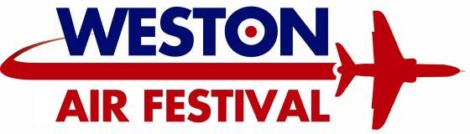
Appendix 1
Terms and Conditions
23 and 24 June 2018

Booking and Payment Terms
  - Bookings will only be made on receipt of your completed application form, health and safety questionnaire, risk assessment and a copy of your relevant public liability certificate (minimum £5 million cover). Incomplete applications will not be processed.
  - A photograph of your trade stand must accompany all applications for exhibition space.
  - The organiser reserves the right to refuse an application for trading at their discretion.
  - Once your booking has been confirmed in writing, an invoice will be raised and sent to you for payment. All invoices are raised on a strict 28 days term.
  - Please see the reverse of the invoice for payment terms and details of how to pay.
  - All pre-payments are non-refundable.
  - If your invoice remains outstanding after 28 days and payment is not received your company details will be placed on the council’s ‘Bad Debtor List’ for any future events. In this instance the organiser reserves the right to cancel the exhibitor’s space without further notice.

Cancellation Policy
  - Once the invoice for pitch fees has been paid no refunds will be given.
  - All cancellations or reductions in stand spaces must be received in writing to the organiser.
  - If an exhibitor fails to occupy the site by the time required on the day of the event the organiser reserves the right to re-allocate the site. No refund will be given in this instance.

Space
  - The space booked must include sufficient room for all guy ropes, tow bars, foldout flaps on units, tables and chairs, accessories and equipment required for the exhibition.
  - The organiser reserves the right to change the layout and location of the exhibition space without prior notice.
  - You will be allocated your space on arrival. Change of space on arrival or during the event is not permitted under any circumstances.

Electricity
  - The organiser will not provide electricity supply to any stand and the following rules and regulations must be adhered to:
  - Any generator brought onto site must be a super silent diesel generator.
  - The exhibitor must ensure the generator is switched off before refuelling.
  - The refuelling of a generator must be carried out by a competent person.
  - Exhibitors must ensure spill mats are provided and used during refuelling.
  - All outlets must be protected by RCD.
  - It is the exhibitor’s responsibility to ensure generators are placed in a fenced area separate to the public.
  - The exhibitor must ensure the generators are well maintained and in good working order with no leaks or excessive fumes.
  - The organiser reserves the right to demand removal of any generator that does not comply with these terms or meet basic health and safety requirements.
  - Only sufficient fuel for one day’s trading may be allowed on site at any time and this must be stored in the correct containers in a safe environment.
  - Any generator coming onto site must be rated below 62dBA as a minimum requirement.
  - There is a minimum requirement of a 2kg CO₂ fire extinguisher for any stand with electricity which will be checked on site.

Security
  - Overnight security will be provided on the Friday and Saturday nights. Should additional security be required this can be provided at an additional cost to the exhibitor through our contracted supplier.
  - Personal items left on stands are done so at the owner’s/exhibitor’s risk. The organiser takes no responsibility for items left unattended or for the security of the exhibitor’s property.
  - The organiser reserves the right to undertake security checks as deemed necessary and to refuse entry to vehicles or personnel at their discretion.

Litter
  - It is the exhibitor’s responsibility to remove litter from their immediate area and to keep their area tidy.
  - All rubbish must be cleared from your site at the end of each day and put in the relevant recycling areas or in the large bins provided by the council’s waste contractor.
  - Any rubbish not cleared away at the end of the event will be photographed as evidence and then a charge will be made to you as a fine.
  - Cardboard waste needs to be flattened and placed in the areas provided. Exhibitors must not place boxes in the public bins.
  - Exhibitors who leave litter will be charged a litter fine and this may jeopardise any future trade application by the exhibitor.
  - Black sacks are to be used for rubbish. These are to be provided by the exhibitor.

  - Any used cooking oil should be removed from site. Under no circumstances should oil be disposed of in flower beds, drains, etc. Any such action will forfeit the exhibitor’s right to attend future North Somerset events.

Access
  - Set up details for trade stands will be included on the Exhibitor Instructions that will be sent to you once your application has been approved.
  - All deliveries to stands must be made between 06:00 and 09:00 hours on the mornings of the event. Delivery vehicles will not be allowed access onto the site after this time. All vehicles must be off site by 09:00 hours.
  - A banks man must be provided when reversing any vehicle.
  - There is no provision for parking on site. Once set up is complete all vehicles must be moved off site to the trade parking area.
  - A speed limit of 5mph is in force whilst on site and vehicle hazard lights must be used at all times.
  - Exhibitor passes need to be collected from Trade Area Marshals upon arrival for set up.

Health and Safety
  - It is the exhibitor’s responsibility to comply with all health and safety and fire legislation.
  - Public liability insurance of a minimum of £5 million is required. This must be submitted at time of booking.
  - Should the exhibitor’s insurance documents not cover the event date, the current form should be submitted with the replacement document being sent once it comes into force. In these cases the replacement document must be received prior to the event start date.
  - The exhibitor is responsible for all equipment brought onto site and for ensuring all insurances are obtained and contractual obligations are met.
  - The exhibitor is responsible for all stand conduct, public handling of exhibits, all consequential and other injury or loss.
  - The exhibitor shall not do anything to jeopardise the organiser’s insurances or licences in connection with the exhibition.
  - The exhibitor will indemnify the organiser in respect of loss or damage to the premises or property.
  - Exhibitors participate at their own risk.
  - All exhibitors must hold suitable and sufficient fire-fighting equipment at their stand and all staff must be trained in its use.
  - Marquee structures must adhere to fire regulations and must be securely and safely constructed.
  - The organiser reserves the right to request that an exhibitor leaves the site for any reason, or close any exhibit that is deemed unsafe or a risk to the general public, or that does not conform to the rules and conditions. There will be no entitlement to refunds in this situation.
  - In the case of an emergency please notify one of the organisers immediately. Ensure that all persons are removed in a calm and effective manner and access routes left clear for the emergency services.
  - The organisers will monitor health and safety for the duration of the event. Visits will be made throughout the event to ensure that stands comply with all terms and conditions.
  - All exhibitors must complete the health and safety questionnaire in full along with a risk assessment and supply the necessary documents.
  - Gas appliances must be fully tested and relevant certificates available on site for inspection.
  - Exhibitors are responsible for all third parties associated with their stand and for ensuring relevant insurances are held.
  - Exhibitors using equipment and machinery during the event must ensure that suitable guards and safety devices are in place. All machinery must be properly maintained in accordance with the Provision and Use of Work Equipment Regulations 1998 (PUWER).
  - It is the exhibitor’s responsibility to ensure that the public have no access to any hazardous areas.
  - New regulations with effect from 13 December 2014 makes it a requirement for caterers to provide information and to answer any questions from customers about any allergy risks associated with the foods they produce or sell. For more information please visit http://www.nsomerset.gov.uk/business/Food/Pages/Food.aspx.

General Exhibition Site
  - Exhibitor Instructions will be sent out to you with other documentation prior to the event.
  - Traders and exhibitors are expected to provide their own marquees and exhibition stands. These should be risk assessed by you and meet all health and safety standards. A copy of your risk assessment and a separate fire risk assessment must be supplied before you are allowed on site to ensure that you comply with the Regulatory Reform (Fire Safety) Order 2005.
  - The organiser accepts no responsibility for loss or damage from an error in appointment of space or encroachment by one exhibitor into the space apportioned to another.
  - No requests can be made for stand locations. Sites will be allocated on arrival at the organiser’s discretion.
  - Sub-letting or sub-contracting of exhibition space is prohibited.
  - The organiser reserves the right to refuse or cancel entry with good reason.
  - The organiser may decline proposed exhibits or order removal of, or remove without reason. It is the organiser’s discretion on any refund.
  - Stands and exhibits are expected to be of a high standard. The organiser reserves the right to remove any unsuitable stands.
  - No balloons of any kind are to be given away, sold or used to decorate a stand at the Air Festival.
  - The use of microphones or amplifiers on stands is prohibited. The organiser reserves the right to demand removal if found on site.
  - No roaming sales or sampling is allowed unless previously agreed by the organiser.
  - Exhibitors must man stands during the opening times of the event.
  - Exhibitors are not permitted to call out from their stands.
  - Exhibitors must leave their site in the condition they found it in. The organiser will charge the exhibitor for the repair of any damage caused.
  - No obstruction of gangways or open spaces is allowed. No signs or projection may be hung over gangways or open spaces or in any way affect neighbouring displays.
  - The organiser will not provide any storage for equipment or stock.
  - The exhibitor is responsible for ensuring that all goods sold on stands comply fully with UK and European Consumer Laws with regards to safety, fair trading, price display, food and weights & measures. Any services provided and statements about services provided should comply with trading standards legislation. Trading standards advice can be found on http://www.businesscompanion.info/
  - On no account should any goods be sold that infringe any copyright or trademark.
  - The exhibitor is responsible for any faulty or mis-described goods sold by them. The organiser accepts no responsibility for any contractual liabilities of the exhibitor. In the event of a contractual dispute the exhibitor’s business details will be passed to the ‘injured’ party.
  - Exhibitors are required to display full details of the business owners on stands.
  - Exhibitors are advised to take out cancellation cover. The organiser is not liable for refunds or compensation in regard to the event including cancellation or curtailment for any reason beyond the reasonable control of the organiser.
  - No food, confectionery or drink may be sold or given away from your stand unless previously agreed with the organiser.
  - No kites may be displayed, sold or given away from stands except in a packed condition and provided a notice is displayed to advise ‘No flying of kites during the air festival’.
  - No unauthorised goods as described below may be displayed, sold or given away from your stand: refreshments (unless previously agreed), balloons of any description, items deemed as weapons (knives, crossbows, airguns or catapults), livestock, live fish, caged birds, dogs, pets, lottery, raffle or gaming tickets, event branded souvenirs, tobacco products, adult toys or games, radio or radar equipment (without prior authorisation), age restricted products or any item deemed unsuitable by North Somerset Council or the Police.
  - Each exhibitor must have an exhibitor pass for identification whilst on their stand.
  - North Somerset Council will work closely with Trading Standards throughout the event, and will supply information on exhibitors if requested. All goods sold on council land must be of marketable and satisfactory quality, and comply with all Trading Standards legislation.
  - A condition of your booking is that you comply with any requests from officers employed by North Somerset Council relating to the safety, hygiene and admittance of the public to your stand.
  - Please note, North Somerset Council will not be liable for any loss of earning, or any other losses incurred as a result of the event for any reason being cancelled or abandoned.
  - North Somerset Council reserves the right to have exhibitors on site who give away free samples of food, drink or any other products at the event.
  - An official souvenir programme will be published prior to the event. If you wish to advertise in the programme please contact our Marketing Team on 01934 427 561 for competitive rates.

