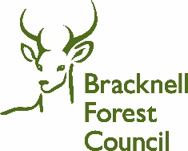
Request for Information: Bracknell Forest Charging Network Provision

This is a soft market test to engage possible suppliers in advance of procuring a contract or contracts for a comprehensive residential and destination EV charging network across Bracknell Forest Borough.
Overview of Work to Date and Aspirations
Strategic Context
Bracknell Forest Council has been exploring and investigating EV charging solutions since 2015, when we installed our first public-use charge point in the High Street multi-storey car park in Bracknell town centre. We have since added more chargepoints in this, and other, town centre car parks. During 2021-23, we worked with a commercial supplier to deliver 34 ORCS-funded charging sockets across 12 council-owned Community car parks.
We are now looking to further expand the public chargepoint network in Bracknell Forest, but it is very important we achieve the best solution for the Borough.
Bracknell itself is a ‘new town’, built in the 1950s and 60s around a planned network of roads and community facilities. As such, the town has quite unique characteristics, particularly in the layout of many of its residential streets and associated parking provision – see examples at Annex A. Sandhurst Town and Crowthorne village lie to the south of the Borough and have more traditional housing and street layouts, whilst the north of the Borough is more rural in nature.
Bracknell Forest is a high car-ownership Borough, and despite sustainable transport policies which will aim to reduce car use, we envisage this trend continuing. We have used the National EV Insight and Strategy (NEVIS) tool to roughly calculate the likely number of EVs in the Borough to 2040
 | 2020 | 2030 | 2040
Total predicted EVs in Bracknell Forest | 925 | 31,293 | 79,194

As EV technology has continued to rapidly evolve, we have taken time to reflect on our role in delivering or facilitating chargepoints, and how it sits alongside our day-to-day duties in providing core Council services.
Our approach is summarised in our Electric Vehicle Charging Summary and Guide, which is now evolving into a more formal strategy since its initial publication in April 2021. The guide is hosted on our dedicated webpage, where residents can also take part in an EV survey, helping us to understand demand.
The strategy promotes a chargepoint network combining both residential charging opportunities for those without off-street parking, and destination charging with a mix of fast and rapid chargers at council-owned car parks and leisure sites. We are keen to work with suppliers to provide practical yet innovative solutions for all residents, visitors, and those passing through on the strategic A322, A329 and A3095 corridors.
Chargepoints would need to be a minimum of 7kW. We have used the NEVIS tool to roughly calculate the likely EV public chargepoint requirement in the Borough to 2040
Power rating | 2020 | 2030 | 2040
7kw | 13 | 627 | 1187
22kw | 3 | 48 | 89
50kw | 2 | 23 | 44
150kw + | 1 | 14 | 63

Please Note: These figures are provided as an indication of the total number of public chargepoints required across the Borough and not specific targets for the chargepoint network we are aiming to deliver. We do not anticipate that all of these chargepoints will need to be delivered by the Council, and that the private market will deliver a proportion of these chargepoints. But we hope the majority of the chargepoints up to and including 22kw will be provided via LEVI funding allocated to the council.
Current Position
In adopting our EV strategy, we have engaged with key internal stakeholders (Parking, Property, Highways, Legal, Procurement, Parks & Countryside and Energy teams), along with external stakeholders (Town and Parish Councils, Local Housing Authority – who are a major landowner, local businesses and our Leisure Facility concession operator).
These discussions have helped in forming our approach and give us confidence to proceed in partnership to deliver a more comprehensive solution that we hope, in turn, is attractive to potential suppliers.
Key Aims and Principles
Our overarching goal is to secure a partner or partners to provide investment and collaborate with us on the planning, installing and operation of a substantial borough-wide chargepoint network.
From recent discussions with the Energy Saving Trust we anticipate we could secure LEVI funding in the region of £350,000 to contribute towards the on-street residential element of our charging network.
Our general principle for residential charging excludes charging points located on/in streetlights. Our streetlights cannot support 7kW chargers and are generally located at the back of the footway.
We have identified a list of destination sites where, subject to feasibility, we will be happy for EV chargers to be installed. A list of these sites is provided at Annex B. We would welcome an indication of your interest in these sites, albeit we recognise that any interest will be subject to local DNO connection fees which are unknown at this stage.
It is our intention that any future contract will make provision for our Parish and Town Councils, registered social housing providers who are not-for-profit organisations (housing associations, registered charities etc.), Community Groups, Churches, Village Halls, Schools and any other not-for-profit community landowners within the County to access and make use of the contract via the Council.
Portfolio Approach
We are aware that some sites where individuals and or communities want to see chargepoints may not be commercially viable in the immediate future.
Our aim is therefore to secure a solution that uses the revenue from more commercially viable sites to support the delivery of less commercially viable, but socially critical sites, across the borough.
Garage blocks and parking courts
Many of the neighbourhoods in Bracknell Forest were built with parking courts and associated garages, separate to the main properties (see example image overleaf). The parking spaces are not formally allocated, but equate to roughly one space per property. The garages are a mix of privately owned and those owned by the local housing authority, but they are generally over 50 years old and some are in a poor state of repair. Many of the garage blocks are adjacent to substations.
We would be keen to receive views, ideas and possible solutions from charging providers on a potentially innovative approach to providing chargepoints in the parking courts and garage blocks.
Funding
Our EV Strategy states that any solution must be at zero cost to the council.
Therefore we are aiming to work with suppliers on a concession approach for destination chargers, and LEVI funding for an on-street residential solution.
For the residential network it is our intention to secure a supplier and then work with them to plan the network, combining their knowledge of EV solutions, and our knowledge of communities.
Once the network plan, and a realistic delivery plan is understood, we would work with our supplier to enter a LEVI funding bid.
We believe taking this approach will help us to
- Build a plan that is grounded on EV market knowledge
- Reflect the operating model of the chosen supplier when planning a network, avoiding duplication of effort
- Target funding towards delivering chargepoints that the market would not have been able to provide without it

For the destination charging network although we are offering access to our land assets, under our proposed model the financial risk sits with the supplier.

By adopting a portfolio approach the supplier will be required to use revenue from chargers in prime commercial locations to invest in less commercially viable sites. To achieve this, we recognise that the supplier will require a contract long enough to achieve a realistic return on investment.

However, it is important the solution for the end user is not over-priced, particularly given disparities and equity issues between costs for those who have access to a home charging and those who do not. As such, we wish to have a degree of influence over tariffs to ensure there is parity with the average EV charge price for comparable speeds in the region.

End of contract
It is our intention that, at the end of the contract term the Council will take ownership of both the below ground infrastructure and DNO connection at no cost.
For the purpose of clarity, we will not make any payment in consideration of this title transfer.
We would ask this to:
- secure the long term provision of the chargepoint network in a way that enable residents to benefit from reduced cost of charging
- ensure we comply with concession contract regulations that other operators are able to compete in this space in future once a reasonable value over ROI is reached.

Questions for Prospective Suppliers
- Would you be interested in:
  - Planning
  - Installing
  - Operating
  - Maintaining
the Bracknell Forest publicly accessible EV charging network either:
  - at destinations - via a concession contract
  - in residential areas - funded or part-funded by LEVI

- After engaging with multiple suppliers, we understand that many believed that a 10-year concession contract length was too short to enable return on investment. What would be your minimum, and optimum contract length given the complexity of the contract and semi-rural nature of the Borough? (Please note, we will assume ownership of the underground infrastructure at the end of the contract at no cost, so please factor this to any calculations.) Please explain the reasoning for any differences in contract length.

- Given the mixed rural / urban nature of our Borough, and our aspiration for a good geographical spread of chargers, is our aspiration of a portfolio approach which uses funding to target less commercially viable sites realistic, and would it enable you to deliver a Borough-wide network? We would welcome further comments on this approach.

- Our aspiration is that the network is operated by the supplier with minimum input from authorities. Is this realistic? If not, what role would you like to see the council take on?

- Is it realistic to expect a collaborative approach to plan the EV chargepoint network (especially for the residential element), and then the Council bid for external funding post-tender award?

- Will you be more likely to bid for this tender if we carry out network planning in advance, and secure LEVI funding against it? Please explain your reasoning, and if there would be any additional benefit to us, other than you bidding, for example increasing the profit return to the Council or enabling a reduced contract length.

- Is there any information you would want to see before tender submission, or additional work that would mean you would be likely to bid?

- We understand that all suppliers use different finance models, but we need to find a consistent way of fair comparison of these models, both in terms of return to partners and cost to residents. Would the stipulations of our financial model be a cause for concern and prevent you from bidding? If you have any other suggestions for financial modelling, please let us know.

- Is a target proportion of 30% rapid (minimum 50kw) chargers (the remaining being fast chargers(7-22kw)) across the destination chargepoint network problematic for your business? If so, what would your recommended target proportion be for rapid chargers across the borough for the portfolio network we are aiming to establish?

- We are aware that agreement clauses allowing early termination puts additional risk on suppliers. It’s possible that individual partner landowners may struggle to guarantee alternative sites close to the original, but collectively the partnership could commit to providing a suitable alternative site. Would this be acceptable mitigation against early termination lease clauses? What proportion of the costs would you expect a landowner to cover of this relocation?

- Are you experiencing, or do you foresee, any issues that might impact on your rate of installations, finance models, or any other aspect of your business as a result of the external environment including new trading relationships with the EU and the labour market?

- Are there any other comments that you would like to make at this point? Any learning that refers to your previous experience of installing charging networks would be of interest to help shape the tender.

- What is your normal process for setting the charging tariff? To what degree would the Council be able to influence the tariff to ensure our residents are not overcharged?

- Do your chargepoints accept contactless payment using a bankcard? (so that users are not required to download an app)

- Do your chargepoints, and any associated groundworks, comply with PAS 1899:2022 guidelines for accessibility?

Please note that we are not asking for commercial details or offers at this stage and we are only seeking your thoughts and comments to help shape our procurement process.
Thank you for your response.

Annex A

A typical Bracknell residential Street, with garage blocks visible with lighter-coloured roofs

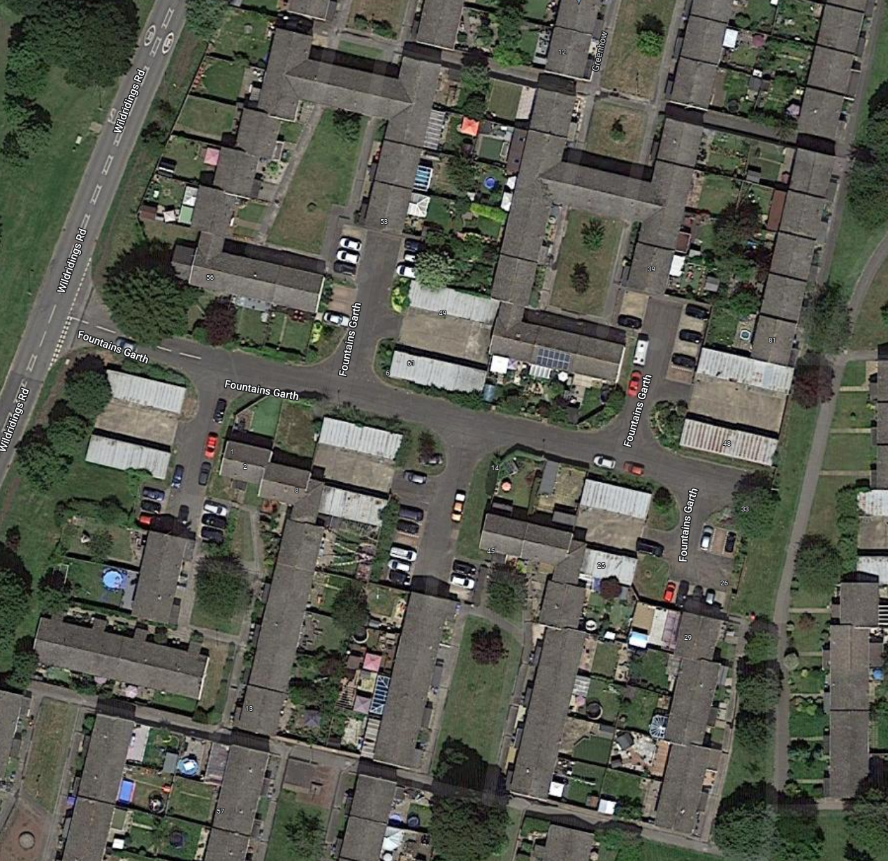

Google links to typical street layouts in Bracknell Forest Council
50 Keldholme - Google Maps
59 Vandyke - Google Maps
61 Ringwood - Google Maps

Annex B – a list of potential destination sites is contained in a separate spreadsheet

