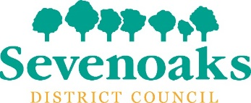

The design and printing of Sevenoaks District Council’s ‘In Shape’ magazine

2 Mini brief

16 May 2022

Design and printing of ‘In Shape’ magazine

- To produce a 24 page A4 size full colour magazine
- The magazine will be bound together with two staples or with glue
- We are asking tenders to provide quotes on two alternative Lots: Lot 1 is 75 gsm environmentally friendly paper and Lot 2 is 75gsm Carbon Neutral Paper.
- The Council will produce up to four issues of the magazine a year.
- The Council will provide the copy and images for the magazine via e-mail.
- The Council will ask for charts and graphs to be laid out as required.
- The magazine will include paid-for adverts. These will be either supplied as finished artwork or as copy and images that will be laid out by the successful company.
- For each edition, the Council will ask for up to five PDF proofs sent by e-mail.
- The Council will produce a production schedule for each edition that will need to be agreed and followed by the successful company.
- Under no circumstances shall the layout or design of In Shape be sub-contracted to a third party.
- The Council will require 57,000 copies of the magazine to be printed for each issue.
- The tender sum should include delivering approximately 1,000 copies to the Council offices in Sevenoaks, 4,000 copies to a local mailing company and approximately 52,000 copies to a Kent-based Royal Mail distribution centre.
- The contract will be for a period of two years and may be extended by a further two years at the Council’s discretion.

