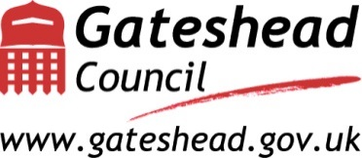

Provider Engagement Forum
Information, Advice & Advocacy contracts

Thursday 11th July 2019 2pm - 4pm
Bewicks B (back of Bewicks restaurant) Gateshead Civic Centre Gateshead NE8 1HH
Pay & Display Car parking at venue

Engagement session for current & potential Providers delivering Information, Advice and Advocacy services.

The session will provide information about the Corporate Review of Information, Advice & Advocacy and involve you in a dialogue about how these services may be delivered in the future in Gateshead.

- How the Council delivers Information, Advice & Advocacy support and services
- The Corporate Review – where it’s at.
- Information Strategy in developent, what you’ve told us so far
- Contract(s) due for Tender, outline of current position
- Share our thinking on what might change & a potetial new delivery model
- Engage with Providers – what do good outcomes look like?
- Outline process and tender timescales
- Address Provider questions
- Provider registration on NEPO for future business/notifications

To confirm your attendance please email: andiparker@gateshead.gov.uk
Any queries: Andi Parker, Commissioning Officer 0191 433 2346
Health & Social Care Commissioning and Quality Assurance
Corporate Review lead Alison Dunn: Strategic Lead for Poverty and Inequality

A Vision for IA&A services:
Gateshead advice services do much more than help people to solve their practical problems, they give people a fair chance, they build skills so people can support themselves and each other, they enable people to fight for a better future and they tackle inequality; they help to make Gateshead a place where everyone thrives.

