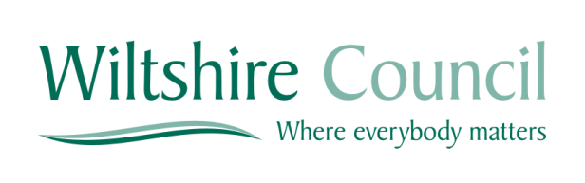

Expressions of Interest for the Provision of
Dementia Services

Wiltshire Dementia Strategy has been developed by Wiltshire Council and NHS Wiltshire Clinical Commissioning Group (CCG) in conjunction with various local partners from the statutory and voluntary sector, as well as through talking to people with dementia and their carers and families about their experiences in Wiltshire.
The main purpose of the strategy is to ensure that people with dementia, their carers and families are able to live well and are supported to do so through being able to access the right services and support at the right time, whether that be from organisations or their local community.

Wiltshire Council along with the CCG in Wiltshire are looking to tender for a Countywide Dementia Service.

A Bidders Day has been arranged for interested parties and this will take place on Monday, 10th October 2016 at 1500 the Council Offices, at County Hall, Bythesea Road, Trowbridge BA14 8JN where there will be an opportunity to receive further details regarding the services that are to be included within the tender. The aim is for tender documents to be issued W/C 24th October 2016.

The procurement process will be run fully electronically. Register free to view further details and documents on the contract opportunity.

This will be a one stage process with no pre-qualification process.

