Specification for technical and feasibility services
Property
Colomendy Outdoor Education, Loggerheads, Denbighshire, North Wales, CH7 5LB.
Location
The premises are situated approximately three kilometres south west of Mold, almost opposite the main entrance to Loggerheads country park on the A494 Ruthin Road. The site is shown as “Kingswood camp” on the Google map below.
Location plan
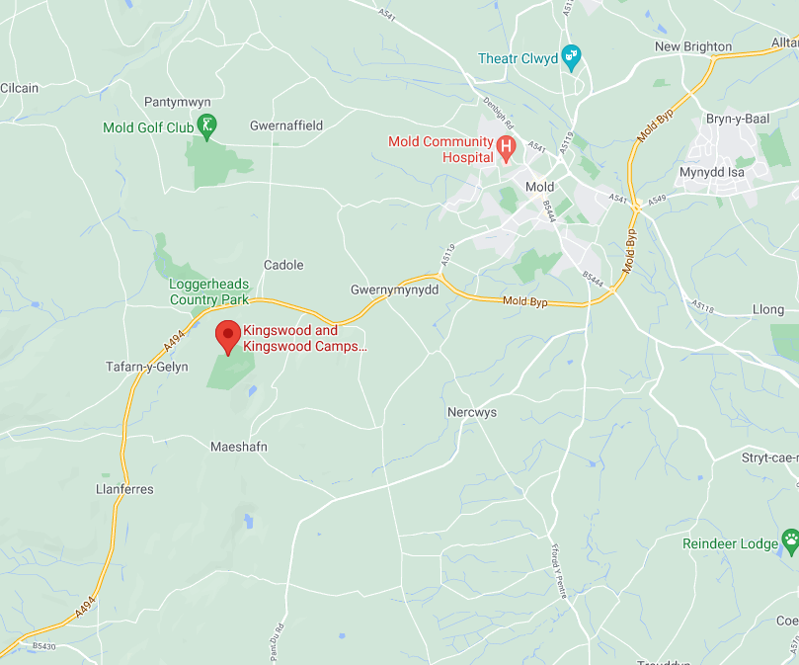
Description
There are approximately thirty-six buildings across nine areas of the site ranging from toilet blocks, dormitories, teaching classrooms, assembly halls and farm buildings of which eighteen are identifiable listed buildings and structures associated with the grade II listed Hall and Hay/Dutch Barn (“the centre”).
The centre is situated within an area of outstanding natural beauty (AONB) and site of special scientific interest. It is surrounded by farmland and woodland.
Further information about the facilities at the centre can be found on the website:
https://www.kingswood.co.uk/activity-centres/colomendy/
Site area
Approximately 130 acres
Purpose
Liverpool City Council would like to procure surveys of the site and premises for the purpose of establishing the overall condition, specifically:

- Liverpool City Council would like to obtain a comprehensive schedule of the asset’s condition with a view to manging and improving the properties future maintenance and management.
- Also, to establish a true reflection of the value in managing the asset’s maintenance and refurbishment with a view to bringing the properties up to a reasonable condition to meet current legislation.
- Preparation of an asset management plan for the premises.
- Outline of the services to be provided with detail on the programme and timescale for implementation.
- Outline any requirements including documentation needed to fulfil the project task.

Background information
Liverpool City Council own the freehold of the land. The centre is let to a third party for a term of thirty years commencing on 07 June 2007. The centre is used for educational training, recreational activities and provides residential accommodation.
Background papers
Lease dated 07 June 2007
Scope of works
The scope of works is to include the following:
Undertake an inspection of the centre and prepare a report including:
Implement condition survey.
- To include scheduling outstanding reinstatement, repair, decorations, and other legal compliance obligations
- Implement fully costed and appraised schedule of repair
- Note structural defects
- To include the physical, mechanical and electrical condition of all buildings within the leased demise
- Identify Health and Safety issues at all premises and across the whole demise
- Devise maintenance strategy; grading requirements on a priority scale

Apply condition survey to preparation of interim dilapidations schedule. The schedule must identify the relevant lease clauses that may have been breached and the estimated cost of remedial works.
Additionally:
- Liaise with the lessee and or their representatives regarding access to the site for the undertaking and management of the required information
- Define the demised premises included landlords’ fixtures and fittings
- Define the obligations for repair, redecoration, and reinstatement
- Document alterations carried out during the lease term
- Note all matters of a planning nature and heritage in relation to listed buildings and conservation area
- Identify the individual buildings in a state of disrepair and provide fully costed schedule for reinstatement to an acceptable standard
- Identify any structural alterations and defects

Price
The tender will be evaluated on Price-Only

