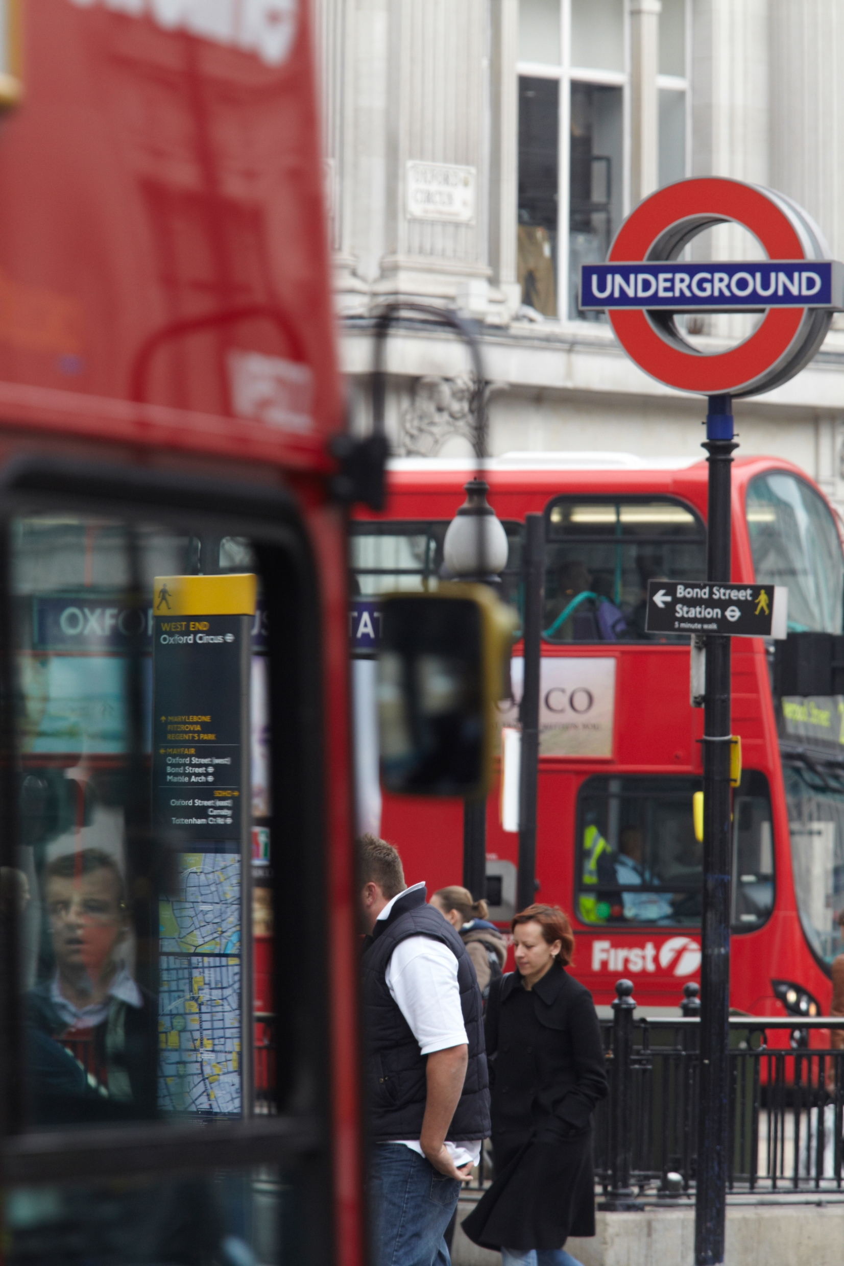
Market Sounding Questionnaire
Unattended Deployable Cameras (UDCs)
- Introduction
This Market Sounding Questionnaire (MSQ) is issued by Transport for London (TfL) and seeks to obtain market feedback in relation to Unattended Deployable Cameras (UDCs). The primary focus is to better understand if suppliers are able to provide such cameras, their capability in relation to the existing camera infrastructure and system, as well as perceived risks and opportunities of such cameras being installed across the Transport for London Road Network (TLRN).

There is a proportion of the Transport for London Road Network (TLRN) where the existing Closed Circuit Television (CCTV) camera network does not have coverage; affecting congestion, safety and bus reliability at those locations. Greater enforcement of bus lanes, banned manoeuvres and yellow box junctions in these parts of the network will reduce congestion and ensure key routes remain clear. This will reduce the number of collisions (supporting Vision Zero outcomes) and congestion (supporting the Healthy Streets agenda).

TfL is trialling four UDCs to: understand the logistics of introducing this new technology; develop end to end (E2E) deployment processes, and monitor how road compliance is affected. Please note, any UDCs would feed in to the existing Digital Traffic Enforcement System (DTES) where moving traffic contraventions are captured and validated (current supplier is SEA). Any resulting Penalty Charge Notices (PCNs) would then be generated by the Enforcement Operations element of the London Road User Charging (LRUC) contract (current supplier is Capita). TfL is part of the Greater London Authority family led by Mayor of London. We are the integrated transport authority responsible for delivering the Mayor’s Transport Strategy.
For the purposes of this document please note the below definitions:
- Capture: The video footage of the driving offence prior to validation through TfL’s validation process. For clarity, this is prior to a PCN being issued.
- Vision Zero: This is TfL’s target to combat deaths and serious injuries on London’s roads and transport networks. TfL’s target is to eliminate all deaths and serious injuries from London’s transport by 2041.
- Healthy Streets: This is TfL’s long-term vision to help encourage more Londoners to walk and cycle, by making London’s streets healthier, safer and more welcoming.
- Feedback Request
As part of this market sounding exercise, TfL wishes to understand views on the extent of your capabilities and appetite for deploying UDCs across the TLRN.
The feedback from this questionnaire will help inform decisions any future procurement strategy for Unattended Deployable Cameras (UDCs).
TfL would appreciate your feedback in the form of a response to the questionnaire in Section 4. Please submit your responses via TfL’s e-procurement portal ProContract.
All responses will be treated confidentially. Following analysis, TfL may choose to share a high level summary report to participants of the market engagement giving an overview of the general themes and findings, but no participant will be mentioned by name in the report.
This exercise does not form part of any formal procurement process. All responses will be carefully considered but will not bind TfL to any particular approach to the procurement, nor will responses be treated as conveying any promise or commitment on the part of the respondent.
For your feedback to be taken into account, your completed MSQ must be received by 21st October 2019 17:00PM GMT.
- Proposals for Consideration and Feedback
Short description of the nature and scope of information requested
- TfL is seeking market feedback to understand the capability of UDCs currently available and their potential functionality for the future.
TfL expect the following from the UDC equipment:
- Capture moving contraventions in daylight and at night;
- Able to be uninstalled and re-installed in different locations as required;
- Remotely configurable, should they be required for emergency purposes; and
- To be Installed and maintained in accordance with current regulations (e.g. CDM, NRSWA, LoPS, TLRS, TMA) and Highway Sector Schemes (e.g. NHSS 8, HERS, FORS, CHAS, NICEIC)

- TfL would like to understand the market appetite for a contract meeting the following preliminary requirements:
- Deploy 50 cameras per year (with the potential to speed up after year 1);
- Circa 460 potential enforceable locations on the TLRN where UDCs could be deployed, these would be prioritised by TfL for the supplier on a case by case basis; and
- Ability to deploy two cameras every two weeks.

- TfL has estimated expected camera purchase numbers and the resulting volumes of Captures from those driving infractions over the next 6 years:

 | from Go Live | Capture volumes
50 cameras | year 1 | 83,300
100 cameras | year 2 | 238,000
150 cameras | year 3 | 392,700
200 cameras | year 4 | 547,400
250 cameras | year 5 | 702,100
250 cameras | year 6 | 773,500

Based on the trial that is in progress and additional benchmark information, TfL assume on average 238 PCNs per camera per period per site (please understand each site will be unique).

- TfL asks suppliers to provide their expertise on the following considering the requirements and the existing systems:
- Strategy for maintaining the hardware and software of the cameras across the term.
- Strategy for moving the cameras across the circa 460 proposed sites, including resourcing approach and notification period.
- Understanding of the requirements of the interface between the proposed cameras and the back-end.

Please outline your technology, capability and capacity to meet these requirements through the questions on this questionnaire.

- Indicative Procurement Programme

Activity | Date
Market Sounding Questionnaire | 04/10/2019 – 21/10/2019
Issue Market Sounding Questionnaire (2 weeks) | 04/10/2019
Market Sounding Questionnaire Deadline | 21/10/2019 17:00 GMT
Standard Selection Questionnaire (SSQ) | 24/01/2020 – 13/03/2020
Issue OJEU and SSQ (30 days) | 24/01/2020
SSQ returns | 24/02/2020
Evaluation and notification of results | 24/02/2020 – 13/03/2020
Invitation to Tender (ITT) | 16/03/2020 – 10/06/2020
Issue ITT | 16/03/2020
Tender Returns & Evaluation | 14/04/2020 – 01/06/2020
Standstill Period | 01/06/2020 – 10/06/2020
Contract Award | 11/06/2020
Contract Finalisation | 11/06/2020 – 26/06/2020
Mobilisation | 29/06/2020 – 31/12/2020
Operational Commencement | 04/01/2021

- Questionnaire
TfL would appreciate your feedback in the form of a response to the following questionnaire, with the specific questions to be answered in the blank tables/boxes provided. Should you consider a particular question is not applicable to your organisation, please state “not applicable” in the tables/boxes provided.

Unattended Deployable Cameras – Market Sounding Questionnaire
Please complete:
Organisation Name
Company Registration Number
Key Contact Name
Email Address
Telephone Number
Interest and capability
- a) Please specify which of the following services you are interested in providing:
Services required | Capability  (Y/N)
Provision of UDC cameras.
Camera set up - Site surveys, installation and commissioning
Provide maintenance and monitoring for the cameras’ hardware when they are deployed on street.
Provide maintenance and monitoring for the cameras’ software when they are deployed on street.
Provide strategy for how the UDCs would be repositioned across the TLRN.
Amendments and/or changes required to the interface with existing DTES.
b) If you are not interested in delivering any of these services, please explain your reasons below.
- How many public authorities have you provided these cameras/services to in the past? Please provide details below of the cameras/services you provided and the scale of the service(s) provided.
- TfL would like to gauge how the market would prefer to deliver the services, please indicate whether you would self-deliver and if not, the percentage you would be likely to subcontract delivery.
Element | Self Delivery  Yes/No | % of Subcontract  20% - 40%  40% - 60%  60% - 80%  80% - 100%
Provision of UDC cameras.
Camera set up - Site surveys, installation and commissioning
Maintenance for the cameras (both hardware and software).
How the UDCs would be moved.
Any amendments that may be required to the interface with existing DTES
Cameras, Equipment and Parts
- What types of moving contraventions can be enforced by the cameras available currently in the market that your organisation propose for TfL? What are the limitations if any?
- What technology does the camera use to identify the different types of contraventions and is there capability for a camera to enforce more than one type of contravention at the same time?
- Could a camera be used for multiple purposes if required? (e.g. accident alerts, congestion alerts, traffic flow monitoring). Please provide details.
- Could a camera’s feed be sent to multiple users/systems? If so, please explain from your experience how your organisation has done this in the past.
- What is the end to end connectivity for the cameras your organisation suggest to meet TfL’s needs?
- a) Camera storage – what is the storage capacity of the cameras your organisation suggest to meet TfL’s needs?
b)The current Evidence Pack consists of a contextual video and ANPR video as well as relevant metadata, on average, how many Evidence Packs can your suggested camera hold? What would the delay be from capture to upload to DTES?
- Is it possible for cameras to be reconfigured remotely? If so, please explain from your experience how your organisation has provided such a solution in the past.
- If your organisation is providing equipment/parts, please advise what proportion of your supplies would come from the UK, Europe or Rest of the World, and what are the approximate lead times for critical parts to reach London? ?
- Have you experienced any lead time issues you can share with TfL? How have these impacted delivery to customers, and what steps have you made to mitigate impacts?
- What are the expected minimum stock levels held of cameras, components and critical parts? Where are your stocks based?
Captures
- What volume of captures on average could a camera expect to register over a 24hr enforcement period and what proportion of them are converted into a Penalty Charge Notice?
- Are there any key factors that impact camera performance (i.e. weather, light, etc.)? And to what degree do they affect accuracy?
Installation and Implementation at Sites
- If you were to be successful please describe your approach to deploying cameras at a site from site surveys through to Capture. Please include timescales.
- Are there any limitations of your cameras that may prevent us from enforcing certain banned manoeuvres, bus lanes and yellow box junctions?
- What power supply and connection do your cameras require and will electrical testing be carried out? Please advise what security measures your organisation provides for the cameras when they are on street. This includes anti-theft/anti-tampering and encryption of the device itself.
- Would communications (data transfer) be provided by your organisation or would you expect TfL to manage this?
Ongoing Maintenance
- Please advise on your capacity to provide 24/7 maintenance on faulty cameras. Briefly describe your organisation’s approach to ongoing maintenance for UDCs.
- Please explain how the maintenance of the cameras for the duration of the contract would impact the resources required and how a step change in camera numbers would be accounted for.
- How does your organisation provide proactive and reactive maintenance and monitoring for the cameras? What does your organisation include as part of this monitoring, please specify for both hardware and software.
- Please specify any known recurring issues with the cameras and how your organisation manages the resolution process.
- If your organisation is proposing to supply an interface between the cameras and DTES, please provide details of how the software would be maintained.
Interface with the existing DTES
- Considering the current market, is it reasonable to expect the proposed cameras to output in a prescribed format over a prescribed interface? Do the UDCs your organisation proposes do this? Please provide details of the interface (whether bespoke or open) that your proposed cameras require.
Constraints (inc. Risks), Interfaces and Opportunities
- Do you foresee any shortages in skills needed to deliver the services? What mitigating action do you think can be taken by TfL and/or the supply chain to mitigate these shortages?
- What opportunities for tech innovation can you recommend to TfL for the delivery of the services over the period of the proposed contract?
- What does your organisation consider to be the top risks (up to 5 in order of criticality) to the successful delivery of the Unattended Deployable Cameras contract? What mitigating action do you think can be taken by TfL and/or suppliers?
Rank | Risk and description (up to 3) | Mitigation | Who is best placed to manage this Risk (TfL or Supplier…etc.)
1
2
3
4
5
- What does your organisation consider to be the top opportunities (up to 5 in order of criticality) to the successful delivery of the Unattended Deployable Cameras contract? Please provide the following details.
Rank | Opportunity and description (up to 5) | Who is best placed to manage this Opportunity (TfL or Supplier…etc.)
1
2
3
4
5
- What other elements/services/works not included in the lists above do you think TfL might be interested in/should consider for the procurement?
- From your experience, and review of this document, what technology and innovation can you recommend to TfL to enable further cost saving and improvement of processes?
Procurement Approach
- Please comment on the proposed indicative procurement programme described in section 3 - is this programme realistic? Please provide comments including risks and feasibility below. If the programme is not realistic, please explain why and what TfL could do to deliver this requirement on time. Please advise if the 6 month mobilisation period proposed is reasonable.
- TfL is considering different contract durations. Please advise what contract duration you recommend and why. Please highlight any risks and opportunities of the proposed contract duration.
Other
- Would you be prepared to follow up this market engagement questionnaire with further engagement activity, for example through a 1-2-1 engagement session? Yes/No.
- Do you have any other comments regarding the proposals set out in this market engagement questionnaire?

We would like to thank you for taking the time to respond to this questionnaire –
TfL Commercial

