Invitation to Tender (ITT) for: Refurbishment of Public Toilets at Brockhole on Windermere, LA23 1LJ

Annex 1 Detailed Refurbishment Specification

GROUND FLOOR TOILETS

Summary of Project:

- A full top to bottom refurbishment of these toilets to meet a high quality restaurant specification, finish and design, with very robust fixtures and fittings suitable for heavy use by over 200,000 visitors (of all ages) every year.

- Three price/quality/design options are required on key elements – see Annex 2

- Easy replacement/maintenance of all parts, units and systems is essential.

- Ability for thorough cleaning to all corners and under all fittings essential.

- Lockable vanity units to store cleaning materials and toiletries required.

- Same basic current layout kept to avoid rerouting of waste.

- All hot and cold water pipes will need replacing.

- Suitability for both children and adults to be considered wherever possible.

- Final finishes, materials, fixtures and colours tbc with client at contract pre-start meetings.

Your tender response should include different price/quality options that fulfil the brief. Pros / Cons and Design choices should be given for each option, together with an overview of your Overall Design. Provide this breakdown using the template provided in Annex 2.

Your recommended solution for fixtures/fittings/design/materials should be clearly indicated in the second column of the tables in Annex 2.

Your overall solution, based on your recommendations shown in Annex 2, should be costed and submitted as your bid price on the Form of Tender, Annex 3.

Timescales:

This project will start in January 2021 and must be complete by Friday 12th March 2021.

This should be taken into consideration when specifying materials (particularly in relation to stock availability and order lead times) and the ability to deliver the completed project by this date.

Outline plan of Brockhole Visitor Centre showing location of toilets to be refurbished

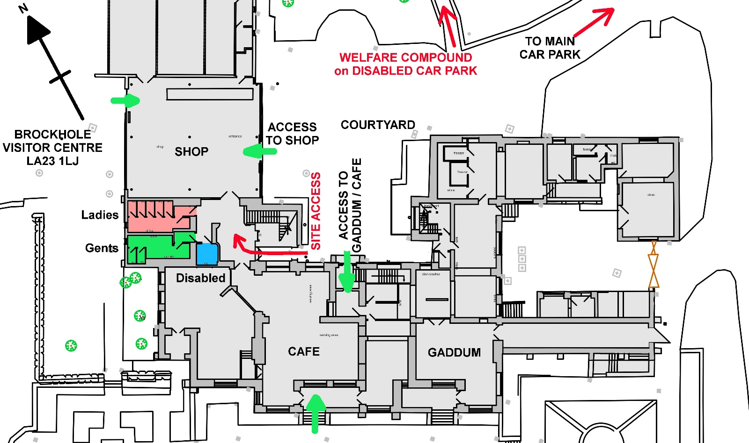

Construction Access

Construction Site Access to the public toilets is via the courtyard – see the red arrow on the plans. Note that our customers will need to have continued access to the Gaddum café and shop throughout – see the green arrows on the plans. Our customers will not need to access the toilets, nor need to pass between the café and the shop.

Site welfare compound should be located in the disabled car park as indicated on above plan.

A skip can be located in the courtyard provided it is safely screened off from the public. Skip delivery vehicles must be banked (walked) both in and out. This is necessary to guarantee the safety of our customers.

Deliveries can be made to the courtyard provided that all delivery / courier vehicles are banked (walked) both in and out. This is necessary to guarantee the safety of our customers.

Works vehicles must not be parked in the courtyard.

Staff working on this project should avoid going into the Shop or Café.

Proposed plan for Brockhole Visitor Centre toilets
The location of these toilets is indicated on the outline plan above as pink / green / blue shading
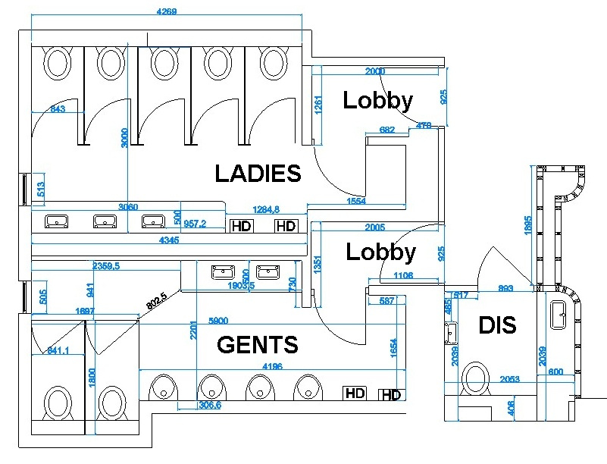

SPECIFICATION

GENTS TOILETS – area shaded green on the outline plan

Gents entrance lobby area
Thoroughly sand down two entrance doors and re-paint – diamond eggshell (colours tbc).

Replace door handles, kick plates (larger) and push plates (larger). Give 3 options on quality/price (design tbc with client)

Install new robust finger guard safety protection devices.

Make good and decorate walls - wipe down paint (colour tbc with client)

Replace light to 2 x LED panel (daylight correction) emergency light operated off motion sensor.
Replace ceiling panels – Give 3 options on quality/price (design tbc with client)

Gents WC’s

Replace existing lights with new 6 x LED (daylight correction) panels operated off motion sensor, include for emergency lighting (existing may be used).

Replace ceiling panels – Give 3 options on quality/price (design tbc with client)

Replace all laminate panelling behind urinals, cubicles and cistern boxing with new robust SGL (or equivalent high quality robust panel system) on a like for like layout basis, apart from the cubicles which will be extended in depth to 1800mm.
Give 3 options on quality/price (design/colours/materials tbc with client)

Remove old and install new radiator to fit under window. Sized smaller than existing due to increase in size of cubicles depth. Modern flat panel robust radiator.

Replace all WC’s, cisterns and urinals with new. Robust/heavy use attractive units required. WC’s to be wall fitted and able to clean underneath,
Give 3 options on quality/price (design/fittings tbc with client)
Give 3 options on flushing systems for WC’s and urinals (including sensor operated).

Remove existing WHB’s and install new laminate vanity unit with 2/3 new ‘sit in’ or “sit on” WHB’s with hot and cold taps. Vanity unit to have access panels located on front face.
Give 3 options on quality/price (design/fittings tbc with client) and options on taps (including sensor operated).

Replace all existing urinal waste pipes with new.

Replace all existing pipework - existing hot and cold water copper pipework to all WC’s, urinals and WHB’s should be cut back to point of entry to room and replaced using multi layer composite pipe MLCP or equivalent.

Remove existing floor covering, prepare floor and replace with a floor covering suitable for commercial heavy footfall toilets.
Give 3 options on quality/price (design/quality tbc with client)

Remove all wall tiles, prepare walls and replace with large format tiles.
Give 3 options on quality/price (design/quality/materials tbc with client)

Altro white rock wall cladding

Install one lit mirror which runs the length of vanity unit.
Give 2 options on quality/price. (Design/quality tbc with client)

Reinstate hand dryers. Give options for replacement.

LADIES TOILETS – area shaded pink on the outline plan

Ladies entrance lobby area
Thoroughly sand down two entrance doors and re-paint – diamond eggshell (colours tbc).

Replace door handles, kick plates (larger) and push plates (larger). Give 3 options on quality/price (design tbc with client)

Install new robust finger guard safety protection devices.

Make good and decorate walls - wipe down paint (colour tbc with client)

Replace light to 2 x LED panel (daylight correction) emergency light operated off motion sensor.

Replace ceiling panels – Give 3 options on quality/price (design tbc with client)

Ladies WC’s

Replace existing lights with new 6 x LED (daylight correction) panels operated off motion sensor, include for emergency lighting (existing may be used).

Replace ceiling panels – Give 3 options on quality/price (design tbc with client)

Replace all laminate panelling – WC’s, cubicles, WHB’s and vanity unit with new robust SGL (or equivalent high quality robust panel system) on a like for like layout basis. Depth of cubicles to remain as is.
Give 3 options on quality/price (design/colours/materials tbc with client)

Install new radiator to fit under window.

Replace all WC’s and cisterns with new. WC’s to be wall fitted and able to clean underneath,
Give 3 options on quality/price (design/fittings tbc with client)
Give 3 options on flushing systems for WC’s (including sensor operated).

Remove existing WHB’s and install new laminate vanity unit with 2/3 new ‘sit in’ or “sit on” WHB’s with hot and cold taps. Vanity unit to have access panels located on front face.
Give 3 options on quality/price (design/fittings tbc with client) and options on taps (including sensor operated).

Existing hot and cold water copper pipework to all WC’s, and WHB’s should be cut back to point of entry to room and replaced with multi layer composite pipe MLCP or equivalent.

Remove existing floor covering, prepare floor and replace with a floor covering suitable for commercial heavy footfall toilets.
Give 3 options on quality/price (design/quality/materials tbc with client)

Remove all wall tiles, prepare walls and replace with large format tiles.
Give 3 options on quality/price (design/quality/materials tbc with client)

Install one lit mirror which runs the length of vanity unit.
Give 2 options on quality/price. (Design/quality tbc with client)

Dispose of one hand dryer and replace with new Dyson Airblade and install.

Relocate existing Dyson Airblade dryer and install.

Make safe and remove redundant electrical trunking adjacent entrance door and remove electrical trunking and feed to dryer located on external wall (the dryer being relocated).

DISABLED TOILET – area shaded blue on the outline plan

Thoroughly sand down entrance door and re-paint – diamond eggshell (colours tbc).

Replace door handles, kick plates (larger) and push plates (larger). Give 3 options on quality/price (design tbc with client)

Install new robust finger guard safety protection devices.

Remove existing floor covering, prepare floor and replace with a floor covering suitable for commercial heavy footfall toilets.
Give 3 options on quality/price (design/quality tbc with client)

Remove all wall tiles, prepare walls and replace with large format tiles.
Give 3 options on quality/price (design/quality/materials tbc with client)

Replace all existing pipework - existing hot and cold water copper pipework should be cut back to point of entry to room and replaced with multi layer composite pipe MLCP or equivalent.

Replace WC and WHB with sensor tap, install new Doc M pack. Robust/heavy use attractive units required. WC’s to be wall fitted and able to clean underneath,

Install Baby Changing Facilities.

Replace laminate vanity unit and pipe boxing behind WC with new SGL on a like for like layout basis.
Give 3 options on quality/price (design/colours/materials tbc with client)

Replace ceiling panels – Give 3 options on quality/price (design tbc with client)

Replace light to 2 x LED panel (daylight correction) emergency light operated off motion sensor.

Reinstate mirror.

Reinstate hand dryer.

