**Extra Care Housing – Local Context**

**Local Context**

The borough of Cheshire East is a mix of rural and urban environments, covering an area of over 1,100km2 and has a population of 372,700 people.[1]

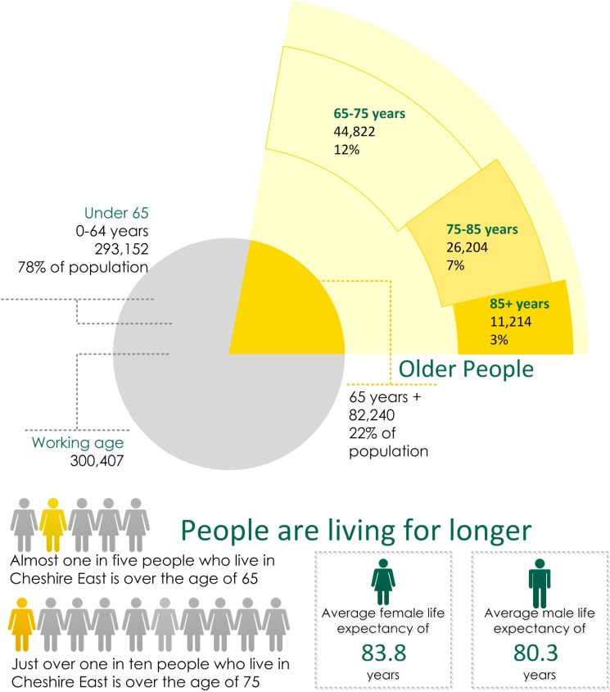

The service transformation and re-commissioning of Care and Support within Extra Care Housing Schemes is a priority within the **Cheshire East Council People Live Well for Longer Commissioning Plan (2017)**[2] which states that there is an aging population in Cheshire East. The aging population means that by 2020, over a quarter of the Cheshire East population will be aged over 65, greater than the UK average. Our challenge when commissioning local services is to enable people to live well and for longer and that we have the right service in place to respond to peoples changing needs and expectations.

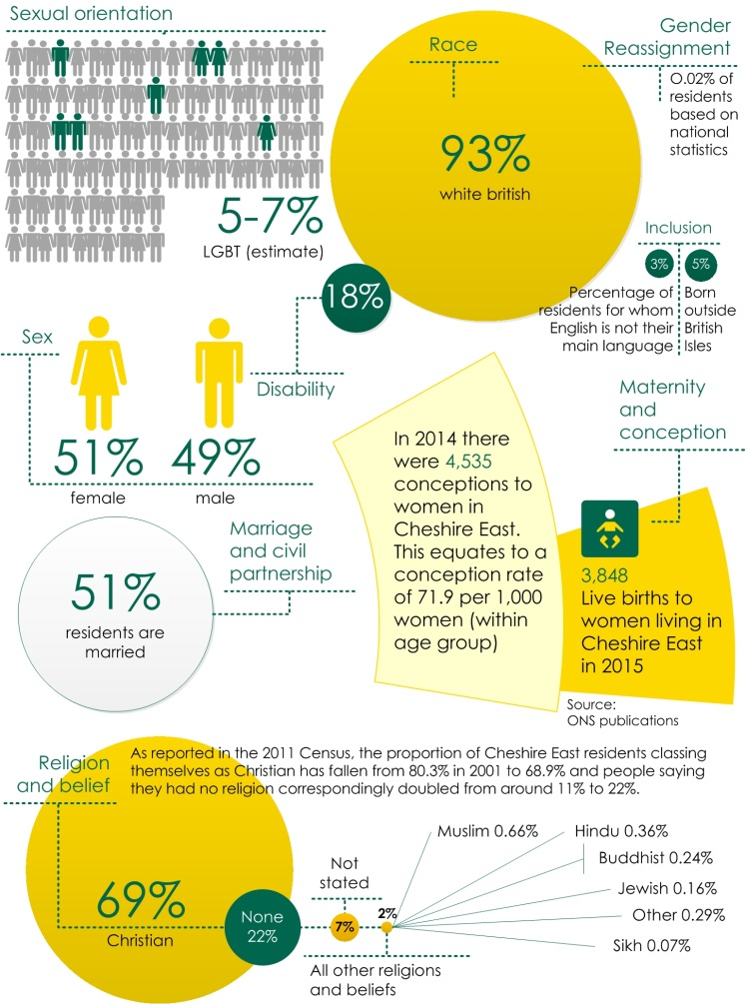

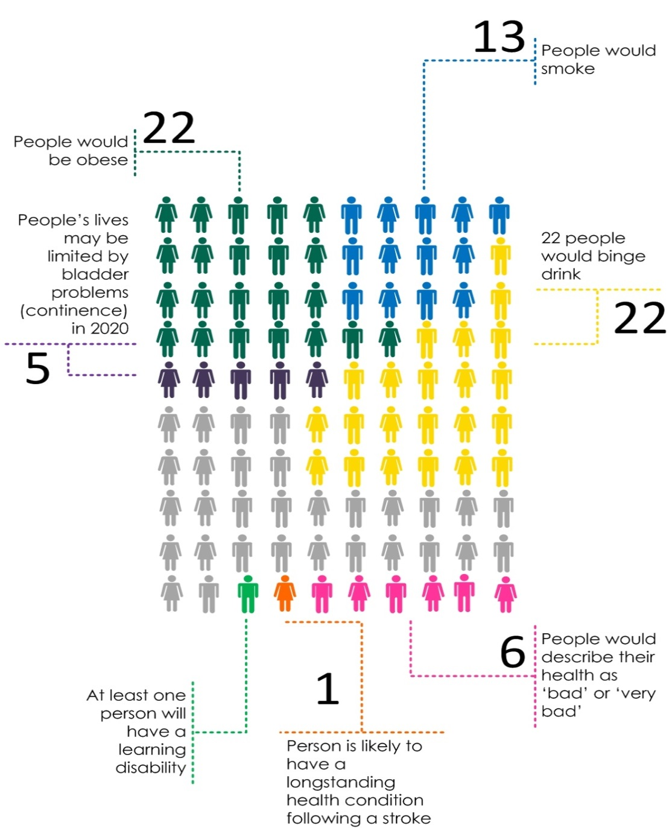**If Cheshire East was a village of 100 people:**

There are **82 elected members in Cheshire East** with **52 Wards** and **7 Local Area Partnerships (LAPS)**. The **Cheshire East Connected Communities Strategy (2017)**[3] describes how Cheshire East Council are undertaking community development activities through assets based approach (ABCD) to develop Connected Community Centres, Neighbourhood Partnerships and Town and Community Partnerships.

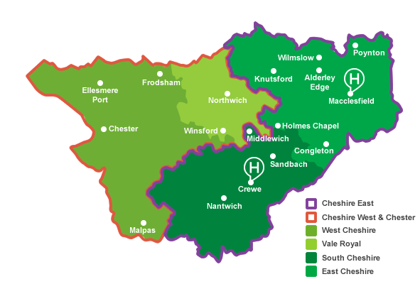The following map indicates the boarders for Cheshire East Council, Cheshire West and Chester Council and CCG areas:

The **Cheshire East Council Corporate Plan (2016-2020)**[4] consists of 6 priority outcomes which include:

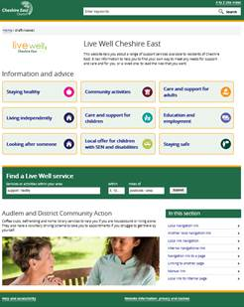**Live Well Cheshire East**[5] is a new online resource developed by the Council launched Spring 2017, providing an asset map of local services and support, giving residents choice and control of available services and information on:

* Staying healthy;
* Community activities;
* Living independently;
* Care and Support for Adults;
* Care and Support for children;
* Local offer for special educational needs and disability;
* Education and employment.

Live Well is a platform that the Council will build on further providing self-assessment of care needs, and people portals linking services to people. Residents will be able to access Live Well via the dedicated ‘live well’ web address.

**The Cheshire East Joint Strategic Needs Assessment (JSNA)** [**http://www.cheshireeast.gov.uk/council_and_democracy/council_information/jsna/jsna.aspx**](http://www.cheshireeast.gov.uk/council_and_democracy/council_information/jsna/jsna.aspx)

In addition to local need it is also important to understand local strengths and assets, which are particularly important to enable the Provider(s) to take an asset based approach to Care and Support within Extra Care Housing Schemes across Cheshire East. The **Live Well Website** provides an evolving asset map of local services and support. The website provides information about local services, as well as wider community assets such as faith groups, community centres, sports groups, and housing support etc.

The **Connected Community Strategy** sets out the Council’s ambition for an assets based community development approach.

1. 2013 mid-year population estimates, Office for National Statistics
2. Cheshire East Council People Live Well for Longer Commissioning Plan (2017)
3. Cheshire East Connected Communities Strategy (2017) <http://www.cheshireeast.gov.uk/council_and_democracy/connected-communities/connected-communities.aspx>
4. The Cheshire East Council Corporate Plan (2016-2020)

   <https://www.cheshireeast.gov.uk/council_and_democracy/your_council/council_finance_and_governance/corporate-plan.aspx>
5. Live Well Cheshire East <http://www.cheshireeast.gov.uk/livewell/livewell.aspx>