MILLOM HEALTH AND WELLBEING HUB

Cumberland Council is seeking organisations interested in operating the proposed community activity and leisure facilities in Millom, which are being delivered as part of the Millom Town Deal.
Millom is situation in southwest Cumbria, within the area of the Cumberland Council and provides a gateway to west Cumbria and the south western Lake District.

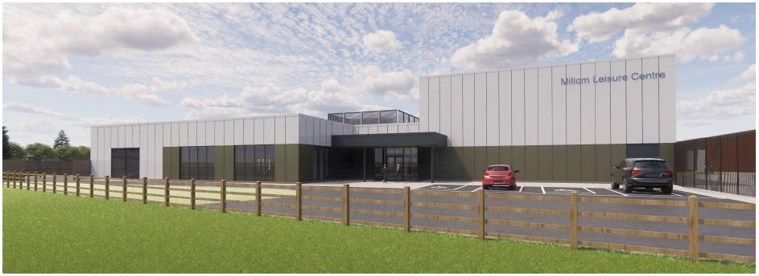

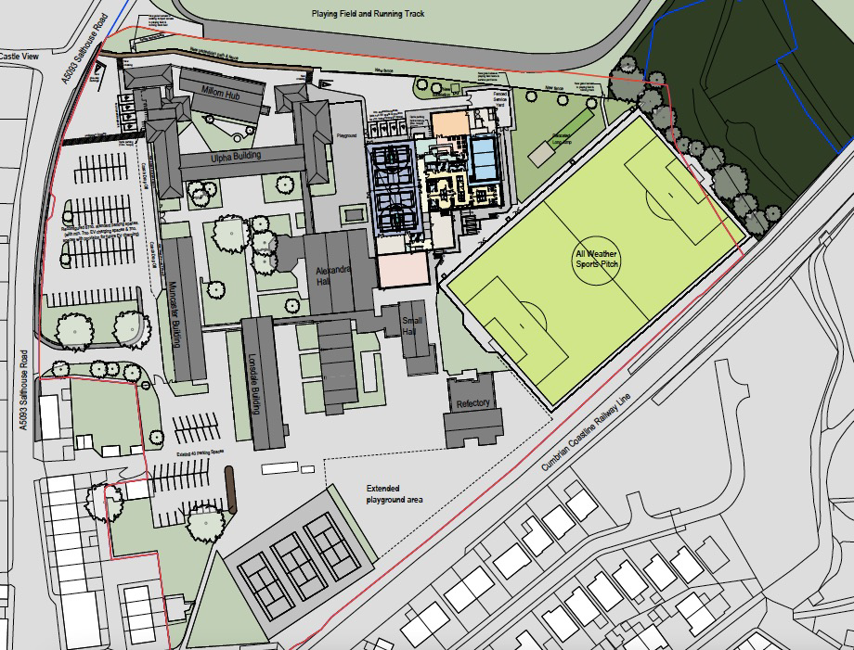

The objectives of the facility are:
- Improve population health and reduce health inequalities.
- Provide enhanced leisure and recreation space.
- To empower residents to live healthier active lifestyles and embed a long term behavioural change.
- Contribute to Millom’s resilience and economic success.
- Facilitate multi-agency working to tackle poor health outcomes.

OPPORTUNITIES
There are opportunities for organisations to operate the centre, offering a range of leisure services and opportunities.
In operating the site would we would expect the optimisation of income generation including through memberships, pay to use, the provision of swimming lessons, hire of rooms, exercise classes, birthday parties etc. as well as potential delivery of externally funded health, wellbeing and sports activities.
We would also seek operators to work with partners to support delivery of sports development/outreach, health and wellbeing interventions, social and cultural activities, and special events.
There is a desire to support partners in the delivery of ‘Social Prescribing’ activities as part of the services being provided from and within the new facilities, supporting local primary care by providing scope for patients with non-medical needs to take part in local services and activities that support their health and wellbeing.
BACKGROUND
The development of the ‘Millom Health and Wellbeing Hub’ will provide local provision of opportunities to take part in physical activity. Existing provision is limited in range and access because there is extensive use by Millom’s specialist gymnastics club and daytime use by Millom School.

The new Millom Health and Wellbeing Hub will provide a community swimming pool for the first time in the town (the previous pool was on the school site and was not open for community use other than a very limited Saturday morning session. This pool closed some years ago as it was very old and in a very poor condition).

Activating community health will provide fully accessible sports and community facilities to improve health and wellbeing, promote social inclusion, increase employability, attract visitors, improve resident and investor perceptions of the town, retain and attract young people and families, and strengthen the local economy.

The new facilities will include:
- A 15m x 8m, four-lane community swimming pool.
- A four-court multipurpose sports hall.
- A fitness suite with between 35 – 40 stations.
- A studio space for group exercise classes and dance /space to deliver health services.
- Upgraded surface 3G to artificial football pitch.
- Equipment store.

The hub will drive improvements in health and wellbeing through:
- Increase participation in swimming:
- A new centre with a balanced mix of wet and dry side facilities will allow for an operator to manage a new pool that is open to schools, for lessons and community use. Primary schools that are currently travelling to enable swimming lessons will also be able to increase swimming provision (from one to three classes with children introduced to swimming at an earlier age) with a pool in walking distance from school.
- Provision of a new studio space, enabling group exercise classes to be held during the day and evenings, meaning the sports hall is available for school and community use.
- Additional space within the new facility to deliver outreach health services.

The nearest leisure centres with a public swimming pool are those at Ulverston, Barrow and Whitehaven which are a considerable distance from Millom meaning there is a need for local swimming provision.

