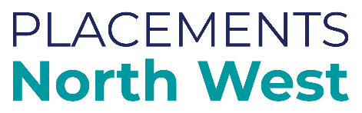
North West SEND Flexible Purchasing System (FPS) for school placements – Events for Schools and Providers | October 2020  4 Virtual Events held via Microsoft Teams  Head of Service/

Aim
We are holding 4 (virtual) events on the North West SEND Flexible Purchasing System in October 2020 for Schools / Providers. The purpose is to:
- Explain the tender process and timescales
- Give an outline of the service specification and outcomes
- Explain how Local Authorities will be using the Purchasing System to make school placements

The events have been arranged on a geographical basis to manage numbers. The details are below:

South (for Cheshire East, Cheshire West & Chester, Warrington)
Thursday, 15 October 2020; 2:00pm – 3:30pm

North (for Cumbria, Lancashire, Blackburn with Darwen, Blackpool)
Friday, 16 October 2020; 1:30pm – 3:00pm

Liverpool City Region (for Liverpool, Wirral, Sefton, Halton, St Helens, Knowsley)
Tuesday, 20 October 2020; 9.30am – 11:00am

Greater Manchester (for Manchester, Salford, Bury, Rochdale, Oldham, Bolton, Tameside, Stockport, Trafford, Wigan)
Thursday, 29 October 2020; 10.30am – 12:00 noon

Registration

To book a place, contact placementsnorthwest@bolton.gov.uk stating your name, email address, name of your school/organisation, location and the session you wish to join.

If you can’t attend the date for your area, you can attend a different session. Places are allocated on a first come, first served basis. An agenda will be confirmed nearer the time.

