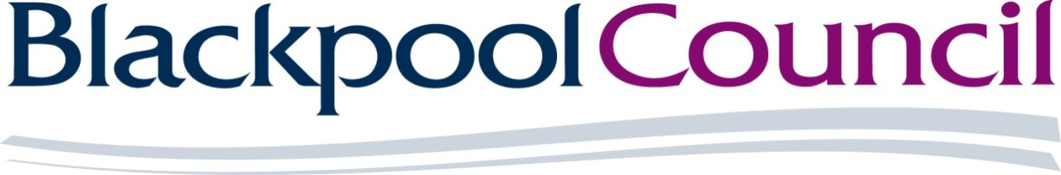



**Provision of Recycling of WEEE**

**Reference: DN732231**

**Specification**

**Introduction**

Blackpool Waste Services Ltd (trading as ENVECO NW) is an arm’s length wholly Blackpool Council owned company that has a statutory duty to provide a facility for its residents to dispose of household waste, this facility is our Household Waste Recycling Centre, Bristol Avenue, Bispham, Blackpool, FY2 0JG.

This includes all aspects of WEEE, including fridges and freezers, TV’s and display monitors (CRT), florescent tubes, small domestic appliances and large domestic appliances taken to the Household Waste Recycling Centre that require disposal.

ENVECO NW seeks to award a contract for the recycling of WEEE collected at the HWRC commencing **Monday 26th August 2024 or as soon as possible after contract award.** The contract duration will be for 1 year from the commencement date with the option of extending for a further **2 (1 + 1) years**.

ENVECO NW will select the successful contractor based on the cost or rebate per tonne and where the cost or rebate is the same we will look at which company provides the greater social value to Blackpool.

**Specification**

**Tonnage Information**

The average monthly tonnage collected over the past 2 years at the Household Waste Recycling Centre for information purposes but not guaranteed for the duration of this contract is as follows:

|  |  |  |
| --- | --- | --- |
| **WEEE tonnages** | | |
|  | **22/23** | **23/24** |
| **WEEE CRTs** | 83.3 | 98.34 |
| **WEEE fluorescent tubes** | 0.58 | 0.68 |
| **WEEE fridges and freezers** | 81.06 | 77.32 |
| **WEEE LDA** | 41.96 | 30.4 |
| **WEEE SDA** | 232.26 | 243.84 |

Irrespective of quantities of Contract Waste collected as part of this contract, other customers and any other source, the Contractor must have capacity to process all of the Contract Waste arising as part of the award of this contract.

**Arrangements for the Collection of WEEE**

The Contractor shall arrange for collection of WEEE in a 35/40 yards roll on roll off vehicle or large box vehicle between the hours of 08:00 and 15:30 hours Monday to Friday. The Contractor must weigh on and off using the weighbridge on site when removing the waste from the container. A weighbridge ticket will be issued which also acts as the Duty of Care for the waste. Hazardous Waste Consignment Notes will be required for the offtake of those items that fall within The Hazardous Waste Regulations 2005 covered by this contract.

**Legislation**

The Contractor will be deemed to have made all the necessary arrangements and obtained all necessary permissions and licences for the handling and processing of the WEEE. The Contractor will be required to demonstrate that such arrangements have been made and permissions, licences and necessary insurances have been obtained.

**Environmental & Sustainability**

The Contractor shall be responsible for the treatment, disposal and associated costs of all residual wastes such as liquids, gaseous or solid arising’s from the processing site. This shall all be handled at the Contractor’s expense using appropriately named licensed facilities.

ENVECO NW requires data on the carbon emissions associated with delivering the Contract. This data is to be provided annually to ENVECO NWl and shall be in a manner that is consistent with ENVECO NW reporting requirements under the Greenhouse gas protocol for Company reporting.

**Invoicing**

ENVECO NW will invoice the contractor on a monthly basis for the WEEE received through the contract.

**Reporting**

The performance of this contract shall be managed by ENVECO NW and the successful bidder and review meetings may be arranged, if required.

All records retained by the Contractor shall be stored adequately and filed in such a way that enables ENVECO NW to gain access to the information recorded. The information shall be stored for three years.

The Contractor will:

* Attend regular review meetings with the Council, as and when requested; and
* Ensure all complaints are dealt with in a timely and professional manner.

ENVECO NW requires a named Contract Manager for the Term of the Contract. The Contract Manager, or nominated deputy, shall be available to ENVECO NW at all reasonable times.