LY² - Lyceum Square Arts and Events Space

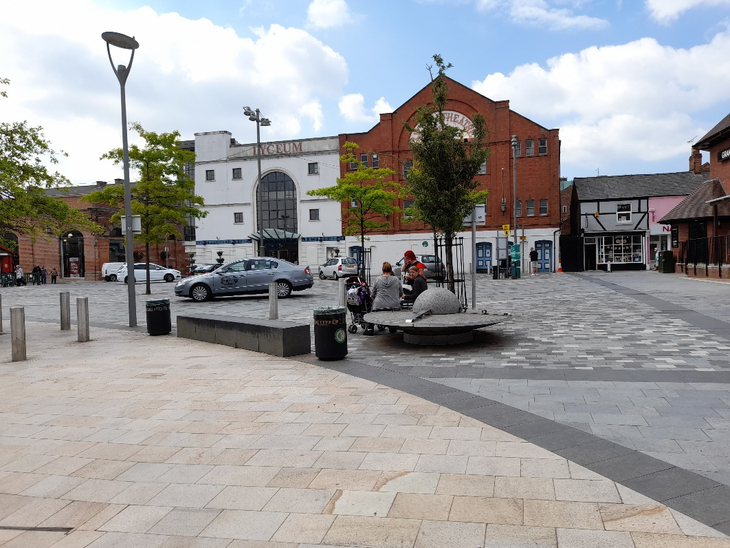

Cheshire East Borough Council

Invitation to provide a Mini Tender for Competition under the

Low Value Construction Services Framework 2021-24
Lot 2 Construction Works (£150,000 to £999,999)

for the Design and Construction

of a New Events and Arts Space in the existing Lyceum Square and Market Shed, Crewe

Cheshire East Borough Council
REQUEST FOR PROPOSAL FOR

LY² - Lyceum Square Arts and Events Space, Crewe

SUMMARY INSTRUCTIONS AND DETAILS OF CONTRACT
ITEM | CONTRACT DETAILS
Procuring Officer: | Steve Cottle, Estates Services
Submission instructions: | Submissions must be received via The CHEST  https://www.the-chest.org.uk  Please note you are required to download the mini tender documentation and upload the completed mini tender submission by 12.00 Noon on Monday 16th August 2021  1. Please ensure you leave sufficient time to upload your mini tender submission prior to the closing date/time.  2. The Council cannot be held responsible for technical/ICT issues in leaving the uploading of your submission too late. No submission received after this closing date and time will be considered other than where there are exceptional circumstances, which may be considered by the Director of Legal Services in his sole discretion. Please note that submissions, which are partly through being uploaded at the closing time, will be considered to have not been received.  3. Where several documents are to be enclosed, preference would be for these to be 'zipped' as one file and attached to the portal. Please do not send any additional company literature/brochures if these have not been requested.  4. Mini tenders which have commenced being uploaded before the closing time but have not finished being uploaded by the closing time will be registered by the system as a late quote.  5. Mini tenders submitted by post, fax or other electronic means will not be accepted.
Date/time for mini tender return: | 12.00 Noon on Monday 16th August 2021

Timetable
This timetable is indicative only. The Council reserves the right to change it at its discretion.

Stage | Date(s)/time
Issue of Mini Tender Documentation | Wednesday 21st July 2021
Site visit | N/A
Clarification questions | By Tuesday 3rd August via Chest, responses by Wednesday 4th August 2021.
Deadline for Submission of Mini Tender | 12 Noon Monday 16th August 2021
Evaluation of Quotations | Monday 23rd August 2021
Notification of result of evaluation | Tuesday 24th August 2021
Expected date of award of Contract | Friday 10th September 2021
Contract commencement | Monday 13th September 2021

IMPORTANT NOTICE

This mini Tender is issued to those companies appointed as Framework Partners (“Contractors”) to Cheshire East Borough Council (the “Council”) to provide the design and construction of an arts and events space, Crewe (the “Contract”), their professional advisers and other parties essential to preparing a mini tender for this Contract (the “Tender”) and for no other purpose.
The contents of this mini Tender, and of any other documentation sent to you in respect of this tender process, are provided on the basis that they remain the property of the Council and must be treated as confidential. If you are unable or unwilling to comply with this requirement you are required to destroy this mini Tender and all associated documents immediately and not to retain any electronic or paper copies.

No contractor will undertake any publicity activities with any part of the media in relation to the Contract or this mini Tender process without the prior written agreement of the Council, including agreement on the format and content of any publicity.
This mini Tender is made available in good faith. No warranty is given as to the accuracy or completeness of the information contained in it and any liability or any inaccuracy or incompleteness is therefore expressly disclaimed by the Council and its advisers.
The Council reserves the right to cancel the mini Tender process at any point. The Council is not liable for any costs resulting from any cancellation of this process nor for any other costs incurred by those quoting for this Contract.

INSTRUCTIONS

- BACKGROUND

  - Further details of the Council’s requirements under the Contract and other relevant information are provided in the Project Brief and Service Specification.

  - If you have any questions or require any clarifications, please contact the Procuring Officer via The CHEST [www.the-chest.org.uk].

  - Other than the person identified above, no Council employee or member of the Council has the authority to give any information or make any representation (express or implied) in relation to this mini Tender or any other matter relating to the Contract.

  - Please note that the Council’s responses to any queries or clarification requests may, at the Council’s discretion, be circulated to all contractors.

  - The Council reserves the right to issue supplementary documentation at any time during the quotation process to clarify any issue or amend any aspect of the mini Tender. All such further documentation that may be issued shall be deemed to form part of the mini Tender and shall supplement and/or supersede any part of the mini Tender to the extent indicated.

  - Contractors must obtain for themselves at their own expense all information necessary for the preparation of their quote.

  - Under the Contract the Council will require compliance with its policies. Suppliers are advised to satisfy themselves that they understand all of the requirements of the Contract before submitting their tender.

  - The tender must be received in accordance with the relevant instructions no later than the time and date indicated.

  - Errors within the tender shall be dealt with in accordance with Alternative 2 contained in the JCT Tendering Practice Note 2012.

- MINI TENDER SUBMISSION REQUIREMENTS

  - Submissions must be written in the English language.

  - Only one tender is permitted from each contractor. In the event that more than one is submitted by a contractor, the one with the latest time of submission will be evaluated and the other(s) disregarded.

  - The Tender (including price) should remain valid for a minimum period of 90 days.

  - The Tender must not be qualified in any way.

  - Any signatures must be made by a person who is authorised to commit the Tender to the Contract.

  - Your full registered business/name and main office address must also be provided on all documents.

  - The Council reserves the right to reject or disqualify a Tenderers submission where documents are completed incorrectly, are incomplete or fail to meet the Councils submission requirements which are detailed in this document.

  - The mini tender submission must provide all of the information requested in the specified format and be completed in full and signed where indicated.

  - In the event that Tenderers believe that they are unable to submit a Tender through the electronic system or require assistance or further information to be able to use the e-tendering process they must contact the Procuring Officer no later than 4 calendar days before the submission date for the Tender to enable any technical queries to be investigated and resolved.

- CONTRACT DOCUMENTS

  - The conditions of contract will be NEC4 Engineering and Construction Contract (June 2017) Option C: Target Contract with activity schedule, completed in accordance with Appendix 3.

  - This Council is bound by procurement rules and cannot enter into any negotiations on the quotation or Contractual Terms and Conditions.

CONTENTS

Mini Tender Document

- Introduction
- Background
- Works Information
- Funding Approval
- Procurement of Provider Partner
- Submission and Evaluation
- Qualitative Questions and Scoring Criteria
- Evaluation Matrix
- Clarifications
- Documents to be Returned

Appendix 1 – Form of Tender
Appendix 2 – Commercial Submission
Appendix 3 – Contract Particulars / Contract Amendments
Appendix 4 – Scope (Stage 3 drawing and report)
Appendix 5 – Programme

- Introduction

This document is intended to give the Lot 2 provider partners on the Cheshire East Borough Council Low Value Construction Services Framework 2021-24 an opportunity to tender for the design and construction of an arts and events space in Crewe.

The tender will take the form of a mini competition between all Lot 2 partners who have expressed an interesting in tendering for the scheme. Your submissions should be based upon the information provided and questions asked within this document.

- Background

Gillespies were appointed by Cheshire East Council (CEC) and partners in December 2020 to provide design proposals for the redevelopment of Lyceum Square (Ly2) in the centre of Crewe. Ly2 is to be delivered through the Accelerated Towns Fund Programme.

The vision is for Ly2 Lyceum Square to be a vibrant community hub at the heart of Crewe’s Civic and Cultural Quarter; a mixed-use, round the clock space allowing locals and visitors to gather and enhance the setting of the Theatre and Market Hall. It will have a strong sense of identity and become known as a creative centre for small businesses, local crafts and exhibitions, as well as a destination for outdoor performances and festivals. Connections to the wider area and exciting new developments will be strengthened, welcoming people to Crewe and encouraging them to stay and explore. Both the square and one of the covered sheds will be encompassed in this development

- Scope

The overall project works will be split into 3 packages:

Highways – repair and replacement of damaged granite paving with textured asphalt to accept thermoplastic artwork treatment. This work will be undertaken by Ringway Jacobs under their framework contract. This package may have completed their siteworks when the main contract commences on site.

Arts commission to create and deliver artwork to standalone structures, highway textured asphalt stage and container units.

(This package) Main works including stage with lighting and sound system, container units under the market sheds, containerised planting, line markings and overall programme management and integration. The stage, lighting and sound system may require a new power supply together with controls to a new lighting and sound control position.

Gillespies have been commissioned to design the works to RIBA stage 3 and submit the planning application. They may also be commissioned by the Council to provide design advice to ensure that the works across the three packages is consistent with the overall vision and design intent.

The Contractor will act as principal designer and principal contractor for their portion of the works.

- Funding Approval

Funding for the works has been approved with contributions from the Future High Street Funds and the Town Deal.

- Procurement of a Provider Partner

  - Procurement Process

Submission of a valid tender will result in the selection of a Contractor from the Framework panel to complete the task as outlined. The submission will be evaluated against an agreed set of criteria following a 70/30 quality/cost scoring split.

- Submission & Evaluation

The submissions received will be judged against the evaluation criteria shown in the table below, the breakdown of which is 70% quality and 30% price

The economic operator’s response to each non-priced contract specific question is scored between 0 and 10 according to the pre-agreed scoring grid.

For each question the actual score is divided by the maximum score allowed. The Overall Percentage per question is then adjusted by the above division.
E.g. a question has an Overall Percentage of 20%; max score allowed = 10; actual score given = 6, hence adjusted score = actual / max = 6/10 = 0.6
As applied to the Overall Percentage, therefore score = 20% x 0.6 = 12%

The quality section of your submission will be based upon the following questions.

As stated above, the answers to these questions carry 70% of the total score as the quality section of the submission.

Your answer to each of the questions asked in this document will be scored using the scoring principles below:

Score | Scoring Principles
0 | Rejected – The response is unacceptable or non-existent, or there is a failure to properly address any issues.
2 | Very Poor – The response is significantly deficient in certain areas.
4 | Poor – The response is deficient in certain areas and requires the reviewer to make assumptions.
6 | Satisfactory – The response is acceptable, but with some minor reservations.
8 | Good – The response meets expectations with some evidence provided.
10 | Excellent – The response comprehensively meets the requirements with substantial amounts of evidence provided.

- Qualitative Questions and Scoring Criteria

  - Questions – Quality

A word limit has purposely not been included in order not to limit the quality of your responses, however you are requested to be sensible and reasonable in the volume of support documentation you propose to submit.

Approach: Please answer all questions in this section with specific regard to the proposed LY2 - Lyceum Square Arts and Events Space, Crewe.

 | Quality Question | Weighting
Q1 | Taking into consideration projects that you have undertaken of a similar nature please can you identify the key personnel that will be involved in the project along with their roles, providing CV’s for each and explain how their experience can be utilised on delivering this project and achieving social value. Please indicate the proportion of their time allocated to the project. | 25%
Q2 | The role of the design and build contractor includes the co-ordination of programmes and site logistics of the highways contractor and arts package, what experience does your team have of this type of proactive co-ordination role? | 10%
Q3 | Please demonstrate by way of a detailed programme how you would intend to undertake both the design and construction stages of the project including key areas of interface and risk. | 20%
Q4 | Taking into consideration challenges that you encountered when undertaking projects of a similar nature, please describe the lessons learnt and how this might influence your approach to this project? | 15%

  - Scoring Criteria – Commercial

The overall lowest price submission will be allocated the full financial score of 30% with pro rata scores applied to the other submissions.

Price (Example Only)

    - Importantly for the award criteria, the price is converted into a score as a percentage of the lowest bid price. The lowest, but feasible price is awarded 100%, and is then converted into a percentage, relative to the Main Criteria Table.
The sum of all of these derived percentages allows final ranking of tender
EXAMPLE
Pricing Element = 30% weighting
Company A = £10,000.00
Company B = £20,000.00
Company C = £30,000.00
Lowest Price submitted / Submitted Price x Price Criteria Weighting
Therefore
Company A = £10,000/£10,000 x 30 = 30%
Company B = £10,000/ £20,000 x 30 = 15%
Company C = £10,000/£30,000 x 30 = 9.99%

- Evaluation Matrix

The evaluation matrix is below:

Evaluation Matrix | Weighting | Marks Awarded
Quality Proposal | 70%
Question 1 | 25%
Question 2 | 10%
Question 3 | 20%
Question 4 | 15%
Total Quality Scores | 70% of 100%
Commercial Proposal | 30%
Total Commercial Score | 30%
Total Quality + Commercial Score | Out of 100%

  - Tender Evaluation Criteria

    - The Council does not undertake to accept the lowest or any tender and reserves the right to accept the whole or any part of any quotation submitted.

    - Each tender will be checked initially for compliance with all requirements of the mini tender

    - Tenders will be evaluated against the award criteria set out below

    - During the evaluation period, the Council reserves the right to seek clarification in writing or by means of a clarification meeting from any or all of the Suppliers to assist it in its consideration of their quotation

    - The Council reserves the right to omit/amend elements of commercial submissions, to create parity between submissions, prior to applying the scoring criteria.

    - Where the pricing of a Tender is abnormally low the Council reserves the right to reject the Tender in accordance with the requirements for further investigation under the Public Contracts Regulations 2015.

    - The Council may decide to interview Suppliers or hold clarification meetings to assist its Quoting process, and Suppliers will be notified in due course

Scoring Panel will be as follows:

Steve Cottle Project Manager, Property and Projects

Chris Jackson Senior Regeneration Manager

Amy Lewis Cultural Economy Manager

Crewe Town Council representative.

- Clarifications

To ensure transparency and fairness any inquires regarding the mini competition are to be submitted in writing through The CHEST portal.

When you first access the documents, please satisfy yourself that you have seen any clarifications which may have already been posted. Clarifications with the relevant responses will be posted on The CHEST for all applicants to view. It is in your interest to visit the clarifications regularly, as a response may fundamentally affect your submission. Questions raised outside of the clarification period may not be answered because responding to a clarification at this stage may not allow revisions to submissions so close to the deadline for the submission returns.

Any information that is dispensed in response to requests for clarification will be distributed to all Suppliers. If a Supplier considers their enquiry to be specifically innovative to their offer, which should be clearly communicated within their correspondence, the team will decide whether the request for information is actually ‘innovative’ to the Supplier’s offer. If not considered to fall within that category the Supplier will be informed so they may make a decision as to whether to continue with this line of enquiry.

No employee except the designated Procuring Officer leading this procurement has any authority to make any representation to Candidates as to the meaning of the mini competition or other such documentation. If clarification is required, please submit your inquiry via The CHEST. No approaches in connection with the work described must be made to any representatives other than formally through the Procuring Officer.

It is not anticipated to hold post tender interviews.

- Documents to be returned

Please return your completed Form of Tender (Appendix 1), Commercial Submission (Appendix 2), fully detailed build-ups of preliminaries costs, a programme sufficiently detailed to enable Pre-construction Services and Preliminaries to be fully costed and your responses to the qualitative questions (Section 7).

Submissions must be uploaded onto The CHEST by 12 Noon Monday 16th August 2021.

You will have open access to The CHEST portal until the above closing date should you wish to amend your submission.

PLEASE NOTE

The electronic system used for the return of tenders has an automatic cut off time of 12.00 noon.

It is important you allow enough time for your submission to be received in The CHEST before the closing date and time as The CHEST will register it as late.

Submission’s which have commence being uploaded before the closing time but have not finished being uploaded by the closing time will be registered by the system as late.

Please allow sufficient time to upload your documents before the closing time.

If your submission is received late it may not be accepted.

Your response must be uploaded onto The CHEST Portal including all the requested information in the following order:

- Form of Tender
- Commercial submission
- Fully detailed build-ups of preliminaries costs
- A programme sufficiently detailed as noted above
- Quality submission

Freedom of Information Act and Environmental Information Statement

  - The Council is subject to The Freedom of Information Act 2000 (“Act”) and The Environmental Information Regulations 2004 (“EIR”).

- As part of the Council’s obligations under the Act or EIR, it may be required to disclose information concerning the procurement process or the Contract to anyone who makes a reasonable request.

- If Tenderers consider that any of the information provided in their Tender is commercially sensitive (meaning it could reasonably cause prejudice to the Organisation if disclosed to a third party) then it should be clearly marked as "Not for disclosure to third parties” together with valid reasons in support of the information being exempt from disclosure under the Act and the EIR.

- The Council will endeavour to consult with Tenderers and have regard to comments and any objections before it releases any information to a third party under the Act or the EIR. However the Council shall be entitled to determine in its absolute discretion whether any information is exempt from the Act and/or the EIR, or is to be disclosed in response to a request of information. The Council must make its decision on disclosure in accordance with the provisions of the Act or the EIR and can only withhold information if it is covered by an exemption from disclosure under the Act or the EIR.

- The Council will not be held liable for any loss or prejudice caused by the disclosure of information that:

    - has not been clearly marked as "Not for disclosure to third parties" with supporting reasons (referring to the relevant category of exemption under the Act or EIR where possible); or

    - does not fall into a category of information that is exempt from disclosure under the Act or EIR (for example, a trade secret or would be likely to prejudice the commercial interests of any person); or

    - in cases where there is no absolute statutory duty to withhold information, then notwithstanding the previous clauses, in circumstances where it is in the public interest to disclose any such information.

