Appendix A
ProContract User Guide
Please note this document is current as at 01 June 2019
For further information refer to the ProContract on-line guidance

Registering on ProContract

How to Register
On the portal home page there is a link to Register (for free) on the right hand side of the screen, as shown below.
Click this link to begin the step-by-step registration wizard, where you will be required to enter your company details.
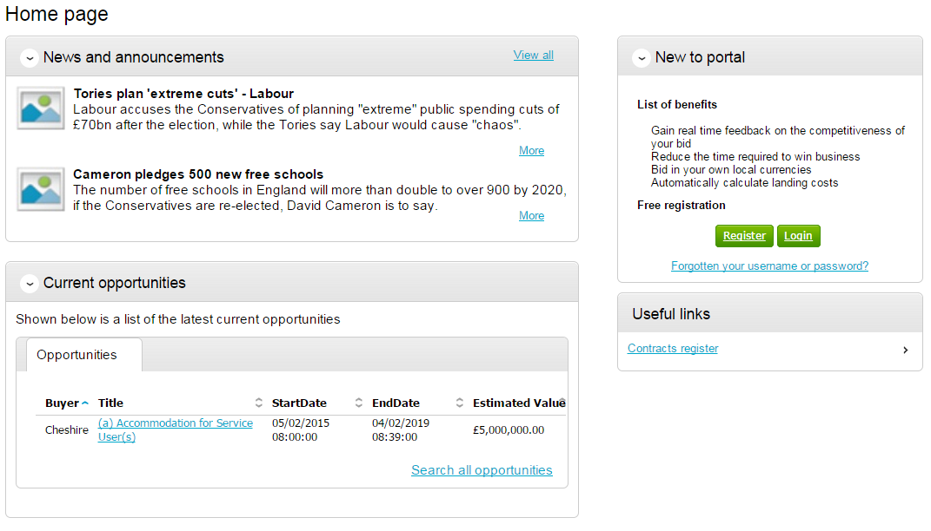

Requirements
This page is an introduction to the process that you will be taken through in order to complete your registration on the portal. Please read this text carefully before proceeding through this process.
Minimum and recommended system requirements can also be viewed here. If you wish to proceed, click Continue from the options at the bottom of the page, or if you want to abort the registration process click Cancel.
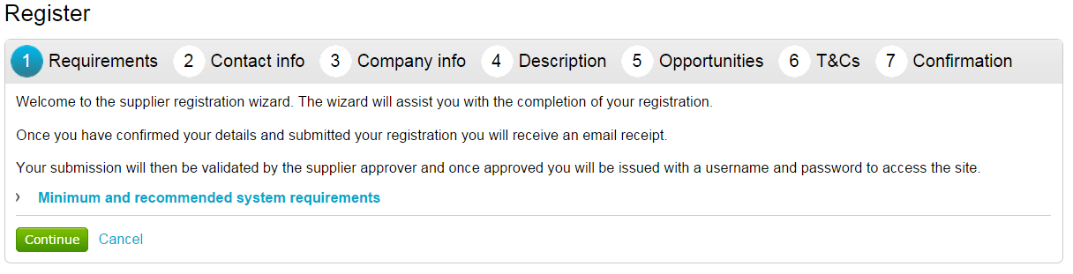

Contact Information
At this stage of the registration process you need to enter your own contact details, a username, a password, and a memorable word/hint. These details will be used when logging into the system. You will be the primary account holder for this company (although details can be changed post registration) so this account will be able to modify the details for the company and add more accounts (which is detailed in another guide).
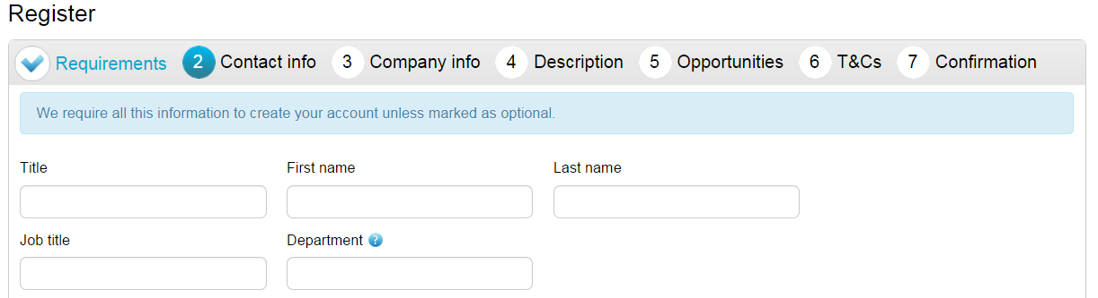
Contact Information
In this section your contact information is entered along with your job details. Complete all mandatory fields as required.
Note: Further help regarding the fields can be found in the by hovering over the icon.
Department - This will form your work group. All future members of this work group will be able to access events you are involved in.
E-mail - This is the e-mail address that messages will be sent to confirming registration details, and all other system communication that may take place during the tender process (including notifications of new tender opportunities). It is recommended in most instances that a GENERIC EMAIL ADDRESS is used, so that communication will not be lost if that person is away or leaves their position (i.e.to a sales@... or tenders@... address possible.) Also this must be of standard email format e.g. name@company.com
Security Information
The second part of this stage is dedicated to setting up your security information. This is where you are asked to specify a password, a memorable word and a hint to help you in case you forget it. This must be something that is secure and also that is memorable to you.
When the details have been completed then please click on the Continue button to proceed, the Back button to go back to the previous stage, or the Cancel button to cancel the registration.

Company Information
In this section you will need to populate details regarding the company you work for/are registering on behalf of, as shown below.
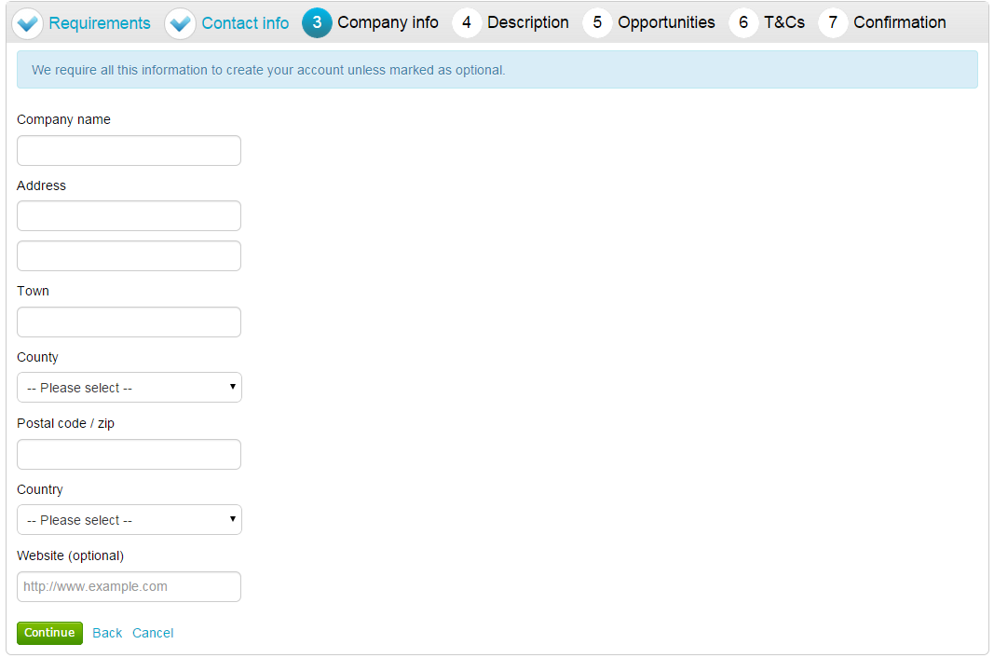
You are required to enter the name of the company you work for and location details.
If any of the fields do not apply but are mandatory, such as “Postcode/ZIP” for companies based outside of the United Kingdom, by entering “N/A” here you can still proceed.
Note: Some of the fields (County and Country) are chosen by using a dropdown menu. To select a County/State click the arrow to the right of the box to reveal a drop down menu containing all the possibilities that can be chosen.
From the list select the required option by clicking on its name and this will populate the field as required.
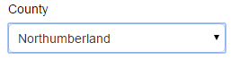
If United Kingdom is selected, then fields will appear requiring Registration number and VAT number.
When the details are complete then please click on the Continue button to proceed, the Back button to go back to the previous stage, or the Cancel button to cancel the registration.

Description
The first part of this stage requires a Company description and up to 6 keywords. Here more information on the company is entered to help the contracting organisation understand what it is your company does. The description helps promote your company to potential buyers, while the keywords can improve the ‘searchability’ of your company.
Note: A description and at least one keyword are required in this section. This is free text and as much information as required can be entered here.
It is important that you complete this information as the procuring organisations can search for a company based on the description or keywords specified.
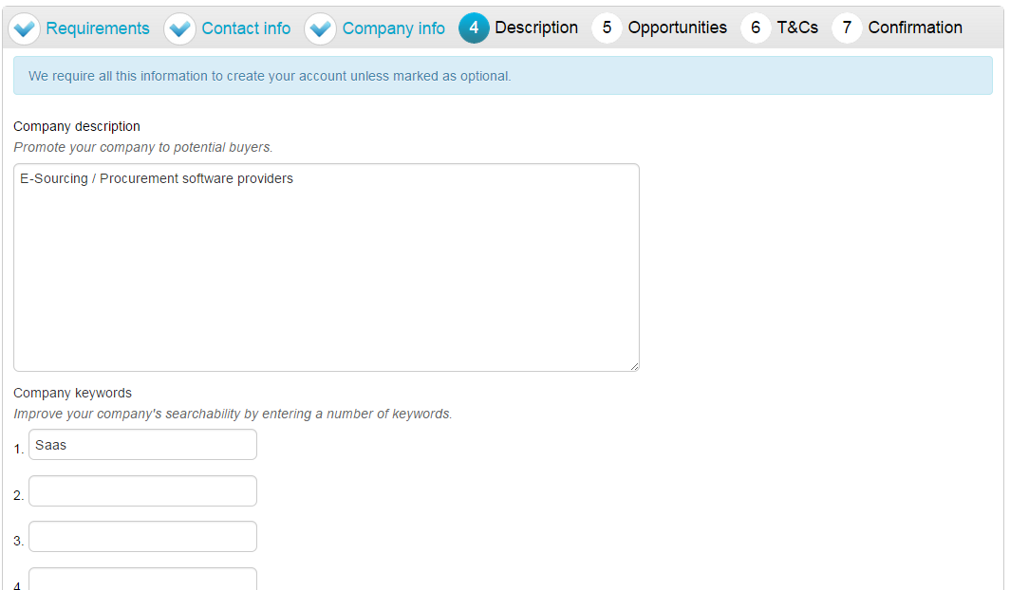
Number of Employees/Classifications
Enter your best estimate as to the number of employees in your organisation within the Number of employees field.
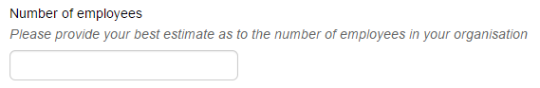
The final section is the Classifications section. This is where the supplier can highlight the classifications that the company belongs to (which is used for reporting purposes only). To select a classification hover over the relevant box and left click on the mouse to mark the box to the left with a tick. You can highlight as many that apply to your organisation.
Note: The first batch of classifications are mandatory and at least one must be selected from the list.
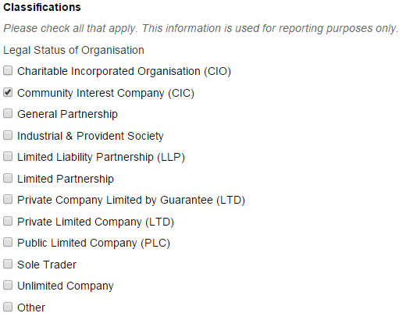
Note: The second batch of classifications are optional, and are selected in the same way as described above.
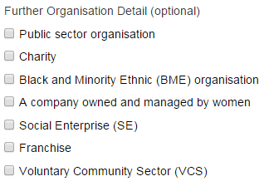
When the details are complete then please click on the Continue button to proceed, the Back button to go back to the previous stage, or the Cancel button to cancel the registration.

Opportunities - Category/Region Selection
This is the category and region selection stage of the supplier registration, which will look as shown below.
To select your chosen categories click the Select Categories button.
Categories List
This section is where you can register your company to receive automatic e-mail notifications of new opportunities that have been published that may be of interest to your company. This will greatly assist you when using the portal and means that relevant opportunities are not missed. At least one category must be selected.
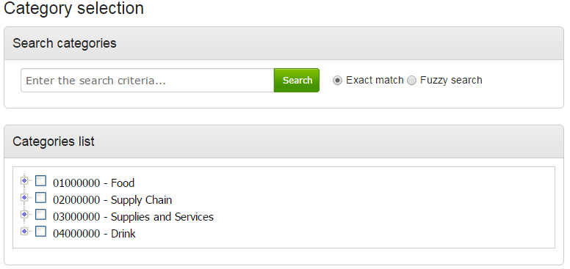
Category: The top level categories that you can register to receive updates under are all listed.
To select a top level category, mark the box to the left of the category by clicking it. You can select multiple categories if required. Ensure that you click on Select Categories to add this to the list.
If you are not sure, or if you want to put your company against lower level classifications, you may use the search facility at the top of the page to search for specific words to help you narrow down the categories to add to your account.
This can also be done by clicking on the blue diamond to the left of the category which will take you down to the next level. This can then be repeated to go down further levels in some categories.
Note: When selecting categories, only categories relevant to the goods or services you can offer as a supplier should be selected. Category selection can be revisited at anytime to carry out required amendments, and searches of advertised opportunities for all categories can also be carried out at anytime.
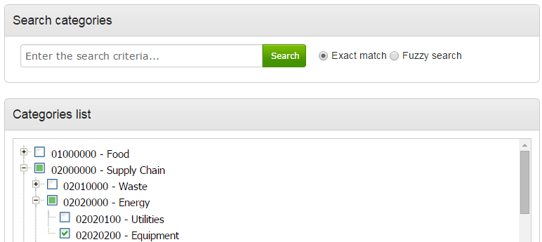
When all required categories have been chosen, click Select Categories from the options at the bottom of the page.
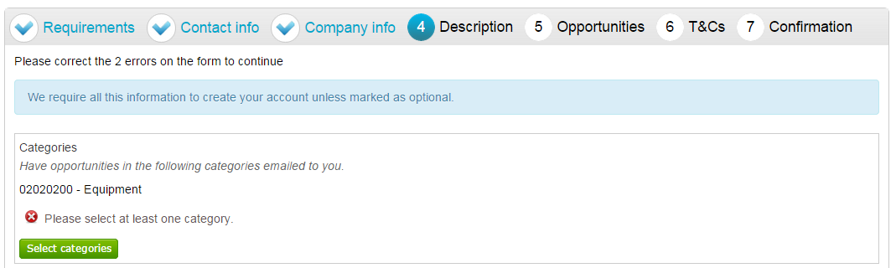
Selected categories are now shown as above.
Note: If a category has been added in error this can be removed by clicking the button.
Regions
At least one Region must now be selected. These will limit the opportunities that you are emailed to only regions that you supply to. Regions are selected in the same way as categories.
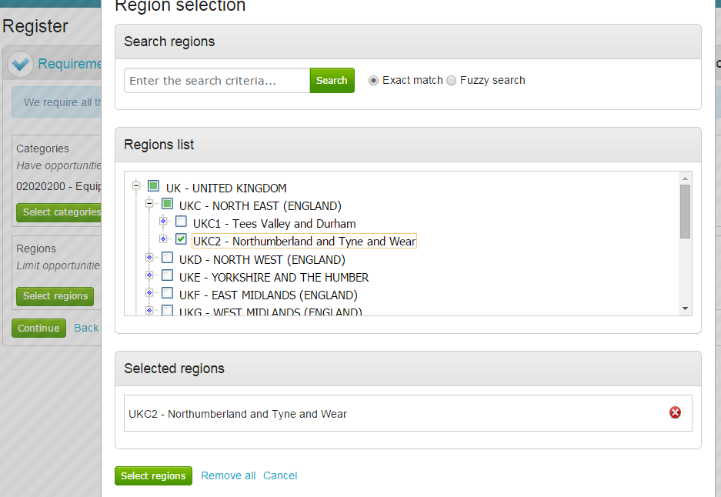
Additional Classifications/Categories
Also further lists/categories may now also be found (if the procuring organisation/portal have used these). This allows you to register against further supplier lists, as set up by the procuring organisation(s) to allow you to be further categorised and found more easily by procurers.
Note: This is totally independent of the Contract Category Interest that is chosen and this will NOT generate any email notifications.
Each list will show up with the title, followed by a classification structure, which you can register your company against. Tick the options that are applicable from this list, this may be done for several lists.
When the details are complete then please click on the Continue button to proceed, the Back button to go back to the previous stage, or the Cancel button to cancel the registration.

T&C’s and Privacy Policy
This is the step where you will be asked to agree to the Terms and Conditions of using the system, and also the privacy policy as laid out by Due North.
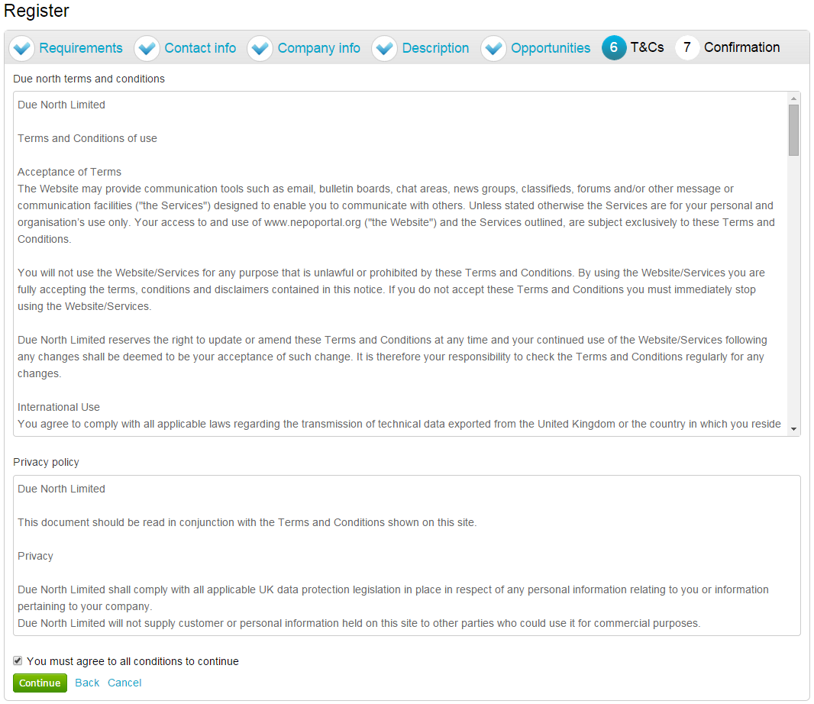
To agree with Due North Ltd’s Terms and Conditions and Privacy Policy tick the box placed at the bottom of the page.
When the box is ticked click on the Continue button to proceed, the Back button to go back to the previous stage, or the Cancel button to cancel the registration.

Confirmation Page
The final screen will be a summary of the details that have already been entered into the system, that need to be checked before completion of registration.
If you are unhappy or would like to change any of the information in the sections then this can be done by clicking on the relevant stage title along the top of the page.
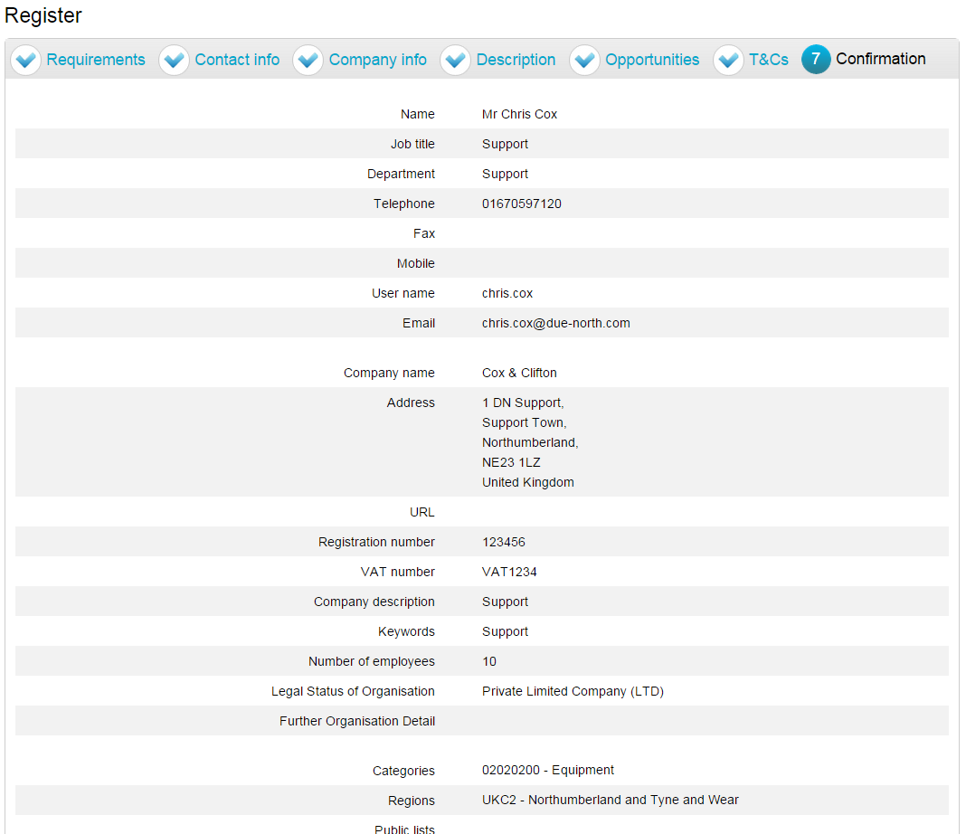

Submitting your Registration
Once you are happy that all details are complete and correct the Registration needs to be submitted.
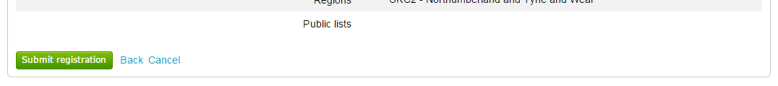
When you are happy that all the information is complete and correct, click Submit Registration at the bottom of the screen. Click the Back button to go back to the previous stage, or the Cancel button to cancel the registration.
This will show the Supplier Registration Confirmation page as shown below.
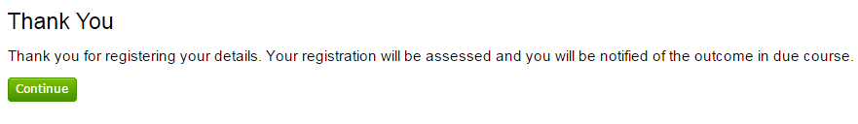
The system will then send a confirmation e-mail to say the application is being considered. The email will also contain an application reference number for your own records.
Click Continue to return to the supplier portal.
When the registration is accepted then you will receive an email containing a reminder of your username and the link to access the opportunity portal.

Registering an Interest

Contract Opportunities
Contract Opportunities are posted by buying organisations to notify you of their up and coming contracts and to give suppliers a chance to express their interest in the opportunity and to receive the relevant documents.
The opportunities area will also show a list of suggested opportunities, based on the Categories and Regions selected in your profile.

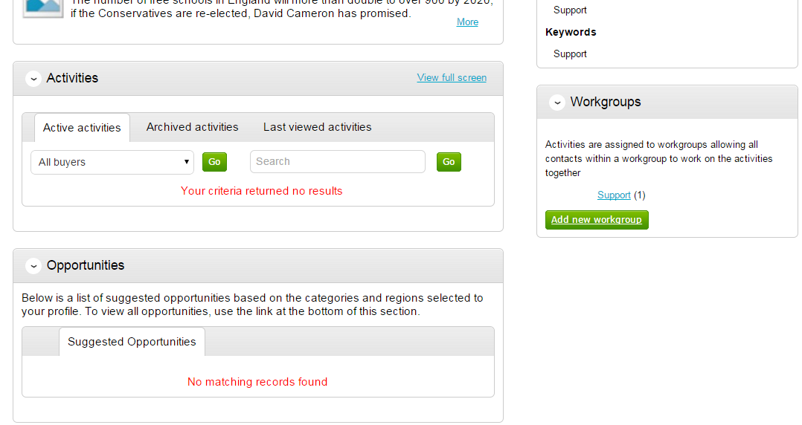

Searching Opportunities
To search for new opportunities from the supplier home page click on Find Opportunities located across the top of the page.
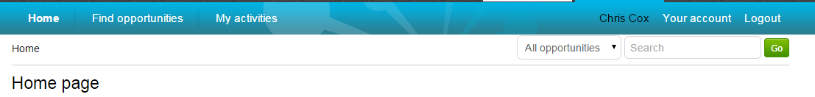
This will then open the Opportunities screen which includes a full list of all current opportunities. You can specify search criteria to narrow your results in the left hand panel, or just do a key word search (on Title, Buyer or All Data) within the Search area in the top right of the page.
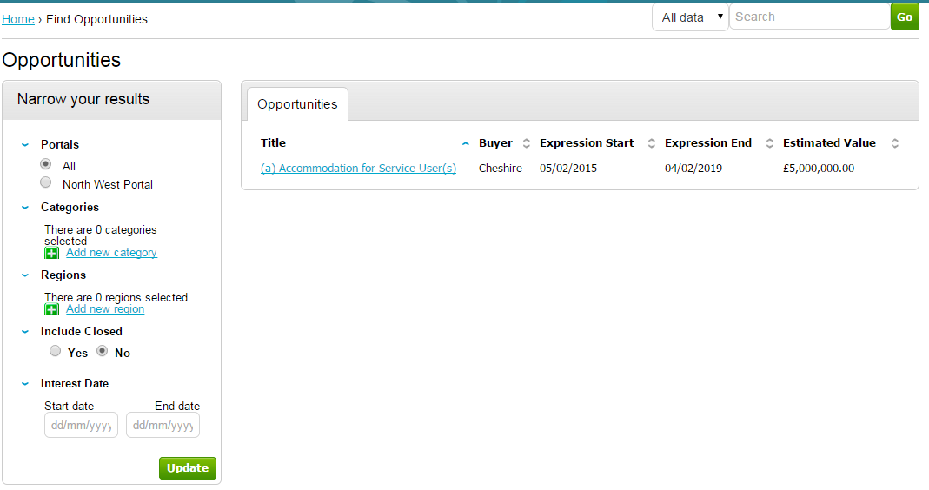
Narrow your results on:
Portals: This setting allows the Portal you are searching on to be chosen.
Categories: This field allows you to choose the category classification to which the opportunities you wish to search for are associated. To select a category, click on the Add new category and search for the relevant entry.
Regions: This field allows you to choose the region to which the opportunities you wish to search for are associated. To select a region, click on the Add new region and search for the relevant entry.
Include Closed: This defaults to No which will show only opportunities that you can currently express your interest in - so the expression of interest window is open. To view all current opportunities, and also all past and future opportunities that are on the portal but have closed, mark Yes.
Interest Date: Refine your results based on the Expression of Interest date.
Once the search has been set up in the desired way then click on Update and the opportunity results in the middle of the page will refresh.
To view the further details of the opportunity, click the corresponding title.
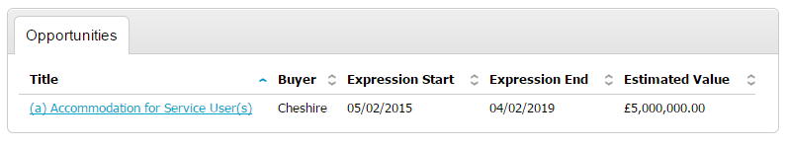
The opportunity details will look as shown, with all the relevant opportunity/contract details.
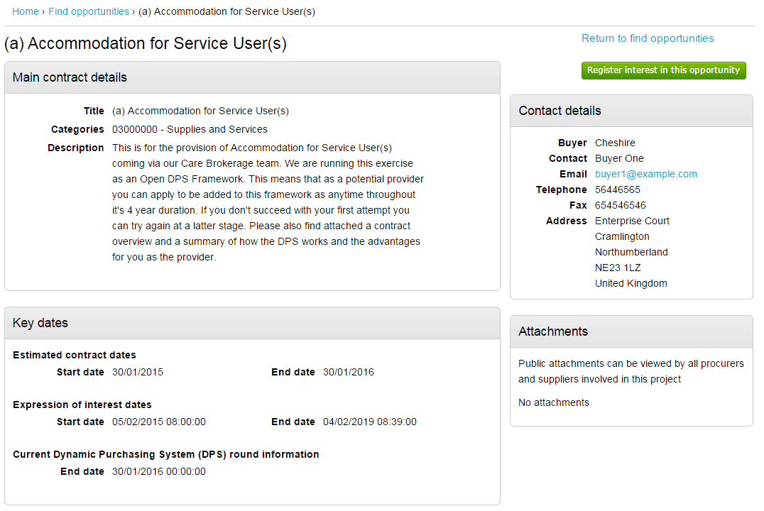
Main Contract Details
This shows key details of the contract including the title, categories and description.
Key Dates
This section shows the estimated contract dates, the expression of interest dates and any other important information (i.e. Current DPS Round end date, for example.) The expression of interest dates determine the options that will be available regarding the opportunity, as the date must fall within these two dates in order to express an interest.
Contact Details
This shows details of the Buyer and Main Contact.
Attachments
Any attachments or links relevant will appear in the bottom right, where they can be viewed/downloaded by clicking on the title.
In the top right there are 2 options – either register an interest in the opportunity, or return to the find opportunities page.

Registering Interest in an Opportunity
To register interest in a particular opportunity you must be registered on the portal.
This process is covered in detail in the section Registering
Once registered, you will have a username and password to access the portal. This allows you to register interest in any opportunities that are advertised on the portal.
Once you are logged in, you can find the relevant opportunity using the process in the section Contract Opportunities.
If after viewing the information regarding the opportunity you decide that you are no longer interested in registering an interest then click the Return to find opportunities button. If you do decide you would like to express your interest then click on Register interest in this opportunity.
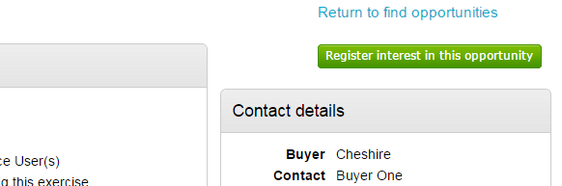
The same area will now show confirmation of the registered Expression of Interest. Click Return to find opportunities to start a New Search.
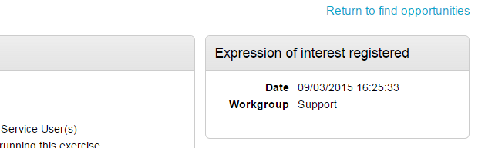

Submitting a Response

Viewing the Details/Documents
Login to the system and then it will take you to your homepage.
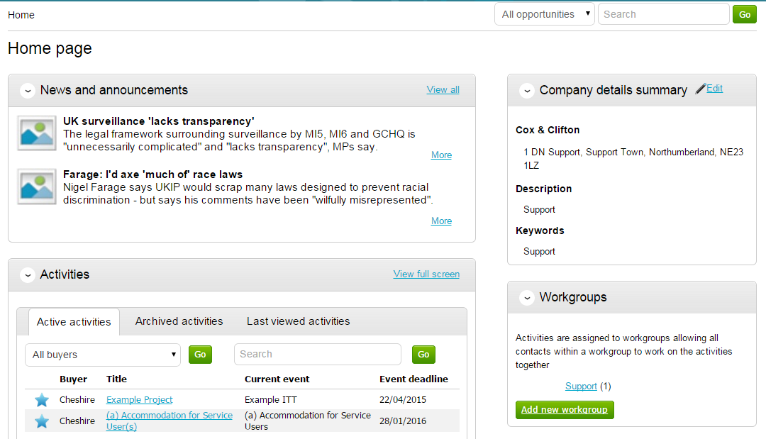
From here to view your current activities that you are working on, from the Activities section click on the title of the Activity you wish to work on.
The Activities area shows all the various tenders that you have registered with, this can be an ITT (Invitation to Tender), RFQ (Request for Quotation), a PQQ (Pre-Qualification Questionnaire) etc.
Note: The process is the same in the system for all types of tender opportunity, PQQ, ITT and RFQ’s, etc. however, in this case the ITT has been chosen to look through, and ITT will be referred to at various points. If you are completing a PQQ or Quotation (using attachments) then the screens will remain the same, it is only the terminology that will change. Online responses to online evaluations are covered in a separate guide/help section.
As you can see above, the Buyer, Title of the project, current event and event deadline is shown. In this case it shows a symbol to reflect it is new and it has not yet been viewed or worked upon yet.
By clicking on the title in blue, further information is now shown. From this screen all aspects of this project can be dealt with; the tender can be viewed, questions can be asked and answers received, additional information can be issued and your response can be put together and sent to the contracting organisation. Each stage of the procurement process will be seen as its own section.
To view the relevant stage of the project click Open Event within the relevant stage, in this instance ‘Example ITT’.
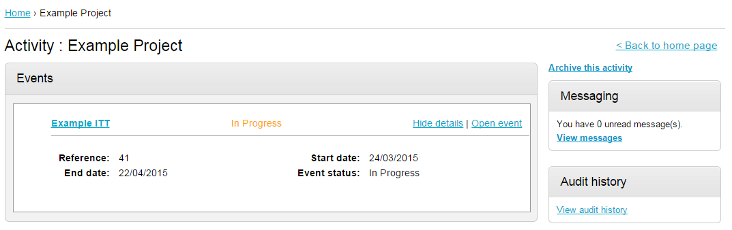
This will open the tender screen. This is broken up into different sections; Main details, Public attachments, Terms & Conditions, Item breakdown and Messaging. Note: There is also a countdown timer in the top right indicating the time left until the submission deadline.
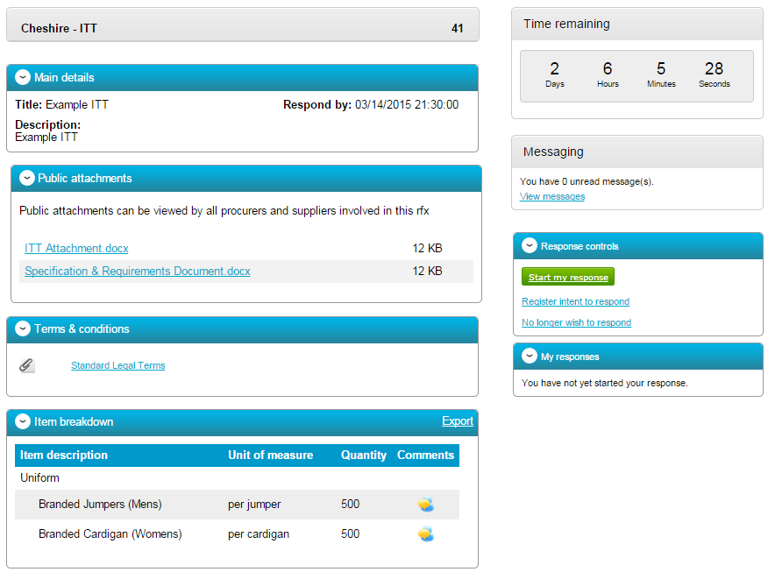
The different sections are explained below;
Main details
This section shows the title, description and date and time the completed tender must be returned by.
Public attachments
This section shows the attachments that have been published by the organisation. To download click on the title of the attachment.
Note: There may be no attachments here, however in the majority of cases there will be. Where there are documents, they should be downloaded and saved to your own network or desktop before working on them.
Item Breakdown
This section is the item breakdown for the tender used for pricing, if one has been created by the organisation.
Note: This is an optional section and there may not be one included with an exercise.
This shows the description of the group/line item, the unit the item is measured in, the quantity of these units required and any additional comments regarding the line item (shown by hovering over the icon.) An example of one is shown below.
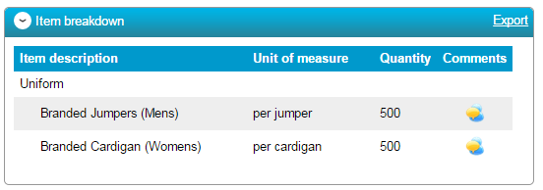
This can also be exported if required, by clicking Export.
Terms and Conditions
The Terms and conditions section shows the terms that have been used with this tender. To view them click on the Terms & Conditions title, shown in blue. There will be at least one set of terms here and there can be more depending what the procuring organisation have set up.

Messages
During the process all questions should be raised using the portal. The ability to ask questions/send messages is found in the Messaging section. Anything sent through this area will go to the member of staff that is working on this within the procuring organisation. Open this area by clicking on View Messages.
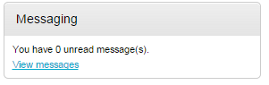
This will show any messages that have already been sent or received. To send a new message, click on the button.
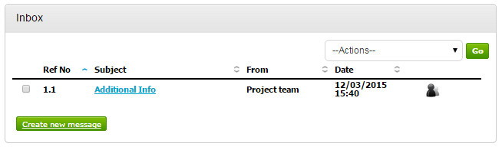
Populate the subject along with the main body of text, and once done then click on the Send button. Attachments can also be added (details of adding an attachment within the system is included later in this guide).
Click to issue the message to the procuring organisation.
The sent message is now shown in the Inbox.
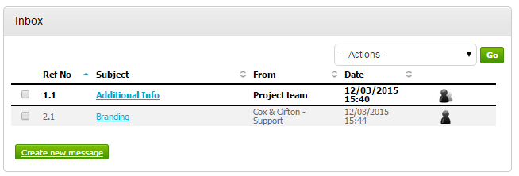
When a reply to that message is sent by the procuring organisation, you will see that the reply is linked to the original message by the numbering. All messages you send to the procuring organisation will be privately sent to them, shown by the symbol. When the procuring organisation replies they may reply privately to you alone (), or publicly (so all suppliers involved in this stage) can see the response ( ). Note: The system will NEVER show which supplier sent the original message.
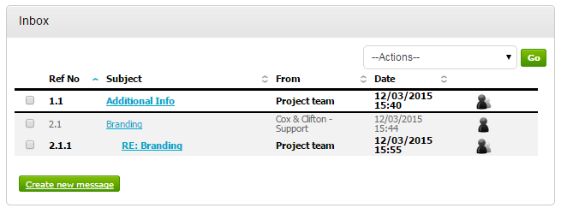

Completing the Response (using attachments)
To begin the response, from the tender summary screen, click Start my response.
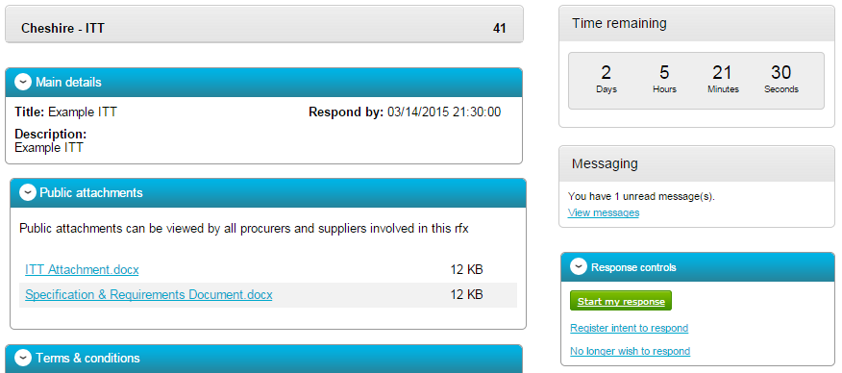

Responding to Online Questionnaires
When the tender is published an e-mail will be sent by the system to inform you of this and that the exercise (Pre Qualification Questionnaire, Invitation to Tender or the Request for Quotation) can now be viewed and worked on.
Note: While this section covers the questionnaire within a PQQ process, it remains the same for the return of any questionnaire, it is just the specific wording/questions that will change, the functionality will not.
Question sets
Within the response wizard, one stage will be the Question sets section. Here, you can view the questionnaire(s) that is being used with the tender.
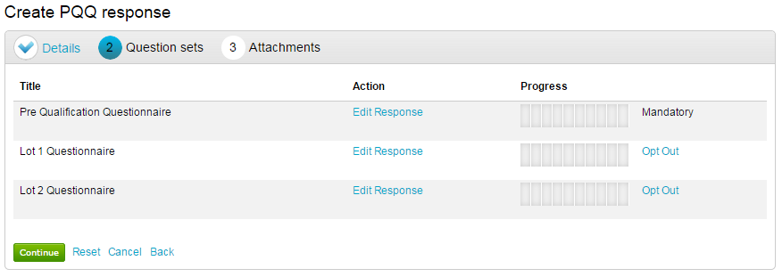
Note: This is optional, and the contracting organisation may not have included an online questionnaire, so if this stage may not be available.
If an evaluation has been included, click on Edit response to begin answering the questions/view further information and help.
This will open the evaluation summary screen.
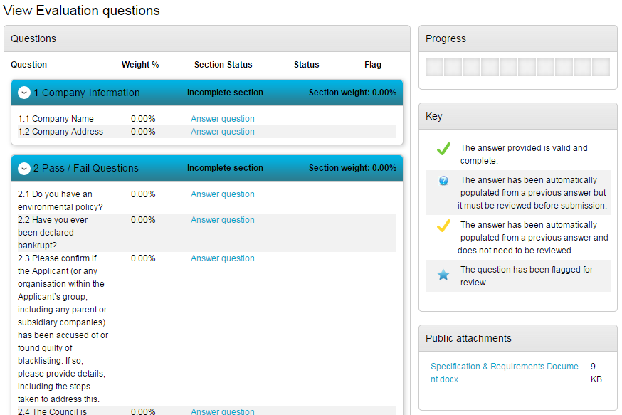Online Response
The screen above shows you the sections and relevant questions in each section and the total weighting value of each individual section and question.
Note: Some questions may have a symbol next to them automatically. This means the question has been answered by you before, and is still valid.
Click on Answer question to obtain more information about that question.
This will now bring up further information, including the title, weighting, and help and public attachments linked to this question. It will also give you the ability to answer the question.
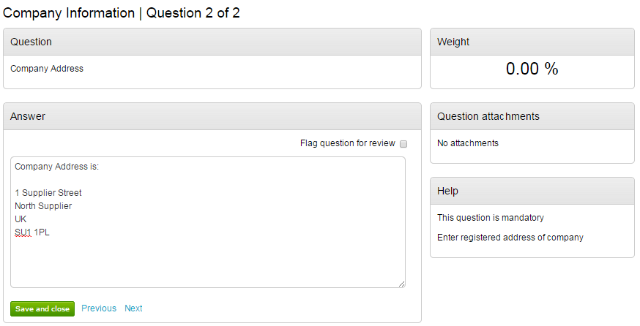
There may be further section help available. To view this, click in the top right of the screen.
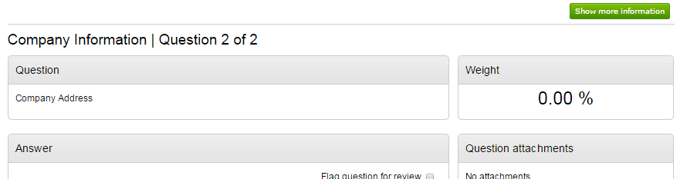
There is also the ability to flag a question for review, by marking the tick box.
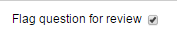
When you have answered a question, and are happy to move forward, you can either Save and close, which will take you back to the summary page, or click Previous / Next to move onto the questions before/after this one.
Alongside each question, you may have one of the following icons;
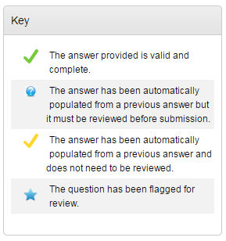
As you move through the questionnaire, the Progress bar on the summary page will reflect this and show how much has been completed.
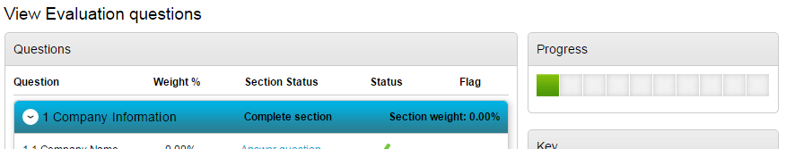
Each question may give different options on how you are required to answer the question. Examples are below; however the answer method is dictated by the organisation who has requested your answers.
Yes/No
This type of question requires you to answer either Yes or No.
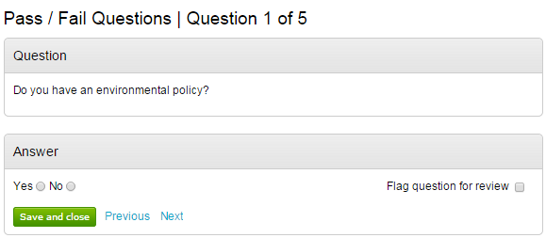
Number
This type of question requires you to answer using numerical values.
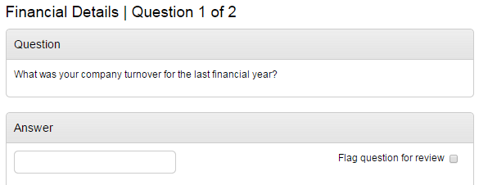
Text
You are required to answer this type of question with text. You will be advised of a maximum number of characters.
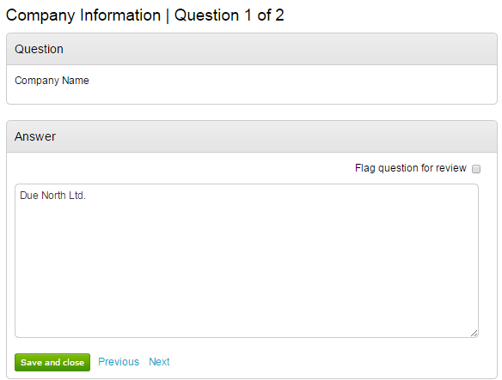
Option
This type of question requires you to choose from a drop down list
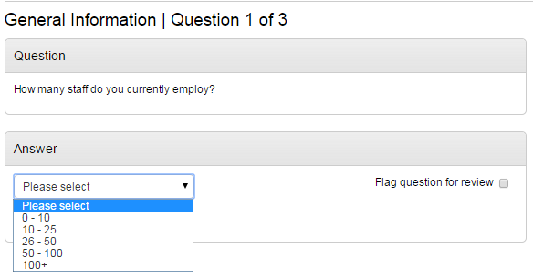
Checkbox
To answer this type of question you must check the box alongside the relevant answer(s). It may be that you are able to give more than one answer.
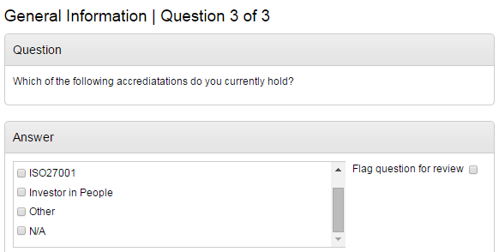
Attachment
With this type of question you are required to add an attachment as an answer.
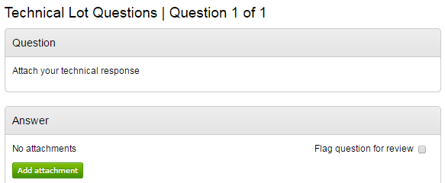
Click ‘Add attachment’ and you will be prompted with the document upload facility.

Responding to Lot Questionnaires
When a buying organisation publishes questionnaire sets using Lots, they will appear in your Tender Summary page as shown below.
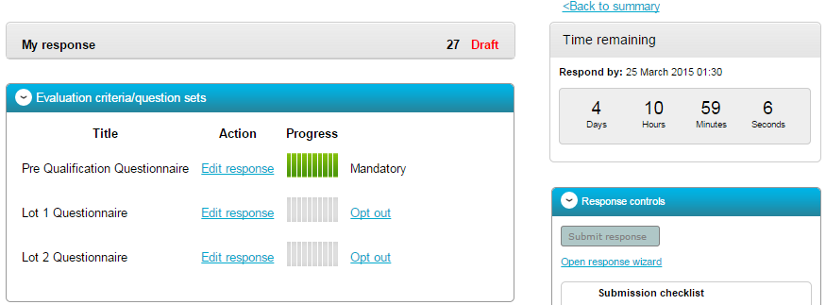
Note: Where ‘Mandatory’ is stated alongside a 'Lot' this means that the question set must be answered.
Note: Where ‘Opt out’ appear this means that the questions are optional to be completed.
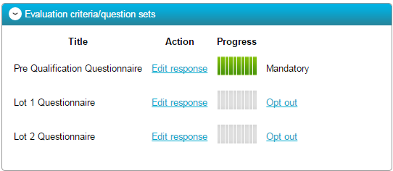
The response is completed by clicking Edit response and answering the questions. Once you have complete a series of questions the progress bar will be full.
If you wish to opt out of a non mandatory set of questions, then you are required to click on Opt out.
The system will then display your question sets in the following manor, to show questions sets you are required to answer and question sets you have opted out of.
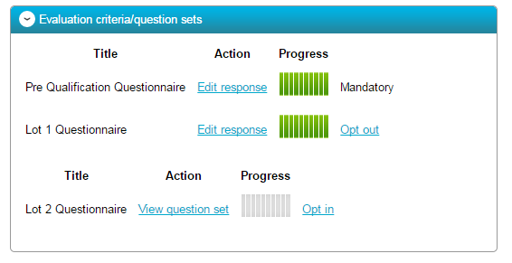
You can easily opt back in by clicking the Opt in option.

The Response Wizard
This will open up the response wizard that will take you through each stage of the tender response to make sure it is completed successfully. Stage 1 will always contain a welcome message which should be read carefully.
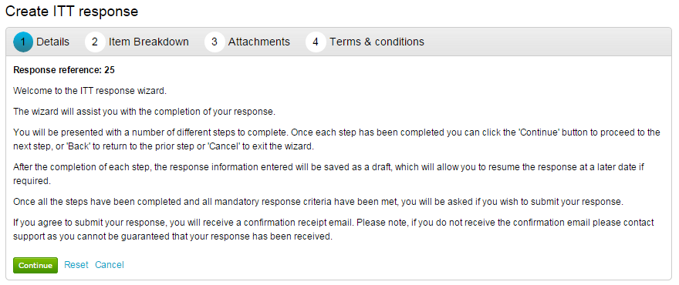
From the options section at the bottom of the page click Continue to move onto the next page or click Cancel to leave the wizard.

Item Breakdown
The next screen in this example is the Item description breakdown, however, if no item breakdown has been specified by the procuring organisation then this stage will not appear.
This stage is where the prices are entered for specific items.
This will show;
Item description- Here the specific item that is being asked for is specified
Unit of measure- Specified by the procuring organisation, this is the items that the item is measured in.
Quantity- The number of items required.
Unit Price-The price per unit of the item, in the specified currency, is entered here.
Total- This is calculated by the system by multiplying the quantity by the item price.
To enter the prices into the system click Edit in the corresponding row and enter the amount per item, with any comments (optional) and click Save to return to the overview, or Next to move to the next item.
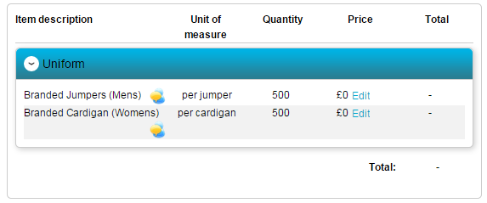
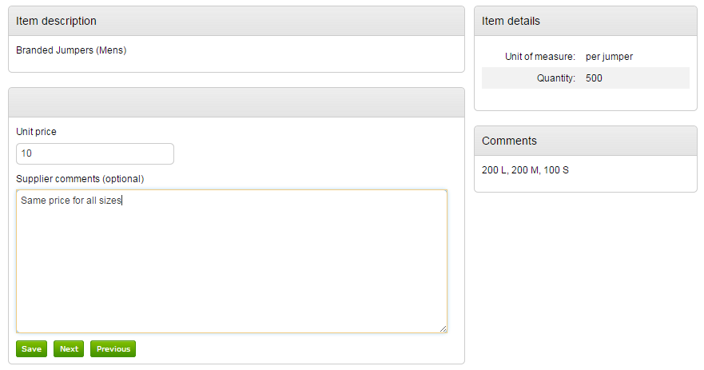
If you prefer, you can export the item template to Excel, complete there, and then upload the completed template using the Import/Export area as highlighted below.
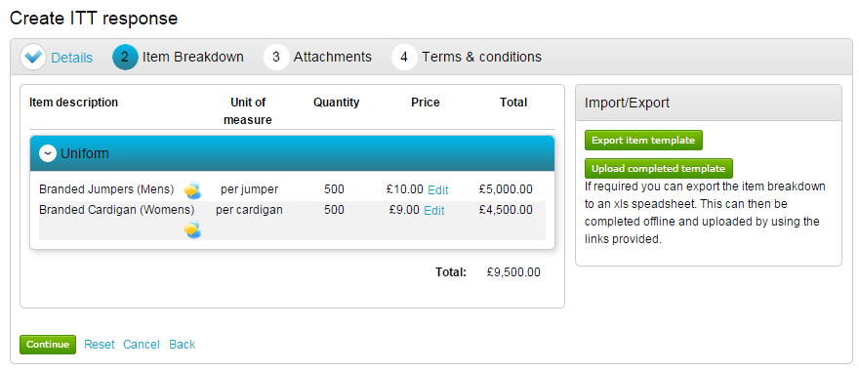
When complete click Continue to move onto the next page, Reset to begin the wizard again and remove all info, Cancel to leave the wizard completely (without saving) or Back to return to the previous stage.

Uploading Attachments
The next stage allows you to upload your relevant tender attachments.
Note: In some cases an attachment will be mandatory, so it may not let you submit until an attachment is added at this stage.
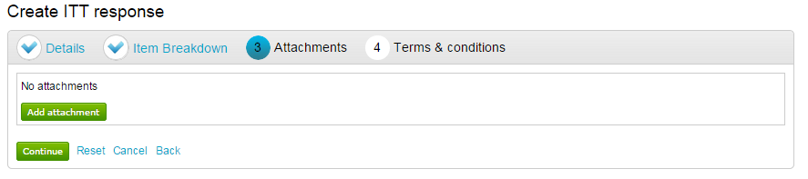
To add an attachment click .
You can now browse your computer for the attachments using the file uploader. You can add as many attachments as you require.
When uploaded, you can view an attachment by clicking its name, to remove the attachment click the red cross icon. When all required attachments have been added, click on the “Next” button to proceed to the next screen.
When complete click Continue to move onto the next page, Reset to begin the wizard again and remove all info, Cancel to leave the wizard completely (without saving) or Back to return to the previous stage.

Terms and Conditions
The next stage asks whether you accept the Terms & Conditions associated with this tender.
You can view the terms by clicking on its name in blue, which will open the Terms and Conditions documents attached.
Then you must select Accept or Decline, and if you do not agree you must specify the reasons why you do not agree in the space provided.
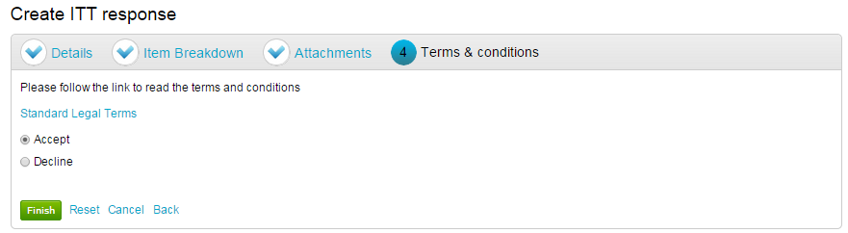
When complete click Finish to go back to the summary screen, Reset to begin the wizard again and remove all info, Cancel to leave the wizard completely (without saving) or Back to return to the previous stage.

Submitting the Tender Response
When all information is added you can submit the response by clicking Submit response. You will be required to reconfirm this by clicking Submit response for a second time.
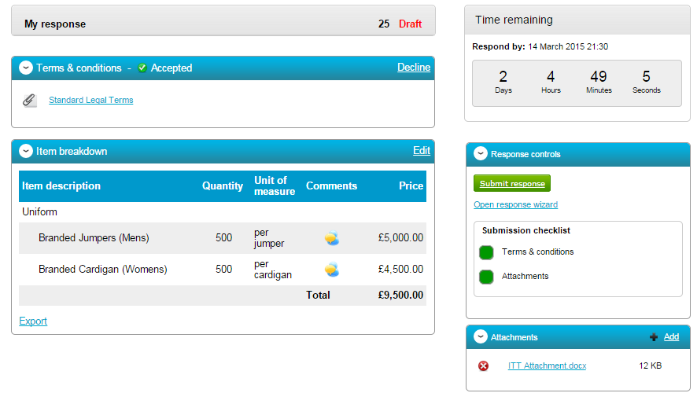
If the Submit response button is greyed out, the Submission checklist can be used to pick out why (anything with a red box will need revisiting.)

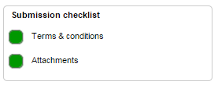

Editing Tender Response and Re-Submission
An important feature that is available after the tender response has been submitted is the ability as a Supplier to edit this response before the submission time and date has passed.
All the procuring organisation will see, is the version number of the response, but no previous submissions, providing they are all returned on time (further information on this later).
To edit a response from the tender summary screen, click Create new version.
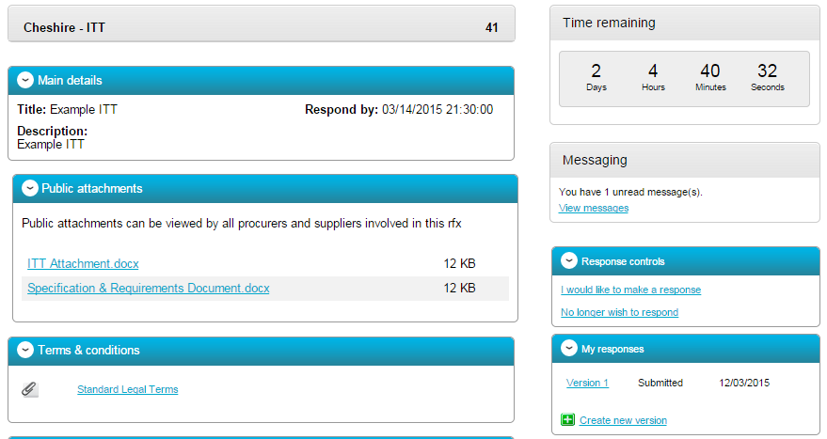
When this is clicked it will create a draft Version 2.
Each area can then be amended, either by editing the relevant section or clicking Open response wizard, and then submitted using the process outlined above.
