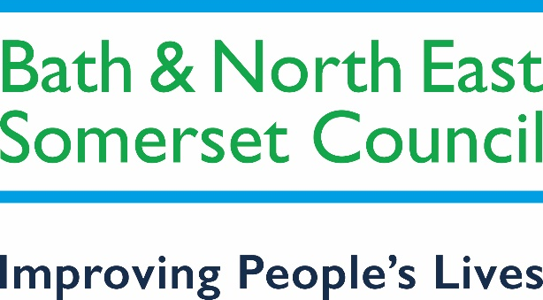

SUPPLIER ENGAGEMENT QUESTIONNAIRE

Upcoming Tender for

Hybrid Mail Services Contract

Introduction

Bath and North East Somerset Council is intending to approach the market with a procurement process, during the summer, to procure a contractor to provide Hybrid Mail Services to the Council.

The Council is aiming to maintain or improve existing services, expand the use of hybrid mail services across the council and gain financial efficiencies from the use of the services.

Background

The Council implemented a hybrid mail services in 2018 and has worked with the existing supplier to develop those services over recent years.

Despite teething issues, the service runs successfully for a number of council departments, although it falls short of the Council’s aspirations.

Approximate volumes for the most recent financial year were as follows:

- Total documents sent via BANES hybrid mail = 585,000
- This splits down into: Ad hoc mail of 185,000 and Bulk Mail volume of 400,000

The estimated annual expenditure of the future contract is likely to be in the range of £250,000 - £300,000, although the actual contract value will be dependant on additional service uptake, the drive for process efficiencies and potential digital delivery.

Intended Tender Approach

The Council intends to run a procurement exercise, using either a Competitive Dialogue or Competition with Negotiation approach in accordance with historical European Procurement Regulations (pending its replacement). The Tenders will include the completion of Supplier Selection Questionnaires and Tender documentation with Method Statement questions.

The service is expected to cover all aspects of hybrid mail delivery including all print and post, but also with the potential to include digital delivery and incoming mail.

Aspirations of the council include improved returned mail processing, expansion of service across other areas of the council, improved efficiencies for Council resource and movement toward digital delivery.

The evaluation of each will be multi-stage, starting with the with the completion of a Selection Questionnaire evaluation, before evaluating the initial tenders from successful suppliers.

The Council may then choose to enter into negotiation with the highest evaluated suppliers and look to clarify and potentially develop proposals.
Following negotiation, successful bidders may be invited to submit a Final Tender. The evaluation of the Final Tenders will lead to the selection of a preferred bidder and the completion of contract discussions.

The Council will clearly define the process within the tender documentation and ensure all engaged suppliers are fully appraised of the progression and any changes within the procurement process.

Method Statement questions are expected to be under the headings shown below. These will be in the form or questions related to the topic headings and will require tender responses, including evidence of the organisation’s ability to deliver.

- Delivery Methodology:
  - Proposed technical solution.
  - Resource and Management Plan
  - Experience of previous delivery

- Mobilisation:
  - Proposed mobilisations plan - system configuration and integration.
  - Movement from existing provider
  - Communication plan
  - Mobilisation resource and structure
  - Expectations and obligation on the Council

- Change, Innovation and Added Value
  - Managing and contributing to changes in delivery
  - Approach to Innovation and Added Value

- Reporting and KPI’s

- Service expansion plans and cultural change

- Climate and Nature emergency

- Social Value

Procurement Plan (subject to change)

Date or Target Date | Activity
29th June to 31st July | Supplier Engagement Exercise – RFI and PIN
31st August | Release Tender – Invitation to Submit Initial Tenders
14th October | Supplier Response Deadline for Outline Submissions
31st October | Initial Evaluation
1st to 30th November | Negotiation Sessions
15th December | Invitation to Submit Final Submissions
15th January 2022 | Supplier Response Deadline for Final Submission
31st January | Evaluation
15th February | Contract award notifications
1st March to 30th September 2022 | Contract Signature and Mobilisation
Engagement Questionnaire

Please answer all questions and respond in any appropriate format.
- Do you have the requisite skills and experience to fulfil the contract?
- Do you have the resource availability to submit the tender within the planned timescales and is it your intention to submit a proposal?
- Have you any comments on the intended procurement approach and tender timescales?
- Have you any comments on the proposed Method Statements headings?
- Would you suggest any additional topics or changes to intended topics to be covered within the Method Statements?
- The technological solution is key to the successful mobilisation and delivery of the service. Can you provide brief detail of you proposed solution and how it is likely to contribute to the service success? Please specify how the solution varies for bulk and “ad hoc” services, and how you deal with varying file formats.
- Using your experience, can you provide any information to assist with returned mail processing and how we could deal with this element of the contract / tender?
- Please provide brief detail of you Mobilisation experience. Please also comment on your expectations from the Council with regard to resources and preparation for mobilisation.
- Are there any lessons you have learned from previous tenders or contracts that you think would be useful for us to take into account as part of this process?
- Are there any additional comments you would like to make that you feel would be helpful?

