TENDER OPPORTUNITY

Document title | Shellfish Sampling Services to Cornwall Port Health Authority – Scope of Services and Specification
Corporate directorate | Neighbourhoods
Service | Neighbourhoods and Public Protection
Contract Manager | Timothy Bage
Date | 28th April 2020

If you would like this information in another format please contact:
Cornwall Council
County Hall
Treyew Road
Truro TR1 3AY

Telephone: 0300 1234 100
Email: enquiries@cornwall.gov.uk
www.cornwall.gov.uk

Opportunity
Port Health is a Service of Cornwall Council. The Council has a statutory duty, overseen by the Food Standards Agency (FSA), to carry out official controls in relation to the regulation of the shellfish industry in Cornwall. This entails regular sample testing of shellfish for bacterial and bio-toxin levels across a number of locations, primarily between Looe and the Lizard Peninsula, but those locations could expand to other sites around the Cornish Coast. This requires the provision, use and maintenance of third party owned and operated vessels, the provision and servicing of between 25-35 (currently 27) individual mooring systems, use of crew members and use of open water diving services.

The Authority is anticipating receiving bids from prime contractors, who will take responsibility for providing all aspects of the service requirements either through their own resources or by suitably managing sub-contractors, where necessary, and as such collaborative bids would be welcomed, as long as it is clear which organisation is the lead bidder and would be responsible for contracting with the Authority.

The tender is split into two Zones (A and B). Bidders may opt to bid for provision of services in either zone, or both. Currently vessels and mooring systems services are required in both zones. Diving in currently limited to Zone A. However, diving may become a requirement within Zone B in the first year of the contract, therefore the authority is also asking for diving service bids for Zone B, on the basis of it being required in due course.

Financials
Indicative Services Budget - Financial Year across both zones inclusive.
2020/2021

£50,000

2021/2022

£50,000

2022/2023

£50,000

2023/2024

£55,000

2024/2025

£55,000

Living Wage Requirement
Cornwall Council is a Living Wage Foundation (LWF) accredited local authority. The LWF Living Wage is currently £9.30 per hour, since November 2019, and increases each November when the new rate is made public. In April 2019, the Council gained Living Wage Foundation accreditation which means that all third-party contractors the Authority contracts, and their sub- contractors, must ensure their staff are paid at this hourly rate, as a minimum.

What we need from service providers
Vessels
Vessels are needed for access to both coastal and estuarine waters for the purposes of obtaining shellfish samples, maintaining buoys and maintaining a presence on the water to increase the visibility of Cornwall Port Health Authority (CPHA).

Vessel owners, operators and skippers of vessels MUST comply with all current Merchant Shipping Acts and Regulations, and codes of practice.

Operators and Vessels must comply with Regulation MGN 280 (N) Small Vessels in Commercial Use for Sport or Pleasure, Workboats and Pilot Boats – Alternative Construction Standards and the Work Boat Code of Practice.

Cornwall Port Health Authority (CPHA) is a service of Cornwall Council – it has more shellfish beds than any other Authority in the UK. The authority predominately uses 27 moorings as Representative Monitoring Points (RMPs) to hold shellfish sampling bags, which need to be easily accessed to obtain samples and restock the bags ready for the next sampling run. There are also monitoring points that require a diver to retrieve the shellfish stock from the seabed.

There are currently 39 active beds (Appendix 4) and this is an indicative not exhaustive list which may be subject to change. There are further classification applications in the pipeline, these are shown in Appendix 3.

Service Providers will be required to meet a Port Health Officer at a designated location/port. The Port Health team may require 2 – 3 vessels at any one time to be operational for this purpose, for example a boat in Falmouth and Penzance at the same time on the same day.

Vessels must be coded (kept in code and regularly maintained / inspected) to meet Maritime and Coastguard Agency (MCA) standards for commercial boats to access both estuarial and open waters – as per MGN 280 and Workboat Code standards for small commercial vessels and it would need to be coded to at least Code standard 3, and above.

The boat must be ‘manned’ to the RYA competent crew standard for the deck hand (s) with the Skipper having the relevant in date qualification for the vessel coding, as shown on Page 124 of the MGN280(N) guidance document, with commercial endorsement. All crew must have either a ML5 or ENG1 medical certification.

The vessel skipper must comply with Annex 7 of MGN 280 (N) for each journey. They must carry the basic number of safety equipment, such as life jackets, fire extinguishers and SOLAS Pack, as required according to the coding of the vessel.

The vessel for shellfish sampling must have capacity to hold at least 6 people and a significant amount of equipment such as cool boxes, live shellfish for restocking bags, and equipment for diving or basic maintenance of RMPs (e.g. sample bags and baskets/ rope).

The vessel must have a low enough draft, conducive to operating at the relevant RMP’s, and to be able to access areas at low tide so that it is usable with the RMP system for all locations. These can be as low as 2m depth.

The vessels must be fast enough (operating at anywhere between 6 knots (harbour limits) and 30 knots in open water), to ensure that trips for shellfish can be completed and processed in good time for laboratory collection and testing.
Trips cannot exceed 6 hours and must be concluded by 2pm at the latest.
There is an expectation that reasonable, yet safe, progress will be made by the skipper at all times to complete the task in good time.

The vessel for patrol must have capacity to hold at least 4 people, and a basic level of equipment – grab bag for each person. Patrol is the motion of having a visible physical presence on the water in order to give confidence to the shell fishing community that we are enforcing regulations and gathering evidence of contraventions of the law.

The vessels for deployment and maintenance of buoys / moorings are to be suitable for the type of work being conducted and must comply with the relevant stability requirements for such vessels.

Day rates provided to CPHA must include all associated costs with administering the journey, i.e. harbour fees, fuel, other consumables and crew.
Representative Monitoring Points (RMPs)
Cornwall Council requires service provider(s) to provide, inspect and maintain moorings. Inspection involves total removal from the water and all parts to be visually inspected for corrosion and / or damage, that might cause failure or loss of all or part of the system.

The authority currently has 27 assets deployed – it requires them to be inspected and serviced and parts replaced as required – this might be a sinker, chains, ropes, buoys, moussed shackles, and bags/baskets or even a whole system to be provided, as required, to suit the various offshore and estuarial environments.

The moorings used are required to hold, in situ, a suspended bag of live shellfish (the sample) or in some instances to act as a temporary hold for the sampling vessel to fix location while dive teams deploy. See image 3, Appendix 5.

RMPs are required to meet a design detail so that they adequately hold a sample bag in situ, whilst being resilient enough to withstand weather and tidal conditions. They are designed to be lightweight, robust, safe to haul and clearly visible for navigation and identifiable as belonging to Port Health.

The RMP’s are required to be maintained on a planned (Annual) basis but also on a reactive basis – if parts are lost or damaged. The moorings you deploy must be fit for purpose (Contractor to provide specification for new moorings to CPHA) and any loss occurred down to poor standard of equipment deployed, would require the contractor to rectify the situation at their own cost.

Maintenance is defined as replacements of parts affected by corrosion or damage.

Deployment is defined as the physical deployment of a system, or parts of a system to a specified location.

Service Provider(s) should be available to work in the current and possible future locations - These are currently located within the Fowey and St Austell Bay areas, along the River Fal and the Helford River, however they may be subject to change (as per maps provided in the document below).

Service Provider(s) will be required to report on necessary actions to be taken to maintain the condition / integrity of the mooring to the Contract manager, in a format to be mutually agreed post contract award.

A reserve stock of parts and systems would need to be held for deployment at short notice, to be deployed by the Service Provider within 2 working days, prevailing conditions allowing.

The authority requires a price for the inspection service at the currently 27 known locations, including costs of provision for each part of a full mooring and any deployment costs for any future moorings, that may need to be added to aid the monitoring programme.

Permissions for deployment would be managed by Port Health.

Service Provider(s) will be liable to pay the relevant harbour access / mooring dues throughout the life of the contract.

The authority has full legal title of the RMPs over existing assets and over any further equipment that is purchased from the contractor.

Rates for deployment of new assets to locations must include all associated costs with administering the journey, i.e., harbour fees, fuel, other consumable and crew etc.

Diving
The dive contractor needs to be able to respond to both planned and reactive work.
The Dive Contractor must have a dive team sufficient and proficient to comply with the requirements of the Diving at Work Regulations 1997 and the Health and Safety Executive Code of Practice for Archaeological and Scientific work.
The Dive Contractor must be aware of and comply with the requirements of the Approved Code of Practice for Diving at Work, and they must also comply with any updates to the legislation or guidance whilst the contract is operable.
The Dive Contractor must provide a dive plan and risk assessments for the dives they are required to perform. The contract manager will request these from the successful service provider before commencement of the contract.
The Dive Contractor must have the relevant competencies (Qualified divers to depths of at least 30ft) and adequate insurance, i.e., Employer’s Liability, Public Liability and Professional Liability etc., as specified within the electronic Invitation to Tender documentation and evidenced during the contract award stage.
The diver team (except supervisor) must hold the relevant ‘in-date ‘diving medical certifications.
The dive operation and harvesting of the differing types of Live Bivalve Molluscs (LBMs) should be undertaken in line with prevailing regulations governing shellfish and as directed by the client.
The Dive Team must have suitable and compliant equipment such as air bottles, regulator masks, pressure gauges, sample bags etc. to gather clams and return them to the surface safely. Razor clams must be hand gathered.
Day rates provided to CPHA must include all associated costs with administering the dive, i.e., safety equipment, insurance, air supplies, other consumables and staffing etc.

Other requirements
A sampling plan will be provided to cover all planned sample dates for each year that will take into account tidal access restrictions. However, due to poor weather that may affect safety to access RMP’s or dive in offsite locations, some flexibility will be required to cancel / resume planned trips. Additionally, Port Health will require further sampling to be conducted at many of the sites and this will be arranged on a short notice basis usually with 24 hours’ notice.

Flexibility – Weather often cancels planned trips or improves to allow for trips that were not thought initially to be viable. Trips are also required at short notice on occasions. You should be able to service the authority within 24 hours’ notice.
There may be the need to deploy boats for reasons other than shellfish or monitoring station – such as the need to have a visible patrol in certain areas at certain times of the year (approximate frequency of 1 – 10 days per year).
Deployability – Each of the zones are large areas to cover geographically.
Over the course of the contract duration, the nature, number and size of the shellfish industry may change, therefore locations and times of deployment, and the type of equipment needed, may also need to change accordingly.
Service Providers should be able to demonstrate contingency plans in event of personnel or equipment (e.g. vessel) failure. This forms part of the quality- based assessment questions, as set out within Section 11 of the electronic invitation to tender documentation.
Cancelled Trips – There is an expectation that through contract management, there will be advance discussions between the provider and officers of the Port Health Authority. If it is decided that the outlook for the planned journey is favourable, then both parties will agree vessel deployment on a 24 hours’ notice basis. If there is a substantial change to the prevailing conditions, then a pre-deployment phone call must be made to agree deployment. If no agreement can be made, then no deployment shall take place on that day. If deployment is agreed, then in all circumstances the skipper of the vessel shall have signed agreement of the officer and dive team (if applicable to proceed) and stand down shall can be agreed by all parties, subject to an inter-trip change in prevailing conditions that would hinder the collection of samples and/or health and safety. In these circumstances, 25% of the full day’s costs may be considered acceptable by way of compensation to the vessel operator and dive team (if applicable and justifiable).
Potential Conflict of Interest - Where you have a vested interest in the shellfisheries industry, if you are an appointed service provider, whether main or sub-contractor, then you must ensure that you are providing the same standards of care and service across the whole the county to ensure that Cornwall Council and/or the service providers do not attract any negative publicity. You will be required to follow the processes and instructions of CPHA in relation to standards of service delivery / security of sample collection.
Changes to Service Delivery – during the lifetime of the contract there may be changes to the level of service delivery provided by Cornwall Council. These changes in service may bring about an increase or a decrease in the use of the various service providers. From time to time Cornwall Council may seek assistance of industry partners who offer to contribute to the operation of the service on a pro bono basis. Cornwall Council reserves the right to make changes to service delivery or utilise industry assistance.

Key Performance Indicators

These shall be assessed on a 12 month rolling basis.

Vessels

The contractor shall ensure that they supply a vessel (upon request) to the Port Health Team for 95% of the scheduled and reactive work, over a rolling 12 month period, in relation to shellfish collection.

The contractor shall also seek to ensure, over a rolling Twelve-month duration, that 90% of all journeys started are successful at achieving the full sampling run.

RMPS

No more than 2 RMPs shall be lost to sea/land in a single contract year.

Diving

The contractor shall seek to ensure, over a rolling Twelve-month duration, that 90% of all journeys started are successful at achieving the full sampling run.

Appendix 1 - Sample Plan for Current Runs in Zone A and Zone B

The table below shows the work calendar where vessel deployment is required for the rest of 2020 until May 2021 as an illustration of the planned work to be undertaken by the Port Health Team.

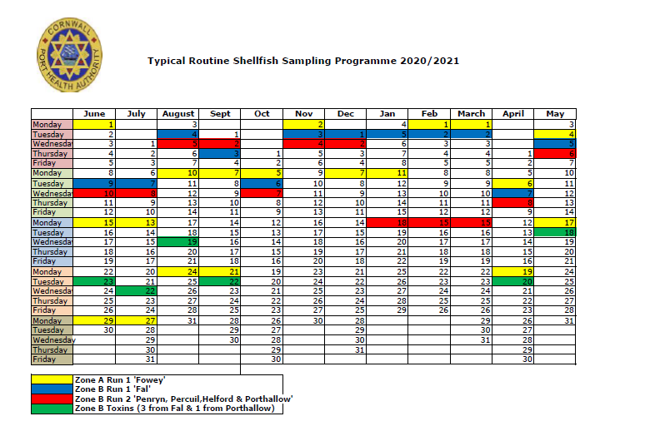

The table below shows a typical calendar year where vessel deployment is required, it is provided as an illustration of both the planned and reactive work that was undertaken by the Port Health Team in 2019. This provides some background on the requirements last year, from which you can project likely future demand.

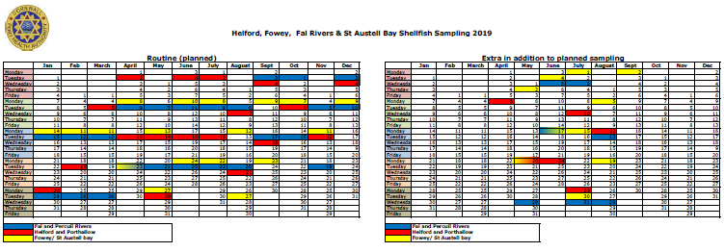

Appendix 2 – Zone Maps and Co-ordinates

Zone A Run 1 ‘Fowey’ production area monitoring locations (Blue = sample point, Red = dived)
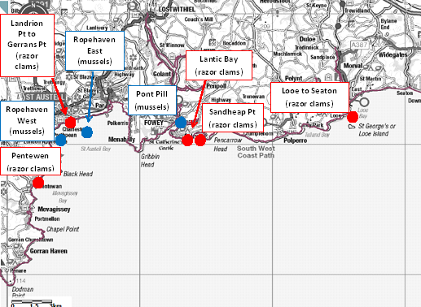

Monitoring Point Name (RMP) | NGR | Latitude & Longitude (WGS84) | Sample requirements
Landrion Point to Gerrans Point | SX03975121 | 50°19'.85N 04°45'.62W | Dive team to retrieve sample
Lantic Bay | SX13855036 | 50°19'.58N 04°37'.25W | Dive team to retrieve sample
Looe to Seaton | SX25985311 | 50°21'.30N 04°27'.08W | Dive team to retrieve sample
Pentewen | SX02264678 | 50° 17.266N’  4° 46.633W’ | Dive team to retrieve sample
Pont Pill | SX 1302 5157 | 50°20.05’N  4°37.72’W | Sample bag attached to mooring
Ropehaven West | SX 0441 4929 | 50° 18.662’N  4°44.902’W | Sample bag attached to mooring
Ropehaven East | SX 0574 4972 | 50°18.920’N 4°43.796’W | Sample bag attached to mooring
Sandheap Point | SX 1630 5094 | 50°19'.95N 04°35'.20W | Dive team to retrieve sample

Zone B Run 2 ‘Penryn, Percuil, Helford & Porthallow’ production areas monitoring locations (all sample bags)

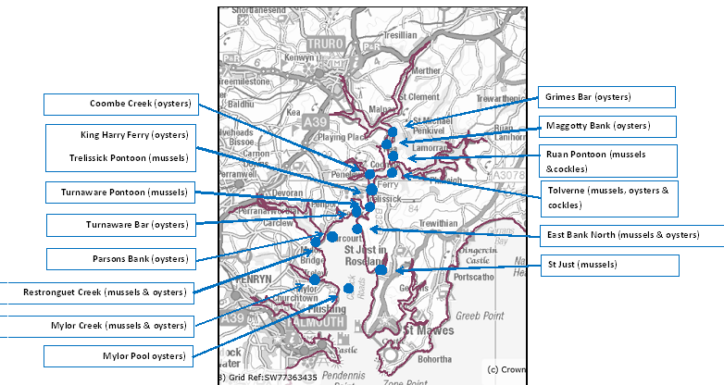

Monitoring Point Name (RMP) | NGR | Latitude & Longitude (WGS84) | Sample requirements
Coombe Creek | SW8400 4030 | 50° 13.39’N 5° 1.77’W | Sample bag attached to mooring
East Bank North | SW 8366 3789 | 50°12.08N 5°1.97W | Sample bag attached to mooring
Grimes Bar | SW8513 4212 | 50° 14.40’N 5° 0.88’W | Sample bag attached to pontoon
Maggotty Bank | SW8492 4143 | 50° 14.02’N 5° 1.04’W | Sample bag attached to mooring
Mylor Creek | SW 8196 3546 | 50°10.74N 5°3.32W | Sample bag attached to mooring
Mylor Pool | SW 8280 3517 | 50°10.60N 5°2.60W | Sample bag attached to mooring
Restronguet Creek | SW 8147 3719 | 50°11.65N 5°3.79W | Sample bag attached to mooring
Ruan Pontoon | SW8502 4095 | 50° 13.76’N 5° 0.93’W | Sample bag attached to pontoon
Tolverne | SW8480 4037 | 50° 13.45’N 5° 1.10’W | Sample bag attached to mooring
Trelissick Pontoon & King Harry Ferry | SW8409 3949 | 50° 12.96’N 5° 1.67’’W | Sample bag attached to mooring
Turnaware Bar | SW 8351 3870 | 50°12.52N 5°2.13W | Sample bag attached to mooring
Turnaware Pontoon | SW8407 3879 | 50° 12.58’N 5° 1.66’W | Sample bag attached to pontoon
St Just | SW 8491 3645 | 50°11.336N  5°0.874W | Sample bag attached to mooring

Zone B Run 2 ‘Penryn, Percuil, Helford & Porthallow’ production areas monitoring locations (all sample bags)
Percuil River (oysters)
Porthallow
(mussels)
Black Rock (mussels)
East of Groyne Point (oysters)
South of Port Navas Bar (oysters)
Falmouth Wharves (mussels & oysters)
Monitoring Point Name (RMP) | NGR | Latitude & Longitude (WGS84) | Sample requirements
Black Rock | SW 8573 3281 | 50:9.39185N 5:0.06298W | Sample bag attached to mooring
East of Groyne Point | SW 7445 2643 | 50° 5.703’N 05° 9.297’W | Sample bag attached to mooring
Falmouth Wharves | SW 7994 3400 | 50°9.91N 5:4.96W | Sample bag attached to pontoon
Percuil River | SW 8585 3369 | 50:9.86867N 4:59.99203W | Sample bag attached to mooring
Porthallow | SW 8021 2383 | 50° 4.432N 05° 4.382W | Sample bag attached to mooring
South of Port Navas Bar | SW 7537 2692 | 50° 5.988’N 05° 8.543’W | Sample bag attached to mooring

Appendix 3 - Map of Potential Future Classification Locations
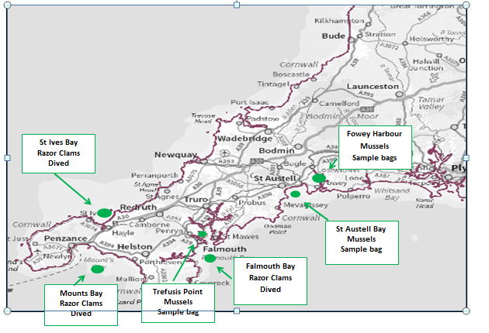

Appendix 4 - Shellfish Beds currently classified by Cornwall Port Health Authority

Fal River | Bed ID | Species
- GRIMES BAR | B033E | Native Oyster & PO
- MAGGOTTY BANK | B033F | Native Oyster & PO
- RUAN PONTOON | B033Y | Mussel
- TOLVERNE | B033H | Native Oyster & PO
- COOMBE CREEK | B033V | Native Oyster & PO
- TRELISSICK PONTOON | B33BD | Mussel
- KING HARRY FERRY | B33BI | Native Oyster & PO
- TURNAWARE PONTOON | B033Z | Mussel
- TURNAWARE BAR | B33BF | Native Oyster & PO
- EAST BANK NORTH | B33BM | Native Oyster & PO
- EAST BANK NORTH MUSSELS | B33BQ | Mussel
- PARSONS BANK | B033L | Native Oyster & PO
- RESTRONGUET CREEK | B33BE | Native Oyster & PO
- RESTRONGUET CREEK | B33BN | Mussel
- MYLOR CREEK | B033N | Native Oyster & PO
- MYLOR CREEK | B33AN | Mussel
- MYLOR POOL | B33BG | Native Oyster & PO
- ST JUST UPPER | B33BK | Mussel
- PERCUIL RIVER | B033R | Native Oyster & PO
- BLACK ROCK | B33BL | Mussel
- FALMOUTH WHARVES | B033X | Native Oyster & PO
- Helford River
- EAST OF GROYNE POINT | B034Q | Native Oyster & PO
- PEDN BILLY | B34AG | Native Oyster & PO
- Porthallow
- PORTHALLOW NORTH | B34AA | Mussel
- St Austell Bay/ Fowey
- PONT PILL | B70AB | Mussel
- ROPEHAVEN WEST/ ST AUSTELL BAY | B070W | Mussel
- ROPEHAVEN EAST/ ROPEHAVEN OUTER | B70AE | Mussel /Razor Clams
- SANDHEAP POINT RAZOR CLAMS | B70AH | Razor Clams
- PENTEWEN RAZOR CLAMS | B70AL | Razor Clams
- LANDRION POINT TO GERRANS POINT | B70AN | Razor Clams

Appendix 5 – Photographs of Shellfish Sample Bags and Buoys (RMP)

Image 1 – A Shellfish Sample Bag

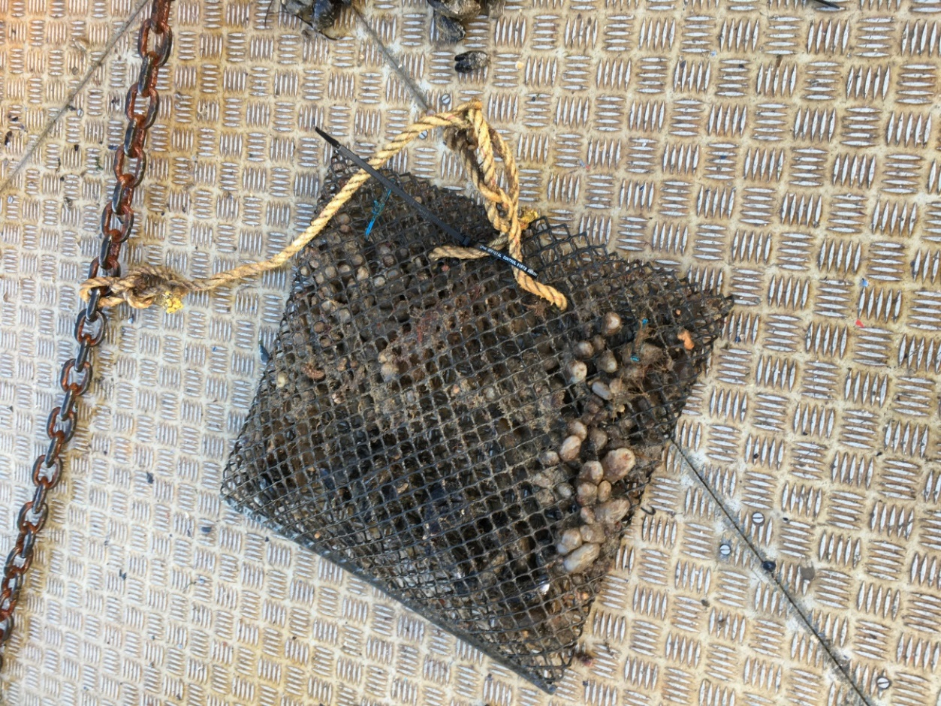

Image 2 – A sample basket

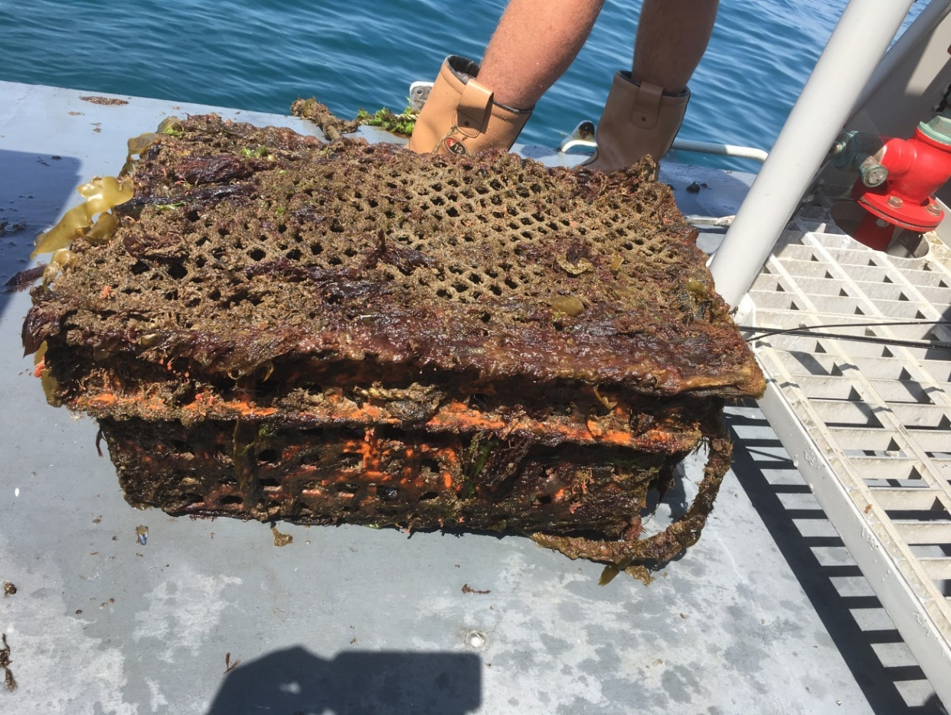
Image 3 – a Buoy deployed at Porthallow – Example of a 200ltr can at a deep-water site.

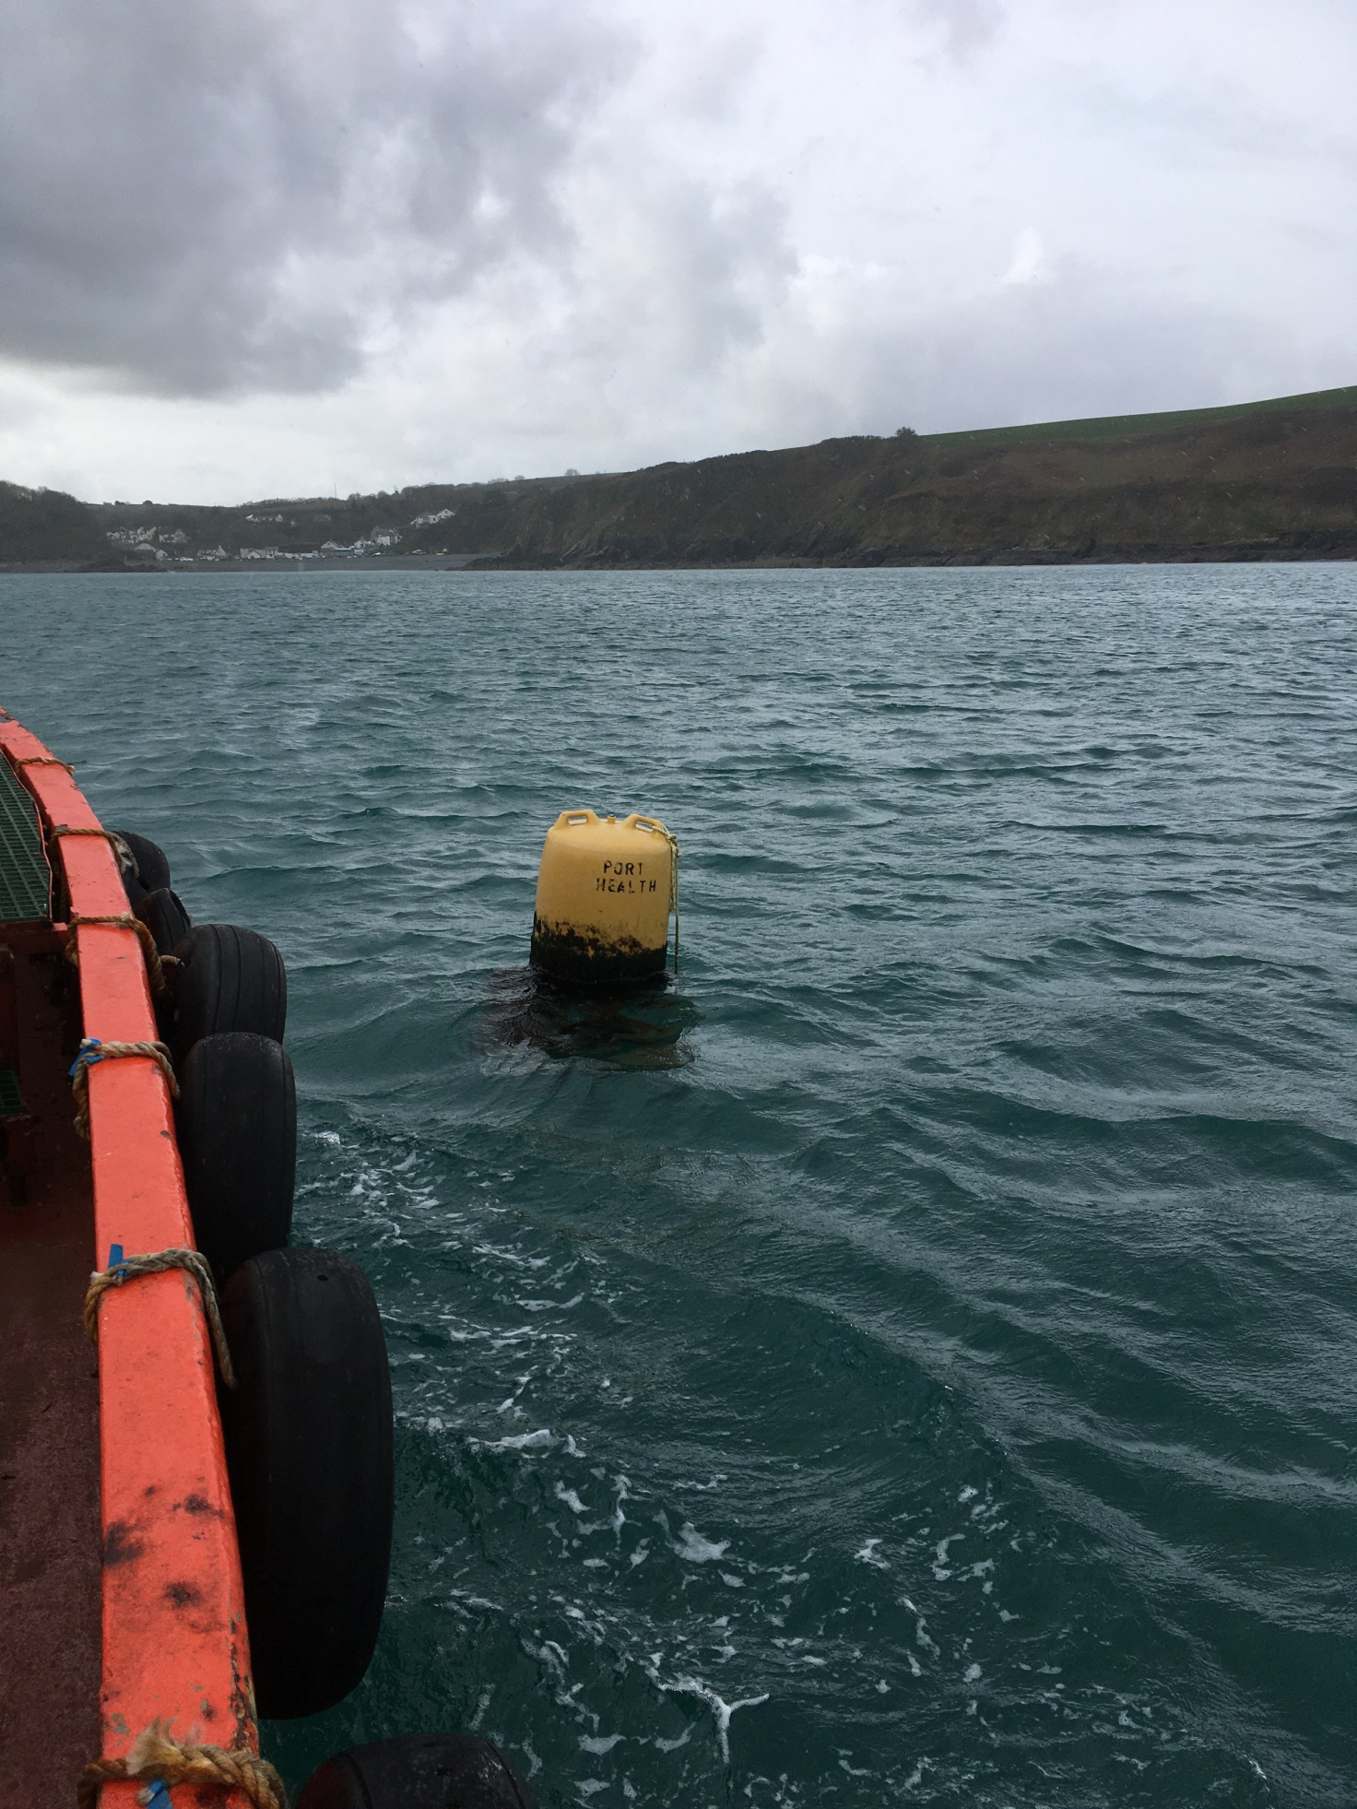

Image 4 – Officer on board with stock and shellfish monitoring documents / timetable

