Breast High Road (Borrowdale and Bretherdale) Method Statement.
Location of proposal
Breast High Road - 3555003/367004.
- ‘Borrowdale’ section runs from the junction with the A6 at GR NY 553,035 and the fell wall at GR NY 566,043 , and
- ‘Bretherdale’ runs from the fell wall at GR NY 566,043 to the entrance onto the common from Bretherdale at GR NY 575,048.

See maps provided.
Access to the site can be reached either from the A6 at GR NY 553,035 (Borrowdale side) or GR NY 575,048 (in Bretherdale) where the Byway leaves the road.
General Description of Works
Breast High Road is a Byway Open to All Traffic and Unclassified County Road within the Parishes of Whinfell, Tebay and Orton within the Lake District National Park. The route crosses mainly open fell land and is unsealed for most of its length, climbing steeply to 430m from either direction. Approximately 3km in length its surface consists of bedrock, large loose stones, hard packed stony track and broken tarmac.
The route has over a number of years suffered significant deterioration, due to the exposed nature of the route, visitor pressure and significant flood events in the area. This has caused damage to the route including:
- blocked drainage gullies and culverts,
- exposed, broken concrete drains, where the surrounding road surface has washed away.
- displaced and unstable stone on steeper sections,
- the lane surface has sunken to below the surrounding hillsides, forming channels for water to run down.
- Erosion of surrounding landscape.
- As a consequence of its condition, users are now deviating from the route itself, causing further damage to the fragile landscape surrounding the road.

We are proposing maintenance and repair works to the route to create a sustainable route enjoyable for all users.
The route has been divided into two sections for funding purposes. These are referred to as
- ‘Borrowdale’ running from the junction with the A6 at GR NY 553,035 and the fell wall at GR NY 566,043 , and
- ‘Bretherdale’ running from the fell wall at GR NY 566,043 to the entrance onto the common from Bretherdale at GR NY 575,048.

For further details please refer to the maps, photos and specification provided. We require separate itemised costings for ‘Borrowdale’ and ‘Bretherdale’ due to the funding application requirements.
Materials to be used
Surface material – Burlington Oversize/Subbase 6F2 aggregate (or another similar material agreed with site supervisor) will be required to provide a 6 inch capping layer over the subsoil sections of path.
See Work Specification for dimensions and estimated aggregate required.
Pitching Stone – will be required for pitching waths and fords on the route. This will need to be of local provenance and the source agreed with the site supervisor.
See Work Specification for dimensions and estimated stone required for Pitched Waths/Fords and Culvert headwalls.
Environmental Protection
All plant and machinery will run on Bio Oil and will be in a suitable and safe condition.
Suitable protection will be in place to stop any run off or silt entering any water courses. Straw bales will be in any small streams drains to help filter any silt.
Spill kits will be onsite at all times to prevent any damage to the surrounding area and all staff on site will know where the spill kits are and will be stored in an agreed location.
All turf will be landscaped to cover up any bare soil to stop any visual impact on the landscape and any soil being washed into water courses.
Any excess soil will be landscaped into the surrounding area and if necessary reseeded when the work is finished.
All Machinery will be washed off and cleaned to maintain Bio Security on the work site at all times.
Designated turning sites will be agreed with site supervisor to protect any damage to the surrounding area.
All vehicles will use the access routes agreed by the site supervisor at all times. Any alteration to this will be agreed with the site supervisor and contractor.
Fuel transfer pumps will be used when refuelling machines so there is reduced risk of fuel being released into the natural environment.
Health and Safety
All Plant and machinery will be operated by trained and experienced drivers and will be stored securely and safe overnight.
Correct Risk assessments will be in place before any work is carried out.
The general Public will be excluded from the work site where necessary and any public access will be signed to warn people of the work being carried out. We anticipate implementing a temporary Traffic Regulation Order to enable us to restrict access to the route by motorised vehicles during the works, and for a period afterwards whilst the route stabilises.
Work will only be carried out in daylight hours and when the weather conditions are safe to do so.
All unloading and loading areas will be fenced off using Heras fencing to create a safe area as agreed with the site supervisor.
Any material being delivered will be tipped in an agreed area and a designated turning area will be agreed with the site supervisor.
All Machinery will be up to standard and safe to operate and will have regular pre start checks carried out and daily inspections.
People at work signs will be at each end of the track to warn the general public of work being carried out.
Alternative routes will be put in place to get walkers safely around any work site. Each section that is being worked on will also have the correct signage in place at all times.
Flood Risk Assessment
We have applied for Flood Defence Consent for the installation of the two bridges on the route. The method statement for the bridges must be adhered to.
Method Statement
The track has been assessed by the LDNPA Rangers and has been divided into 2 sections Borrowdale and Bretherdale. Please see the map and specification for details of the work proposed.
To allow the work to be carried out a temporary TRO will be put in place. This will reduce the risk of damage to the fell side and any conflict with motor vehicles.
All users of the track will be notified via notices on site, and by information distributed to local user groups before the work starts. Local farmers and landowners will also be notified in advance.
The work will start at the top of the route on either side of the fell. The work needs to be carried out in this way to prevent plant and machinery driving over finished sections.
Plant and machinery can access the route from either end depending on where work is taking place and the best route to access the site.
Pitching stone will need to be sourced from the local area.
The pitching stone, and aggregate used on the route will need to be transported onto site using. The stone tip site will be cordoned off using Harris fencing to keep the public safe.
It is expected that you will need to use a 6 tonne digger to load the stone from the tip site into dumpers that will be used to transport the stone to site.
Agreed turning areas will be agreed with the landowner to reduce any damage to the fell why the work is been carried out.
All the work carried out will be within the scope of the project plan and work specification. Any changes will be agreed with the site supervisor which may change from time to time while the work is been carried out.
All drainage work will be carried out in line with the specification provided by the LDNPA.
All landscaping work will be finished with turf on top as much as possible and any soil will be reseeded once the work is complete.
All the work will be carried out to a very high standard and will be completed by a suitably experienced contractor.
Contractors will receive an induction on the site and the specification talked through before works start.
All machine operators will have all the relevant certification that is up to date. This will be checked by the site supervisor before any work is carried out.
Subsoiling/Soil Inversion:
Please see link below for the Upland Path Management standards which the Lake District National Park Authority adhere to:
http://themountainsandthepeople.org.uk/cms/wp-content/uploads/2018/05/Publication-2016-Upland-Path-Management-standards-for-delivering-path-projects-in-Scotlands-mountains.pdf
Please see below a sketch of a subsoil technique to be used on Breast High Road (to be discussed with site supervisor on site):
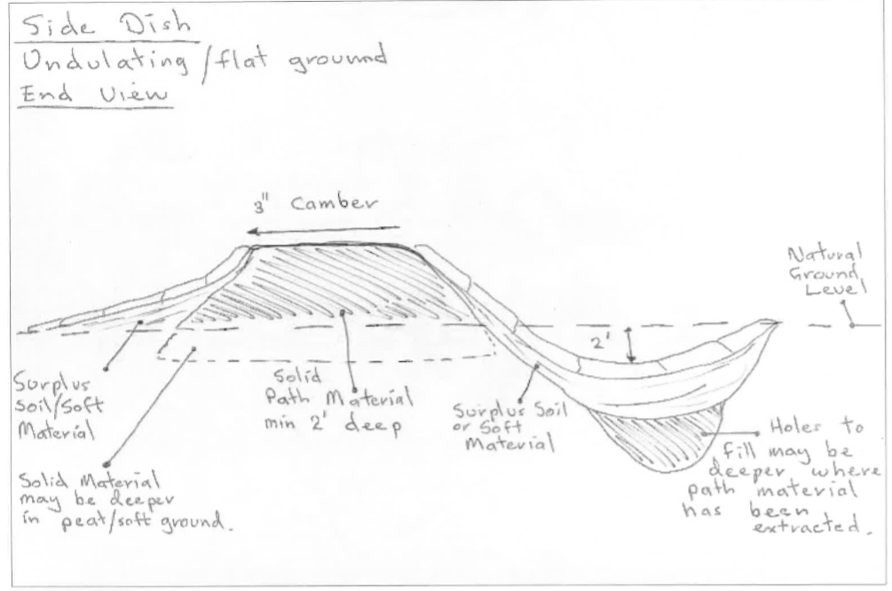

Side Drains:
A number of side drains have been identified as requiring clearing out or reinstating. The depth and width of the side drains will be agreed on site with the site supervisor taking into account the terrain, bedrock etc.
Pitched Wath/Fords
Please see diagram of Pitched Wath/Ford technique to be used on Breast High Road:
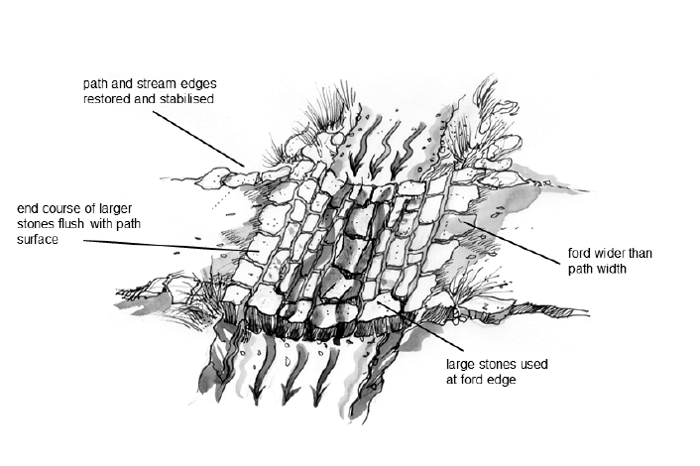

LDNPA Method of work for culvert pipe installation:
- Peg down Coir Silt mat 2m below the worksite before works begin.
- Works to be completed in spells of very dry weather, to reduce water flow through culvert structure.
- Track machinery and materials in from downhill side to excavate existing pipe from the track and new pipe width. Any material excavated to be piled between the culvert and machine on downhill side, reducing the risk of sediment pollution. The pipe will be removed in Metre sections as produced and removed for disposal.
- Any material retrieved from the top of culvert will be broken up and re-used within the surface of the track.
- Once completed, lay new pipes onto channel bed, ensuring correct fall and depth to allow gravel accumulation along bottom of pipe. Once set, bring any required stone or hardcore to site with the 1T tracked dumper. Stone will be transferred from dumper to the worksite by hand to wall up the pipe ends.
- Head Walls will be built with a geotextile layer between stone and compacted fill to prevent any movement of fines. The headwall structure shall be built to meet flush with pipe ends to prevent washout and a large slate will be placed over each edge to denote culvert end. As shown in the diagram, stone will be walled in long ways for increased strength and resilience. On bottom side, a splash plate will be inserted to reduce channel erosion.
- Pipes to be packed in either side and topped off with original track bed or hardcore where necessary before compaction. Soil/ grass sods then landscaped to edges of vehicle track to allow surface to grow and bind.
- Remove silt mats after 24 hours to catch any suspended solids.
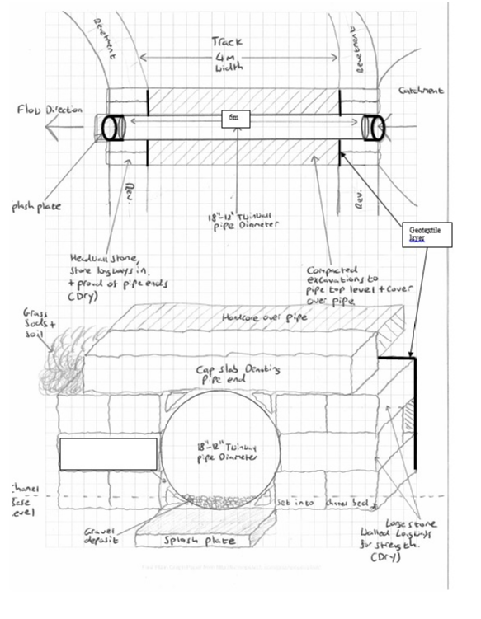
Bridge - Design and build of 2 x composite steel and plaswood bridges.
The bridge must be capable of withstanding a minimum of 1:100 year flood event. It should have a minimum life span of 50 years for bridges that carry vehicles and or have steel beams. It should be capable of withstanding the expected usage. It will be aesthetically sympathetic to the surrounding environment.
It must be a 15ton capacity vehicle bridge which has frequent recreational 4x4, agricultural and occasional plant and equipment use, and moderate pedestrian, horse and cycle use.
The proposed bridge is within the Lake District National Park – designated a World Heritage Site and in an upland farming landscape and should be sympathetic with the character of the area.
The LDNPA will be appointing suitably skilled and experienced Contractor(s) who have the capability and experience to deliver construction projects in these environments.
The bridge will not require planning permission but the LDNPA has applied for a Flood Defence Consent for the bridge structure from Cumbria County Council and the Method of Work detailed will need to be adhered to. Particular attention should be made to mitigation of risks from pollution or flooding.
Due to the location buildability is a key consideration; the Designer must consult with the LDNPA to ensure designs are within the capability and capacity of the contractors. The design must consider the challenges of constructing in catchments where:
- Water levels can rise and fall rapidly in response to rainfall events
- The nature of the sites may restrict the nature of plant and equipment than can be used in construction.

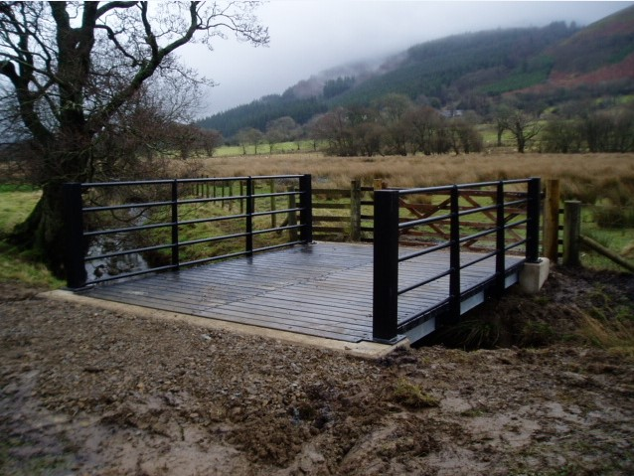
Image of similar bridge construction within the LDNPA.

