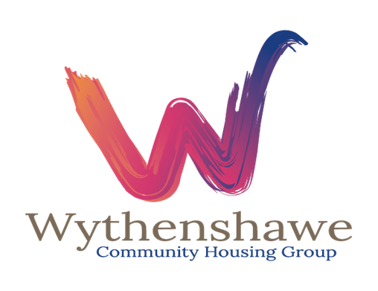

**Soft Market testing**

631 - Energy Broker

Contract Period:

**1 November 2024 – 31 October 2027**

**With an option to extend 2 x 12 months**

1. **Background**

Wythenshawe is 8 miles south from Manchester City Centre and is home to c79,000 residents with 45% of these people in Wythenshawe being housed by Wythenshawe Community Housing Group (WCHG). There are many positive aspects to Wythenshawe which for many years has been improving as a place to live and work. WCHG owns and managed circa 14,000 homes predominantly across Wythenshawe.

We would like to take the opportunity to do some `soft market testing’ as outlined below, to determine current interest levels in the market for a new Energy Broker.

1. **Key Aims**

The provider will need to carry out meter readings twice a year, provide the meter readings to WCHG and also be able to provide photographic evidence upon request.

* The partner will be responsible for procuring and negotiating gas, electricity and water prices on behalf of WCHG and offer support on cost benchmarking

The partner will also need to carry out the following actions:

* Request and receive current and historical information (for example consumption history, supply numbers, pricing details)
* Complete portfolio management as part of our estates
* Issue termination notices with regard to existing supply contracts on WCHG behalf
* Obtain information from third party industry databases such as metering details
* Contact WCHG current suppliers to resolve any objections or rejections regarding transfers
* Support with invoice validation by requesting and receiving all billing information and supporting with cost recovery
* Authorise any adjustments, refunds, billing or payment method changes
* Update billing address details
* Request refund cheques / credits and support with re-charges where applicable
* Support on sustainable initiatives and Net Zero compliance
* Complete meter readings on behalf of WCHG
* Support with forecasting and budget planning

We would also like to understand:

* What Portals you are using, with functionality for downloading invoices, reviewing accruals
* Support you can provide in relation to smart metering and sustainable initiatives

**Project Timescales**

|  |  |
| --- | --- |
| **Stage of the project** | **Anticipated Timeline** |
| Soft market testing | 01/08/2024 |
| Soft Market Closing Date | 12pm – 21st August 2024 |
| Progress to tender | Estimated: 16/09/2024 |
| Result of Procurement Process | 14/102024 |
| Contract Start Date | 1 November 2024 |

1. **Soft Market Testing**

**THIS IS NOT A CALL FOR COMPETITION**

The Soft Market Test is intended to allow interested organisations with relevant experience to outline their views and provide information with no commitment to themselves or Wythenshawe Community Housing group (WCHG).

WCHG is looking to award a contract commencing 1st November 2024. If a decision is made to tender this service. It is further envisaged that the initial contract would be for a period of 3 years. During the Soft Market Test, we would like to gauge the level of interest.

**Stage 1 -** Interested suppliers are required to complete the following company information form and a short questionnaire (at appendix 1). Suppliers who complete and return the questionnaire ***may*** be invited to meet with WCHG representatives to discuss its requirements.

The questionnaire should be returned via the messaging function on the Proactis Portal.

If Suppliers have any questions about this soft market test, such questions should be submitted to the WCHG using the ‘Question and Answer’ facility within the opportunity advertised via the Proactis Procurement Portal. A copy of the question and a copy of the written reply may be circulated to all Suppliers, with anonymity of the Supplier preserved. Suppliers must not raise questions through any other channels, including direct emails. No questions will be responded to, other than those raised through the appropriate channels as described above.

**We encourage your participation in this soft market testing** **exercise, but must emphasise that your involvement in this exercise will not carry any commercial advantage in any ensuing procurement process.**

**No information provided in response to this soft market testing exercise will be used in any evaluation of any subsequent response to a procurement exercise.**

1. **General Information**

|  |  |  |
| --- | --- | --- |
| **3.1** | Full name of your organisation: |  |
| Contact Details Name: |  |
| Job Title: |  |
| Address: |  |
| Telephone no: |  |
| Fax No: |  |
| Mobile No: |  |
| Email Address: |  |
| Web Address (if any): |  |

1. **Undertaking from the supplier**

|  |  |
| --- | --- |
| Name: * |  |
| Signed: | Duly authorised on behalf of the Supplier  (Electronic signature required here) |
| Position: |  |
| Date: |  |

**Appendix 1 – Questionnaire**

**Please complete the following questionnaire fully, highlighting any information that you consider to be commercially sensitive\***

1. Would you be interested in bidding for this proposed Project?

(Word Count: 100)

If yes, why?

If No, why not?

Response:

1. Please detail the experience your organisation has in delivering this type of service and support for Housing Associations?

(Word Count: 500)

Response:

1. Please detail how you will meet the current and future requirements as detailed in section 2? Please include details of the Portal you currently use and its functionality aswell as how you would support on the transfer of supply if applicable (Word Count: 750)

Response:

1. When/if WCHG go to tender following the soft market test, is there anything in addition to the information in this brief that suppliers would need to be advised of in order to aid in their response.

(Word Count: 500)

Response:

1. Can you provide indicative costs