Integrated and Smart Travel (IST) Programme
Supplier Market Engagement: WebEx joining instructions

Thank you for attending the IST Programme Supplier Market Engagement event on 19th June 2017.
This document contains instructions and details of how to join and use WebEx.

WebEx details: Monday 19th June 2017 14:00 - 16.00
- Join WebEx meeting:
https://eval-uk.webex.com/eval-uk/j.php?MTID=mbb2bf703f8aeecf5eb503dc40b0c1cec
- Meeting number (access code): 849 302 318
- Join by phone: 0800-051-3810 Call-in toll-free number (UK) +44-203-478-5289 Call-in toll number (UK)
- Global call-in numbers: https://eval-uk.webex.com/eval-uk/globalcallin.php?serviceType=MC&ED=578329712&tollFree=1
- Toll-free dialing restrictions: https://www.webex.com/pdf/tollfree_restrictions.pdf
- Can't join the meeting? https://help.webex.com/docs/DOC-5412
Important notice: Please note that this WebEx service allows audio and other information sent during the session to be recorded, which may be discoverable in a legal matter. By joining this session, you automatically consent to such recordings. If you do not consent to being recorded, discuss your concerns with the host or do not join the session.

General Notes
- Please ensure you join the meeting promptly; the session will be open 10 minutes prior to the meeting start and we will start on time.
- All participants are asked to remain on mute unless requested to speak by the facilitator.
- When this occurs, please ensure you are in a suitable environment to minimise background noise.
- Please see the rest of this document for detailed instructions about how to use WebEx.

Instructions for joining WebEx Meeting
- Click on the meeting link in the meeting invite. The URL is:
https://eval-uk.webex.com/eval-uk/j.php?MTID=mbb2bf703f8aeecf5eb503dc40b0c1cec
- Meeting number (access code): 849 302 318
- When asked for your name please include your name as well as the name of your organisation. This will help us know who is on the call.
- Please only dial in once per supplier.
- Please include your email address if prompted.
- Click ‘join’.
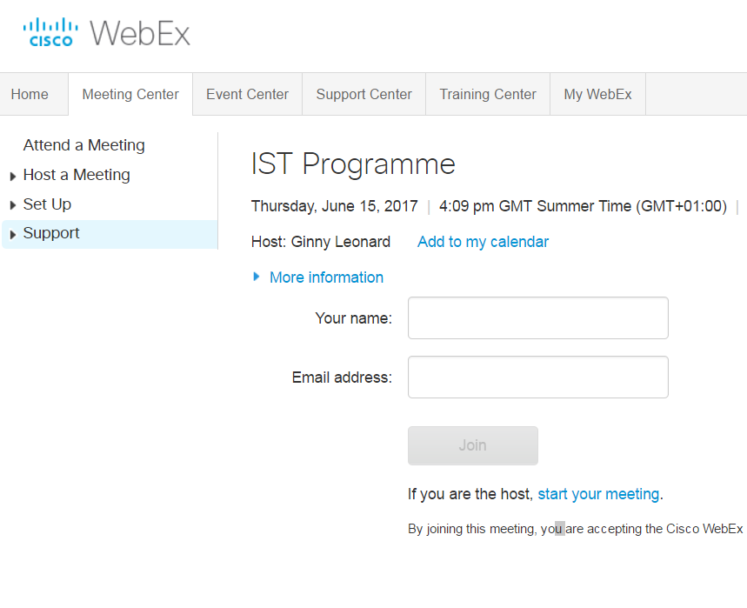
You will see the following screen:

This will be replaced by the WebEx window after you click ‘join’:
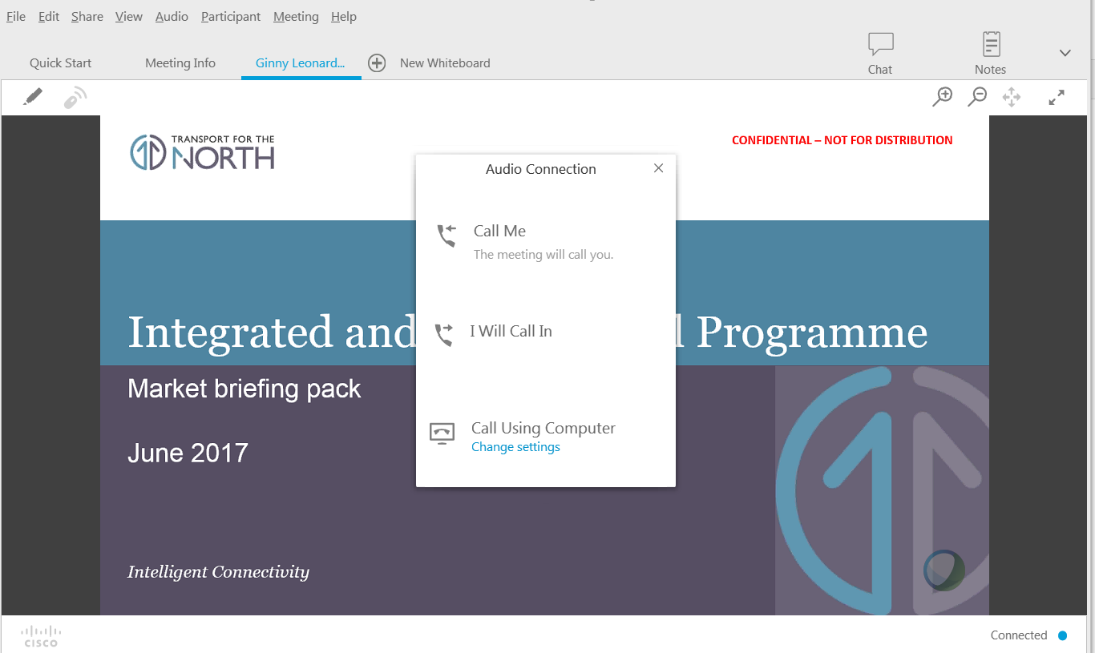

When prompted, please select one of the three options below for audioconferencing:
- ‘Call me’ – by providing your phone number to WebEx when prompted the system can automatically call you and admit you to the conference. Please pick up your phone when it rings and press ‘1’ when prompted to join.
- ‘I will Call In’ - To call in by phone you will be given the option of the dial-in details shown in the image below (the numbers shown below are just an example).
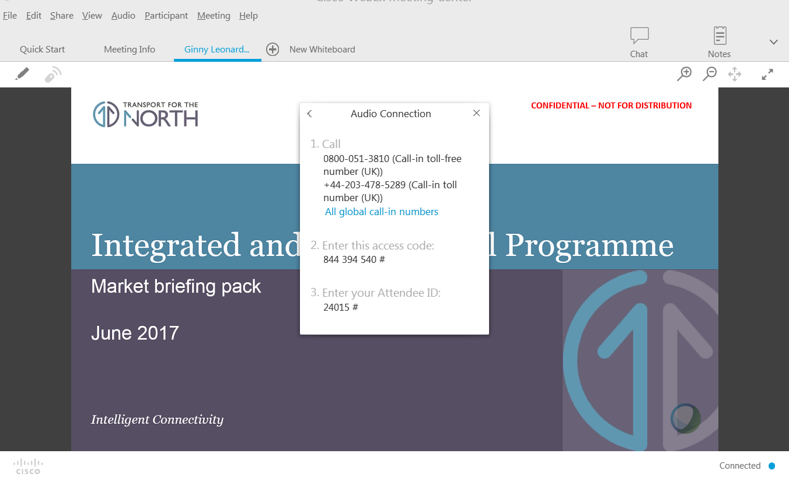
- ‘Call Using Computer’ – to call using your computer and a headset with microphone, simply click the button and it is automatic. You will see a green check mark to indicate you are connected.
Full screen mode
Double-clicking on the title slide will allow you to watch the presentation in full screen mode.
Instructions for raising questions
At the end of the briefing session suppliers will be given the opportunity to ask questions. Please note that all questions and responses will be recorded and made available to all suppliers in the marketplace.
Please use the ‘chat’ button when prompted to open the chat panel and raise questions: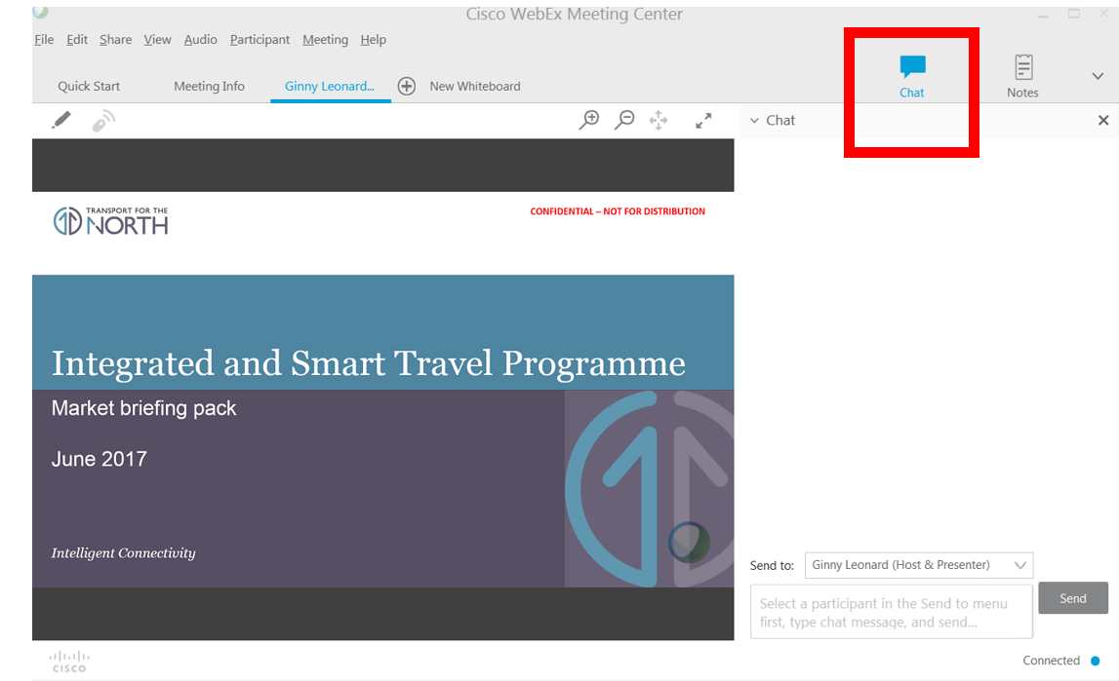
Please ensure that you have selected the Host and Presenter from the drop-down list before sending your questions.
Help and support
If you are unable to join the meeting then please visit https://help.webex.com/docs/DOC-5412 for support.
We recommend joining the meeting early to ensure that the technology is working before the briefing begins.

