FOLKESTONE COMMUNITY WORKS CLLD PROGRAMME

Brief to provide support and advice to the EU funded Folkestone Community Works programme

1. FOLKESTONE COMMUNITY WORKS PROGRAMME

  - In December 2017 Shepway District Council secured £2.49 million of European funding for a Community Led Local Development (CLLD) Programme to operate in Folkestone until 2022. The programme is called Folkestone Community Works.

  - The funding secured for the Folkestone Community Works programme is from European Structural and Investment Funds Growth programme and comprises £1.5 million from the European Regional Development Fund and £975,000 from the European Social Fund. The European funding for the programme has to be matched 50:50, with the result that some £5 million will be invested into the area and local people.

  - The aim of Folkestone Community Works is to improve the social and economic community cohesion in some of Folkestone most deprived areas by:
  - Helping residents to access jobs
  - Helping local businesses and start-ups to grow
  - Providing new job opportunities.

1.4 In April 2018, Shepway District Council changed its name to "The District Council of Folkestone & Hythe", normally referenced as "Folkestone & Hythe District Council".
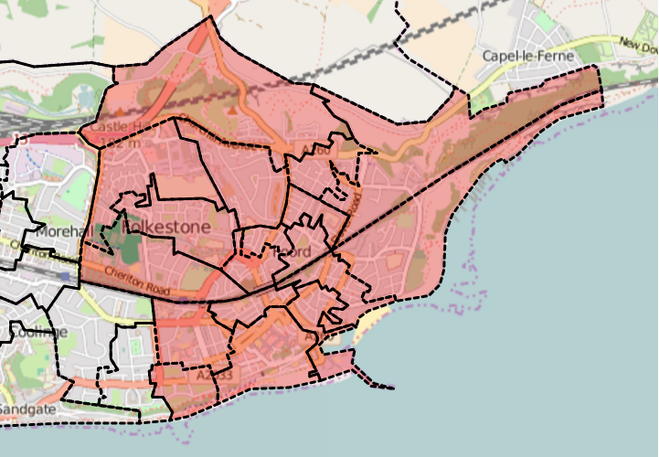

Figure 1 - Map showing the Folkestone Community Works in Folkestone

1.5 Funding for the Folkestone Community Works programme will be targeted on a defined area of Folkestone (Figure 1), where grants will be available for organisations and businesses to deliver the programme strategy, which was developed in 2016 as part of the programme application process.

  - Folkestone Community Works programme is structured around three objectives with eight activities:

Objective 1 – Enhancing work-readiness and well –being
Action 1.1: Work experience and job preparation for young people
Action 1.2: Getting people back into work
Action 1.3: Promoting emotional and physical well-being
Action 1.4: Promoting financial wellbeing

Objective 2 – Promoting local business and social enterprise
Action 2.5: Promotion of social enterprise
Action 2.6: Support for business start-ups
Action 2.7: DIY Space /incubation

Objective 3 – Integrated delivery mechanism for the strategy
Action 3.8: Setting up and operating the Community Hub

  - Folkestone Community Works aims to support 1,000 people including 350 unemployed, 350 economically inactive, 250 people with disabilities, 75 people from ethnic minorities and 100 people over 50+. We expect the programme will help at least 200 people to enter education or training who were not previously, 160 unemployed to find a job and 189 economically inactive people to find a job or start looking for one.

  - Folkestone Community Works also aims to support 148 new enterprises to be created, 195 existing businesses to grow, and create at least 98 new jobs as well as help 175 potential entrepreneurs to be enterprise ready. There is also scope to refurbish 400sqm of public/commercial buildings.

- PROJECT WORKSHOPS

During 2019 and 2020 there is expected to be a number of additional calls for projects and support is required to hold workshops for prospective project applicants and for projects already contracted.

We envisage similar workshops to those held for prospective applicants during the first Call for Projects in 2018 as outlined below
- Workshop
  - First session 10:30am to 1:00pm presentations on key topics for organisations wanting to access ESF and/or ERDF funding and complete the project application form such as budgets, match funding, procurement, outputs and results, monitoring and evidence and state aid.
  - Second session: 1.00pm to 4pm 1:1’s or small groups. Organisations will be asked to pre-book and identify areas they want further guidance on.

In addition, we envisage workshops for contracted projects on topics relevant for ESIF funded projects, including on topics including, but not necessarily limited to, the ESIF claims process, procurement rules, evidence and data retention requirements.

At this stage we estimate a requirement for up to 6 workshops during the contract period.

- FOLKESTONE COMMUNITY WORKS PROGRAMME MANAGEMENT

  - Folkestone and Hythe District Council is the accountable body for the Folkestone Community Works programme. A Programme Management Team has been established within Economic Development to deliver the programme. This team comprises a Programme Manager and Programme Assistant who oversee the delivery of the Folkestone Community Works programme with support from other officers in the legal, communications, HR and finance departments.

3.2 Folkestone Community Works programme will meet its outputs and results by offering to local organisations and businesses funding through two funding streams:

- Main Projects: to be delivered by intermediary organisations who are the project applicants. The beneficiaries are residents or businesses in the Folkestone Community Works area (ESF & ERF funding)
- SME Business Grant Scheme: Businesses are the applicants and beneficiaries (ERDF funding).

  - The application process is a two stage process, stage 1 is an Eligibility Questionnaire and the stage 2 is the full application. Workshops are planned to be held to support and the applicants to ensure they understand the requirements that need to be meet and the level administration associated with EDRF and ESF funding.

  - The first round was launched in February 2017 and as a result five main projects and one SME business grant has been agreed and contracts put in place. A further application Call for SME Business Grants was issued in November and these applications are currently being assessed. It is envisaged that there will be at least a further two calls during 2019 and the programme management team is seeking additional consultant support for the management of the programme.

- BRIEF SPECIFICATION

  - Folkestone and Hythe District Council is seeking consultant support to undertake support for its programme management responsibilities for the Folkestone Community Works CLLD Programme. The key deliverables required are to:

- Support the delivery of the Call for Project Application workshops and in providing training and advice to project applicants for projects through:
- Support for programme management team (content to be confirmed)
- presenting on key aspects of the programme in conjunction with the programme management team at the workshops for project applicants
- providing answers to questions from the potential project applicants at the workshops
- provide 1-2-1 support for project applicants as required during the project grant funding process.
- Provide support for the management of contracted projects, including support with monitoring visits, ensuring claims compliance and providing training to project lead organisations where necessary.

- Provide training and on-going advice to the Folkestone Community Works Programme team on the relevant rules and guidance for the England 2014 to 2020 European Structural and Investment Funds in administering, delivering the programme and in submitting financial claims, maintaining evidence, etc to the managing authorities for ESF and ERDF funding

  - If the Folkestone Local Action Group (LAG) and Folkestone and Hythe District Council consider further funding rounds are needed to meet the outputs and results for the EU funding, then further funding calls will be undertaken. If this occurs then the contract may be extended to cover future rounds in 2020-2021

  - The contract will run from 7th January 2019 to 31st December 2020, with the potential for this to be extended to provide support for future project calls.

  - The budget for these services is up to £8,000.

5 PAYMENT

5.1 Payments will be made by monthly invoicing and the tracking of time spent in. Timesheets will be required.

