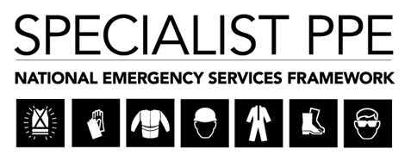

Thank you for your attendance and feedback at the Supplier Event held in Kent on 27th January 2020. Presentations of this event have been published on the Kent Business Portal. This newsletter serves to provide an update of progress since this event;

1) Procurement timeline:

The National Project Team are progressing well with the invitation to tender documentation to ensure that a full and comprehensive tender pack is published at the start of the competition. As mentioned at the supplier engagement event on the 27th January, the Project Team were also scheduled to engage with the NFCC Inland Water Technical Rescue Group with regards to the specification for Lot 8, and we can confirm that we shall be making some adjustments to the specification as a result of this meeting. Taking this into account, the National Project Board has agreed to a short delay to the ‘go live’ date for competition to the 21st February 2020. An amended timetable shall be issued as soon as possible. The revised timetable will still be considerate of Intershutz in June and will allow a 12 week lead time for production of garments.

2) Certification:

Feedback was received from some attendees at the event on the 27th January regarding supplier’s ability to have all relevant EC certificates by commencement of the wearer trials, and requested that the Authority consider acceptance of test results on the premise that EC certification will follow. The National Project Board were engaged for their feedback on these concerns and concluded that full EC certification was critical as it confirmed that the essential health and safety requirements covered by the EU regulations had been met and it would therefore be a risk to conduct wearer trails without this in place. The National Project Board took the risk-based decision that the requirement remains unchanged, taking into consideration that the lead time for delivery of garments for trialling had been extended from 10 to 12 weeks in response to the feedback provided in the Supplier questionnaire in addition to prior notification of requirement at previous engagement events for this project. All presentations and Q&A from the previous events were published on the Kent Portal for all interested suppliers to view. The Authority is therefore content that sufficient notice has been given to all interested Suppliers to enable a fair and equitable procurement process. All EC Certification of garments will therefore need to be submitted to the Authority prior to the commencement of the wearer trials based on the requirement for firefighter safety during the evaluations.

Regards

Mark Rist
Kent FRS – SPPE Project Sponsor
7th February 2020

