Supplier submission help
To begin you tender response please click “Start my response”.
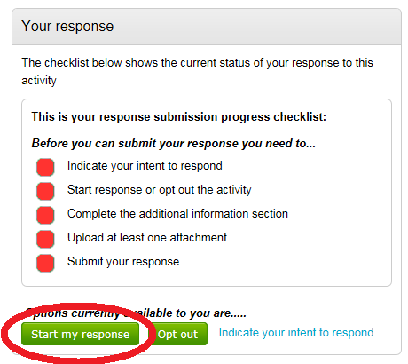
On the next page, click “edit” on the “Additional information” widget.
On this page, you may wish to make additional comments to accompany your tender. However, if not, click the tick box to say you do not wish to include additional information and then click “Save”.
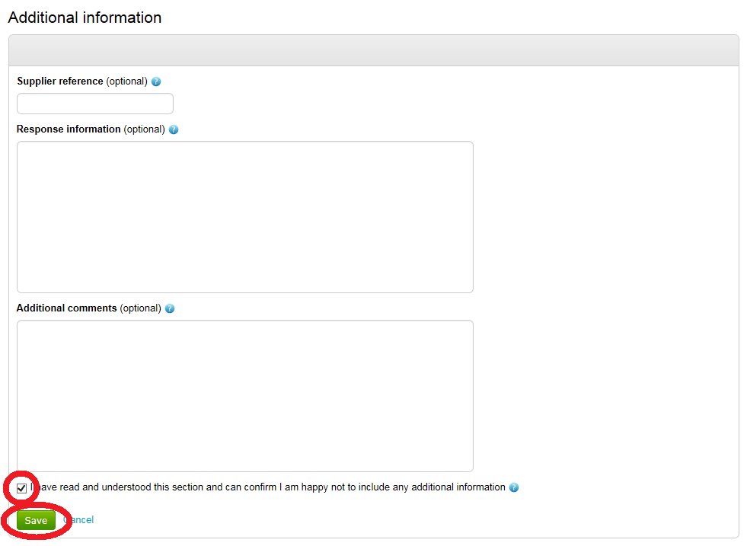
To upload your completed tender documents, click “Add” on the “Response documentation, files & links” widget.
Once you have uploaded your documents, they should be shown as per the picture below.
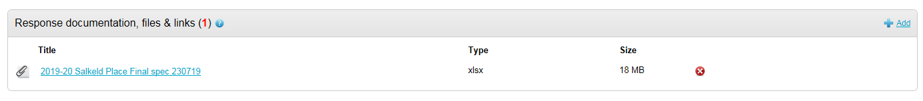
To submit your tender, click “Submit response”.
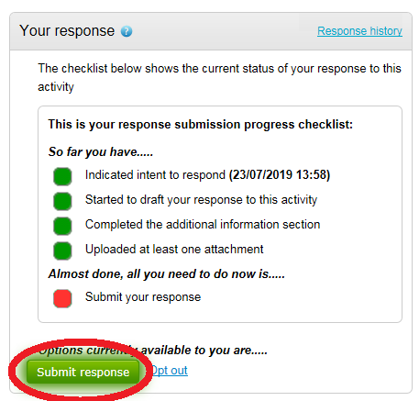
Please note that you can amend your response as many times as you wish following submission. Therefore it is important that you do not leave this step until the last minute.

