Project Title:
Torrington Road & Wallers Close
Name of Employer:
London Borough of Redbridge
Description of Works:
Torrington Road Site address: 2-24 Torrington Road, South Woodford, London Borough of Redbridge, E18 2AS.
Design and build of 7 flats within one block including site clearance and external works.
Torrington Road Existing site area: 1108 m2 with a GIFA of 669 m2.
This prominent site sits on the corner of Torrington Road in a predominantly residential area. The site was previously an underutilised garage and refuse storage area. This has been demolished by another contractor. The site shares a boundary with a public footpath that runs alongside a local railway line. The west boundary of the site sits adjacent to 2-24 Torrington Road, a 3-storey block of flats.
Wallers Close
Wallers Close Site address: Wallers Close, Woodford Green, London Borough of Redbridge, IG8 8BW.
Design and build of 2 houses with private gardens including site clearance.
Waller Close Existing site area: 236 m2 with a GIFA of 229 m2.
This site is an empty piece of land in a predominantly residential area. The site is currently an unused amenity area with redundant drying area to the rear of the site. The site is bounded by a 2-storey house to the north and 2-storey residential flat units to the south of the site. The site has local amenities within a 5- and 10-minute walk. The site is well located for local amenities and, whilst not in a close proximity to a tube line, there are a number of bus routes which link to more central transport links.

Type of Tender:
- Open Procurement Single Stage Design & Build; tendered on the basis of a significantly complete RIBA Stage 4 design
- Tenderers will be required to competitively tender for delivery of RIBA Stage 5 (Start of Construction) through project delivery and Defects Liability Period
Location of the Works:
Site address’: Torrington Road Site address: 2-24 Torrington Road, South Woodford, London Borough of Redbridge, E18 2AS.

Wallers Close Site address: Wallers Close, Woodford Green, London Borough of Redbridge, IG8 8BW.
Anticipated date of issue of tender documents:
August 2022
Anticipated starting date of the works:
November 2022
Anticipated duration of the works:
To be determined by the Contractor as part of the Tender
Access to the site:
As shown in attachment
Tender Period:
6 weeks
Form of Contract:
Amended JCT 2016 Building Contract with Contractors Design. The contract is to be executed as a deed
Details of Collateral Warranty Requirements:
Contractor/Employer, Design Consultants/Employer, Design Sub-Contractors/Employer
Bond:
Required
The criterion for assessing the tender:
Price/Programme/Experience/Quality/ social value

Early Market Engagement Questionnaire
Please note: A questionnaire needs to be completed with Expression of Interest
Contractor Response Form

You are required to express interests in either
- Joint Development of both opportunities tendered together as one package
- Tendered as individual opportunities

YOU ARE REQUIRED TO ANSWER THE FOLLOWING
I am expressing an interest in option:

A/ B (please delete to show interested option)

INTRODUCTION
1.1 The purpose of this Notice is to undertake a pre-market engagement to establish whether the client, (London Borough of Redbridge (LBR)) chosen contractor procurement route is attractive and objective for the project in question, and what market factors should be considered for the procurement strategy to deliver on the Council’s objectives.
1.2 The notice is made available on Find a Tender Service (FTS) and does not constitute commencement of the procurement process or any commitment by LBR to undertake any procurement exercise, nor is it a call for competition.
1.3 LBR is currently exploring the procurement of Contractors to complete the design and build using the ‘Find a Tender Service’ in compliance with the Public Contracts Regulations 2015.
1.4 It is the intention to procure the Main Works (i.e., all Works excluding some elements of enabling works undertaken by others) as Single Stage procurement contracted under a JCT Design and Build Contract 2016 (the Building Contract) incorporating LBR’s standard amendments to contract. LBR encourage contractors to look at all forms of construction, including Modern Means of Construction as part of a tender return.
1.5 LBR is carrying out an early market engagement exercise to engage in early consultation with the market, prior to any formal procurement taking place. The process is designed to assess the potential sector interest given the changing market conditions and understand from contractors how LBR’s requirements might best be met.
1.6 Part of the notice also invites contractors to express their interest in bidding for
the works.
1.7 Based on the responses to the notice a preferred procurement route shall be selected.
1.8 Contractors that are interested in participating in this exercise are invited to complete the below questionnaire and submit their responses via the ProContract e-procurement portal.
1.9 This early market engagement stage is anticipated to run for 10 days from 1st August to 12th August 2022.
1.10 The closing date for responses to the early market exercise and expression of interest is midday on 12th August 2022.

The Procurement Strategy and the Selection Process
Tender Process: Open Procurement Single Stage Design & Build, designed to Stage 4 complying with the Public Contracts Regulations 2015.
Process

- The criterion for assessing the tender will be: Price/Programme/Quality /Social value

- Contract documents produced and signed.

EARLY MARKET ENGAGEMENT QUESTIONNAIRE

General Guidance
3.1.1 Please give your responses to the following questions.
3.1.2 It would be appreciated if responses are direct and succinct and a font size of no less than 11.
3.1.3 Contractors are requested to omit marketing or corporate literature when preparing their responses.
Please reference your reason for the option chosen.
3.2 Questions:
Ref | Question
Q1 | It is envisaged that the project shall be tendered via a Single Stage fixed price Design & Build competition. Redbridge wish to gauge the market’s views on the appropriateness of single tender for both opportunities. From a contractor’s perspective, please set out your views on whether this tendering strategy is the most suitable.  (Maximum 1 page at A4).
Q2 | Based on the information provided, would your organisation and supply chain be interested in bidding for the opportunity whether as single or separate tenders?  (Maximum 1 page of A4).
Q3 | - For funding purposes, the Client requires a ‘Start on Site’ by November 2022. In your opinion, do you think this is achievable? (Y/N)  - If no, what are your reasons and what do you consider an achievable ‘Start on Site’ date?  (Maximum 1 page of A4).
Q4 | - Based on the initial cost information provided for the works, do you find this build cost range to be within the parameters for this type of project and location? (Y/N)  - If different what are your expectations?  (Maximum 1 page of A4).

Contractor Response Form
4.1 Please see enclosed form to be completed and submitted with your responses to the questions

COMPLETED BY

Name

Role in organisation

Company name

E-mail

Date

Signature

You are required to express interests in either
- Joint Development of both opportunities tendered together as one package
- Tendered as individual opportunities

YOU ARE REQUIRED TO ANSWER THE FOLLOWING
I am expressing an interest in option:

A/ B (please delete to show interested option)

Torrington Road & Wallers Close
For London Borough of Redbridge
Outline Project Summary for Contractor Expression of Interest

- Background
Torrington Road
Torrington Road Site address: 2-24 Torrington Road, South Woodford, London Borough of Redbridge, E18 2AS.
Design and build of 7 flats within one block including site clearance and external works.
Torrington Road Existing site area: 1108 m2 with a GIFA of 669 m2.
This prominent site sits on the corner of Torrington Road in a predominantly residential area. The site was previously an underutilised garage and refuse storage area. This has been demolished by another contractor. The site shares a boundary with a public footpath that runs alongside a local railway line. The west boundary of the site sits adjacent to 2-24 Torrington Road, a 3-storey block of flats.
The site is easily accessible by foot, cycle, car, and public transport. The site is close to the North Circular Road. Torrington Road is surrounded by residential streets and is relatively close to local amenities and to South Woodford town centre.
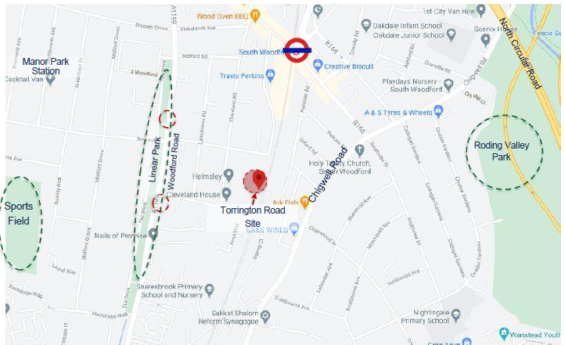
Figure 1: Torrington Road Site – Local Transport Links
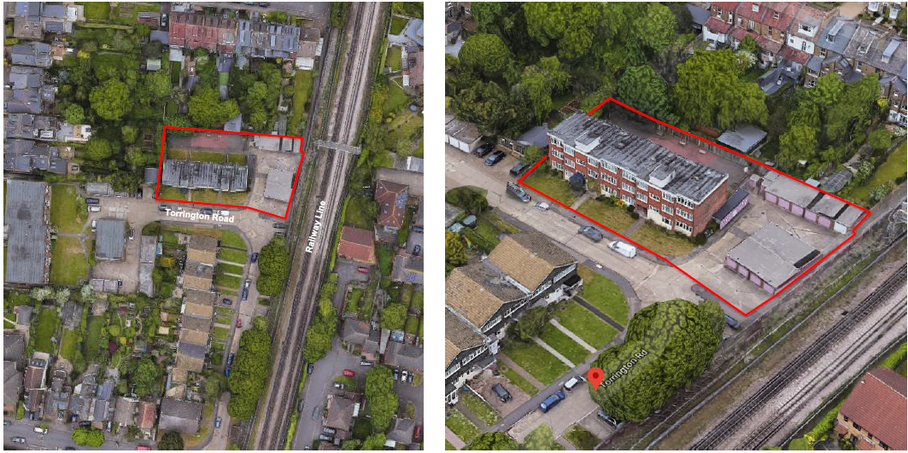
Figure 2: Torrington Road Site - Arial View of Existing Site.
Note that the existing garages on the right hand side of the picture above have recently been demolished by another contractor in an enabling works package which included installation of semi-permanent hoarding around the construction site area.
Wallers Close
Wallers Close Site address: Wallers Close, Woodford Green, London Borough of Redbridge, IG8 8BW.
Design and build of 2 houses with private gardens including site clearance.
Waller Close Existing site area: 236 m2 with a GIFA of 229 m2.
This site is an empty piece of land in a predominantly residential area. The site is currently an unused amenity area with redundant drying area to the rear of the site. The site is bounded by a 2-storey house to the north and 2-storey residential flat units to the south of the site. The site has local amenities within a 5- and 10-minute walk. The site is well located for local amenities and, whilst not in a close proximity to a tube line, there are a number of bus routes which link to more central transport links.
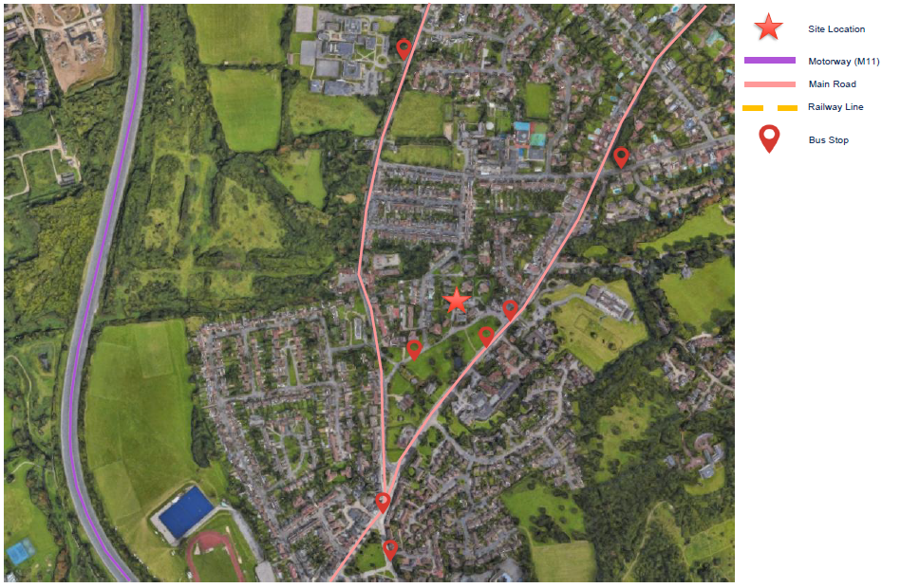
Figure 3: Wallers Close Site – Local Transport Links
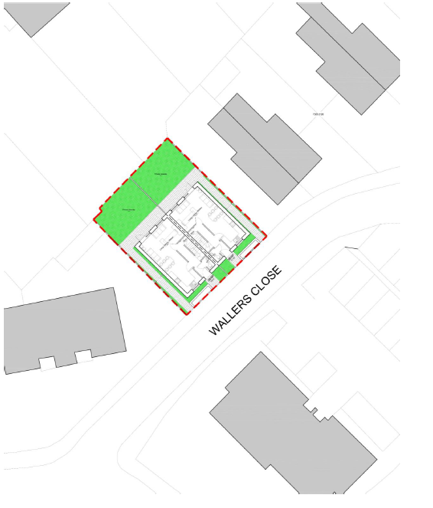
The development proposals comprise of 2 semi-detached houses in total. Both houses are 3-Storey 3B/6P Units. The new Units are directly accessed from the footpaths along Waller Close.
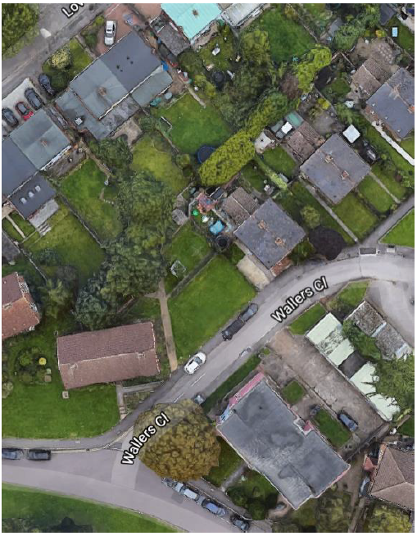

Figure 4: Wallers Close Site – Outline Development Plan & Arial View of Existing Site
- Site Constraints

Torrington Road
- The development should have regard to the surrounding scale and massing of buildings, so cannot be overbearing and impact upon sunlight and daylight/amenity of the existing buildings.
- The layout and design of the new buildings will need to have regard to privacy and amenity of neighbouring dwellings and adjacent rear gardens.
- A foul water sewer crosses the site along the eastern boundary. The pipeline has an easement of 3 metres either side of the pipeline. The development will need to consider any restrictions to the pipeline and the associated easement.
- The mainline railway to Eastern boundary creates noise and building restriction zone.
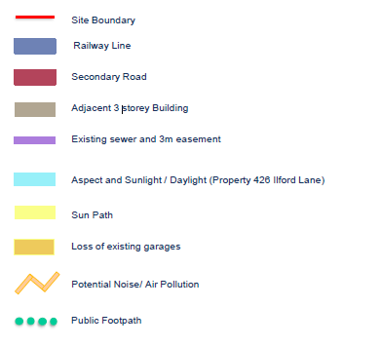
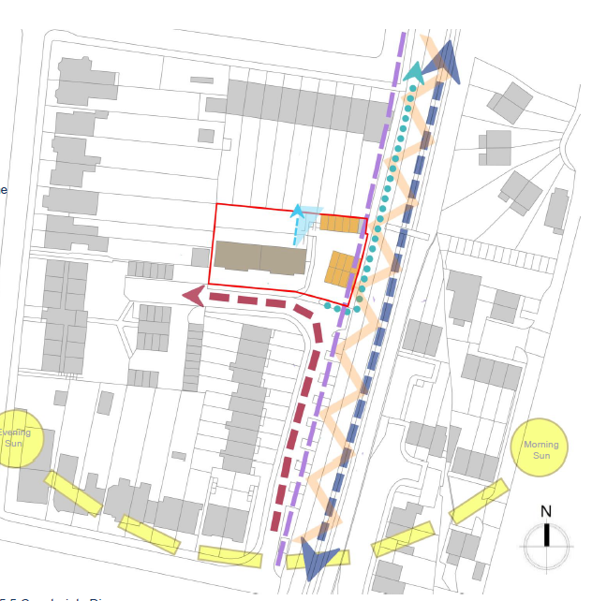

Figure 5: Torrington Road Site – Constraints Diagram
- General Matters

- The scheme will be competitively tendered on the basis of a signicantly complete RIBA Stage 4 design
- Tenderers will be required to competitively tender for delivery of RIBA Stage 5 (Start of Construction) through project delivery and Defects Liability Period
- Tenderers will not be required to carry out any significant design development or technical design, but minor design update may be required and it is anticipated that the design team will be novated over to the successful contractor
- Contract period anticipated at 52 weeks
- The works will be awarded under a JCT DB2016 Design & Build Contract
- It is anticipated that the tender enquiry documents will be sent out early September 2022, with tender returns around early October, and site commencement around November 2022
- The Employer has not yet decided whether to tender these developments as a single package for each site or whether to separately tender each site with a separate delivery contract for each. Contractors responding to the Expression of Interest are requested to note their intention to respond to a combined or separated tender enquiry

