Picture Palace

Building information pack for operators and pre tender survey

01/06/2020

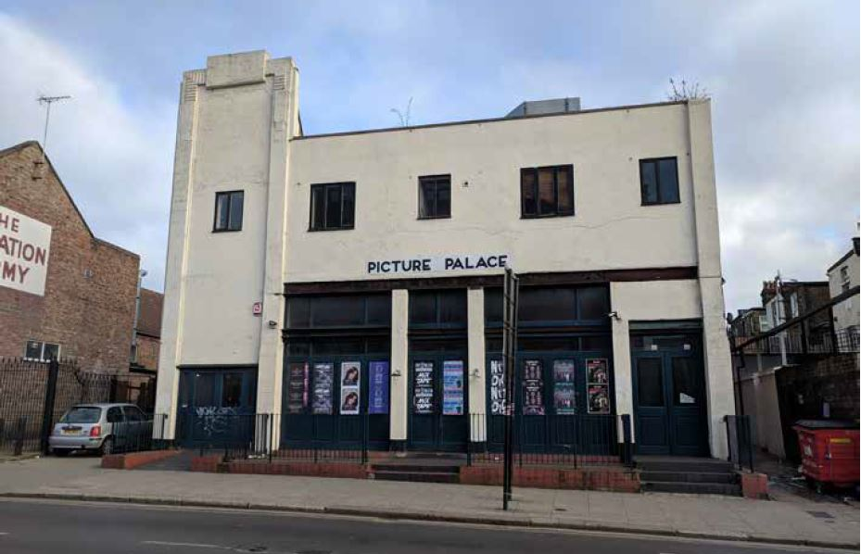

The Picture Palace
26 Manor Park Road
NW104JJ

The space
The Picture Palace, formerly owned by JD Wetherspoons has previously been used as both a cinema and public house and occupies approximately 5,000 sq ft in the heart of Harlesden Town Centre. It has excellent bus connections and is less than a ten minute walk from Willesden Junction overground station.
Background
In 2019 the council, in partnership with Hawkins\Brown, conducted an in-depth study of Harlesden town centre which included spatial and historical analysis of the town centre, mapping of its demographics and physical assets, and robust consultation with local people. The recommendations of the study included, amongst other things, a re-provision of cultural space, community space, and youth amenity in the immediate vicinity of the town centre.
If you would like to receive a copy of the study, please contact kaya.chatterji@brent.gov.uk, asking for a copy of the Harlesden Town Centre Framework.
Vision and Objectives
The London Borough of Brent acquired the Picture Palace in January 2020 to aid its placemaking vision for the town centre. Central to that vision is an aim to re-provide cultural and community amenity to Harlesden, in a way that benefits the diverse residents of Harlesden.
Vision
The Council’s aim is to lease the Picture Palace to an operator or organisation for a temporary period to deliver a fully occupied building; provide social, economic and community benefits; and to kick start the re-provision of cultural, community or youth amenity space within Harlesden Town Centre.
The council is keen to support local organisations or those with links to the local area to tender, or to partner with other organisations in order to form a consortium. Local organisations who are interested in applying are encouraged to complete the survey so that the council is aware of their interest.
Objectives
The key objectives for operators:
- Have a clear proposal for use of the building which responds to the vision outlined above and the Harlesden Town Centre - Planning and Design Framework
- Is committed to providing an element of affordability to end users and customers
- If not a locally based organisation is open to working in partnership with local organisations
- Is willing to work with economically inactive people in refurbishment and operational phases
- Has a robust business and cost plan which stands up to scrutiny
- Has a strong track record of delivery of challenging projects and can demonstrate organisational capacity to take on the opportunity
- Will undertake regular evaluation and monitoring of key outputs and outcomes
- Will pay their staff and contractors at a minimum the London Living Wage
At this stage the council is open to ideas on suitable proposed uses which meet the vision set out above. Viability is important as there is no provision for revenue funding, and council expects that ancillary uses such as hospitality or workspace may be needed to ensure viability of the project.
Planning and Use
Currently the building is classified as A4. This use is not consistent with the Harlesden Town Centre - Design and Planning Framework (Hawkins\Brown) or the council’s long term plans for the building. Any proposed change of use would be assessed against Development Management Policy DMP 21.
Interested operators should familiarise themselves with these policies.
The council will work with, and provide financial support, to facilitate a change of use application with the chosen operator.
Building Condition and Scheduled Repairs
The building has been unoccupied for three years and during this period has lacked maintenance.
A number of reports have been commissioned to inform the work that is to be scheduled ahead of the chosen operator taking occupation. These reports include:
- Asbestos Register (there was a small amount of asbestos found in ceiling areas which will need to be removed prior to any refurbishment work)
- Beam condition survey
- Visual structural survey including assessment of the roof
The council has scheduled imminent internal and external repair work and the chosen operator will have the opportunity to commission further work in consultation with the council to ensure that the scheduled works support the proposed end use.
The site will require a full refurbishment including the building plant. The council has allocated a budget towards the cost of fit out and repairs. A full condition report will be provided during the tender process, along with an update of all completed works undertaken by the council.
EPC
An EPC ws last carried out on 30th January 2018 (Certificate Reference Number 0290-2939-0338-4670-4010) with a recorded Energy Performance Asset Rating of 103 (E).

Social value
Although a full specification is not yet available, the council wishes to advise prospective tenants that the evaluation criteria will be weighted in favour of delivering social value through the day to day operation of the Picture Palace.

Service Level Agreement
An SLA will be attached to the lease agreement which will include a requirement for monitoring against social outputs agreed in the tender process.

Commercials
Lease length: 7 years with possibility for extension subject to local authority agreement
Rent: Operators will be required to submit a proposal as part of the tender procurement process.
VAT: VAT will be charged on rent. A rental subsidy may be available to those organisations not able to reclaim the VAT, subject to agreement with the council.
Rent-free period: between award of contract and opening of the facility (expected to be approximately 12 months)
Running costs: once the rent-free period ends, the operator will also be responsible for the running costs of the building. These include service charge, utilities, business rates, office cleaning, refuse collections, IT and wifi (including installation).
Fit out costs: the council will manage and fund reasonable fit-out costs for the building providing a sound business case is provided at tender stage. A budget guide will be provided at the tender process and bidders will be expected to provide a request at the tender process based on their proposed use.
Soft furnishings: the operator will remain responsible for provision of soft furnishings, IT and AV equipment, etc.
Repairs: the council will take on the full responsibility for external repairs and structural repairs. Tenants/operators will be responsible for interior repairs.
Building Insurance: the operator will insure and keep insured with a reputable insurance office the building for the full reinstatement cost against loss or damage for the duration of the lease.

Pre-tender Survey
In order to inform the specification for the Picture Palace, operators are asked to provide responses to the following questions.
Please note that responding to these questions does not commit you to tendering for the building or to any further engagement with the council.
Your answers will not be scored and will only be used to inform the specification.
Please submit the answers to these questions by 19 June 2020 via the London Tenders Portal.
Question | Response
Organisation name

Organisation type (charity, CIC, businesses etc.)

Type of space(s) typically provided
To help the council provide further advice on Planning and change of use expectations - what do you propose to use the building for? Also are there particular uses, ancillary or not, which are important for viability of your operations?
After reviewing this high level information pack are there particular issues or constraints which would stop you tendering for the space? If so could you please list.
For the proposed fit out contribution and delivery - would you prefer to tender with a design team or work with a team appointed by the council?
Would you consider operating the space in partnership with another organisation?
What further information would you require from the council prior to tendering to help with your decision to tender?
Given the current government restrictions on movement due to COVID-19 what measures can the council take to ensure the process is managed in an appropriate manner?
Would you be happy for us to contact you to discuss this opportunity further?

