User Guide for Completing a Tender response

Contents
1 Getting started & creating an account on the tender Portal. 2
2 Registering an Interest 2
2.1 My Activities list 3
2.2 Tender Event list 3
2.3 Tender Summary page 4
3 Completing a Tender response 4
3.1 Response summary 4
3.2 Attach your completed Form of Tender & any other documentation 5
3.3 Terms & conditions 5
3.4 Response Check list and Submit button 6
3.5 Editing response 7

Getting started & creating an account on the tender Portal.
In order for you to submit a tender you will first need to create an account with the tendering portal. We use a system from Proactis.
To register for a free account, you will need to provide some basic details about you and the type of tenders you are interested in. It does not matter if you are not a company. If you are a private individual or a sole trader just put in your normal contact information.
If you have not already registered you can follow this link. You can also reach this link from lots of different places on the portal and also via our tenders homepage www.eastmidstenders.org
For assistance in registering for an account or managing it please see the help tab or click Registering on the ProContract Portal. This includes further instructions and videos.
You may have followed a link that has brought you straight to the project you are interested in. Otherwise you can search through the lists of opportunities on the portal www.eastmidstender.org. Once you have found an opportunity you’re interested in, you will need to click on the blue tender title which will show further details.
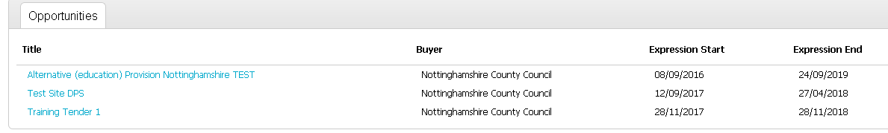

Registering an Interest
To proceed further you will need to log into your account to view tender documents and ultimately submit your tender, the first step is to register an interest in a tender. If you are already logged in, you simply press the green Register Interest button.
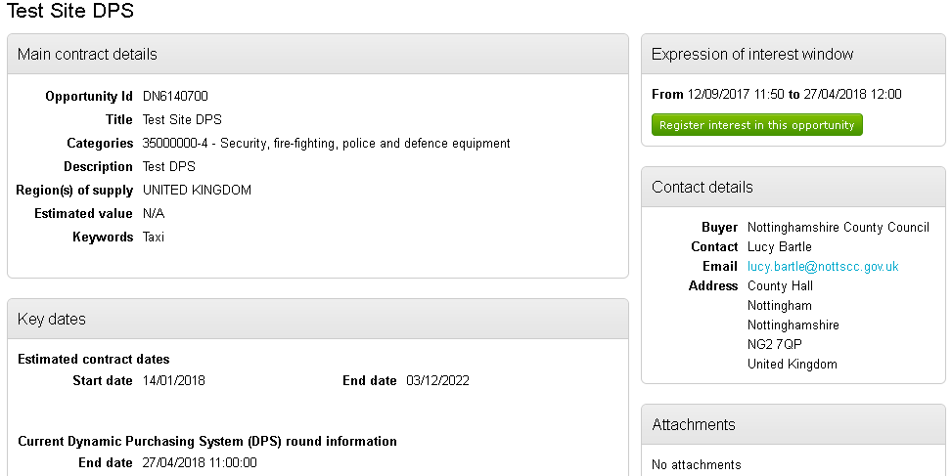

Registering interest automatically adds the project into your “Activities” area. It also confirms by email your resigistration and there will be a a Pop window showing a link to the tender. You can access the tender from any of these links.
Note: Please check your junk folder or spam filter if you don’t get a notification straight away!

My Activities list
Once you have registered / expressed an interest in a tender, the tender will appear in the ‘My Activities’ tab which can be found in the top tool bar.
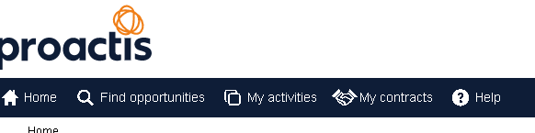
N.B. In the ‘My activities’ tab, ensure the correct buyer is ticked in the left-hand side filter to allow tenders to show, without any buyers ticked the page will be blank.

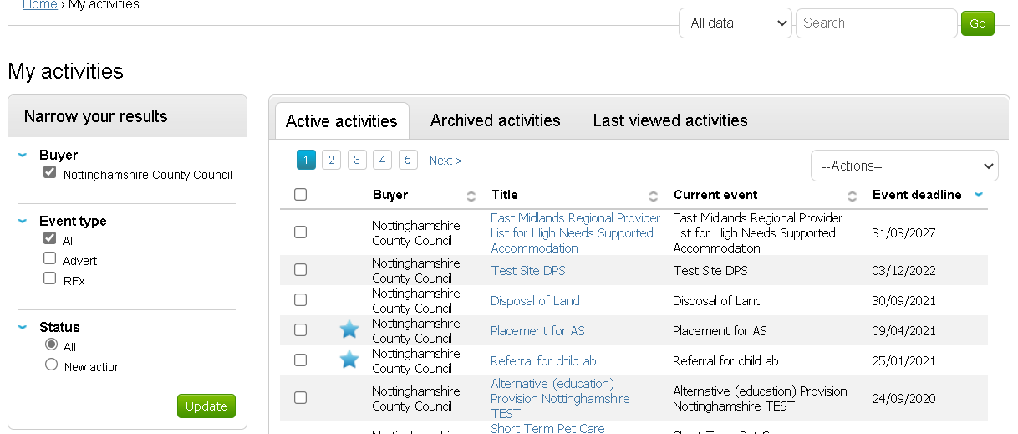
The saved tender will always appear in the ‘My activities’ tab and this where you should go to access it. From the ‘My Activities‘ tab the tender link will take you to the tender event list.

Tender Event list
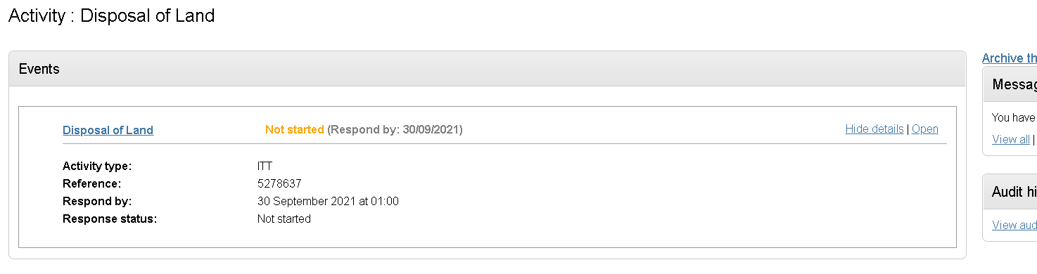
Click Open to see tender
Clicking Open will take you to the main tender Summary page for the opportunity. From this Summary page you can view and read any relevant documents and the terms and conditions

Tender Summary page
This screen shows a READ ONLY view of the tender. You can download and read associated documents without committing to starting your response.
Countdown to submission deadline
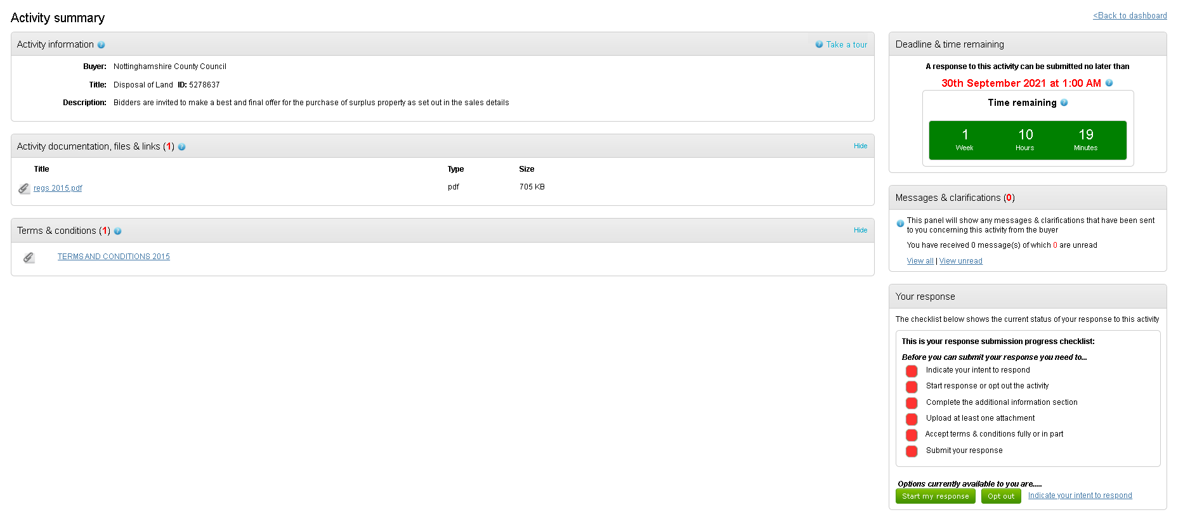
You can Start Response or Opt out if the tender is not for you.
Send and receive messages to and from the project team
Any attached documents will be listed here
Check list of actions. When all are green you can submit your tender

Once you’ve read the documents and decided you want to proceed you can then press the green Start my Response button. Or if you are not of interested you should press the Opt out Button and the project will be removed from your Activities.

Completing a Tender response

Response summary
Once you press Start my Response the screen changes and the check list items on the right start to show when they are completed.
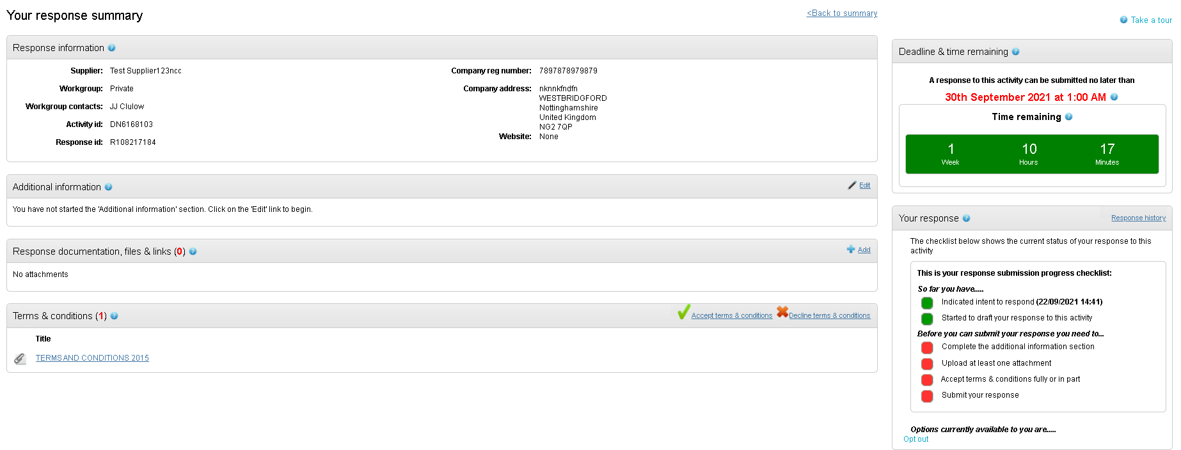
To complete the remaining check list items follow these instructions;

Attach your completed Form of Tender & any other documentation
You must attach your completed Form of Tender as per the instructions in the tender. It is important that provide all the information requested and, in the format, specified otherwise your tender may be rejected.
Click Add to start adding documents
This opens the file upload tool. You can drag and drop documents from File explorer or browse your computer. Once all the documents you want are assembled you need to press Start upload to finish the upload.
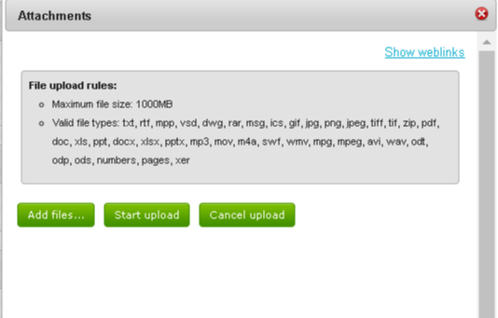
Click here to browse your files. Then click “start upload” to import them into your response.

Terms & conditions
Click on the green tick symbol to accept the terms and conditions. Note that if you do not accept them you will be unable to complete your submission.
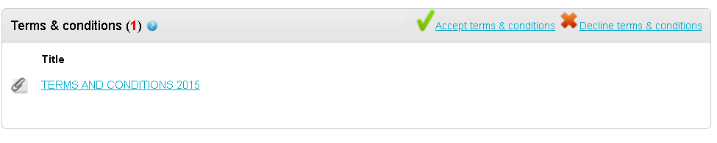

Response Check list and Submit button
Only after all of the Check list tasks have been completed will a green Submit Response button appear.
As each task is completed the checklist goes green. When all are green the Submit response, button will appear.
You will be prompted to confirm.

The screen now shows the date and time of your submission.

Editing response
You can change your mind at any point up until the deadline.
If you want to amend your submission you can click on Change Response button.
Note if you press Change response it removes the response from the system and you must press submit response again to submit a new version.
You will see a log of the versions of your bid here;
All submitted bids are secured by the system until after the deadline. Only after it has expired will anyone from the Council be able to open any of your documents.

