Blackpool Council Engineering (Trams)

Tamping Operations on Blackpool and Fleetwood Tramway

Revision History

Version | Date | Description of Change
1.0 | June 2020 | Final issue

BC Document Number: | BPL-TWY-GD-001
Issue Number: | 1.0
Issue Date: | June 2020
Author: | Blackpool Council, Track Services
Approver:  Signature: | Tramway Safety Officer  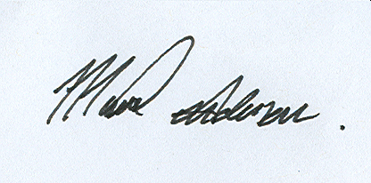
Review Date: | June 2021

Record of Review
Date of Review | Occasion  A- Annual  X- Exceptional | Name of Reviewer | Signature

Issue Record:
Copy No. 1 Track Safety Officer
Copy No. 2 Blackpool Council Occupational Health & Safety Department
Copy No. 3 Blackpool Transport Services

Contents
1 Introduction 7
1.1 Background 7
1.2 Roles 7
2 Permanent Way 8
2.1 Network Layout 8
2.2 Plain Line Track Construction 9
2.2.1 Track Gauge 9
2.2.2 Minimum curve radii 9
2.2.3 Ballasted Track Construction 9
2.3 Switch and Crossing Track Construction 10
3 Wheel Rail Interface 12
3.1 Compatible Wheel Profile 12
4 Platforms & Structural Clearances 13
4.1 Tram Stops 13
4.2 Structures 13
5 Track Access 15
5.1 Guidance 15
5.2 Stabling & Security 15
6 Requirements Specification 16
6.1 Scope 16
6.1.1 Special precuations………………………………………………………………………………………………………………16
6.2 Possession Strategy 16
6.2.1 Protection Arrangements 16
6.2.2 Permit Applications 16
6.3 Working Safely on the Tramway 16
6.3.1 Wrong Direction Tamping Operations 17
6.4 Suggested Methodology 18
6.5 Tram Stops 18
6.6 Tamping Extents 18
6.7 Tamping Technical & Functional Requirements 19
6.7.1 Measurement Capability 19
6.7.2 Heights and Staggers 19
6.7.3 Track Handback Requirements 19
6.8 Out of Hours Working 19
6.9 Road closures 19
6.9.1 Track crossing installations 20
6.10 Contact 21

List of Figures
Figure 1 Blackpool & Fleetwood Tramway Network Layout 8
Figure 2 Ri60R1 Groove Rail Profile 10
Figure 3 Crossing Nose & Check Rail Flange Running Profiles 11
Figure 4 Compatible Wheel Profile 12
Figure 5 Critical Wheel Profile Dimensions 12
Figure 6 Platform Edge Clearances 13
Figure 7 OLE Centre Pole Minimum Clearance 14
Figure 8 Tamper On Tracking 15
Figure 9 Tamping North of Fleetwood Road, Anchorsholme 16

List of Tables
Table 1 Tamping Extents 19

Abbreviations
BC Blackpool Council
BTS Blackpool Transport Services
IM Infrastructure Manager
OLE Overhead Line Equipment
ORR Office of Rail Regulation
ROGS Railways and Other Guided Transport Systems (Safety) Regulations 2006
RSP2 Guidance on Tramways
RRV Road Rail Vehicle
TSO Tramway Safety Officer
TO Transport Operator
TU Transport Undertaking

References
RSP2, Guidance on Tramways
URL: http://orr.gov.uk/__data/assets/pdf_file/0018/2637/rspg-2g-trmwys.pdf
Tramway Technical Guidance Note 1 Design Requirements for Street Track
URL: http://orr.gov.uk/__data/assets/pdf_file/0019/5068/ttgn1-StreetTrack.pdf

Introduction

Background
The Blackpool & Fleetwood Tramway is the only remaining first generation tramway in the United Kingdom, having remained in constant operation since it first opened in 1885. The current network extends for 18.2Km along the Fylde coastline from Starr Gate terminus at the southern end of the alignment to Fleetwood Ferry in the north.
Blackpool & Fleetwood Tramway is owned by Blackpool Council (BC) and operated under licence by Blackpool Transport Services (BTS).

Roles
The Railway and Other Guided Transport Systems (Safety) Regulations 2006 places legal obligations on persons carrying out specific duties under the regulations. These bodies are called Duty Holders. The Duty Holder’s for Blackpool & Fleetwood Tramway are:
- Infrastructure Manager - Blackpool Council Track Safety Officer
- Transport Operator – Blackpool Transport Services Head of Tramway
The Infrastructure Manager is responsible for the condition of the asset and is the principal point of contact for all matters relating to the tramway.

Permanent Way

Network Layout
The track layout is as shown in Figure 1.
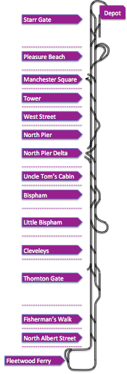
Figure 1 Blackpool & Fleetwood Tramway Network Layout
Ballasted track construction is used on Blackpool & Fleetwood tramway between Uncle Tom’s Cabin and Fisherman’s Walk only. However, the ballast track is punctuated at regular intervals by short sections of paved track construction types between these 2 tram stops. Therefore there is a requirement for plant that cannot easily disengage steel wheel contact with the rails to exhibit rail wheel interface characteristics that are compatible with the requirements set out in this section of this Guidance Document, especially through the embedded Switch & Crossing (S&C) Permanent Way configuration.

Plain Line Track Construction
Track on United Kingdom tramways is classified as integrated and segregated depending upon the environment in which it operates. Track on the Blackpool & Fleetwood tramway is fundamentally of two construction types:
- Ballasted track form to Network Rail Track Construction Standard to satisfy the requirements for Category 4; and
- Paved track with encapsulated groove rail (Ri60R1).
All Switch & Crossing units are constructed in paved track sections of the alignment and Tamper & Road Rail Vehicle (RRVs) wheel profiles proposed to be used on the network will need to be compatible with both the plain line Ri60R10 and S&C in respect of rail groove and gauge corner compliance.

Track Gauge
Track gauge is 1435mm throughout.

Minimum curve radii
The minimum curve radii on the network are as follows for the different types of track construction:
- Ballasted track 147m; and
- Paved Track 22.5m.

Ballasted Track Construction
The ballast track on the network is constructed from the following materials:
- Rail profile predominantly CEN56E1 with some 95lb bullhead rail on tight curves (see Note);
- Rail inclination 1:20 nominal;
- Sleeper spacing nominally 700mm (26 per 18.288m);
- Sleeper type G44 except for tight radius curves where timber sleepers are used with check rail; and
- Depth of ballast 250mm nominal.
Note: At Thornton Gate and Cumberland Avenue there are extended lengths of vertically mounted Ri60R1 on 001 Bearers. Note that the gauge corner for the asymmetric groove rail used on the network is 10mm. The groove is 36mm wide at its maximum width and 47mm deep. The detailed drawing is shown in Figure 2.
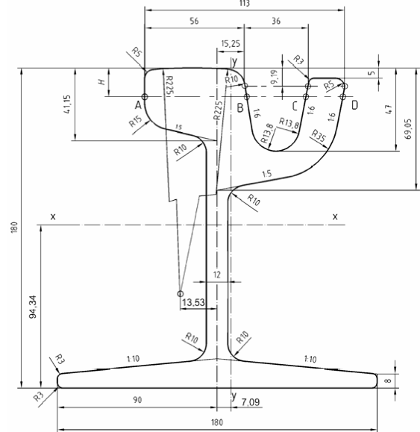
Figure 2 Ri60R1 Groove Rail Profile

Switch and Crossing Track Construction
S&C construction is important because tampers and rail mounted plant that ideally need to stay on the rail head to move from site to site must be compatible with the changes in the rail configuration as the wheel flange passes through the crossing nose and parallel check rail section. At this point the groove width and depth alter significantly to present a rail profile to the wheel that forces the wheel out of the groove and generates ‘flange running’ during which the flange makes contact and runs on the shallow (circa 14mm) rail channel. Figure 3 illustrates the changes in the rail groove profile through all S&C crossing noses and check rail sections and the transitional arrangements between full Ri60R1 groove rail.

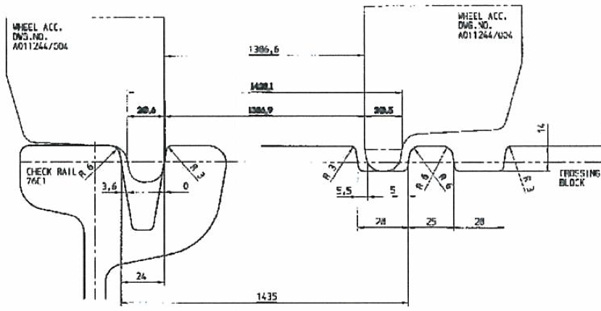

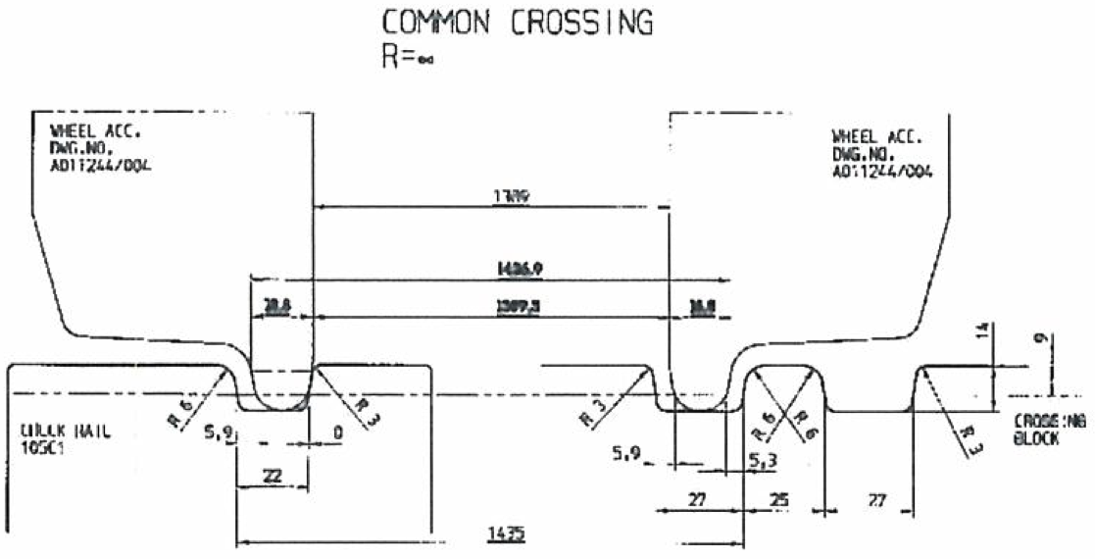

Figure 3 Crossing Nose & Check Rail Flange Running Profiles

Wheel Rail Interface

Compatible Wheel Profile
Figure 4 illustrates a proven compatible wheel profile for plant utilised on the Blackpool & Fleetwood tramway during the 2009-2011 track renewal works.
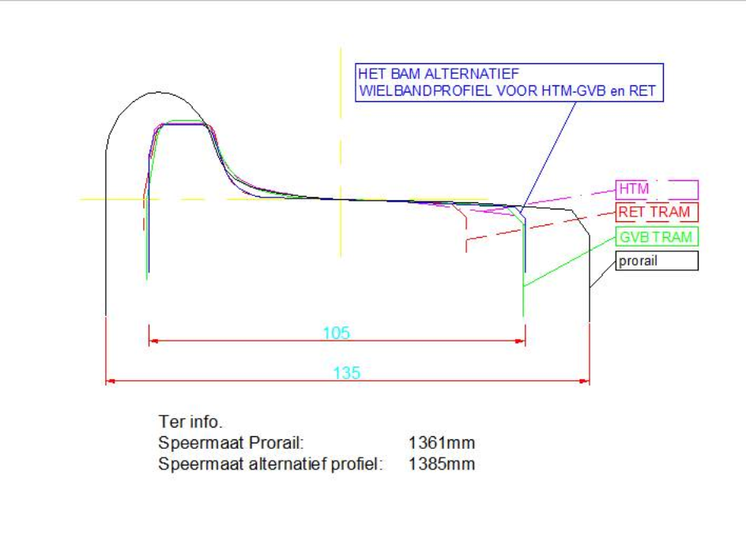
Figure 4 Compatible Wheel Profile
Figure 5 tabulates the critical dimensions of the proven wheel profile illustrated at Figure 4.
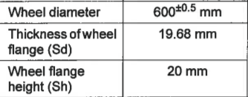
Figure 5 Critical Wheel Profile Dimensions

Platforms & Structural Clearances

Tram Stops
Blackpool & Fleetwood Tramway complies with the Mobility Inclusive Regulations and Rail Vehicle Accessibility Regulation through the provision of low level platforms across the network with stepping distances nominally 50mm between tram and stop edge in both the vertical and horizontal planes. Figure 6 identifies the setting out clearances that are applied at all tramstops across the network.
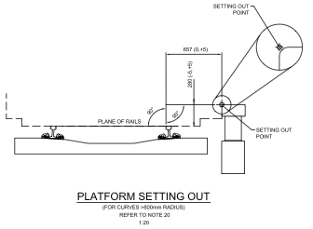
Figure 6 Platform Edge Clearances

Structures
The minimum clearance to any structure is to centre mounted Overhead Line Equipment (OLE) poles. The clearance to these structures is set at Developed Kinematic Envelope (DKE)+100mm (minimum) based on the DKE of the Flexity 2 tram. This means that for straight and level track the closest point of a centre mounted OLE pole can be 857.5mm from the running edge of the 6ft rail (1575mm from the track centre line). As dynamic effects of track curvature and cant influence different vehicles in different ways it is the responsibility of the prospective supplier to ensure that gauging clearances are satisfied for operation on the Blackpool & Fleetwood tramway. It should however be noted that the structural clearances applied on the network are both consistent with the requirements of RSP2 and those installed on all other UK light rail networks. Figure 7 is an extract from RSP2 that illustrates the minimum clearances.
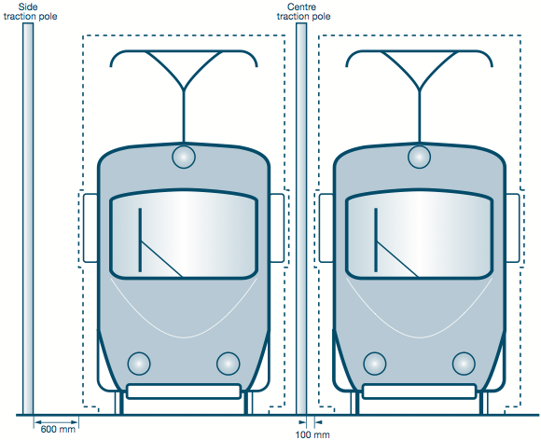
Figure 7 OLE Centre Pole Minimum Clearance

Track Access

Guidance
Standard precautions and procedures for gaining access to the network are contained in the document ‘Safety on the Line’, which is available upon request from the TSO. Amongst other things it sets out the minimum OLE wire height for the network and the standard safe working heights to be adopted.
Figure 8 shows a tamper on tracking at Fishermans Walk close to the northern limit of the ballast track construction.

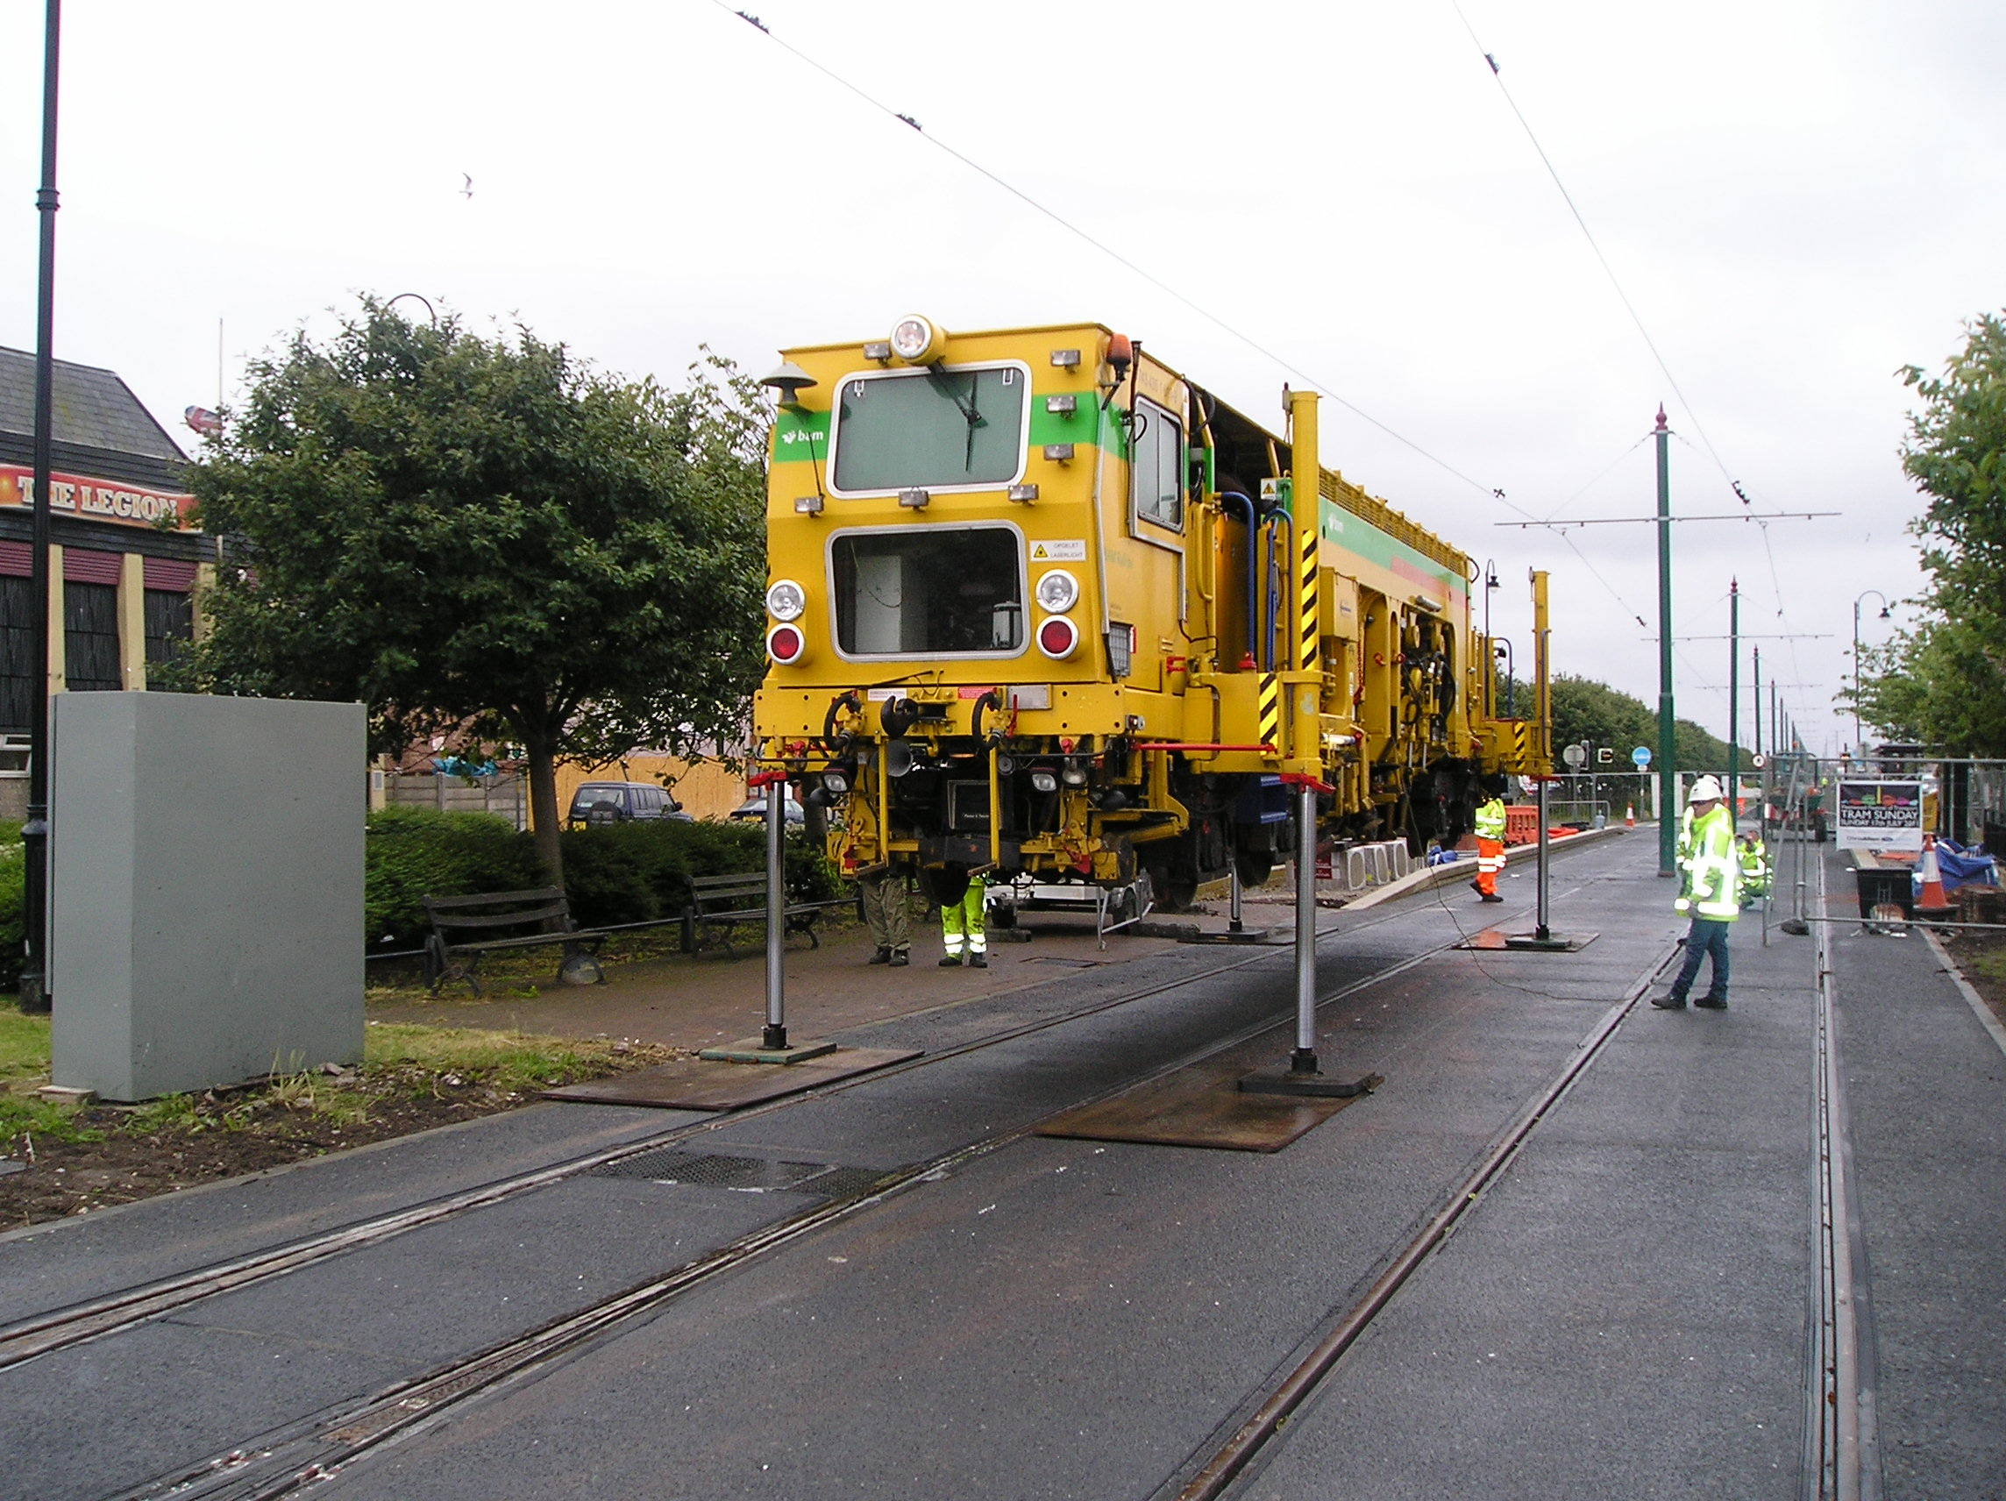
Figure 8 Tamper On Tracking
The selection of the most appropriate on and off tracking point requires careful consideration due to the close proximity of residential properties and constricted turning opportunities for Long Wheelbase vehicles. Fishermans Walk is a good choice of location because it represents the boundary between integrated on street and segregated off street track construction types.

Stabling & Security
All areas of the tramway between Uncle Tom’s Cabing and Fishermans Walk are entirely accessible with no secure area available for stabling Tampers or other large items of plant. The most appropriate stabling areas are at Thornton Gate or Bispham. Access to the secure tram depot at Starr Gate is impractical because of the nature of the network south of Uncle Toms Cabin and the tight radius curves within the depot. The requirements for stabling and security should be discussed with the TSO during the consultation process which will happen post-award and prior to commencement on site.

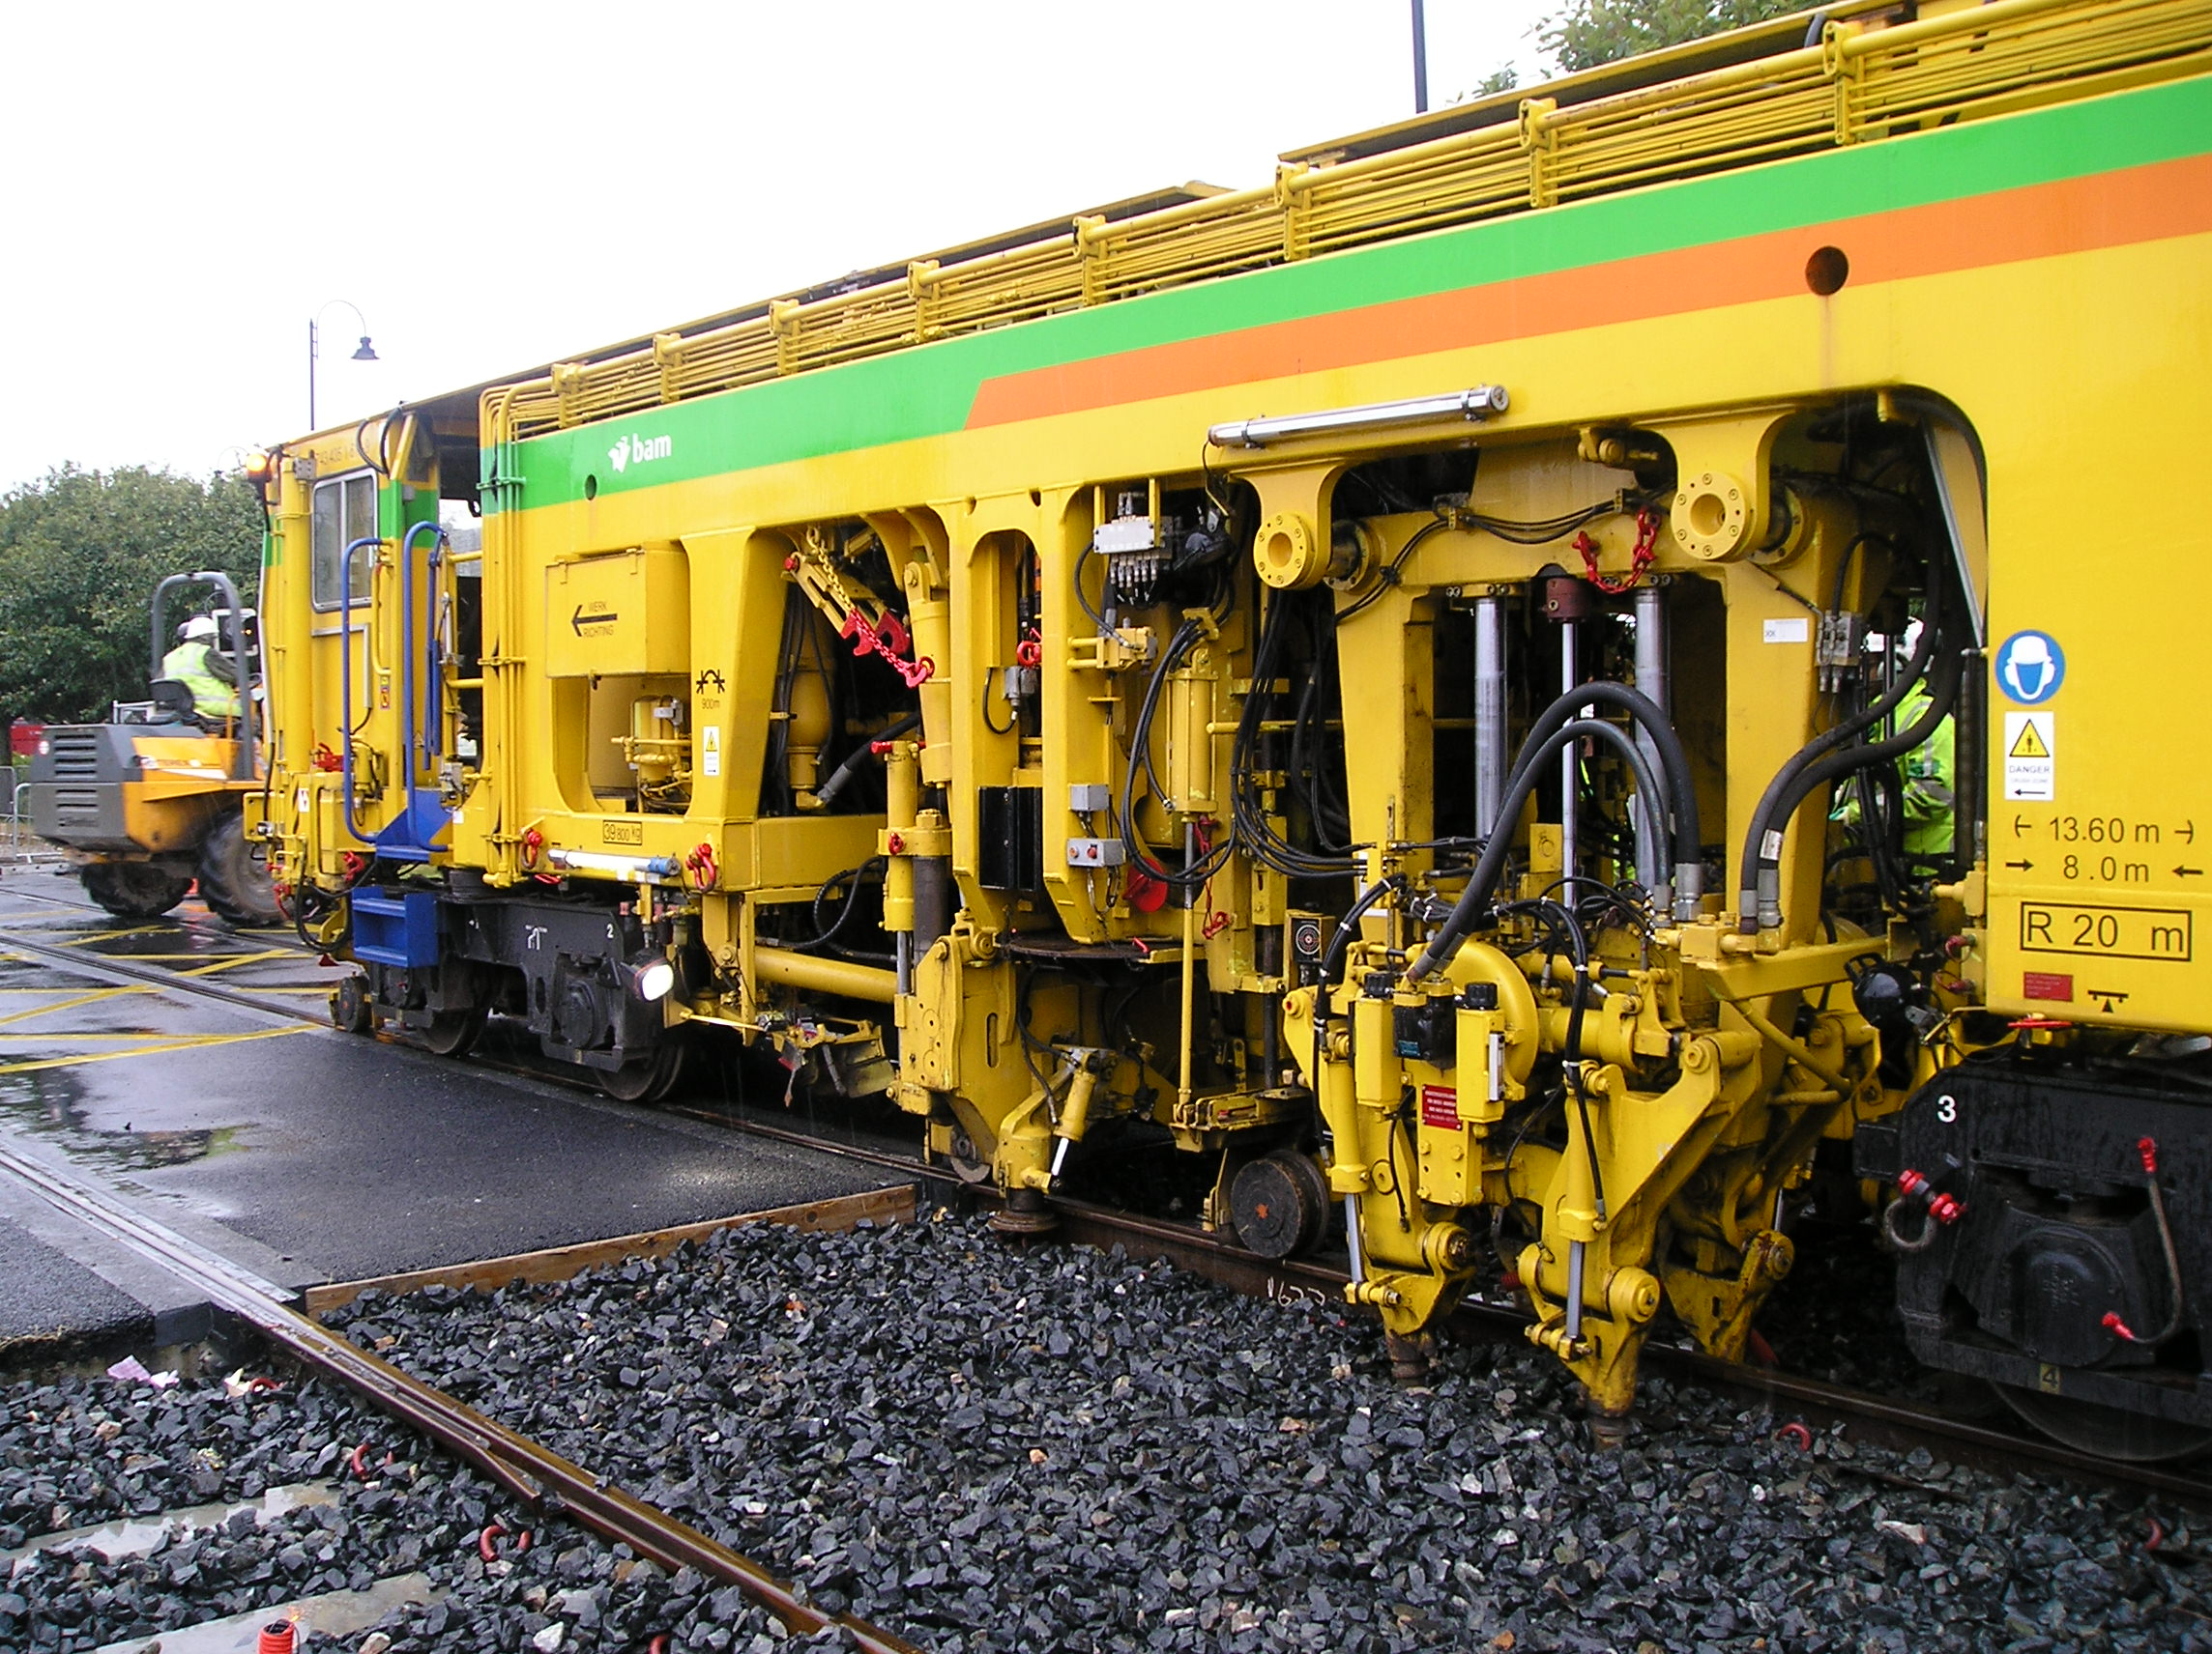
Figure 9 Tamping North of Fleetwood Road, Anchorsholme

Requirements Specification

Scope
This section outlines the key information necessary to enable interested suppliers to develop a technical proposal to undertake tamping operations on the Blackpool & Fleetwood tramway system. Applications to Blackpool Council should include an indicative programme of works, a schedule of rates and an offer price.

6.1.1 Scope of the work, special precautions
The system shall be surveyed by the tamping machine to determine if any of the vehicle crossings underrun needs to be removed. Additionally, the pedestrian crossings formed in hard materials will also need to be identified and removed by the Council to necessitate the work.

All platforms shall remain untouched. Please note restricted access when passing through the platforms.

Other works are programmed during the system closure, this includes sub arc welding and rail replacement. Refer to the other appropriate lots to clarify where the proposed works are and what if any impact it will have on the tamping work.

Possession Strategy
Works on the tramway are to be undertaken outside the resorts tourist and illumination season. The preferred date for undertaking the works is the February half term holiday (Week commencing 15th Feb 2021). Track access required to complete the tamping operations should be indicated in the works programme to enable the Tramway Safety Officer to establish whether the required access can be negotiated with the Transport Operator.
Contractors must be aware of other potential works during this period including sub-arc welding and track relay (Little Bispham to Cleveleys) which may be undertaken by other Contractors. The successful Contractor should liaise with BC to avoid scheduling conflicts.

Protection Arrangements
Tamping operations will be carried out under Type 3 Green Zone conditions otherwise referred to as a total block of the line. Full details of the definitions and requirements for establishing safe systems of work are contained in Blackpool Council’s track safety publication, ‘Safety on the Line’. This document is the equivalent of the Rule Book GE/RT8000.

Permit Applications
Permits should be submitted to the Tramway Safety Officer. A copy of the Permit Application Form, including information on how to submit can be found via the following URL:
https://www.blackpool.gov.uk/Business/Licensing-and-permits/Documents/Tramway-Activity-Permit-Application.pdf

Working Safely on the Tramway
Full details of how to implement safe systems of work on the tramway including working adjacent and under overhead line electrification equipment is contained within the document ‘Safety on the Line’. A condensed version of the document outlining the salient points is available on Blackpool Council’s website via the following URL:
https://www.blackpool.gov.uk/Business/Licensing-and-permits/Documents/tramway-overhead-powerlines.pdf

Wrong Direction Tamping Operations
Wrong direction (aka ‘Bang Road’) tamping operations are permitted within a Type 3 protected Green Zone. Requirements for the marshalling of On Track Plant when operating wrong direction across road traffic junctions and implementing an appropriate Safe System Of Work should be agreed with the Tramway Safety Officer.

Suggested Methodology
Tamping operations will be carried out under a full line blockage as set out earlier within this section of the document. To minimise the impact on revenue service it is recommended that tamping commences at the southern limit (Uncle Tom’s Cabin tram stop) and tamping of both lines should be completed up to the next natural blocking point where tram services can be turned back.
The network layout map indicates where the turnback locations are but for clarity these are scheduled out here:
- Bispham;
- Little Bispham;
- Cleveleys; and
- Thornton Gate.
Once tamping is complete beyond the recognised turnback point the line block will be shortened to enable revenue service to be extended.

Tram Stops
Tamping through tram stop locations is not required and is not to be included in any proposal.
The contractor must take special notice of the restricted access through the platforms to ensure the tamping machine can safely negotiate the platform edge.
Table 1 indicates the number of tramstops between the required limits of tamping. Tramstops are nominally 44m in length between Bottom Of Ramp limits. Rubber mat ‘flat and level’ surfacing at tramstops should not be removed for the purpose of tamping although under-run protection placed in the 4ft beyond recognised pedestrian crossing points will require removal to allow tamping prior to re-instatement on completion of works.

Tamping Extents
Tamping is to be undertaken between the following tramstops. Precise metreage should be confirmed as part of a site visit. Platforms are not to be tamped, however, the extended underrun in the 4 foot can be removed to allow tamping operations.
The following table outlines the scope of the work. For all pedestrian crossings, usually in Holdfast rubber, shall be removed, this includes the panels in the Cess, 4 foot and 6 foot. Also the extended 4 foot.
Vehicle crossings are usually in STRAIL. All panels need to be removed prior to tamping (where tamping is required).

Vehicle crossings are:
- Norbreck
- Anchorsholme Lane (previously tamped, likely to be acceptable)
- Westmorland.
- College Farm
- Rossall Lane
- South Strand
- Larkholme Ave

Following the tamping operations, where practicable, the underrun should be reinstated as soon as possible.
 |  | Rubber mat crossings - removal, tamp and reinstatement req’d
Between | Distance (nominal) | Road | Pedestrian | platforms
Uncle Toms Cabin & Bispham | 1200m | 1 | 2 | 3
Bispham (North) & Little Bispham | 1700m | 1 | 3 | 4
Little Bispham (North) & Cleveleys | 1400m | 1 | 1 | 2
Cleveleys (North) & Thornton Gate | 600m | 0 | 4 | 2
Thornton Gate (North) & Fishermans Walk | 4000m | 5 | 5 | 7
Table 1 Tamping Extents

Tamping Technical & Functional Requirements

Measurement Capability
Tampers should have a track geometry measurement capability to be able to automatically calculate ‘best fit’ lift and slew solutions to achieve Track Category 4 SD values. Lifts and slew application solutions indicating values of greater than +/-20mm should be discussed with the Tramway Safety Officer before implementation.

Heights and Staggers
Overhead line contact wire relative position to the final (post tamp) track alignment should be assured for compliance as part of the deliverables pack track handback documentation.

Track Handback Requirements
A pack of agreed assurance deliverables should be presented for acceptance by the Tramway Safety Officer prior to opening any section of track for passenger service on completion of tamping operations. It is recommended that the Form G and relevant supporting Forms are used to validate compliance and safety in respect of track geometry, site condition and Overhead Line Equipment status.
A copy of the pre-tamp and post-tamp measurement runs undertaken by the tamper are to be included within the final assurance pack to update track maintenance records.

Out of Hours Working
Due to the nature of the tramway and its general close proximity to residential and business premises out of hours working is not permitted. The normal permitted hours of working are 0800-1800 daily.

Road closures
Road closures will be required at certain locations where proprietary rubber mat crossings have been installed. Road closure notice periods are set out on Blackpool Council’s website at the following URL:
https://www.blackpool.gov.uk/Business/Working-with-the-council/Organising-an-event/Advice-and-guidance/Traffic-management---Special-events-procedure.aspx
The current minimum notice period is 40 days. Contractor’s should make allowance for road closures and appropriate traffic and pedestrian management within their programme of works.
Anticipated road closures
Anchorsholme Lane
Westmorland
Rossall Lane
South Strand
Larkholme Ave

Track crossing installations
The price for the works should include for the removal and reinstatement of all rubber mat crossings. Proprietary rubber mat crossings are installed at the following locations:
- Road (vehicular):
  - Bispham
  - Norbreck
  - Anchorsholme Lane
  - Westmoreland Avenue
  - College Farm
  - Rossall Lane
  - South Strand
  - Larkholme Avenue
- Pedestrian:
  - St Stephens #
  - Admiral Point
  - Madison Ave#
  - Leyburn Ave#
  - Norkeed Rd #
  - Melton Place #
  - Lauderdale #
  - Vicarage Ave
  - Clarence Ave
  - Stockdove Way
  - Beach Road#
  - Lingfield Rd
  - Wyre Street
  - Nansen Rd #
  - Copse Rd #
# denotes solid constructed crossing that the Council shall remove prior to commencement.

Contact
All enquiries to undertake works on the tramway should be directed to the Tramway Safety Officer at Blackpool Council’s Layton Depot site at the following address:
Plymouth Road
Blackpool
FY3 7HW

Full contact details for Blackpool Council can be found via the following URL:

https://www.blackpool.gov.uk/Contact-us.aspx.

