QUOTATION REQUEST
Gosport Borough Council invite quotes from suppliers for the supply and delivery of materials for the maintenance of sports pitches and horticultural features as detailed below for delivery between 5th April and 14th April 2021.
General considerations
The supplier must agree to Gosport Borough Council terms and conditions.
The materials examples listed are given as guideline to the nature of the materials required and the nature of the environment in which the materials are to be used.
Requirements
All products must conform to relevant BS:EN standards and be appropriate for the location of use indicated on the table below.
Quantities are stated either as values to apply products to or volume to be delivered.
USE | MATERIAL | APPLICATION QUANTITY | APPLICATION  NUMBER | DELIVERED QUANTITY
LINES | Liquid natural turf sports pitch linemarking fluid |  |  | 200 L
LINES | Nozzle spray machine for applying linemarking fluid |  |  | 4

Delivery
All materials are to be delivered to Grange Farm, Little Woodham Lane, Gosport, PO13 8AB shown on plan of area below.
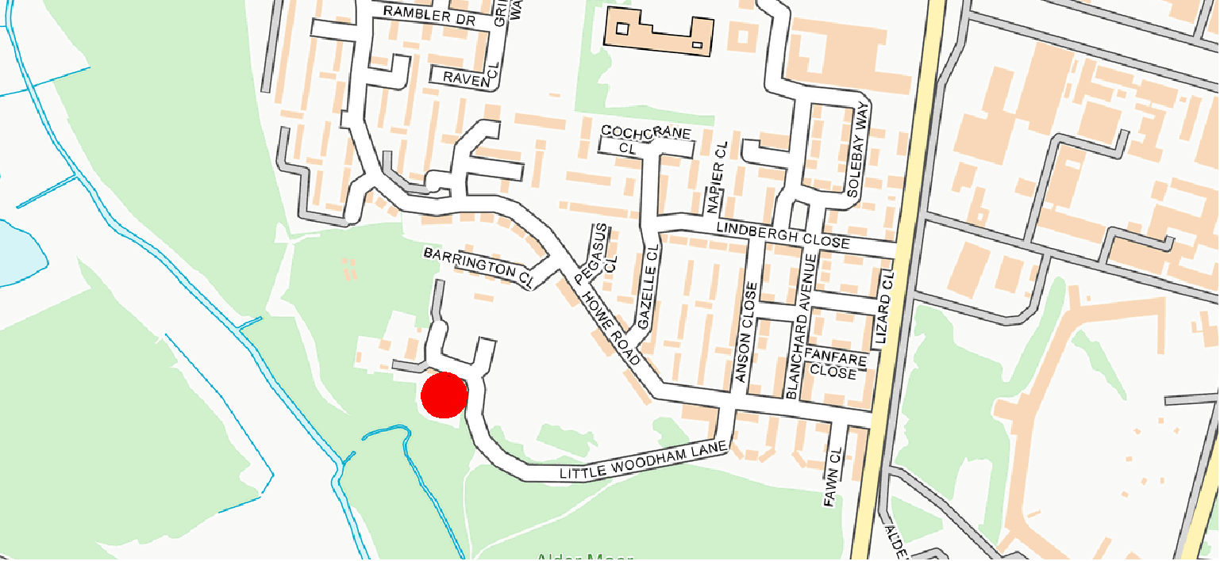
QUOTATION PROCESS
Please return quotes through the South East Business Portal, also known as Proactis, this must be your full and final price.
Quotes are to be returned by 15th February 2021.
Evaluation
These works will be awarded on best value price, provided the quotation covers all of the required considerations detailed above.

