The Durham Centre
Belmont Industrial Estate, Durham, DH1 1TN
T: 0845 481 2191
E: enquiries@thedurhamcentre.co.uk
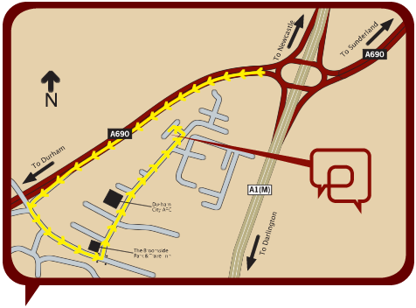

Directions
From the A1(M):
- Exit A1(M) at Junction 62, signposted Sunderland, Durham (A690), Consett (A691)
- At roundabout, take exit signposted Durham (A690), Consett (A691)
- Leave A690 at first exit, signposted Belmont, Dragonville, Karting Centre
- At Junction, turn left, signposted Belmont, Dragonville
- At traffic lights, turn left, signposted Belmont Business Park, Belmont Industrial Estate
- Continue for 1/2 mile, turn left into Belmont Industrial Estate
- At junction, turn left
- The Durham Centre is on your right
Distance from Durham Train Station: 2.8 miles*
Distance from Newcastle Airport: 24.5 miles*
Distance from Durham Tees Valley Airport: 26.8 miles*
View on Google Maps
*All mileages are approximate

