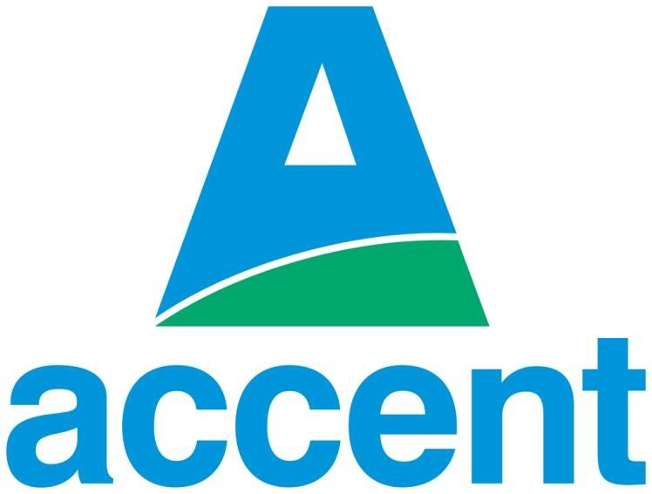

Grounds Maintenance Services
Form of Quotation

Notes:

This declaration must be completed by director or other authorised senior representative of your organisation with the appropriate capacity and authority to execute contracts and Printed on the Supplier’s Letterhead.

Form of Quotation

I Name the undersigned, having examined the ITT and all the documentation and appendices, offer to provide Grounds Maintenance as specified in those documents and in accordance with the attached documentation to Accent Housing Ltd commencing on the date of the award and continuing for the period specified in the contract.

If this offer is accepted, we will execute the contract within 14 days of being asked do so.

I acknowledge this is an output based specification as noted in section 5 – appendix 6 of the ITT. The delivery approach undertaken is at the discretion of the Contractor. Provided the output specification is met in full, the Contractor has the latitude to deliver the work in the manner they deem most efficient. And the decision of what is an acceptable output specification delivered at each site rests with Accent.

I also acknowledge should an incumbent Contractor of any “Lot” fail to consistently deliver the required standards during the contract term, Accent may at its discretion terminate that Contract and subject to (i) price maintenance (ii) the agreement of both parties; re-let the contract to any successful respondent Contractor without the need for further competition.

I agree that before executing the contract (and associated schedules) substantially in the form set out in the ITT, the formal acceptance of this Tender in writing by Accent Housing Ltd or such parts as may be specified, together with the contract documents attached hereto shall comprise a binding contract between Accent Housing Ltd and or Domus Services Ltd and the Contractor.

I further agree:

- with Accent Housing Ltd in legally binding terms to comply with all the provisions set out in ITT Procurement Section 6 Notice to Contractors.
- any prices, rates or discounts quoted in the Tender are valid for 3 months after the Submission return date and we confirm that the terms of the Tender will remain binding upon us and may be accepted by you at any time before the expiry of that period.

I undertake and it shall be a condition of any contract, that:

- I will have the capacity and personnel to undertake all associated work and services for the duration of the agreement.
- the amount of our Tender has not been calculated by agreement or arrangement with any person other than Accent Housing Ltd and that the amount of our Tender has not been communicated to any person until after the closing date for the submission and in any event not without the consent of Accent Housing Ltd;
- I have not canvassed and will not, before the notification of the outcome of the evaluation process, canvass or solicit any member or officer, employee or agent of Accent Housing Ltd or other contracting authority in connection with the award of the contract and that no person employed by us has done or will do any such act;
- the information contained in this Quotation is complete and accurate to the best of my knowledge and I understand that false information will exclude the organisation I represent from proceeding further with the application. Furthermore, it is agreed that continuing accuracy of this information will be a requirement of this process up to the signing of any contract; and

I warrant that I have all requisite authority to sign this Tender and confirm that I will abide and have complied with all the requirements of the ITT.

I understand that Accent Housing Ltd shall be entitled to cancel the contract and to recover from my organisation the amount of any loss or damage resulting from such cancellation if:

- my organisation has offered or has given or has agreed to give to any person any gift, consideration, inducement or reward of any kind for doing or not doing any action in relation to the contract or any other contract Accent Housing Ltd (or any of its Group or associated companies);
- the acts detailed above have been done by any person employed by my organisation or acting on behalf of my organisation (whether with or without my organisation's knowledge);
- in relation to any contract with Accent Housing Ltd (or any of its Group or associated companies) my organisation or any person employed by my organisation or acting on my organisation's behalf has failed to disclose any conflict of interest that might result in Accent Housing Ltd (or any of its Group or associated companies) contravening any statutory or regulatory obligation.

I understand that the information in this Tender will be used to assess my organisation’s suitability to become a prospective Supplier to Accent Housing Ltd (or any of its group or associated companies) and that information will be held both electronically and manually for this purpose in accordance with the GDPR.

I further confirm that all the information contained in the Company Information supplied within Due North ProContract and the ITT is correct, and I have not amended, altered or edited the text in any way.

Signature
Print Name
Position
Date
For & On Behalf of

N.B. this declaration must be completed by director or other authorised senior representative of your organisation with the appropriate capacity and authority to execute contracts and Printed on the Supplier’s Letterhead.

